**COMSATS University, Islamabad Pakistan**

**OculaCare**

***By***

**Awais Ur Rehman CUI/SP21-BSE-019/ISB**

**Bilal Khan CUI/SP21-BSE-023/ISB**

***Supervisor***

**Dr. Uzair Iqbal Janjua**

**Co – Supervisor Miss. Lailma Javed**

***Bachelor of Science in Software Engineering (2021-2025)***

**The candidate confirms that the work submitted is their own and appropriate credit has been given where reference has been made to the work of others**.

**COMSATS University, Islamabad Pakistan**

**OculaCare**

**A project presented to**

**COMSATS University, Islamabad**

**In partial fulfillment**

**of the requirement for the degree of**

***Bachelor of Science in Software Engineering (2021-2025)***

**By**

**Awais Ur Rehman CUI/SP21-BSE-019/ISB**

**Bilal Khan CUI/SP21-BSE-023/ISB**

Declaration

We hereby declare that this software, neither whole nor as a part has been copied out from any source. It is further declared that we have developed this software and accompanied report entirely based on our personal efforts. If any part of this project is proved to be copied out from any source or found to be reproduction of some other, we will stand by the consequences. No Portion of the work presented has been submitted of any application for any other degree or qualification of this or any other university or institute of learning.

Awais ur Rehman Bilal Khan

Certificate of Approval

It is to certify that the final year project of BS (SE) OculaCare was developed by **Awais ur Rehman (CIIT/SP21-BSE-019)** and **Bilal Khan (CIIT/SP21-BSE-023)** under the supervision of **Dr. Uzair Iqbal Janjua** and co supervisor **Miss. Lailma Javed** and that in their opinion; it is fully adequate, in scope and quality for the degree of Bachelor of Science in Software Engineering.

**Supervisor**

**External Examiner**

**Head of Department**

**(Department of Computer Science)**

**Executive Summary**

OculaCare represents a groundbreaking approach to addressing the global challenge of preventable eye diseases, which affect millions worldwide. This mobile application leverages advanced machine learning models to detect and classify a wide range of eye conditions, including cataracts, strabismus, bulging eyes, and pterygium, with exceptional accuracy. By integrating personalized treatment recommendations, therapy exercises, and vision self-assessment tools, the application offers users a comprehensive and proactive solution for managing eye health. The project’s core objective is to bridge the gaps in accessibility and affordability of eye care services, particularly for underserved populations and remote areas where professional medical assistance is often unavailable.

The development of OculaCare focuses on creating a seamless and user-centric experience, with features like secure patient registration, an intuitive interface, and a robust system for capturing high-quality eye images using smartphone cameras. The application also includes a health facility locator, providing users with easy access to nearby hospitals and specialists. For healthcare administrators, an integrated web-based dashboard offers insightful data analytics, patient management tools, and interactive reporting to monitor trends and outcomes effectively. The system’s architecture and design prioritize scalability, reliability, and data security, ensuring compliance with international healthcare standards.

OculaCare’s innovation lies in its ability to transform eye health care from a reactive to a proactive model by facilitating early detection and intervention. It empowers users to take charge of their eye health through continuous monitoring and evidence-based recommendations, ultimately aiming to reduce the burden of visual impairments and enhance the quality of life. With a strong emphasis on inclusivity, the application supports a diverse demographic, ensuring accessibility for individuals across various socioeconomic backgrounds. The successful implementation of OculaCare not only highlights the potential of technology in revolutionizing healthcare but also paves the way for further advancements in personalized and accessible medical solutions.

.

**Acknowledgement**

All praise is to Almighty Allah who bestowed upon us a minute portion of His boundless knowledge by virtue of which we were able to accomplish this challenging task.

We are greatly indebted to our project supervisor **Dr. Uzair Iqbal Janjua** and our co supervisor **Miss. Lailma Javed.** Without their personal supervision, advice and valuable guidance, completion of this project would have been doubtful. We are grateful to them for their encouragement and continual help during this work.

And we are also thankful to our parents and family who have been a constant source of encouragement for us and brought us with the values of honesty & hard work.

Awais ur Rehman Bilal Khan

**Abbreviations**

|  |  |
| --- | --- |
| **SRS** | Software Require Specification |
| **AI** | Artificial Intelligence |
| **CNN** | Convolutional Neural Network |
| **API** | Application Programming Interface |
| **ML** | Machine Learning |
| **UI** | User Interface |
| **JSON** | JavaScript Object Notation |

**Table of Contents**

1. Introduction 12
   1. Vision Statement 12
   2. Related System Analysis/Literature Review 13
   3. Project Deliverables 14
   4. System Limitations/Constraints 15
   5. Tools and Technologies 15
   6. Relevance to Course Modules 16
2. Problem Definition 17
   1. Problem Statement 17
   2. Problem Solution 17
   3. Objectives of the Proposed System 18
   4. Scope 18
   5. Modules 19
      1. Module 1: Patient Registration and Account Management 19
      2. Module 2: Disease Detection and Classification 19
      3. Module 3: Disease Analysis and Medicinal Recommendations 19
      4. Module 4: Monitoring and Therapy Plans 20
      5. Module 5: Self-Assessment and Vision Monitoring 20
      6. Module 6: Health Facility Locator and Doctor Management 20
      7. Module 7: Admin Dashboard 21
      8. Module 8: Data Analytics and Reporting 21
3. Requirement Analysis 22
   1. User classes and characteristics 22
   2. Requirement Identifying Technique 23
      1. Requirement Gathering Approach 23
      2. Use Case Diagram 24
      3. Detail Use Cases 30
   3. Functional Requirements 81
      1. Module 1: User Registration and Account Management 81
      2. Module 2: Disease Detection and Classification 93
      3. Module 3: Disease Analysis and Treatment Recommendations 101
      4. Module 4: Monitoring and Therapy Plans 106
      5. Module 5: Self-Assessment and Vision Monitoring 114
      6. Module 6: Health Facility Locator 126
      7. Module 7: Admin Dashboard 135
      8. Module 8: Data Analytics and Reporting 144
   4. Non-Functional Requirements 151
      1. Reliability 151
      2. Usability 151
      3. Performance 151
      4. Security 151
   5. External Interface Requirements 152
      1. User Interfaces Requirements 152
      2. Software interfaces 152
      3. Hardware interfaces 152
      4. Communications interfaces 153
4. Design and Architecture 154
   1. Architectural Design 154
      1. Context Diagram 154
      2. Architecture Diagram 155
   2. Design Models 156
      1. Activity Diagrams 156
      2. Class Diagram 164
      3. Sequence Diagrams 165
   3. Data Design 173
      1. Schemas 173
      2. Data Dictionary 180
5. Implementation 182
   1. Algorithm 182
      1. Disease Detection and Classification from Uploaded Image 182
      2. Performing Therapies 183
      3. Performing Self-Assessment Test 185
      4. Visualize Disease Data 188
   2. External APIs/SDKs 190
   3. User Interface 191
      1. Onboarding Screen 191
      2. Registration Screen 192
      3. OTP Screen 193
      4. Login Screen 194
      5. Account Recovery Screen 195
      6. Home Screen 196
      7. Feedback Screen 197
      8. Disease Detection Screen 198
      9. Upload Image from Gallery Screen 199
      10. Image Capture Screen 200
      11. More Screen 201
      12. Profile Screen 202
      13. Add Address Screen 203
      14. Therapy Screen 204
      15. Test Screens 205
      16. Dashboard Page 206
      17. Patients Page 207
      18. Tests Page 208
   4. Deployment 209
6. Testing and Evaluation 210
   1. Unit Testing 210
      1. Unit Testing 1: User Registration and Account Management 210
      2. Unit Testing 2: Disease Detection and Classification 212
      3. Unit Testing 3: Disease Detection and Classification 213
      4. Unit Testing 4: Disease Detection and Classification 214
      5. Unit Testing 5: Disease Detection and Classification 216
   2. Functional Testing 218
      1. Functional Testing 1: User Registration and Account Management 218
      2. Functional Testing 2: Disease Detection and Classification 219
      3. Functional Testing 3: User Registration and Account Management 220
      4. Functional Testing 4: User Registration and Account Management 222
      5. Functional Testing 5: User Registration and Account Management 223
   3. Business Rules Testing 225
      1. Business Rule Testing 1: 225
      2. Business Rule Testing 2: 225
      3. Business Rule Testing 3: 225
      4. Business Rule Testing 4: 226
      5. Business Rule Testing 1: 226
      6. Business Rule Testing 2: 227
      7. Business Rule Testing 3: 227
      8. Business Rule Testing 4: 227
      9. Business Rule Testing 1: 228
      10. Business Rule Testing 2: 228
      11. Business Rule Testing 3: 228
      12. Business Rule Testing 1: 229
      13. Business Rule Testing 2: 229
      14. Business Rule Testing 3: 229
      15. Business Rule Testing 4: 230
      16. Business Rule Testing 1: 230
      17. Business Rule Testing 2: 230
      18. Business Rule Testing 3: 231
   4. Integration Testing 232
      1. Module 1: Integration Test M1 232
      2. Module 2: Integration Test M2 234
      3. Module 4: Integration Test M4 236
      4. Module 5: Integration Test M5 238
7. Conclusion and Future Work 241
   1. Conclusion 241
   2. Future Work 241
8. References 242
9. Plagiarism Report 243

**List of Figures**

Figure 1: Use Case Diagram for Patient (1/4) 24

Figure 2: Use Case Diagram for Patient (2/4) 25

Figure 3: Use Case Diagram for Patient (3/4) 26

Figure 4: Use Case Diagram for Patient (4/4) 27

Figure 5: Use Case Diagram for Admin (1/2) 28

Figure 6: Use Case Diagram for Admin (2/2) 29

Figure 7: Context Diagram of OculaCare 154

Figure 8: Architecture Diagram of OculaCare 155

Figure 9: Activity Diagram for Patient Registration 156

Figure 10: Activity Diagram for Capturing Eye Image 157

Figure 11: Activity Diagram for Generating Treatment Recommendations 158

Figure 12: Activity Diagram for Taking Therapy 159

Figure 13: Activity Diagram for Performing Self-Assessment Test 160

Figure 14: Activity Diagram for Locating Eye Hospital 161

Figure 15: Activity Diagram for Managing User Feedback 162

Figure 16: Activity Diagram for Visualizing Data 163

Figure 17: Class Diagram of OculaCare 164

Figure 18: Sequence Diagram for Patient Registration 165

Figure 19: Sequence Diagram for Capturing Eye Image 166

Figure 20: Sequence Diagram for Generating Treatment Recommendation 167

Figure 21: Sequence Diagram for Generating Therapy Plan 168

Figure 22: Sequence Diagram for Performing Self-Assessment Test 169

Figure 23: Sequence Diagram for Locating Eye Hospitals 170

Figure 24: Sequence Diagram for Managing Users Profile 171

Figure 25: Sequence Diagram for Visualizing Data 172

Figure 26: Onboarding Screens 191

Figure 27: Registration Screen 192

Figure 28: OTP Verification Screen 193

Figure 29: Login Screen 194

Figure 30: Account Recovery Screen 195

Figure 31: Home Screen 196

Figure 32: Feedback Screen 197

Figure 33: Disease Detection Screen 198

Figure 34: Upload Image from Gallery 199

Figure 35: Image Capture Screen 200

Figure 36: More Screen 201

Figure 37: Profile Screen 202

Figure 38: Add Address Screen 203

Figure 39: Therapy Screens 204

Figure 40: Test Screens 205

Figure 41: Dashbaord Page 206

Figure 42: Patients Page 207

Figure 43: Tests Page 208

Figure 44: Plagiarism Report 243

# Introduction

In a world where over 285 million people suffer from preventable eye diseases and millions worldwide are at risk. The key to addressing this crisis lies in timely detection and treatment, however existing eye care systems fall short due to long waiting periods for appointments and limited access to specialized diagnostic equipment resulting in delayed diagnosis. This not only hinders timely medical intervention but also increases the risk of progressive vision loss. While these barriers affect patients globally, its impact is most severe among poor populations, where financial constraints significantly limit access to eye care services. The high costs associated with eye care from diagnostic tests to treatments, render it inaccessible for many, leaving them vulnerable to visual impairments or blindness due to financial constraints.

Eye health is critical, and early detection of eye diseases is crucial for preventing vision loss. With OculaCare, a revolutionary mobile application, we aim to provide a comprehensive and personalized eye health care solution. OculaCare accurately detects and classifies a wide range of eye diseases in their early stages, providing customized recommendations for therapy and exercises by combining advanced deep-learning methods and a user-friendly interface.

In this document, we describe the system, and the approaches used to analyze and detect eye diseases. By offering a precise and timely diagnosis of eye diseases, improving patient satisfaction, and minimizing vision loss, the proposed system has the potential to revolutionize the field of eye health care. As we continue to push forward in eye health management, we aim to revolutionize how we safeguard and enhance our vision, making OculaCare an essential companion for every individual.

## Vision Statement

For individuals seeking thorough and personalized eye healthcare solutions, OculaCare is a revolutionary application that transcends traditional approaches to eye healthcare. Unlike traditional methods, our product combines trained models and streamlined self-assessment tools to ensure early disease diagnosis, personalized treatment recommendations, and enhanced eye health care. OculaCare allows users to proactively manage their eye healthcare by offering a user- friendly platform accessible to diverse demographics. Unlike other eye healthcare applications, our product distinguishes itself by focusing on optimizing efficiency, promoting accessibility, and providing personalized recommendations, therefore establishing a new standard for user-centric eye care. OculaCare is a revolutionary companion that revolutionizes global eye care by combining innovation with a holistic vision wellness strategy.

## Related System Analysis/Literature Review

**Table 1: Related System Analysis with OculaCare**

|  |  |  |
| --- | --- | --- |
| **Application Name** | **Weakness** | **Proposed Project Solution** |
| Ogler Eye scan | 1. The Ogler Eye Scan app is only available on iOS, limiting its accessibility to a diverse demographic. 2. It is focused primarily on disease detection but lacks features that may provide further support, such as therapy, and regular self- assessment vision tests. | 1. OculaCare will be deployed as a cross-platform application, catering needs for both Android and IOS users to make the application accessible to a larger audience and diverse demographic. 2. OculaCare offers a comprehensive approach by providing disease diagnosis, treatment recommendations, therapy exercises and vision tests to the users. |
| D-EYE | 1. D-EYE hinders accessibility and ease of use as it requires access to an external hardware camera to capture eye images to diagnose  diseases. | 1. OculaCare offers ease of use and accessibility by using the smartphone's camera to capture high-quality eye images, eliminating the need for external hardware. |
| SELENA+ | 1. SELENA+ is limited to diabetic retinopathy, this narrow focus overlooks other potential eye diseases including cataracts, strabismus, bulgy eyes and pterygium. | 1. OculaCare employs advanced machine-learning models to diagnose a range of eye diseases including cataracts, strabismus, bulgy eyes and pterygium. |
|  | 2. SELENA+ only processes fundus images and cannot detect diseases from images captured using mobile phone camera hindering timely intervention and diagnosis to users. | 2. OculaCare ensures immediate diagnosis, by utilizing image processing models to analyze images captured from mobile phones. |

## Project Deliverables

This section provides information about the OculaCare deliverables.

**Final Project Documentation**

* **Final Project Report:** A comprehensive report detailing the development process, AI model performance, challenges faced, solutions implemented, and system evaluation. It will include a thorough analysis of the problem, system objectives, and how the implemented solution meets them.
* **SRS (Software Requirements Specification):** A refined document capturing all functional and non-functional requirements, including disease detection modules, therapy plans, and user interaction workflows.
* **SDS (Software Design Specification):** A detailed document outlining the system architecture, AI integration, data flow, and module-level designs. It will include UML diagrams, ERDs, and workflow models.
* **User Manual:** A step-by-step guide for users, including instructions for uploading eye images, accessing analysis reports, and using therapy tools.
* **Plagiarism Report:** A certification of originality for the documentation and implemented solution.

**OculaCare Mobile App**

* **Patient Management:** Secure patient registration, OTP verification, and account recovery.
* **Disease Detection:** AI-powered analysis for conditions like cataracts and pterygium using high-quality eye images.
* **Therapy Dashboard:** Disease-specific and general eye therapies with progress tracking and reminders.
* **Vision Monitoring:** Self-assessment tools, vision tests, and interactive progress analytics.
* **Health Facility Locator:** Interactive map for locating nearby doctors and hospitals with bookmarking features.

**OculaCare Web App**

* **Admin Dashboard:** Tools to manage patient profiles, view analytics, and respond to user feedback.
* **Data Analytics and Reporting:** Insights into disease trends, user engagement, and performance visualized through interactive charts and heatmaps. Exportable reports in multiple formats (CSV, PDF, Excel).

## System Limitations/Constraints

**LI-1:** Variations in camera specifications across various mobile devices and the quality of images users capture may limit the accuracy of disease diagnosis and treatment recommendations, possibly influencing image acquisition and analysis.

**LI-2:** Securing diverse and representative datasets for training ML models poses a potential challenge. More data variety might help the model reliably detect an extensive spectrum of eye diseases, especially across different demographics and unique cases.

**LI-3:** Regulatory restrictions on telemedicine and healthcare recommendations vary from one region to another. Compliance with various regulatory frameworks may pose challenges, especially if the application is for a global demographic.

## Tools and Technologies

This section provides information about the tools and technologies used for OculaCare.

**Table 2: Tools and Technologies for OculaCare**

|  |  |  |  |
| --- | --- | --- | --- |
| **Tools and Technologies** | **Tools** | **Version** | **Rationale** |
| Android Studio | 2023.3.1 | IDE |
| Xcode | 15 | IDE |
| Visual Studio | 1.84 | Editor |
| MongoDB | 5.0 | DBMS |
| git | 2.4.2 | Version Tool |
| Figma | 116.15 | Design Work |
| Docker | 23.0.3 | Containerization |
| Kubernetes | 1.28.4 | Container Management |
| Rive | 0.8.1677 | Animations |
| Flame Engine | 1.19.0 | Game Development |
| Microsoft Office | 365 | Documentation |
| MS PowerPoint | 365 | Presentation |
| draw.io | 22.1.3 | Diagrams |
| MS Visio | 2019 | Diagrams |
| **Technology** | **Version** | **Rationale** |
| dart | 3.2.0 | Programming language |
| Flutter | 3.16.0 | Front-end Development |
| Node.js | 21.2.0 | API Development |
| Python | 3.11.0 | Data Processing |
| MongoDB | 5.0 | Back-end Development |
| Firebase | 12.18.0 | Back-end Development |

## Relevance to Course Modules

This section provides information about the relevance of OculaCare with our course modules.

* **CSC101 - Introduction to Computing:** OculaCare's foundational system design reflects the core computing principles taught in this course.
* **CSC211 - Data Structures:** Efficient storage, retrieval, and processing of data for disease detection and therapy tracking are based on the concepts of data structures from this course.
* **CSC241 - Object-Oriented Programming:** OculaCare’s modular architecture and reusable components utilize object-oriented programming principles.
* **CSC322 - Operating System Concepts:** System optimization and resource management in OculaCare align with the concepts of operating systems taught in this course.
* **CSC356 - Human-Computer Interaction:** User-centered design in OculaCare's mobile and admin applications adheres to the principles of HCI learned in this course.
* **CSC462 - Artificial Intelligence:** AI-driven features like adaptive questioning and disease classification models directly apply AI concepts covered in this course.
* **CSE302 - Software Quality Engineering:** Ensuring reliability, usability, and quality of OculaCare follows the testing and quality assurance techniques taught in this course.
* **CSE494 - Software Project Management:** Planning and managing the development lifecycle of OculaCare aligns with the principles of project management from this course.
* **CSE303 - Software Design and Architecture:** The overall design patterns and architectural frameworks of OculaCare follow the principles learned in this course.
* **CSE499 - Senior Design Project:** The project development, from requirements gathering to deployment, applies knowledge gained from senior project courses.

# Problem Definition

## Problem Statement

In a world where over 285 million people suffer from preventable eye diseases and millions worldwide are at risk. The key to addressing this crisis lies in timely detection and treatment, however existing eye care systems fall short due to long waiting periods for appointments and limited access to specialized diagnostic equipment resulting in delayed diagnosis. This not only hinders timely medical intervention but also increases the risk of progressive vision loss. While these barriers affect patients globally, their impact is most severe among poor populations, where financial constraints significantly limit access to eye care services. The high costs associated with eye care, from diagnostic tests to treatments, render it inaccessible for many, leaving them vulnerable to visual impairments or blindness due to financial constraints. These inadequacies in eye care systems contribute to a reactive, rather than proactive, approach to eye health. Locally, in underserved communities, there is a critical necessity to address the financial barriers that prevent individuals from seeking medical care. Moreover, the issue extends beyond traditional urban settings to remote areas, where access to professional eye care is even more limited. Travelers, tourists, and residents in these areas face challenges in accessing eye care, making them vulnerable when eye health issues arise. The absence of professional care in these locations highlights an urgent need for an efficient and accessible solution for early eye disease detection.

## Problem Solution

There is a critical need to address the gaps in eye healthcare, especially in the areas of early detection and affordability, OculaCare introduces a technologically adept solution. Utilizing advanced machine learning algorithms, OculaCare excels in timely identifying various eye conditions such as cataracts, pterygium, crossed eye and bulgy eye, reducing the time to diagnosis. It's a significant step forward in ensuring that potential eye diseases are not just accurately identified, but also caught early when treatment can be most effective. OculaCare tackles head-on the challenges of accessibility and cost, particularly crucial in poor and remote regions. The app takes advantage of smartphones, bringing essential eye care services directly to users. This approach significantly cuts down the expenses related to eye care, making it a practical option for many. For individuals in remote areas, where access to specialist care is limited, OculaCare serves as an essential health tool, ensuring that geographical distances don't limit access to quality eye care. Designed with ease of use as a priority, OculaCare allows people to take an active role in their eye health. Its intuitive interface allows users from diverse backgrounds to effortlessly manage their eye health. The application doesn’t stop at detection, it provides services for ongoing monitoring and managing eye health, supporting a proactive and continuous approach to eye care. OculaCare thus stands as a vital innovation in eye health, making comprehensive and effective eye care accessible to everyone.

## Objectives of the Proposed System

**BO-1:** Enhance the early detection rate of eye diseases by applying advanced machine learning models to identify potential conditions accurately at their onset.

**BO-2:** Increase the accessibility of eye care services by providing remote eye healthcare, thus expanding patient reach to underserved areas.

**BO-3:** Streamline the method of routine self-assessment to encourage more individuals to regularly monitor their eye health.

**BO-4:** Implement personalized treatment recommendations to effectively reduce the severity of impaired vision among patients.

**BO-5:** Reduce the time spent on traditional eye treatment processes, thereby enhancing the overall efficiency of eye health management.

**BO-6:** Develop robust data security and privacy measures to ensure compliance with data protection standards, thereby increasing user trust and confidence in the application.

**BO-7:** Improve user satisfaction with the OculaCare app, aiming for a high user rating on the App Store and the Play Store within the first year of launch.

## Scope

The scope of OculaCare surrounds a revolutionary approach to comprehensive eye health management, catering to a diverse demographic. The primary objectives of the proposed project involve utilizing advanced machine learning models, including neural networks, to enhance the early detection and diagnosis of a broad range of eye diseases, such as cataracts, crossed eyes, bulging eyes, and pterygium. By leveraging these technologies, the application aims to significantly reduce the time required for an accurate diagnosis, thereby promoting timely interventions, treatments, and improving patient outcomes.

In addition to early detection, the proposed system simplifies the process of regular self- assessment, enabling users to proactively monitor their eye health and detect potential issues before they worsen. Personalized therapy suggestions tailored to individual patient needs are a vital component of the system, leading to a measurable decrease in the severity of defective vision among patients over time. Moreover, OculaCare improves overall eye health management efficiency by streamlining traditional eye care methods, reducing unnecessary in-person visits, and allowing for ongoing management and monitoring from the comfort of the user’s home.

Looking toward the future, OculaCare envisions a world where personalized, accessible, and proactive eye care solutions significantly alter the global landscape of eye health care. By providing a user-friendly interface, the system guarantees ease of use for a wide range of users, irrespective of their technical proficiency. Ultimately, OculaCare seeks to empower individuals to take control of their eye health, thereby improving quality of life and minimizing preventable vision-related issues on a global scale.

## Modules

### Module 1: Patient Registration and Account Management

**FE-1:** Register patient profiles securely with assurance of privacy by providing essential details including name, email, and password.

**FE-2:** Sign up using social media accounts such as Google or Facebook for a quick and convenient registration process.

**FE-3:** Verify patient account through an OTP code sent to email for secure registration.

**FE-4:** Recover account via OTP through email in case you forget your login details.

**FE-5:** Change and update password securely whenever necessary to maintain account security.

**FE-6:** Edit and update profile information within account settings.

**FE-7:** Submit feedback and inquiries regarding features and services directly through the application’s feedback system.

### Module 2: Disease Detection and Classification

**FE-1:** Provide on-screen instructions to guide the patient in capturing high-quality eye images.

**FE-2:** Detect the presence of eyes in the camera stream before allowing the patient to proceed with taking a picture.

**FE-3:** Capture high-quality eye images once the presence of eyes has been confirmed, ensuring accurate diagnosis.

**FE-4:** Enhance image quality through post-processing techniques to improve clarity and detail.

**FE-5:** Classify the eye condition by detecting whether the eye is normal or affected by a condition such as cataracts, pterygium, strabismus, or bulging eyes.

### Module 3: Disease Analysis and Medicinal Recommendations

**FE-1:** Receive a comprehensive disease detection report with detailed analysis of diagnosed eye condition.

**FE-2:** Access information about the potential causes of the detected disease and prevention measures.

**FE-3:** Get customized treatment recommendations specifically designed for diagnosed condition.

**FE-4:** Receive appropriate medicinal recommendations based on diagnosis to support treatment plan.

**FE-5:** Access and review past disease reports and treatment history to track eye health and monitor changes over time.

### Module 4: Monitoring and Therapy Plans

**FE-1:** Engage in general eye therapy exercises, including Mind Chest Breathing, Jumping Stripes, Palming, Kaleidoscope Focus, Yin-yang Clarity, Eye Rolling, Figure Eight Focus, Distance Gazing, Blinking Exercise, and Focus Shifting.

**FE-2:** Access disease-specific therapies, tailored to eye conditions such as cataracts, bulging eyes, strabismus, and pterygium.

**FE-3:** Receive clear written and voice instructions throughout each therapy session.

**FE-4:** Schedule general eye and disease specific therapies and receive timely notifications as reminders for your scheduled therapies.

**FE-5:** Access and manage scheduled therapies, to view upcoming therapies or remove any scheduled therapy.

**FE-6:** Track and analyze therapy progress over time through interactive graphs and charts.

### Module 5: Self-Assessment and Vision Monitoring

**FE-1:** Perform vision tests, including the Snellen chart, animal tracking, and contrast sensitivity, with clear, test-specific guidance provided.

**FE-2:** Ensure correct phone distance before starting any test, utilizing machine learning to confirm the phone is positioned 35 cm from your eyes for optimal results.

**FE-3:** Perform color perception tests, such as Ishihara plates, color matching, and odd one out, to evaluate color vision accuracy.

**FE-4:** Schedule vision and color perception tests and receive timely notifications as reminders for your scheduled tests.

**FE-5:** Access and manage scheduled tests, to view upcoming tests or remove any scheduled test.

**FE-6:** View detailed test reports, complete with analysis, personalized recommendations, and insights on potential impacts to eye health.

**FE-7:** Track and analyze vision progress over time through interactive graphs and charts.

### Module 6: Health Facility Locator and Doctor Management

**FE-1:** Locate nearby eye hospitals and doctors based on your current location.

**FE-2:** View doctors and hospitals on an interactive map for easier navigation and accessibility.

**FE-3:** Search for eye health hospitals by applying filters such as proximity, hospital name, or ratings.

**FE-4:** Access detailed information about doctors and hospitals, including address, operating hours, specialization, and services offered.

**FE-5:** Bookmark your preferred doctors or hospitals for quick access to their information. **FE-6:** Manage your bookmarked list by adding new entries or removing records as needed. **FE-7:** Access your bookmarked doctors and hospitals at any time to view important details.

### Module 7: Admin Dashboard

**FE-1:** Access the admin dashboard to view system activity, key metrics, and an overview of patient engagement.

**FE-2:** Search and filter patient profiles based on criteria such as name, condition, or registration date.

**FE-3:** Analyze patient data, including disease diagnosis and treatment histories, through the dashboard.

**FE-4:** View detailed user engagement analytics, such as test completion rates, therapy participation, and session activity.

**FE-5:** View and manage user feedback and inquiries.

### Module 8: Data Analytics and Reporting

**FE-1:** Analyze patient data to identify disease trends, treatment outcomes, and patient engagement levels.

**FE-2:** Visualize disease trends using interactive charts and graphs including Bar Charts, Line Charts, Pie Charts, and Radar Charts.

**FE-3:** Generate filtered reports based on specific criteria, such as disease type, treatment progress, or user demographics.

**FE-4:** Generate heatmaps to track high-incidence areas for specific eye conditions.

**FE-5:** Export reports in various formats (CSV, PDF, Excel) for documentation purposes.

# Requirement Analysis

## User classes and characteristics

**Table 3: Shows User Classes and their Characteristics for OculaCare**

|  |  |
| --- | --- |
| **User Class** | **Description** |
| Patients | Patients encompass individuals from diverse demographics who are concerned about their eye health. They may range from young adults to elderly individuals and may have varying degrees of eye-related issues, from minor discomforts to serious conditions. Patients seek accurate diagnosis, personalized treatment recommendations, and easy-to-follow therapy plans for their eye conditions. They utilize the application to monitor their eye health, receive timely interventions, and engage in vision-enhancing exercises. |
| Administrators | Administrators are responsible for managing the application's operation and ensuring its smooth functioning. They include healthcare administrators and support staff who oversee user registration, data management, and security protocols. Administrators require administrative privileges to monitor user accounts, system performance, and generate reports for regulatory compliance and business insights. They focus on maintaining data privacy and security, adhering to regulatory requirements, and ensuring the application meets industry standards. |

## Requirement Identifying Technique

### Requirement Gathering Approach

Following requirements gathering techniques are followed to gather information about the users’ and system needs and to gather information associated with medicines and treatment for eye diseases.

* + - 1. **Ethnographic Interviews**

Our team conducted in-depth ethnographic interviews with a variety of key stakeholders in the eye care field. This included engaging with medical professionals, eye care specialists, project supervisor and project co-supervisor. A highlight was our interview with Dr. Ateeque Yousuf, an eye care specialist based in London. We discussed at length the potential impact of OculaCare on various eye diseases and gained valuable insights into the specific needs and challenges within the field. These interactions were crucial in shaping our understanding of user needs and aligning the app's functionalities with practical healthcare requirements.

* + - 1. **Brainstorming Sessions**

We organized multiple brainstorming sessions within our development team, focusing on the generation of innovative ideas for eye care applications. These sessions were dynamic and interactive, encouraging each team member to think outside the box and contribute unique perspectives. The ideas ranged from basic usability enhancements to advanced technological features, ensuring a comprehensive approach to the app’s development. This process not only enhanced team cohesion but also ensured that we explored a diverse range of solutions, some of which were pioneering in the realm of digital eye care.

* + - 1. **Related System Analysis**

We embarked on an extensive analysis of existing digital solutions in the eye care market. This involved examining a variety of traditional eye care applications and newer digital health technologies. Our team scrutinized these systems to understand their features, user interfaces, market performance, and most importantly, user feedback and trends. This strategic evaluation allowed us to identify both the strengths and weaknesses of current market offerings.

Consequently, this provided us with a clear pathway to innovate and position OculaCare as a unique solution in the market, especially in areas where other applications fell short.

### Use Case Diagram

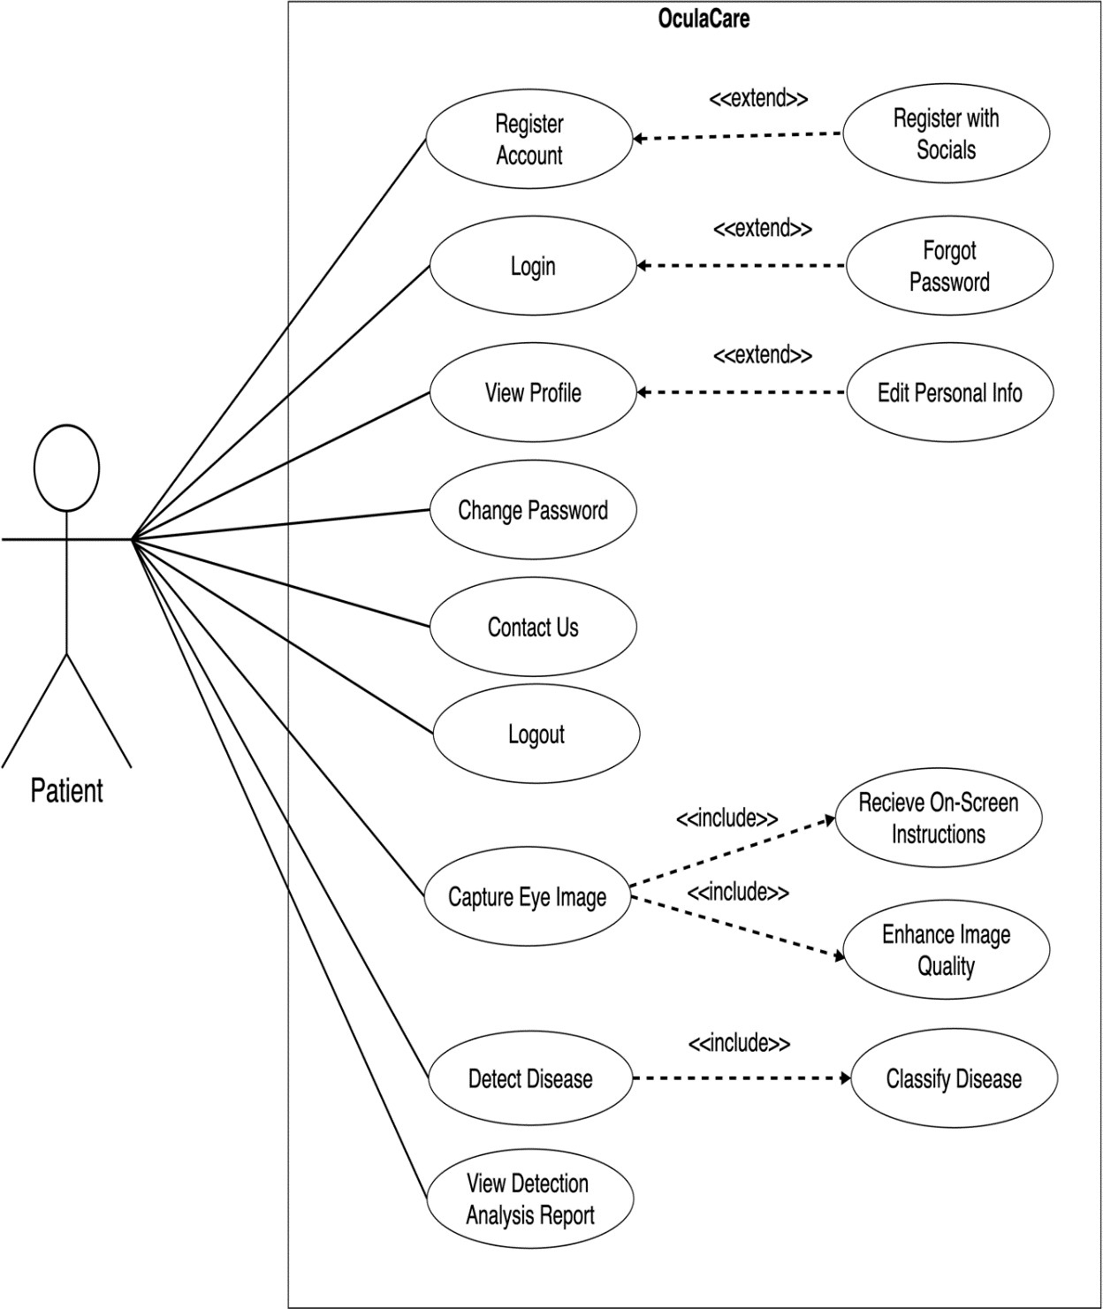

**Figure 1: Use Case Diagram for Patient (1/4)**

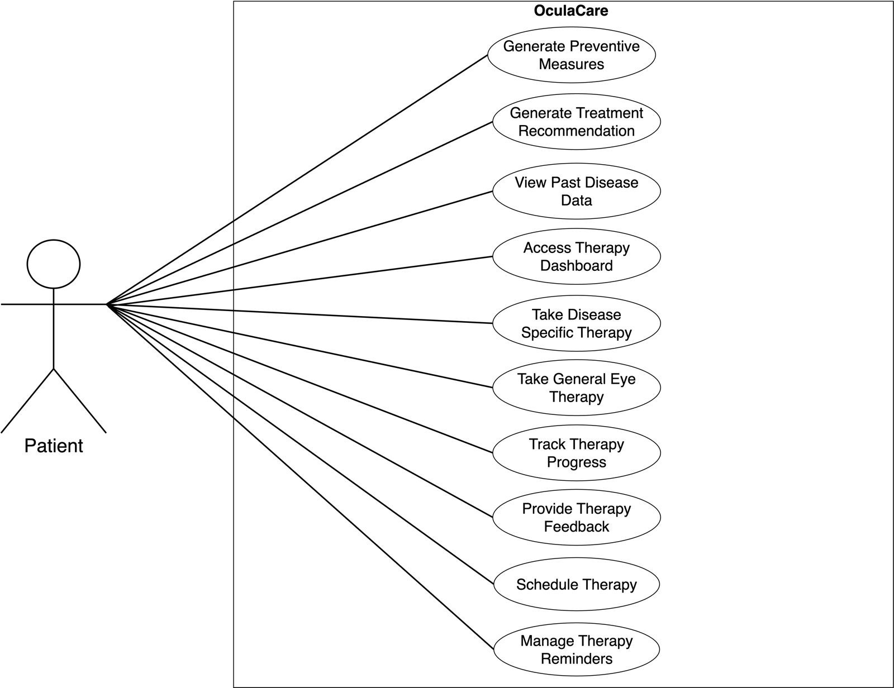

**Figure 2: Use Case Diagram for Patient (2/4)**

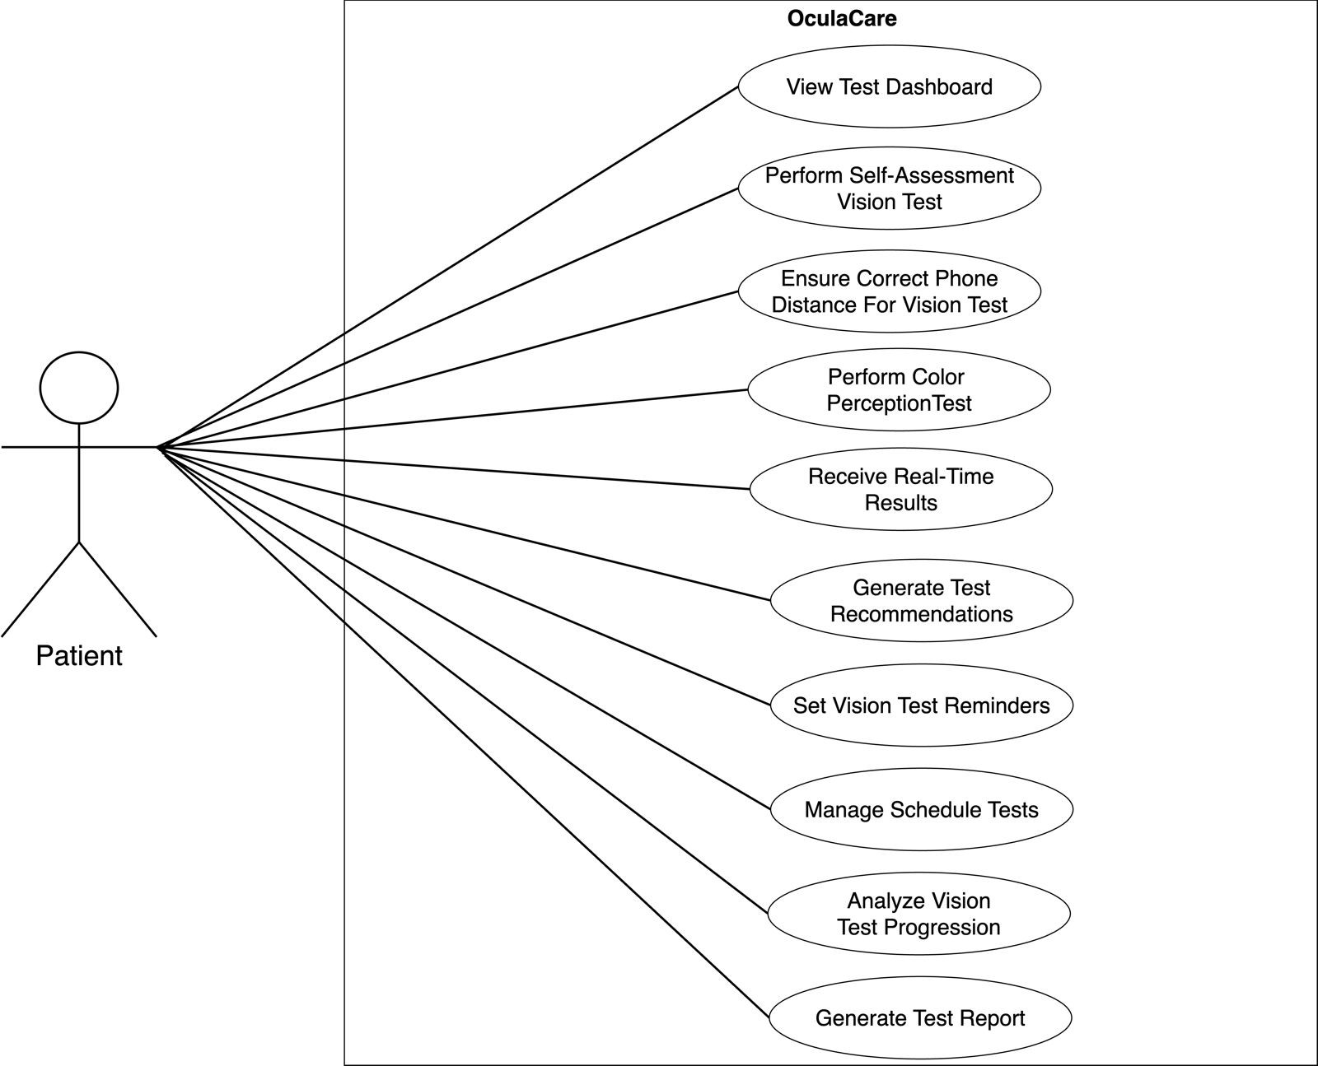

**Figure 3: Use Case Diagram for Patient (3/4)**

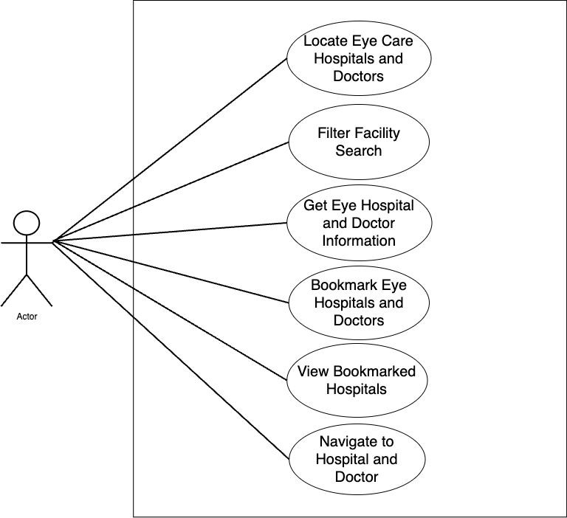

**Figure 4: Use Case Diagram for Patient (4/4)**

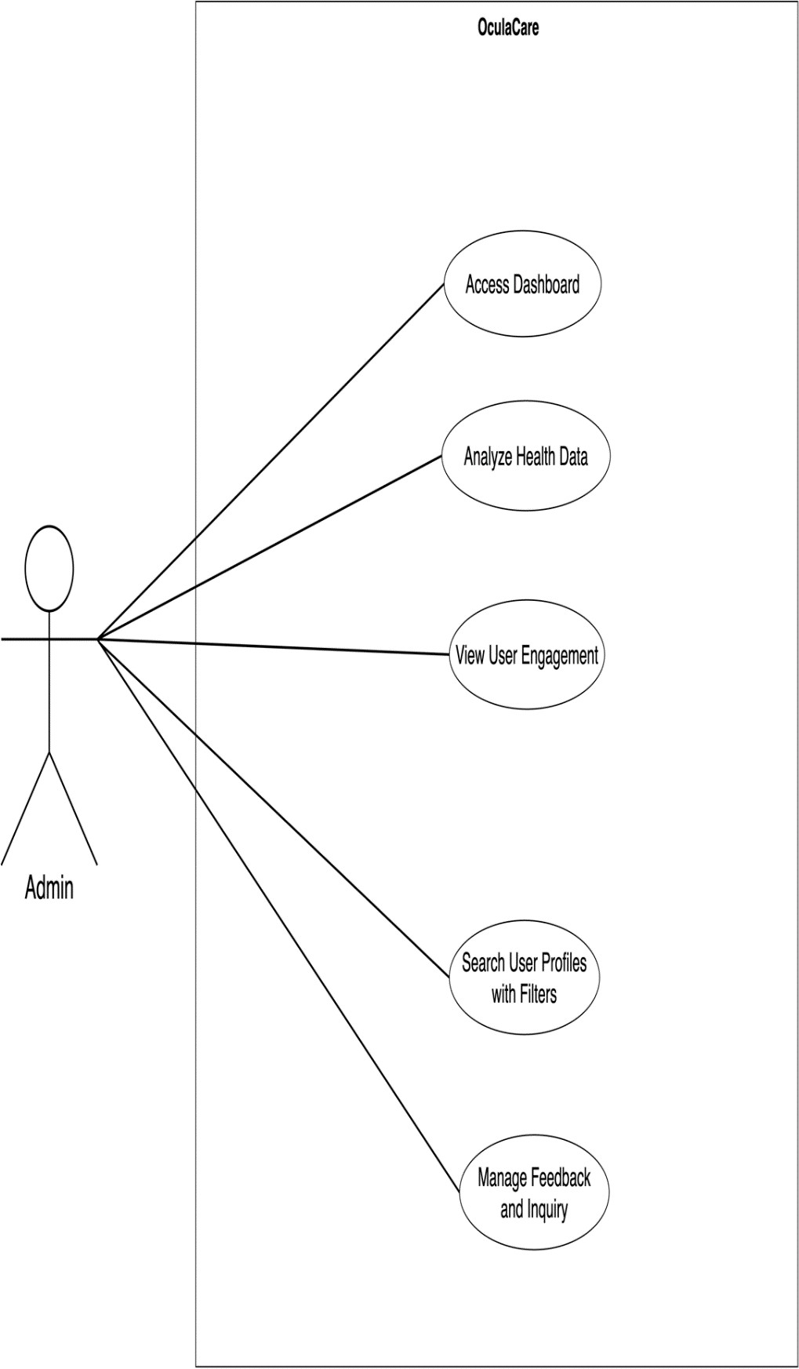

**Figure 5: Use Case Diagram for Admin (1/2)**

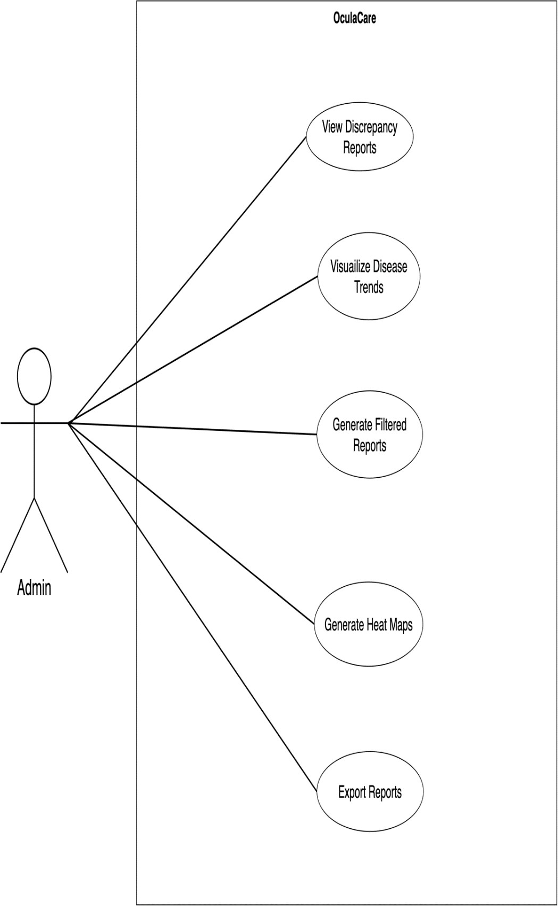

**Figure 6: Use Case Diagram for Admin (2/2)**

### Detail Use Cases

The detailed use cases for OculaCare are given below:

**Table 4: Register Account**

|  |  |
| --- | --- |
| **Use Case ID** | M1-UC1 |
| **Use Case Name** | Register Account |
| **Actors** | Primary Actor: Patient |
| **Description** | A new patient registers for an account on the OculaCare mobile application to access its features and functionalities. |
| **Trigger** | Patient wants to create a new account on OculaCare mobile application. |
| **Preconditions** | PRE-1. The patient has access to a stable internet connection. PRE-2. The patient has not previously registered on OculaCare. |
| **Postconditions** | POST-1. The patient's account is successfully created. |
| **Normal Flow** | 1.0 Patient registers a new account with email.   1. Patient taps on the "Register" button on the app's login screen. 2. Patient enters personal information. 3. Patient confirms registration details. 4. System sends a verification email to the patient's provided email address. 5. Patient receives and enters OTP for validation. 6. System validates the entered OTP. 7. Patient account is successfully verified and created. |
| **Alternative Flows** | In Step 2 of the Normal Flow if the entered OTP has expired.   1. The system informs the user about the expired OTP error. 2. The patient is prompted with a dialog box to request for OTP resend. 3. The patient taps on the “Resend” button. 4. Return to Step 4 of the Normal Flow. |
| **Exceptions** | 1.0. E1 Entered email is already registered.  1. The system informs the patient that the provided email is already registered. 2a. If the patient provides a new valid email, then return to step 5 of normal flow. 2b. Else, terminate the use case.  1.0 E1: Server error preventing data update.   1. System informs the patient about server error.   2a. If the error is resolved, patient retries registration, and normal flow continues at Step 2 of the Normal Flow.  2b. Else if, error persists terminate the use case. |
| **Business Rules** | BR-1. The system must verify the authenticity of the email provided during registration through an OTP to ensure account security.  BR-2. The system should allow the Patient to request the verification email to be resent up to 3 times. |
| **Assumptions** | 1. Patients have access to a valid email address for account verification purposes. 2. Patients provide accurate and valid information during the registration process. 3. The patient can access the registered email account. |

**Table 5: Register Account with Social Media Account**

|  |  |
| --- | --- |
| **Use Case ID** | M1-UC2 |
| **Use Case Name** | Register Account with Social Media Account |
| **Actors** | Primary Actor: Patient |
| **Description** | A new patient registers for an account on the OculaCare mobile application to access its features and functionalities using their existing social media account for quick  registration. |
| **Trigger** | Patient selects option to register OculaCare account with social media account. |
| **Preconditions** | PRE-1. The patient has a stable internet connection.  PRE-2. The patient has downloaded the OculaCare mobile application. PRE-3. The patient has an active social media account. |
| **Postconditions** | POST-1. The patient's social media account is successfully linked to the OculaCare account.  POST-2. The patient receives confirmation of successful account creation. POST-3. The patient can now access features of the OculaCare application. |
| **Normal Flow** | 1.0 Patient registers a new account with Google.   1. The patient taps on the “Register with Google” button on the app's login screen. 2. The patient grants permission for OculaCare to access Google account information. 3. The patient selects their Google account for registration. 4. The system imports necessary information from Google. 5. The system creates an OculaCare account linked to the patient’s Google account. 6. The patient receives confirmation of successful account creation. |
| **Alternative Flows** | In Step 1 of the Normal Flow if the patient taps on the “Register with Facebook” button instead of Google.   1. The patient grants permission for OculaCare to access Facebook account information. 2. The patient chooses their Facebook account for registration. 3. The system imports necessary information from Facebook. 4. Return to Step 5 of the Normal Flow. |
| **Exceptions** | 1.0. E1 Social account already linked to another OculaCare account.  1. The system informs the patient that the account is already linked.  2a. If the patient selects a new account, then return to Step 5 of normal flow. 2b. Else, system prompts the patient about unsuccessful registration, then terminate  the use case. |
| **Business Rules** | BR-1. Social media accounts used for registration must be verified and active. BR-  2. The system should ensure that personal information imported from social media accounts is handled securely and confidentially.  BR-3. The system must prevent the creation of multiple OculaCare accounts with the same social media credentials |
| **Assumptions** | 1. Patients prefer using their existing social media accounts for quick registration. 2. Patients agree to share certain information from their social media accounts for registration purposes. |

**Table 6: Login**

|  |  |
| --- | --- |
| **Use Case ID** | M1-UC3 |
| **Use Case Name** | Login |
| **Actors** | Primary Actor: Patient |
| **Description** | An existing patient logs in to their account on the OculaCare mobile application to access personalized features and view their eye health data. |
| **Trigger** | The patient selects the option to log in to their account upon launching the OculaCare mobile application. |
| **Preconditions** | PRE-1. The OculaCare mobile application is installed and launched on the patient's device.  PRE-2. The patient has previously registered for an account on the OculaCare platform.  PRE-3. The patient has an active internet connection. |
| **Postconditions** | POST-1. The patient is successfully authenticated. POST-2. The patient gains access to their account.  POST-3. The patient can navigate through the application. POST-4. The patient can access personalized features. |
| **Normal Flow** | 1.0 Patient logs in to their account.   1. Patient enters registered email address. 2. Patient enters password. 3. Patient taps on the “Login” button. 3. System validates the entered credentials. 4. System authenticates the patient's identity. 5. Patient is navigated to the Home Screen. |
| **Alternative Flows** | In step 2 of the Normal Flow if the patient enters incomplete or incorrect credentials.   1. System detects incomplete or incorrect login details. 2. Patient is prompted to re-enter the login credentials correctly. 3. Return to step 2 of the Normal Flow. |
| **Exceptions** | 1.0. E1 Incorrect email entered.  1. System informs the patient that the entered email is incorrect.  2a. If the patient enters a new email, then proceed to step 2 of the Normal Flow. 2b. Else, patient remains on the login screen to re-enter credentials.  1.0. E1 Incorrect password entered.   1. System informs the patient that the entered password is incorrect.   2a. If the patient enters a new password, proceed to step 2 of the Normal Flow. 2b. Else, patient remains on the login screen to re-enter credentials. |
| **Business Rules** | BR-1. Patients must authenticate using their registered credentials to ensure the security of their account and the integrity of their health data. |
| **Assumptions** | 1. Patients remember their registered email address. 2. Patients remember their registered password. 3. Patients do not share their login credentials with unauthorized individuals. 4. The OculaCare mobile application's login page is functioning correctly without any bugs or glitches. |

**Table 7: Forgot Password**

|  |  |
| --- | --- |
| **Use Case ID** | M1-UC4 |
| **Use Case Name** | Forgot Password |
| **Actors** | Primary Actor: Patient |
| **Description** | A registered patient recovers their account via email in case they forgot their login credentials. |
| **Trigger** | Patient taps on the "Forgot Password" button. |
| **Preconditions** | PRE-1. The patient has previously registered for an account on the OculaCare platform. |
| **Postconditions** | POST-1. Patient receives a password reset link. POST-2. Patient resets their password.  POST-3. The patient gains access to their account.  POST-4. The patient can navigate through the application. POST-5. The patient can access personalized features. |
| **Normal Flow** | 1.0 Patient recovers an account with email.   1. Patient taps on the "Forgot Password" button. 2. Patient enters their email address. 3. System validates the entered email. 4. System sends an OTP to the email. 5. Patient enters the OTP provided. 6. System validates the OTP. 7. Patient enters a new password. 8. System resets the password. 9. Patient regains access to the account. |
| **Alternative Flows** | In Step 4 of the Normal Flow if the patient enters an incorrect OTP.   1. System informs the patient that the OTP is incorrect. 2. Patient requests to resend the OTP. 3. The system sends a new OTP to the patient's email. 4. Return to Step 4 of the Normal Flow. |
| **Exceptions** | 1.0 E1 Email not found in the system.  1. The system informs the patient that entered email is not associated with an account.  2a. If the patient enters a registered email, then return to Step 3 of normal flow. 2b. Else if the patient fails to provide a registered email, then terminate the use case.  1.0 E2: New password does not meet security requirements.   1. System prompts the patient about the password criteria.   2a. If the patient provides a valid new password, return to Step 7 of normal flow. 2b. Else if patient does not provide a strong password, terminate the use case. |
| **Business Rules** | BR-1. The system must verify the identity of the patient through an OTP before allowing a password reset to ensure account security. |
| **Assumptions** | 1. The patient has access to the email associated with the account. 2. Patients do not share their login credentials with unauthorized individuals. |

**Table 8: View Profile**

|  |  |
| --- | --- |
| **Use Case ID** | M1-UC5 |
| **Use Case Name** | View Profile |
| **Actors** | Primary Actor: Patient |
| **Description** | A patient views patient profile in the OculaCare mobile application. The patient profile includes personal information, health data, therapy progress, and other  relevant details. |
| **Trigger** | The patient wants to review and check their personal information in the OculaCare app. |
| **Preconditions** | PRE-1. The patient is registered and has an active account on OculaCare. PRE-2. The patient is logged into the OculaCare application. |
| **Postconditions** | POST-1. The patient successfully views their profile information.  POST-2. Any discrepancies or outdated information in the profile can be identified by the patient. |
| **Normal Flow** | 1.0 Patient accesses their user profile.   1. The patient selects the 'Profile' tile from the side drawer menu. 2. The system navigates the patient to the user profile screen. 3. The system displays the patient's profile. 4. The patient views and reviews the information presented in their profile. |
| **Alternative Flows** | N/A |
| **Exceptions** | 1.0 E1: Server error preventing profile data render.  1. System informs the patient about server error.  2a. If the error is resolved, patient retries to view profile and normal flow continues at step 4.  2b. Else if, error persists terminate the use case.  1.0 E2: Profile Data Mismatch.   1. The patient notices discrepancies in the profile data. 2. The patient reports the issue through contact us section. 3. Terminate the use case. |
| **Business Rules** | BR-1. The patient’s profile must always display the most current and accurate information.  BR-2. Access to view the user profile is restricted to the logged-in patient for privacy reasons. |
| **Assumptions** | 1. Patients understand the importance of keeping their profile information accurate and up to date. 2. Patients have stable internet connectivity when accessing their profile. 3. The app’s user interface is intuitive and easy for patients to navigate to their profile |

**Table 9: Edit Personal Information**

|  |  |
| --- | --- |
| **Use Case ID** | M1-UC6 |
| **Use Case Name** | Edit Personal Information |
| **Actors** | Primary Actor: Patient |
| **Description** | Patient edits their personal information such as name, phone number, date of birth, and address. |
| **Trigger** | Patient taps on the “Edit Personal Information” button in account settings. |
| **Preconditions** | PRE-1. Patient is successfully authenticated and logged into their account. |
| **Postconditions** | POST-1. Patient's personal information is updated.  POST-2. Updated changes are correctly reflected within the system. |
| **Normal Flow** | 1.0 Patient updates the account information.   1. Patient navigates to account settings within the OculaCare application. 2. Patient selects "Edit Personal Information". 3. Patient updates information fields such as name, phone number, date of birth, and address. 4. Patient reviews changes to ensure accuracy. 5. Patient confirms and saves the updates. 6. System validates the new information for format and completeness. 7. System successfully saves the updated information. |
| **Alternative Flows** | In Step 6 of Normal flow if the system detects any discrepancies in the provided information.   1. The system displays a message specifying the nature of the discrepancy. 2. The patient revises the information accordingly. 3. Patient resubmits the updates. 4. Return to Step 6 of the Normal Flow. |
| **Exceptions** | 1.0 E1: Invalid input format for certain fields.  1. System prompts the patient about the format error.  2a. If the patient corrects the input format, return to Step 4 of normal flow. 2b. Else, keep the text field focused and terminate the use case.  1.0 E1: Server error preventing data update.   1. System informs the patient about server error.   2a. If the error is resolved, patient retries submission, and normal flow continues at step 6.  2b. Else if error persists terminate the use case. |
| **Business Rules** | BR-1. Patients must provide complete and accurate information in all required fields to successfully save updates.  BR-2. Patients can update their personal information a maximum of three times per month to prevent abuse of the system. |
| **Assumptions** | 1. The patient has the necessary information to update their profile. 2. Patients are aware of the significance of providing true and current information for the purpose of health care services. |

**Table 10: Change Password**

|  |  |
| --- | --- |
| **Use Case ID** | M1-UC7 |
| **Use Case Name** | Change Password |
| **Actors** | Primary Actor: Patient |
| **Description** | Patient changes their account password for security reasons or personal preference. |
| **Trigger** | Patient taps on the “Change Password” button in account settings. |
| **Preconditions** | PRE-1. The patient has previously registered for an account on the OculaCare platform.  PRE-2. The patient has an active internet connection. PRE-3. Patient is logged into their account. |
| **Postconditions** | POST-1. Patient's password is updated in the system.  POST-2. Patient logs in again with the new password. POST-3. The patient gains access to their account. |
| **Normal Flow** | 1.0 Patient changes the account password.   1. Patient navigates to account settings. 2. Patient selects "Change Password". 3. Patient enters current password. 4. Patient enters new password. 5. Patient confirms the change. 6. System validates the password. 7. System updates the password. 8. Patient is logged out of account. |
| **Alternative Flows** | In Step 4 of the Normal Flow if the patient enters a new password similar to the current password.   1. System detects the similarity. 2. The system prompts the patient to choose a different password. 3. Patient enters a distinct new password. 4. Return to Step 5 of the Normal Flow. |
| **Exceptions** | 1.0 E1: Current password is incorrect.  1. System displays incorrect password and prompts the patient to reenter the password.  2a. If the patient enters the correct current password, return to Step 3 of normal flow. 2b. Else if the patient fails to provide the correct current password terminate the use case.  1.0 E2: New password does not meet security requirements.  1. System prompts the patient about the password criteria.  2a. If patient provides a valid new password, return to Step 3 of normal flow. 2b. Else if patient does not provide a strong password, terminate the use case. |
| **Business Rules** | BR-1. Passwords must adhere to established complexity standards and cannot be identical to the current password to enhance security. |
| **Assumptions** | 1. The patient knows their current password. 2. The patient can create a new password that meets security criteria. |

**Table 11: Contact Us**

|  |  |
| --- | --- |
| **Use Case ID** | M1-UC8 |
| **Use Case Name** | Contact Us |
| **Actors** | Primary Actor: Patient |
| **Description** | Patient submits feedback or inquiries regarding the OculaCare mobile application or services. Patients can select specific categories for their feedback to ensure it is  directed to the appropriate department. |
| **Trigger** | Patient taps on the "Contact Us" tab within the account drawer. |
| **Preconditions** | PRE-1. The patient has an active internet connection.  PRE-2. The patient is authenticated and logged into their OculaCare account. |
| **Postconditions** | POST-1. The patient’s feedback or inquiry is successfully submitted to the OculaCare team.  POST-2. The patient receives confirmation of the submission. |
| **Normal Flow** | 1.0 Patient submits feedback to the admins.   1. Patient navigates to the drawer menu and taps on the "Contact Us" option. 2. The feedback form is displayed with various categories such as "App Functionality," "Medical Inquiry," or "General Feedback." 3. Patient selects the relevant category for their feedback or inquiry. 4. Patient completes the form with details of their feedback or inquiry. 5. Patient submits the form. 6. System validates the submitted information. 7. System sends the feedback to the appropriate department based on the category selected. 8. Patient receives a confirmation message that their feedback has been submitted. |
| **Alternative Flows** | In Step 6 of the Normal Flow, if the patient attempts to submit an incomplete form.   1. The system prompts the patient to complete all required fields. 2. Patient fills in the missing information. 3. System validates the input fields. 4. Return to Step 5 of the Normal Flow. |
| **Exceptions** | 1.0 E1: Server error preventing successful feedback submission.   1. System informs the patient about server error.   2a. If the error is resolved, patient retries submission, and normal flow continues at step 6.  2b. Else if, error persists terminate the use case. |
| **Business Rules** | BR-1. Patients must select a specific category for their feedback or inquiry to be processed.  BR-2. Feedback and inquiry submissions must be timestamped and logged for tracking and quality assurance purposes.  BR-3. Patients are limited to submitting feedback or inquiries no more than three times per day to prevent system abuse. |
| **Assumptions** | 1. Patients understand the importance of logging out, particularly on shared or public devices. 2. The patient submits an appropriate inquiry. |

**Table 12: Logout**

|  |  |
| --- | --- |
| **Use Case ID:** | M1-UC9 |
| **Use Case Name:** | Logout |
| **Actors:** | Primary Actor: Patient |
| **Description:** | The patient logs out of their account on the OculaCare mobile application, ensuring that their session is securely closed. |
| **Trigger:** | The patient decides to log out of the OculaCare mobile application. |
| **Preconditions:** | PRE-1. The patient is logged into their account on the OculaCare application. |
| **Postconditions:** | POST-1. The patient is logged out of their account. POST-2. All session data is securely closed.  POST-3. The patient is redirected to the login screen. |
| **Normal Flow:** | 1.0 Patient registers a new account with email.   1. The patient selects the "Logout" option within the app. 2. The system asks the patient to confirm their decision to log out. 3. The patient confirms their choice to log out. 4. The system securely logs the patient out and clears any session data. 5. The patient is redirected to the app's login screen. |
| **Alternative Flows:** | In Step 2 of the Normal Flow if the patient decides not to log out.   1. The patient selects "Cancel" in the confirmation prompt. 2. The system maintains the user session. 3. Return to Step 1 of the Normal Flow. |
| **Exceptions:** | a. E1: A server error occurs during logout.  1. The system informs the patient through a toast error message.  2a. If the patient retries successfully, proceed to Step 2 of the Normal Flow. 2b. Else if the issue persists, terminate the use case.  1.0 E2: Incomplete session data synchronization.   1. The system informs the patient that the session data has not fully synchronized. 2. The patient is requested to wait for data sync.   2a. If the patient waits for the data sync, proceed to Step 4 of Normal flow. 2b. Else, system prompts the patient about unsuccessful data sync, then terminate the  use case. |
| **Business Rules** | BR-1. The system must ensure that all data and session information are securely cleared upon logout.  BR-2. The logout process should be simple and straightforward for the patient. BR-3. Prompt confirmation for logout helps prevent accidental logouts. |
| **Assumptions:** | 1. Patients understand the importance of logging out for security reasons. 2. Patients have stable internet connectivity when initiating the logout process to successfully end user sessions. 3. Patients understand the importance of logging out for maintaining their privacy and security. 4. Patients recognize the logout confirmation step as a security measure. |

**Table 13: Capture Eye Image**

|  |  |
| --- | --- |
| **Use Case ID** | M2-UC1 |
| **Use Case Name** | Capture Eye Image |
| **Actors** | Primary Actor: Patient |
| **Description** | Patient uses the OculaCare mobile application to capture a high-quality image of their eye for medical analysis. The application guides the patient through the  process, ensuring the image meets the necessary quality standards. |
| **Trigger** | The patient decides to capture an eye image using the OculaCare app. |
| **Preconditions** | PRE-1. The patient is in a well-lit environment. |
| **Postconditions** | POST-1. A high-quality eye image is captured and stored locally. |
| **Normal Flow** | 1.0 Patient captures eye image for disease detection.   1. Patient navigates within the OculaCare app and selects the "Capture Eye Image" feature. 2. The app checks for and requests camera permissions if not already granted. 3. The app provides on-screen instructions for optimal image capture, including positioning. 4. Patient aligns their eye with the on-screen template and takes the photo. 5. The app evaluates the image for quality and either confirms successful capture or prompts for retake. 6. If the image is confirmed, the patient reviews the image. 7. Patient submits the image for analysis. |
| **Alternative Flows** | In Step 2 of the Normal Flow if the patient decides to upload an image from the gallery.   1. Patient taps on the “Upload from Gallery” button. 2. The system presents the patient's photo gallery. 3. Patient chooses an eye image from their gallery. 4. Return to Step 5 of the Normal Flow.   In Step 5 of the Normal Flow if the image does not meet quality standards.   1. The system prompts the patient with reason why the image is not suitable. 2. Patient is guided to retake the image. 3. Return to Step 4 of the Normal Flow. |
| **Exceptions** | 1.0 E1: Camera permission is denied.  1. System informs the patient of the permissions issue.  2a. If camera permission is granted, proceed to Step 1 of the normal flow. 2b. Else if camera access remains denied, terminate the use case. |
| **Business Rules** | BR-1. The application requires the capture of an image that meets predefined quality criteria to proceed with the analysis.  BR-2. The application must provide real-time feedback on the quality of the image and instructions for improvement.  BR-3. Images that do not meet the quality criteria after three attempts should trigger a suggestion for environmental improvements or professional help. |
| **Assumptions** | 1. Patients have the necessary understanding and physical ability to follow through with the image capture instructions provided by the app. |

**Table 14: Receive On-Screen Instructions**

|  |  |
| --- | --- |
| **Use Case ID** | M2-UC2 |
| **Use Case Name** | Receive On-Screen Instructions |
| **Actors** | Primary Actor: Patient |
| **Description** | The system guides the patient through capturing an eye image using real-time feedback from a machine learning (ML) kit. The camera shutter remains disabled  until the eye is correctly positioned and detected in the frame. |
| **Trigger** | The patient initiates the eye image capture function within the app. |
| **Preconditions** | PRE-1. OculaCare app is installed on the patient’s device. PRE-2. The patient grants camera access to the app. |
| **Postconditions** | POST-1. The patient successfully captures a clear eye image.  POST-2. The ML model is ready to detect and classify any eye conditions. |
| **Normal Flow** | 1.0 Receive On-Screen Instructions   1. The patient opens the eye image capture feature in the app. 2. The ML kit starts to scan the live camera feed for eye detection. 3. On-screen instructions guide the patient (e.g., "Adjust position," "Eyes not in frame"). 4. Camera shutter remains disabled until the eye is correctly detected. 5. Once the eye is detected, the shutter is enabled. 6. The patient captures the image. |
| **Alternative Flows** | In Step 2 of the Normal Flow, if the ML Kit does not properly detect the patient’s eyes:   1. The app continues to provide real-time feedback to guide the patient to adjust their position until the eye detection criteria are met. 2. If the eyes are still not detected after several attempts, the app advises the patient to find a well-lit area and try capturing the image again. 3. Return to step 1 of the Normal Flow. |
| **Exceptions** | 1.0 E1: If camera Access is denied.  1. The app prompts the patient to allow camera access in settings. 2a. If the patient enables access, return to step 1 of the Normal Flow. 2b. If the patient does not enable access, the use case ends.  1.0 E2: Server error preventing on-screen instructions.   1. The app informs the patient of a server error preventing on-screen instructions. 2a. If the error is resolved quickly, the patient is prompted to retry capturing the image and the normal flow resumes at Step 3.   2b. If the error persists, the patient is advised to try again later and the use case is terminated. |
| **Business Rules** | BR-1: The shutter should be enabled only when the ML kit confirms correct eye detection.  BR-2: All instructions must be clear and easily understandable. |
| **Assumptions** | 1. The patient understands basic instructions and can follow guided steps. 2. The patient’s device supports the ML kit functionalities. |

**Table 15: Enhance Image Quality**

|  |  |
| --- | --- |
| **Use Case ID** | M2-UC3 |
| **Use Case Name** | Enhance Image Quality |
| **Actors** | Primary Actor: Patient Secondary Actor: System |
| **Description** | The system enhances the quality of an eye image uploaded by the patient, adjusting for optimal analysis suitability. |
| **Trigger** | Patient uploads an eye image for disease detection. |
| **Preconditions** | PRE-1. The patient has previously registered for an account. PRE-2. The patient has an active internet connection.  PRE-3. Patient captures an eye image. |
| **Postconditions** | POST-1. The image quality is enhanced. POST-2. Image is ready to be processed. |
| **Normal Flow** | 1.0 System enhances the quality of the uploaded image.   1. Patient captures an eye image. 2. OculaCare enhances the image by applying rotation, gaussian blur. 3. Patient uploads the eye image. 4. The system analyses the image quality. 5. The system enhances the image quality. |
| **Alternative Flows** | In Step 4, if after enhancement the image still does not meet quality standards.   1. The system notifies the patient that the image could not be enhanced to the required standard. 2. Patient is prompted to either retake the image or select a different image from the gallery. 3. If the patient selects a new image, return to Step 2 of the Normal Flow. 4. If the patient retakes the image, return to Step 1 of the Normal Flow. |
| **Exceptions** | 1.1 E1: Uploaded image is below quality threshold.  1. The system informs the patient that the image is below quality threshold. 2a. If the patient captures or selects a new image, then return to Step 2 of the Normal Flow.  2b. Else if the patient does not provide a quality threshold meeting image, terminate the use case.  1.0 E2: Server error preventing successful conversion.   1. System informs the patient about server error.   2a. If the error is resolved, patient retries submission, and normal flow continues at step 3.  2b. Else if, error persists terminate the use case. |
| **Business Rules** | BR-1. Only images that meet quality threshold are accepted for disease detection. BR-2. The enhancement process must not alter diagnostic features of the image. BR-3. The patient must be informed of the reason for any image rejection due to  quality issues. |
| **Assumptions** | 1. The patient is willing to follow instructions for retaking for better quality. 2. The patient is willing to select images for better quality. |

**Table 16: Detect Disease**

|  |  |
| --- | --- |
| **Use Case ID** | M2-UC4 |
| **Use Case Name** | Detect Disease |
| **Actors** | Primary Actor: Patient |
| **Description** | The patient uploads an eye image to the OculaCare application. The system analyses the image using machine learning to detect diseases. |
| **Trigger** | Patient initiates the process to analyze an eye image for disease detection. |
| **Preconditions** | PRE-1. The patient is authenticated and logged into the OculaCare application. PRE-2. The patient has a table internet connection.  PRE-3. The patient has a high-quality image ready for upload. |
| **Postconditions** | POST-1. Disease detection results are displayed to the patient. |
| **Normal Flow** | 1.0 Detecting disease in real-time.   1. Patient taps on the “Capture Image” button to capture eye image for disease detection. 2. The eye image is uploaded to the OculaCare system. 3. The system processes the image using the disease detection algorithm. 4. The results are displayed to the patient immediately after processing. |
| **Alternative Flows** | In Step 1 if the patient prefers to use an image from the gallery.   1. Patient selects the option to upload an image from the gallery. 2. Patient chooses an image that was previously taken. 3. Return to Step 2 of the Normal Flow. |
| **Exceptions** | 1.0 E1: Image upload to server fails because of no internet access.  1. System informs the patient about the network issue.  2a. If the patient reconnects and internet access is restored, return to Step 2 of the Normal Flow.  2b. Else if no internet access is available, terminate the use case if the patient is unable to establish a connection.  1.0 E2: Poor Image Quality   1. The system detects that the uploaded image cannot be processed by the model for detection. 2. The system informs the user about the image quality issue.   3a. If the patient uploads a new image, return to Step 2 of the Normal Flow. 3b. If the patient is unable to provide a better-quality image, the use case is terminated. |
| **Business Rules** | BR-1. The image must meet specific resolution and clarity standards. BR-2. The analysis must be performed in real time.  BR-3. The system must ensure patient data privacy and comply with healthcare regulations during the disease detection process. |
| **Assumptions** | 1. The patient has access to a device with camera functionality. 2. The disease detection algorithm is accurate and reliable for the conditions it is designed to identify. 3. The ML model used for disease detection is regularly updated and fine-tuned   with diverse dataset |

**Table 17: Classify Disease**

|  |  |
| --- | --- |
| **Use Case ID** | M2-UC5 |
| **Use Case Name** | Classify Disease |
| **Actors** | Primary Actor: System |
| **Description** | The system applies machine learning algorithms to classify diseases from preprocessed eye images uploaded by the patient. |
| **Trigger** | A pre-processed image is ready for analysis. |
| **Preconditions** | PRE-1. A clear, pre-processed eye image is available for analysis. PRE-2. The classification system is operational. |
| **Postconditions** | POST-1. The system provides a disease classification result. |
| **Normal Flow** | 1.0 Classifying pre-processed image into a disease category.   1. The system queues the uploaded and pre-processed image for analysis. 2. The system retrieves the image and runs it through the neural network model. 3. The neural network model analyses the image for patterns indicative of disease. 4. The system interprets the model's output to determine the presence of disease. 5. If a disease is detected, the system categorizes it according to the type and severity. 6. The system updates the patient's records with the classification results. |
| **Alternative Flows** | In Step 2 of the Normal Flow if the initial analysis is inconclusive.   1. The system prompts the patient to a new image capture if possible. 2. If a new image is provided, the system uploads it to the server. 3. Else if, patient decides not to capture a new image, the previous image is used for re-evaluation. 4. Return to Step 2 of the Normal flow. |
| **Exceptions** | 1.0 E1: Analysis fails due to processing error.  1. System informs the patient about the processing issue.  2a. If the error is temporary, the system attempts to reprocess the image, returning to Step 2 of the Normal Flow.  2b. Else if the error is critical and the image cannot be processed, the use case is terminated.  1.0 E1: Image upload to server fails because of no internet access.   1. System informs the patient about the network issue.   2a. If the patient reconnects and internet access is restored, return to Step 2 of the Normal Flow.  2b. Else if no internet access is available, terminate the use case if the patient is  unable to establish a connection. |
| **Business Rules** | BR-1: All disease classifications must meet a high threshold of confidence. BR-2: Inconclusive results must trigger a secondary analysis process. |
| **Assumptions** | 1. The system and its algorithms are validated for accuracy. 2. The patient's device can capture images of sufficient quality for analysis. 3. The patient has access to a device with camera functionality. 4. The ML model used for disease classification is regularly updated and finetuned with diverse dataset. |

**Table 18: View Detection Report**

|  |  |
| --- | --- |
| **Use Case ID** | M3-UC1 |
| **Use Case Name** | View Detection Report |
| **Actors** | Primary Actor: Patient |
| **Description** | The patient accesses their disease analysis report generated by the system after an eye image examination. This report summarizes the findings, potential disease  conditions, and suggested next steps. |
| **Trigger** | Patient taps on the “Generate Report” button. |
| **Preconditions** | PRE-1. The disease detection analysis has been completed for the patient’s submitted eye image.  PRE-2. The patient has an active account and is logged into the OculaCare application. |
| **Postconditions** | POST-1. The patient reviews the detailed findings of their disease analysis report. POST-2. The patient is informed about potential disease conditions.  POST-3. The patient has options to download, print, or securely share their report  with healthcare professionals. |
| **Normal Flow** | 1.0 Patient generates disease analysis report.   1. The patient receives a notification to view analysis report. 2. The patient navigates to the 'Reports' section. 3. The system displays the list of available reports. 4. The patient selects and opens the respective disease analysis report. 5. The system displays the content of the report. 6. The patient reviews the findings and potential conditions outlined in the report. |
| **Alternative Flows** | In Step 5 of the Normal Flow if the patient wishes to access further explanation on specific findings within the report.   1. The patient taps on the “Read more” text button. 2. The system provides additional explanatory content related to the findings. 3. The patient reads the additional information. 4. Return to Step 5 of the Normal Flow. |
| **Exceptions** | 1.0 E1: Report fails to load due to server error.   1. The system informs the patient about the server issue.   2a. If the issue is related to connectivity, the system refreshes the attempt to display the report, returning to Step 3 of the Normal Flow.  2b. Else if the report remains inaccessible, the patient is advised to try again later, and the system logs the incident for review and terminate the use case. |
| **Business Rules** | BR-1. All disease analysis reports must be accessible to the patient in a readable and understandable format.  BR-2. The system must ensure the confidentiality and privacy of the patient's health data. |
| **Assumptions** | 1. The system and its algorithms are validated for accuracy. 2. Patient has the necessary understanding to interpret the results provided with additional guidance. 3. The patient values the importance of this report and utilizes the information for   their health benefit. |

**Table 19: Generate Preventive Measures**

|  |  |
| --- | --- |
| **Use Case ID** | M3-UC2 |
| **Use Case Name** | Generate Preventive Measures |
| **Actors** | Primary Actor: Patient |
| **Description** | Upon receiving a diagnosis through the OculaCare app, the patient is given access to information and guidelines on preventive measures to manage or mitigate the  eye condition diagnosed. |
| **Trigger** | The patient requests information on prevention after receiving a disease diagnosis. |
| **Preconditions** | PRE-1. The system has diagnosed an eye condition for the patient.  PRE-2. Preventive care information is available for the diagnosed condition. PRE-  3. The patient is proficient with the necessary knowledge to understand preventive care information. |
| **Postconditions** | POST-1. The patient has accessed and understood preventive care information.  POST-2. The patient is empowered to take proactive steps towards eye health maintenance or improvement. |
| **Normal Flow** | 1.0 Patient requests for preventive measures associated with the diagnosed disease.   1. Patient navigates to the disease diagnosis result tab. 2. Patient taps on “View Preventive Care” to access preventive care information. 3. The system presents the patient with preventive guidelines tailored to their diagnosis. 4. The patient reads to develop understanding of the preventive information. |
| **Alternative Flows** | NA |
| **Exceptions** | 1.0 E1: Preventive care information is unavailable due to a system update or content revision.   1. System informs the patient about the temporary unavailability.   2a. If the content is expected to be available shortly, return to Step 3 of the Normal Flow.  2b. Else if the content will not be available in the foreseeable future, provide general eye health guidelines and terminate the use case. |
| **Business Rules** | BR-1. Preventive information provided must be evidence-based and vetted by eye care professionals.  BR-2. The system must ensure that preventive care information is easily accessible post-diagnosis.  BR-3. Patient acknowledgment of the information must be recorded for compliance and future engagement tracking. |
| **Assumptions** | 1. The patient is proactive and interested in engaging with preventive measures to enhance their eye health. 2. Patients have the willingness and ability to follow through with the suggested preventive measures. 3. Patients are comfortable receiving health advice in a digital format. |

**Table 20: Generate Treatment Recommendations**

|  |  |
| --- | --- |
| **Use Case ID** | M3-UC3 |
| **Use Case Name** | Generate Treatment Recommendations |
| **Actors** | Primary Actor: Patient |
| **Description** | The patient generates personalized treatment recommendations based on the disease analysis and health profile. The patient can then review, save, or print these  recommendations for their personal use. |
| **Trigger** | Completion of the disease analysis process. |
| **Preconditions** | PRE-1. An eye disease has been identified in the patient's eye image. |
| **Postconditions** | POST-1. The patient receives personalized treatment recommendations.  POST-2. The system updates the patient’s health record with the generated treatment recommendations.  POST-3. The patient can act on the recommendations. |
| **Normal Flow** | 1.0 The system provides personalized medical recommendations post disease diagnosis.   1. The patient taps on the “Generate recommendations” button. 2. The system identifies the disease from image analysis. 3. The system generates tailored treatment recommendations. 4. The system notifies the patient. 5. The patient reviews and understands the recommended treatment options. |
| **Alternative Flows** | In Step 2 of the Normal Flow if the patient’s diagnosis data is missing.   1. The system prompts the patient to take the image again. 2. The system analyses the photo and classify the disease. 3. The system saves the results. 4. Return to Step 3 of the Normal Flow. |
| **Exceptions** | 1.0 E1: The system experiences an internal error during the generation of recommendations.   1. The system prompts the patient to save their progress.   2a. If the patient chooses to save, return to Step 3 of the Normal Flow.  2b. Else if the user chooses not to save, the system discards any unsaved data, and the use case is terminated. |
| **Business Rules** | BR-1. The generation of treatment recommendations must be aligned with current medical standards and the patient’s health data.  BR-2. The system must confirm the patient’s understanding of the recommendations  to ensure proper follow-through. |
| **Assumptions** | 1. The patient is proactive about their health. 2. The patients are willing to follow through with the recommended treatments provided. 3. The patient trusts the system’s capability to provide accurate and beneficial treatment recommendations. 4. The patient has a level of health literacy sufficient to understand and evaluate the   treatment recommendations provided. |

**Table 21: View Past Disease Data**

|  |  |
| --- | --- |
| **Use Case ID** | M3-UC4 |
| **Use Case Name** | View Past Disease Data |
| **Actors** | Primary Actor: Patient |
| **Description** | The patient accesses their stored disease history and treatment effectiveness from the system to inform their ongoing health management. |
| **Trigger** | The patient chooses to review their disease progression history. |
| **Preconditions** | PRE-1. Patient is logged in to the app.  PRE-2. Historical disease analysis data is stored in the database. PRE-3. Recommendation data is stored in the database.  PRE-4. System has access to database. PRE-5. The patient has internet access.  PRE-6. The patient is authenticated in the system. |
| **Postconditions** | POST-1. The patient reviews their historical disease and treatment data. POST-2. The patient gains insights into the effectiveness of past treatments. |
| **Normal Flow** | 1.0 The patient requests to view historical disease data.   1. The patient navigates to the historical data section. 2. The patient selects to view their past disease analyses and treatments. 3. The system retrieves and displays the patient's historical data. 4. The patient reviews the data and any associated recommendations. |
| **Alternative Flows** | In Step 3 of the Normal Flow if the patient requests a compiled report of their history.   1. The patient taps on the “View Detail” button of the respective disease data. 2. The system compiles the data into a comprehensive report. 3. The patient selects to download the report in a preferred format. 4. Return to Step 3 of the Normal Flow. |
| **Exceptions** | 1.0 E1: The system encounters an error retrieving the historical data.  1. The system notifies the patient of the database retrieval error.  2a. If the error is resolved, the patient is prompted to attempt retrieval again and the flow proceeds at Step 3 of the Normal Flow.  2b. Else if the error persists, advice the patient to attempt later and terminate the use case.  1.0 E2: System fails to display the past data because of network error.   1. System informs the admin about the network issue.   2a. If the patient reconnects and internet access is restored, return to Step 2 of the Normal Flow.  2b. Else if no internet access is available, terminate the use case if the patient is unable to establish a connection. |
| **Business Rules** | BR-1. The system must present the historical data in a user-friendly manner.  BR-2. Data integrity and privacy must be maintained during access and retrieval. |
| **Assumptions** | 1. Patients have a continued interest in understanding their health progression. 2. Patients will use the historical data to make informed decisions about their future health management. |

**Table 22: Access Therapy Dashboard**

|  |  |
| --- | --- |
| **Use Case ID** | M4-UC1 |
| **Use Case Name** | Access Therapy Dashboard |
| **Actors** | Primary: Patient |
| **Description** | The system uses the patient's health and therapy history to create a personalized  therapy plan when the patient receives a diagnosis requiring therapy, ensuring adherence to medical standards and privacy protection. |
| **Trigger** | The Patient decides to review their therapy progress through the dashboard. |
| **Preconditions** | PRE-1. App is installed on patient’s device. PRE-2. User has an active internet connection.  PRE-3. User is registered and logged into the app.  PRE-4. The system has recorded the Patient’s progress data accurately. |
| **Postconditions** | POST-1. The patient has viewed the list of all the general eye therapies available in the platform.  POST-2. The patient has viewed the list of all the disease specific eye therapies available in the platform.  POST-3. The patient has selected the suitable therapy. |
| **Normal Flow** | 1.0 The patient views the dashboard   1. Patient opens the app. 2. Patient navigates to the therapy dashboard. 3. Patient views all the therapies available in the app. 4. Patient views progress on current therapies. |
| **Alternative Flows** | NA |
| **Exceptions** | 1.0 E1: The system cannot display valid therapies.  1. The patient is prompted to provide complete and accurate health details. 2a. If the patient provides the required information, return to step 3 of the Normal Flow.  2b. If the patient fails to provide the necessary information or chooses not to proceed, the use case is terminated, and no therapy plan is created.  1.0 E2: System fails to display the therapies because of server error.   1. System informs the patient about the network issue.   2a. If the patient reconnects and internet access is restored, return to Step 2 of the Normal Flow.  2b. Else if no internet access is available, terminate the use case if the patient is unable to establish a connection. |
| **Business Rules** | BR-1. Therapy plans must comply with medical standards.  BR-2. All patient data must be stored in compliance with privacy laws. BR-3. Therapies available must be updated in real-time. |
| **Assumption** | 1. Patients have a basic understanding of how to navigate the app. 2. All patients have compatible devices. |

**Table 23: Take Disease Specific Therapy**

|  |  |
| --- | --- |
| **Use Case ID** | M4-UC2 |
| **Use Case Name** | Take Disease Specific Therapy Plan |
| **Actors** | Primary: Patient |
| **Description** | The system uses the Patient's health to create a disease specific therapy when the  Patient receives a diagnosis requiring therapy. |
| **Trigger** | Patient taps on Therapy section of the app. |
| **Preconditions** | PRE-1. The patient is diagnosed with one of the diseases.  PRE-2. The system has the capability to generate personalized therapy plans. PRE-  3. The patient is authenticated and has input the necessary health information for therapy planning. |
| **Postconditions** | POST-1. Disease specific diseases should be available for the patient to take.  POST-2. The patient comprehends the therapy and understands how to follow it. |
| **Normal Flow** | 1.0 Take Disease Specific Therapy.   1. The patient logs into the app. 2. The patient navigates to the Therapy Dashboard section. 3. The app displays a list of diseases. 4. The patient chooses a disease. 5. The patient is shown therapies related to that disease. 6. The patient reviews the therapy instructions. 7. The patient starts the therapy. |
| **Alternative Flows** | In step 3 of the Normal Flow, when the patient is considering a disease specific therapy:   1. The patient taps on the therapy. 2. The system displays details about the therapy, including its purpose, suitability, and benefits. 3. After reading the details, the patient taps 'Back' to return to the general therapy dashboard. 4. The patient then proceeds to revisit the list of therapies, returning to step 3 of   the Normal Flow. |
| **Exceptions** | 1.0 E1: The system cannot generate a valid therapy plan.   1. The patient is prompted to provide complete and accurate health details. 2a. If the patient provides the required information, return to step 3 of the Normal Flow.   2b. If the patient fails to provide the necessary information or chooses not to proceed, the use case is terminated, and no therapy plan is created. |
| **Business Rules** | BR-1. All therapy plans must be generated in line with established medical guidelines and personalized to the Patient’s health profile.  BR-2. The system must safeguard Patient privacy at all stages of the therapy plan generation. |
| **Assumption** | 1. Patients are motivated to actively engage in the therapy planning process and provide accurate health information. 2. Patients takes the therapies for diagnosed diseases. |

**Table 24: Take General Eye Therapy**

|  |  |
| --- | --- |
| **Use Case ID** | M4-UC3 |
| **Use Case Name** | Take General Eye Therapy |
| **Actors** | Primary: Patient |
| **Description** | The system provides general eye therapies for all registered users, which they can use to maintain or enhance eye health. |
| **Trigger** | The patient chooses to explore the general eye therapies available. |
| **Preconditions** | PRE-1. The app is installed on the patient's device.  PRE-2. The patient is registered and logged into the app. PRE-3. The patient has access to the internet. |
| **Postconditions** | POST-1. The patient has accessed the general eye therapies. POST-2. The patient has selected a therapy.  POST-3. Patient has read the details of the therapy. POST-4. Patient has initiated the therapy. |
| **Normal Flow** | 1.0 The patient takes general eye therapy   1. The patient logs into the app. 2. The patient navigates to the Therapy Dashboard section. 3. The app displays a list of therapies. 4. The patient chooses a therapy. 5. The patient reviews the therapy instructions. 6. The patient starts the therapy. |
| **Alternative Flows** | In step 3 of the Normal Flow, when the patient is considering a general therapy:   1. The patient taps on the therapy. 2. The system displays details about the therapy, including its purpose, suitability, and benefits. 3. After reading the details, the patient taps 'Back' to return to the general therapy dashboard. 4. The patient then proceeds to revisit the list of therapies, returning to step 3 of   the Normal Flow. |
| **Exceptions** | 1.0 E1: Therapy session fails to start.  1. The system prompts the patient to check their connection or restart the app. 2a. If the app restarts successfully, return to step 3.  2b. If the issue persists, end the use case and suggest contacting support.  1.0 E2: System fails to display the therapies because of server error.   1. System informs the patient about the network issue.   2a. If the patient reconnects and internet access is restored, return to Step 2 of the Normal Flow.  2b. Else if no internet access is available, terminate the use case if the patient is unable to establish a connection. |
| **Business Rules** | BR-1. Therapies must be accessible to all users.  BR-2. Instructions for therapies must be clear and easy to follow. |
| **Assumption** | 1. Users are motivated for self-care. 2. Users can understand therapy instructions. |

**Table 25: Track Therapy Progress**

|  |  |
| --- | --- |
| **Use Case ID** | M4-UC4 |
| **Use Case Name** | Track Therapy Progress |
| **Actors** | Primary Actor: Patient |
| **Description** | The system allows the patient to view their therapy progress, showing the dates  when therapy sessions were completed and displaying a bar chart of their progress over time. |
| **Trigger** | The patient selects the option to view their therapy progress from the dashboard. |
| **Preconditions** | PRE-1. The patient is authenticated and logged into the OculaCare application. PRE-2. The patient has an active internet connection.  PRE-3. The patient has completed at least one therapy session.  PRE-4. The system has stored and maintained therapy session data for the patient.  PRE-5. The system is capable of generating visual charts (e.g., bar charts) to display progress. |
| **Postconditions** | POST-1. The system displays the patient's therapy progress data in the form of dates and a bar chart.  POST-2. The patient gains insight into their therapy performance over time. POST-3. The patient can make informed decisions about continuing or adjusting their therapy plan based on the progress data.  POST-4. The system logs any new data retrieved during this session, ensuring all future progress reviews are up to date. |
| **Normal Flow** | 1.0 View Therapy Progression.   1. The patient navigates to the 'Progress' section from the dashboard. 2. The system retrieves the therapy progress data (e.g., dates and performance metrics). 3. The system displays the progress data in a list of dates when therapy was taken. 4. The system displays a bar chart showing the patient's performance trend over time. 5. The patient reviews their progress. |
| **Alternative Flows** | In step 2 of the normal flow, if no progress data is found:   1. The system informs the patient that no progress data is available (e.g., "You have not completed any therapy sessions yet"). 2. The patient returns to the main dashboard. |
| **Exceptions** | 1.0 E1: The system fails to log the session or the patient’s performance.   1. The patient is notified of the error. 2. The system retries to load the data. 3. If the error persists, the system suggests troubleshooting steps (e.g., checking internet connection). |
| **Business Rules** | BR-1. Progress data must be accurately recorded for each therapy session.  BR-2. Patients must be able to view all past therapy sessions and progress updates. |
| **Assumption** | 1. The system has the necessary functionality to store and display progress data. 2. Patients are motivated to track their therapy progress. 3. The progress data is visually appealing and easy to understand. |

**Table 26: Provide Therapy Feedback**

|  |  |
| --- | --- |
| **Use Case ID** | M4-UC5 |
| **Use Case Name** | Provide Therapy Feedback |
| **Actors** | Primary Actor: Patient |
| **Description** | The patient evaluates the effectiveness of their therapy sessions by providing feedback to the system, which includes exercise difficulty, satisfaction, and perceived effectiveness. The system analyses this feedback to optimize the therapy  plan. |
| **Trigger** | The patient completes a series of therapy exercises. |
| **Preconditions** | PRE-1. The patient actively participates in therapy sessions. PRE-2. The system collects and analyse feedback.  PRE-3. The patient is adequately informed about the importance and impact of  their feedback on therapy effectiveness. |
| **Postconditions** | POST-1. The system has recorded the Patient's feedback on therapy effectiveness. POST-2. The therapy plan has been assessed and updated, if necessary, based on patient feedback.  POST-3. The patient receives confirmation that their feedback has been received and is being processed.  POST-4. The system generates a summary report of the feedback trends and possible implications for the patient. |
| **Normal Flow** | 1.0 Provide Feedback.   1. Upon completion of a therapy exercise, the patient is prompted to provide feedback. 2. The patient submits feedback through the system interface. 3. The system compiles and analyses the feedback data for trends or issues. 4. If trends indicate a need for adjustment, the system updates the therapy plan accordingly. 5. The patient is informed of any changes to the therapy plan. |
| **Alternative Flows** | In step 2 of the Normal Flow, if the patient provides feedback indicating a critical issue with the therapy:   1. The system immediately flags the feedback for priority review. 2. Admin evaluates the feedback. 3. Admin report immediate necessary changes to the therapy plan. 4. Return to step 4 of the Normal Flow. |
| **Exceptions** | If the patient encounters an error when submitting feedback:   1. The system alerts the patient about the error. 2. The system requests the patient to resend the feedback.   3a. If the retry is successful, the patient continues with step 3 of the Normal Flow. 3b. If the issue persists, the patient is advised to contact technical support. |
| **Business Rules** | BR-1. Feedback must be objectively analysed to improve therapy effectiveness. BR-2. Patient privacy must be protected during feedback submission. |
| **Assumption** | 1. The feedback provided by the patient are honest and accurate to the best of their knowledge. 2. The patients are aware of how their feedback contributes to the personalization   and effectiveness of their therapy plan. |

**Table 27: Schedule Therapy**

|  |  |
| --- | --- |
| **Use Case ID** | M4-UC6 |
| **Use Case Name** | Schedule Therapy |
| **Actors** | Primary Actor: Patient |
| **Description** | Patient schedule therapy using the system's scheduling feature, considering their  preferences and available time slots. The system also sets reminders for these sessions to ensure adherence to the therapy plan. |
| **Trigger** | The patient decides to schedule their therapy. |
| **Preconditions** | PRE-1. The patient has agreed to a therapy.  PRE-2. The patient is committed to following the therapy.  PRE-3. The patient’s calendar, including availability and preferences, is accessible to the system.  PRE-4. The system has access to the available time slots for therapy.  PRE-5. The patient is logged into the system and authenticated. |
| **Postconditions** | POST-1. The patient's therapy is scheduled as per their preferred times and are recorded in the system.  POST-2. The patient receives timely reminders for the upcoming scheduled therapy.  POST-3. The system automatically updates the patient's digital calendar with the newly scheduled therapy. |
| **Normal Flow** | 1.0 Initiate Session Scheduling.   1. The patient logs into the system and navigates to the therapy dashboard. 2. The system displays a calendar for date and time. 3. The patient selects preferred dates and times for their therapy sessions. 4. The system confirms the scheduled sessions and sets up reminders. 5. The patient reviews the final schedule to ensure it matches their preferences. |
| **Alternative**  **Flows** | N/A |
| **Exceptions** | 1.0 E1: The patient attempts to schedule a session but encounters a system error.   1. The system prompts the Patient to retry scheduling.   2a. If the scheduling is successful upon retry, proceed to step 4 of the Normal Flow.  2b. If the problem persists, the system advises the patient to contact technical support. |
| **Business Rules** | BR-1. Therapy sessions should align with the patient's therapy plan and their availability.  BR-2. Reminders for sessions must be configured to alert the Patient adequately in advance of their appointments. |
| **Assumption** | 1. The patient is motivated to actively engage in scheduling and attending their therapy sessions as outlined in their therapy plan. 2. The patient's digital device can receive and displaying reminder notifications effectively. 3. The patient has a reliable internet connection to complete the scheduling   process. |

**Table 28: Manage Therapy Reminders**

|  |  |
| --- | --- |
| **Use Case ID** | M4-UC7 |
| **Use Case Name** | Manage Therapy Reminders |
| **Actors:** | Primary Actor: Patient |
| **Description:** | The system allows the patient to delete a previously scheduled therapy. |
| **Trigger** | The patient decides to delete a scheduled therapy session. |
| **Preconditions** | PRE-1. The patient has scheduled therapy sessions.  PRE-2. The patient has access to the notification settings feature within the app. PRE-3. The patient's device can receive notifications. |
| **Postconditions** | POST-1. The patient’s notification preferences are saved and active.  POST-2. The patient receives reminders for their therapy sessions based on their preferences. |
| **Normal Flow** | 1.0 Manage Notifications   1. The patient opens the app and navigates to the 'Schedule' tab. 2. The patient views the list of scheduled therapies. 3. The patient selects the therapy session they wish to delete. 4. The system prompts the patient for confirmation before deleting the session. 5. The patient confirms the deletion. 6. The system deletes the selected therapy session from the schedule. 7. The system updates the schedule and displays a confirmation message to the patient. |
| **Alternative Flows** | In step 6 of the normal flow, if the system fails to delete the therapy session:   1. The system informs the patient of the failure and suggests retrying later or contacting support. 2. The patient may choose to retry or exit the schedule tab. |
| **Exceptions** | 1.0 E1: The system fails to load the scheduled therapies:   1. The patient is notified of the error. 2. The system retries loading the scheduled therapies. 3. If the error persists, the system suggests troubleshooting steps (e.g., checking internet connection). |
| **Business Rules** | BR-1. Patients must be allowed to delete scheduled therapies at any time before the therapy starts.  BR-2. Deleted therapy sessions must be removed from the patient's calendar and notification reminders. |
| **Assumption** | 1. The system has the necessary functionality to display and modify the schedule. 2. Patients actively manage their therapy schedules and delete sessions when needed. 3. The deletion process is irreversible, and patients are prompted for confirmation. |

**Table 29: View Test Dashboard**

|  |  |
| --- | --- |
| **Use Case ID** | M5-UC1 |
| **Use Case Name** | View Test Dashboard |
| **Actors** | Primary Actor: Patient |
| **Description** | The system presents a dashboard summarizing the patient's vision and perception test results, allowing them to review their test history and track progress over time. |
| **Trigger** | The patient decides to view their vision and perception test results. |
| **Preconditions** | PRE-1. OculaCare application is installed on the patient’s device. PRE-2. The patient has an active stable internet connection.  PRE-3. User is registered and logged into the app. |
| **Postconditions** | POST-1. The patient has accessed the vision and perception test dashboard. POST-2. The patient has reviewed the history and progress of their vision tests. |
| **Normal Flow** | 1.0 The patient views the vision tests dashboard.   1. Patient opens the app. 2. Patient navigates to the vision and perception test dashboard. 3. Patient views all their test results available in the app. 4. Patient reviews their individual test outcomes and tracks progress. |
| **Alternative Flows** | N/A |
| **Exceptions** | 1.0 E1: The system cannot display valid tests.  1. The patient is prompted to provide complete and accurate health details. 2a. If the patient provides the required information, return to step 3 of the Normal Flow.  2b. If the patient fails to provide the necessary information or chooses not to proceed, the use case is terminated.  1.0 E2: System fails to display the tests because of server error.   1. System informs the patient about the network issue.   2a. If the patient reconnects and internet access is restored, return to Step 2 of the Normal Flow.  2b. Else if no internet access is available, terminate the use case if the patient is unable to establish a connection. |
| **Business Rules** | BR-1. Test results must be presented in a user-friendly and understandable format. BR-2. The app must maintain the privacy and security of the patient's health data.  BR-3. Test results should be updated in real-time following each test completion. |
| **Assumption** | 1. Patients are motivated to review their vision test results regularly. 2. Patients' devices can access and displaying detailed test information. 3. The test results and data displayed on the dashboard are assumed to be accurate and up to date. 4. Patients trust that the OculaCare system provides accurate and beneficial insights into their vision health. |

**Table 30: Self-Assessment Vision Test**

|  |  |
| --- | --- |
| **Use Case ID** | M5-UC2 |
| **Use Case Name** | Perform Self-Assessment Vision Test |
| **Actors** | Primary Actor: Patient |
| **Description** | Patients perform self-assessment vision tests using the system, which offers various types of tests compatible with the patient's device. Upon test completion, results are saved to the patient's profile, and patients can understand and follow the  test instructions without external assistance. |
| **Trigger** | The patient initiates a self-assessment vision test through the system interface to evaluate their vision health. |
| **Preconditions** | PRE-1. The system has a range of vision tests available. PRE-2. Patient’s device is compatible with the tests.  PRE-3. The patient has logged into the system. |
| **Postconditions** | POST-1. The vision test is completed by the patient.  POST-2. Test results are saved in the patient’s profile. |
| **Normal Flow** | 1.0 Patient initiates a vision test procedure.   1. Patient selects the option to perform a vision test from the system menu. 2. The system presents a variety of vision tests available to the patient. 3. Patient chooses a specific test and is guided by the on-screen instructions for that test. 4. The patient follows through with the test, completing all required actions and responses. 5. The system processes the patient's inputs and records the test results upon successful completion of the result. 6. The system confirms to the patient that the test results have been successfully   recorded. |
| **Alternative Flows** | In Step 4 of the Normal Flow, if patient decides to take a different test.   1. Patient taps on the 'Back' button. 2. Patient views the list of vision tests. Return to Step 3 of the Normal Flow. |
| **Exceptions** | 1.0 E1: The system encounters technical issues preventing the test from being completed or recorded, possibly due to network connectivity issues.   1. System informs the patient of the technical difficulties and the inability to save the test results.   2a. If the patient chooses to retry the test, then return to step 1 of the Normal Flow. 2b. Else, terminate the use case. |
| **Business Rules** | BR-1. Vision tests must be designed to accurately assess various aspects of vision health and be adaptable to patient needs.  BR-2. Test results should be stored securely, and confidentiality must be maintained, with system alerts for any unauthorized access attempts. |
| **Assumption** | 1. Patients can understand and follow the instructions for vision tests without assistance. 2. Patients trust the system to provide accurate test results data. |

**Table 31: Ensure Correct Phone Distance for Vision Test**

|  |  |
| --- | --- |
| **Use Case ID** | M5-UC3 |
| **Use Case Name** | Ensure Correct Phone Distance for Vision Test |
| **Actors** | Primary Actor: Patient |
| **Description** | The system uses machine learning to check if the patient's phone is positioned at 35 cm from the eyes before starting a vision test. This ensures the accuracy of the test results by maintaining optimal phone distance. |
| **Trigger** | The patient initiates a vision or colour perception test through the system interface. |
| **Preconditions** | PRE-1. The system has machine learning functionality enabled for distance detection.  PRE-2. The phone’s camera and sensors are functional.  PRE-3. The patient has logged into the system and selected a test. |
| **Postconditions** | POST-1. The patient’s phone is confirmed to be at the correct distance from the eyes. POST-2. The test proceeds only if the correct distance is confirmed. |
| **Normal Flow** | 1.0 Patient initiates a vision test.   1. Patient selects the option to perform a vision test from the system menu. 2. The system activates the camera and sensors to measure the phone's distance from the patient’s eyes. 3. The system confirms if the phone is positioned at 35 cm. 4. If the phone is at the correct distance, the test proceeds. 5. The patient performs the test. |
| **Alternative Flows** | In Step 4, if the phone is not at the correct distance, the system prompts the patient to adjust the phone’s position.   1. The system checks the new distance, returning to Step 3 once the phone is positioned correctly. |
| **Exceptions** | 1.0 E1: The system cannot detect the phone’s distance due to a sensor or camera issue.   1. The system informs the patient about the issue.   2a. If the issue is resolved, return to Step 2 of the Normal Flow. 2b. Else, terminate the use case. |
| **Business Rules** | BR-1. The phone’s distance must be verified before any test proceeds. |
| **Assumption** | 1. Patients can understand and follow the instructions for vision tests without assistance. 2. Patients will correctly follow the system’s prompts to adjust their phone distance. 3. The system’s machine learning algorithm will accurately detect the correct distance. |

**Table 32: Perform Color Perception Test**

|  |  |
| --- | --- |
| **Use Case ID** | M5-UC4 |
| **Use Case Name** | Perform Color Perception Test |
| **Actors** | Primary Actor: Patient |
| **Description** | The patient undertakes a color perception test within the system to assess color  blindness. The test provides immediate feedback on the user's color vision, aiding in the detection of color vision deficiencies. |
| **Trigger** | Patients selects to start a color perception test. |
| **Preconditions** | PRE-1. App s installed on patient’s device.  PRE-2. Patient is registered and logged into the system.  PRE-3. The system has the color perception test available and functional. |
| **Postconditions** | POST-1. Patient completes the colour perception test. POST-2. Test results are recorded.  POST-3. Test Results are displayed on the screen.  POST-4. Patient is informed of their color vision status. |
| **Normal Flow** | 1.0 Patient initiates a color test procedure.   1. Patient selects the option to perform a color test from the system menu. 2. The system presents a variety of color tests available to the patient. 3. Patient chooses a specific test. 4. Patient is guided by the on-screen instructions for that test. 5. The patient follows through with the test, completing all required actions and responses. 6. Upon completion, the system processes the patient's inputs. 7. System records the test results. 8. The system confirms to the patient that the test results have been successfully recorded. |
| **Alternative Flows** | In Step 4 of the Normal Flow, if patient decides to take a different test.   1. Patient taps on the 'Back' button. 2. Patient views the list of color perception tests. 3. Return to Step 3 of the Normal Flow. |
| **Exceptions** | 1.0 E1: The system encounters technical issues preventing the test from being completed or recorded, possibly due to network connectivity issues.   1. System informs the patient of the technical difficulties and the inability to save the test results.   2a. If the patient chooses to retry the test, then return to step 1 of the Normal Flow. 2b. Else, terminate the use case. |
| **Business Rules** | BR-1. Color perception tests must be designed to accurately assess various aspects of vision health and be adaptable to patient needs.  BR-2. Test results should be stored securely, and confidentiality must be maintained, with system alerts for any unauthorized access attempts. |
| **Assumption** | 1. Patients can understand and follow the instructions for perception tests without assistance. 2. Patient trusts the system to provide accurate test results data. |

**Table 33: Receive Real-Time Results**

|  |  |
| --- | --- |
| **Use Case ID** | M5-UC5 |
| **Use Case Name** | Receive Real-Time Results |
| **Actors** | Primary Actor: Patient |
| **Description** | The patient receives instant results after completing an eye health assessment  through the OculaCare system. |
| **Trigger** | The patient completes a self-assessment vision test. |
| **Preconditions** | PRE-1. OculaCare application is installed on patient’s device. PRE-2. The patient is logged into the OculaCare application.  PRE-3. The patient has completed a vision test. |
| **Postconditions** | POST-1. The patient views their assessment results immediately after completion.  POST-2. The patient’s vision test history is updated with the latest results. |
| **Normal Flow** | 1.0 Patient undertakes a vision test and analysis.   1. The patient completes the vision assessment test on the OculaCare system. 2. The system immediately processes the test vision assessment test data. 3. The system generates the result based on scores. 4. The system displays the results to the patient. 5. The patient reviews the results. |
| **Alternative Flows** | N/A |
| **Exceptions** | 1.0 E1: The system cannot process the assessment results due to a server error issue.  1. Patient is informed of the error and the inability to analyse the test results. 2a. If error is resolved, proceed to step 2 of the Normal Flow.  2b. Else if the error persists display a toast message to the patient and terminate the use case.  1.0 E2: System fails to display the results because of internet connectivity error issue.  2. System informs the admin about the connectivity issue.  2a. If the patient reconnects and internet access is restored, return to Step 2 of the Normal Flow.  2b. Else if no internet access is available, display a toast message to the patient and terminate the use case. |
| **Business Rules** | BR-1. The system must process assessment results promptly to ensure immediate patient feedback.  BR-2. The system must display assessment results promptly to ensure immediate patient feedback. |
| **Assumption** | 1. The patient can understand the results displayed by the system without needing professional interpretation. 2. Patients trust the accuracy and reliability of the real-time results provided by the system. 3. Patients are motivated to act or seek further advice based on the results of the   assessment. |

**Table 34: Generate Test Recommendations**

|  |  |
| --- | --- |
| **Use Case ID** | M5-UC6 |
| **Use Case Name** | Generate Test Recommendations |
| **Actors** | Primary Actor: Patient |
| **Description** | The patient views the recommendations for vision care after completing a of  vision test. The system processes the test results and generates suggestions for the patient. |
| **Trigger** | Patient selects the option to get recommendations after completing a test. |
| **Preconditions** | PRE-1. The patient has completed a vision assessment using the system. PRE-2. The system has successfully analysed the assessment results. |
| **Postconditions** | POST-1. Patient receives personalized recommendations based on assessment. POST-2. Recommendations are saved in the Patient’s profile for reference. |
| **Normal Flow** | 1.0 The Patient views the vision assessment-based recommendations generated by the system.   1. The patient taps on the 'Complete Test' button. 2. The system processes the results of the vision tests completed by the patient. 3. The system generates personalized recommendations such as lifestyle changes, reducing screen time, or incorporating specific eye exercises based on patient’s test result scores. 4. The system displays these recommendations to the patient. 5. The patient views and reads the recommendations provided by the system. |
| **Alternative Flows** | In Step 4 of the Normal Flow if the patient wants more detail about condition impacts.   1. The patient taps on the “View Impact” button next to the recommendation. 2. The system provides an in-depth explanation of the recommendation, and impacts. 3. The patient reads the detailed information. 4. Return to Step 5 of the Normal Flow. |
| **Exceptions** | 1.0 E1. In Step 2 of the Normal Flow, if the system fails to display test resultbased recommendations due to a technical issue.   1. The system informs the patient about the error and request the patient to reload the screen. 2. If the error is resolved, proceed with Step 4 of the Normal Flow. 3. Else if the error persists, terminate the use case. |
| **Business Rules** | BR-1. Recommendations should be grounded in medically recognized standards and practices to ensure the safety and credibility of the advice.  BR-2. Patient safety and the accuracy of recommendations are paramount, with a system in place for periodic review of recommendations to ensure their currency  and reliability. |
| **Assumption** | 1. Patients are likely to follow through with the recommendations provided by the system. 2. Patients are receptive to making lifestyle changes recommended by the system, such as adjusting screen time, dietary changes, or incorporating specific eye   exercises into their daily routine. |

**Table 35: Set Vision Test Reminder**

|  |  |
| --- | --- |
| **Use Case ID:** | M5-UC7 |
| **Use Case Name** | Set Vision Test Reminder |
| **Actors:** | Primary Actor: Patient |
| **Description** | Patient sets up personalized reminders for vision tests using the OculaCare application. The patient determines the frequency and timing of reminders based  on personal preferences or previous test results. |
| **Trigger** | The patient selects option to set reminder for vision tests. |
| **Preconditions** | PRE-1. Patient has OculaCare application installed in their device. PRE-2. Patient has logged into the OculaCare application. |
| **Postconditions** | POST-1. The patient successfully sets or updates their vision test reminders. POST-2. The system schedules and stores the reminders as per the patient's settings.  POST-3. The patient receives confirmation that their reminders are set. POST-4. The patient receives reminder alert on the selected date and time. |
| **Normal Flow** | 1.0 Patient sets reminder for a test.   1. The patient navigates to the vision self-assessment test screen within the system’s interface. 2. The system displays the list of the tests to the patient. 3. The patient selects a test from the list to set the reminder. 4. The patient taps on the “Set Test Reminder” button. 5. The system prompts the user to enter the date and time for the reminder. 6. The patient enters the date and time. 7. The patient taps on the “Confirm” button. |
| **Alternative Flows** | In Step 3 of the Normal Flow if the patient is unsure about which test to set a reminder for.   1. The patient taps on 'More Info' button on the test tile. 2. The system displays the test details to the patient. 3. Return to Step 4 of the Normal Flow. |
| **Exceptions** | 1.0 E1: The patient fails to set the reminder for a vision test because of no internet access.  1. System informs the patient about the network issue.  2a. If the patient reconnects and internet access is restored, return to Step 6 of the Normal Flow.  2b. Else if no internet access is available, terminate the use case if the patient is unable to establish a connection. |
| **Business Rules** | BR-1. The patient should have complete control over setting and modifying their vision test reminders.  BR-2. The patient should have complete control over disabling or removing their vision test reminders.  BR-3. Any changes made to the reminder settings should be immediately reflected in the system and confirmed to the patient. |
| **Assumption** | 1. Patients are aware of their vision testing needs and can independently set  reminders. |

**Table 36: Manage Scheduled Tests**

|  |  |
| --- | --- |
| **Use Case ID:** | M5-UC8 |
| **Use Case Name** | Manage Scheduled Tests |
| **Actors:** | Primary Actor: Patient |
| **Description** | Patients can view, manage, and remove their scheduled tests through the system  interface. The system allows patients to keep track of their upcoming vision tests and remove any test that is no longer necessary. |
| **Trigger** | The patient decides to manage or view their scheduled tests. |
| **Preconditions** | PRE-1. The system has existing scheduled tests stored in the database.  PRE-2. The patient is logged into the system with proper access credentials.  PRE-3. The patient has scheduled tests in the system associated with their profile. PRE-4. The system can access the database of scheduled tests and retrieve the patient-specific data.  PRE-5. The system's user interface is responsive and accessible, allowing the patient to view the scheduled tests list without delays. |
| **Postconditions** | POST-1. The patient successfully views the list of scheduled tests in an organized manner.  POST-2. The patient can remove a test that is no longer needed or has been completed.  POST-3. The system updates the patient’s test schedule by removing the selected test from the database.  POST-4. The patient receives confirmation of the test being successfully removed.  POST-5. The patient’s test schedule is refreshed and shows updated information. |
| **Normal Flow** | 1.0 Patient accesses scheduled tests.   1. The patient navigates to the scheduled tests section. 2. The system displays the list of upcoming scheduled tests. 3. The patient selects a scheduled test to view or manage. 4. The system provides the option to remove the selected test. 5. The patient removes the test if no longer needed. |
| **Alternative**  **Flows** | N/A |
| **Exceptions** | 1.0 E1. The system fails to display the scheduled tests due to a network error.   1. The system informs the patient about the issue.   2a. If the connection is restored, return to Step 2 of the Normal Flow. 2b. Else, terminate the use case. |
| **Business Rules** | BR-1. The data must be presented in a clear format for the patient to understand.  BR-2. The patient must be able to manage and remove scheduled tests as needed. |
| **Assumption** | 1. Patients are interested in tracking their vision health progress. 2. Patients are motivated to manage their scheduled tests regularly. 3. The system reliably stores and retrieves scheduled test information. 4. Patients understand the process of managing their scheduled tests and can easily navigate the system interface. 5. The patient trusts the system to accurately update and reflect their test   schedules after modifications. |

**Table 37: Analyze Vision Test Progression**

|  |  |
| --- | --- |
| **Use Case ID:** | M5-UC9 |
| **Use Case Name** | Analyze Vision Test Progression |
| **Actors:** | Primary Actor: Patient |
| **Description** | Patient accesses and reviews vision test history, system provides comparative data  and insights into vision changes over time. |
| **Trigger** | The patient selects option to review their history of vision tests. |
| **Preconditions** | PRE-1. Patient has a history of completed vision tests in the system.  PRE-2. The system can access and display historical test data. |
| **Postconditions** | POST-1. Comparative data of vision tests is presented to the patient. POST-2.  Patient gains insights into their vision changes over time. |
| **Normal Flow** | 1.0 Patient accesses vision test history progression.   1. The patient navigates to the 'Test Progression' tab within the system’s interface. 2. The system retrieves all historical vision test data associated with the patient's profile. 3. The test data is organized and displayed to the patient in the form of graphs. 4. The patient reviews the calendar, noting the dates and results of each test. |
| **Alternative Flows** | In Step 3 of the Normal Flow if the patient wants to focus on specific aspects of their vision progress history.   1. System offers filtering options to refine the data presentation. 2. Patient applies filters and views the refined data presentation. 3. Return to Step 3 of the Normal Flow. |
| **Exceptions** | 1.0 E1. If historical data is unavailable or corrupted.  1. Patient is notified of the issue and instructed on how to proceed.  2a. If patient decides to retry accessing the history, return to Step 1 of the Normal Flow.  2b. Else if patient decides not to proceed, the use case is terminated.  1.0 E2: The system fails to display the test data because of no internet access.  2. System informs the patient about the network issue.  2a. If the patient reconnects and internet access is restored, return to Step 2 of the Normal Flow.  2b. Else if no internet access is available, terminate the use case if the patient is unable to establish a connection. |
| **Business Rules** | BR-1. Historical data must be presented in a clear, interpretable graph format for the patient to understand.  BR-2. Accurate historical data is crucial for trend analysis and must be kept up to date. |
| **Assumption** | 1. Patients are interested in tracking their vision health progress and find historical comparisons useful. 2. There is consistent historical data available for each patient to generate a meaningful and comprehensive report. 3. Patients are aware of the significance of tracking their vision health. |

**Table 38: Generate Tests Report**

|  |  |
| --- | --- |
| **Use Case ID:** | M5-UC10 |
| **Use Case Name** | Generate Tests Report |
| **Actors:** | Primary Actor: Patient |
| **Description:** | Patient accesses and reviews vision test history, system provides comparative data  and insights into vision changes over time. |
| **Trigger** | The patient selects option to generate a report of their vision test history for  personal use. |
| **Preconditions** | PRE-1. OculaCare application is installed on the patient’s device. PRE-2. The patient is logged into the OculaCare application.  PRE-3. The patient has a history of completed vision tests recorded in the system. |
| **Postconditions** | POST-1. A comprehensive report of the patient's vision test history is generated.  POST-2. The patient has the option to download the report. |
| **Normal Flow** | 1.0 Patient accesses vision test history.   1. The patient navigates to the vision tests tab in the OculaCare app. 2. The patient selects the option to generate a test report. 3. The system retrieves vision test data associated with the patient's profile. 4. The system compiles the data into a comprehensive report, including dates, types of tests, results. 5. The report is displayed to the patient in a textual format, with options to download. 6. The patient reviews, or download the report generated. |
| **Alternative Flows** | In Step 3 of the Normal Flow if the system does not find any test results history to show.   1. System offers the patient to take a self-assessment vision test. 2. The patient takes the vision test. 3. Return to Step 3 of the Normal Flow. |
| **Exceptions** | 1.0 E1: The system fails to display the test data because of no internet access.  3. System informs the patient about the network issue.  2a. If the patient reconnects and internet access is restored, return to Step 3 of the Normal Flow.  2b. Else if no internet access is available, terminate the use case if the patient is unable to establish a connection. |
| **Business Rules** | BR-1. The report must include all relevant and requested vision test data while ensuring it’s presented in an easily interpretable format.  BR-2. The system must ensure data accuracy and completeness for each test  included in the report. |
| **Assumption** | 1. Patients possess the necessary digital literacy to navigate the report generation feature and understand the report's content. 2. Patients value having a documented history of their vision tests for personal tracking or discussion with healthcare providers. 3. Patients are aware of the significance of tracking their vision health over time and are motivated to use this feature for their benefit. 4. Patients are aware of the significance of tracking their vision health over time. |

**Table 39: Locate Nearby Eye Hospitals and Doctors**

|  |  |
| --- | --- |
| **Use Case ID** | M6-UC1 |
| **Use Case Name** | Locate Nearby Eye Hospitals and Doctors |
| **Actors** | Primary Actor: Patient |
| **Description** | The system uses the patient’s current location to find nearby eye hospitals and doctors, presenting a list of options based on proximity. |
| **Trigger** | The patient selects the option to locate nearby eye hospitals and doctors. |
| **Preconditions** | PRE-1. The OculaCare app is installed on the patient’s device. PRE-2. Patient is logged in to their account.  PRE-3. The app has access to current location data or an entered address. PRE-4. The database of eye care facilities is available and updated. |
| **Postconditions** | POST-1. A list or map of nearby eye care facilities is displayed to the patient. |
| **Normal Flow** | 1.0 The patient searches for local health facilities.   1. Patient launches the Health Facility and Doctor Locator feature in the app. 2. The system requests for location permissions to identify nearby facilities. 3. Upon consent, the app retrieves nearby eye care facility details. 4. The app displays nearby eye care facilities and doctors. 5. Patient reviews the list. 6. Patient chooses the facility or doctor on the map. 7. App displays that facilities details. |
| **Alternative Flows** | In step 2, if the patient decides to manually enter location information.   1. Patient taps on the search bar to enter desired location. 2. Patient enters their desired location. 3. The system updates the map based on the patient’s input. 4. Return to step 3 of the Normal Flow. |
| **Exceptions** | 1.0 E1: Access to the location services permission is denied.  1. The system informs the user about the need for location services to provide accurate and precise results through toast.  2a. If the patient provides the access, continue flow at Step 3 of the Normal Flow. 2b. Else if the permissions are denied, terminate the use case.  1.0 E2: App fails to display the details because of no internet access.   1. System informs the patient about the network issue.   2a. If the patient reconnects and internet access is restored, return to Step 2 of the Normal Flow.  2b. Else if no internet access is available, terminate the use case if the patient is unable to establish a connection. |
| **Business Rules** | BR-1. The system must provide accurate and up-to-date information on eye care facilities.  BR-2. Patient privacy and location data must be protected according to privacy laws. |
| **Assumptions** | 1. Patient actively seeks to visit eye care facilities and is willing to share location data or manually input location details to use the feature. 2. The device has active internet connection. |

**Table 40: Filter Facility Search**

|  |  |
| --- | --- |
| **Use Case ID** | M6-UC2 |
| **Use Case Name** | Filter Facility Search |
| **Actors** | Primary Actor: Patient |
| **Description** | The patient applies filters to refine the search for healthcare facilities based on specific criteria such as services offered, distance, and patient reviews. |
| **Trigger** | The patient wishes to narrow down the search for an eye care facility. |
| **Preconditions** | PRE-1. The patient has app installed in their devices. PRE-2. The patient is logged into their account.  PRE-3. Filter options are available and functional within the app. |
| **Postconditions** | POST-1. The search results are refined based on the selected filters.  POST-2. The patient is presented with a list of facilities that match their criteria. |
| **Normal Flow** | 1.0 The patient filters the search.   1. Patient searches nearby facility. 2. Patient initiates the filter feature within the facility search results. 3. The patient selects criteria such as distance, or rating to apply as filters. 4. The system applies the filters to the search results. 5. The patient views the filtered list of eye care facilities. |
| **Alternative Flows** | In step 3 of the Normal Flow, if the patient finds the filtered results overwhelming and not specific enough.   1. The patient opts to refine their search criteria further. 2. The patient adjusts the filters, possibly adding more specific requirements or narrowing the search radius. 3. Return to Step 3 of the Normal Flow. |
| **Exceptions** | 1.0 E1: The filter functionality encounters a technical glitch.  1. The system informs the patient about the malfunction.  2b. If the patient retries and the filters work correctly, proceed with step 3 of the Normal Flow.  2c. Else if the issue persists, the patient is advised to restart the application and terminate the use case.  1.0 E2: System fails to display the list because of no internet access.  1. System informs the patient about the network issue.  2a. If the patient reconnects and internet access is restored, return to Step 2 of the Normal Flow.  2b. Else if no internet access is available, terminate the use case if the patient is unable to establish a connection. |
| **Business Rules** | BR-1. The filter system should provide accurate results based on the patient’s selected criteria.  BR-2. The system must maintain an up-to-date database to ensure filter relevance and accuracy. |
| **Assumptions** | 1. The patient has specific preferences for eye care facilities. |

**Table 41: Get Eye Hospital and Doctor Information**

|  |  |
| --- | --- |
| **Use Case ID** | M6-UC3 |
| **Use Case Name** | Get Eye Hospital and Doctor Information |
| **Actors** | Primary Actor: Patient |
| **Description** | The patient accesses detailed information about a selected healthcare facility, including its address, operating hours, and available services, using the OculaCare  mobile application. |
| **Trigger** | The patient selects a hospital or doctor from the search results. |
| **Preconditions** | PRE-1. The patient has the OculaCare mobile application installed and running. PRE-2. The patient has an active internet connection. |
| **Postconditions** | POST-1. The patient receives comprehensive information about the selected healthcare facility. |
| **Normal Flow** | 1.0 The patient access details of a health facility.   1. The patient selects a healthcare facility or doctor from the interactive map within the OculaCare app. 2. The app sends a request to retrieve detailed information about the selected facility or doctor. 3. The app receives and displays information including the address, operating hours, and services. 4. The patient reviews the information. |
| **Alternative Flows** | In Step 3 of the Normal Flow if the retrieved information is incomplete.   1. The app displays a toast notifying the patient of partial or outdated information. 2. The patient taps the “Return” button to return to the map to select another facility. 3. Return to Step 1 of the Normal Flow. |
| **Exceptions** | 1.0 E1: The system fails to retrieve information.  1. The system informs the patient about the connectivity error.  2b. If the error is resolved, prompts the user to chooses another facility, proceed with step 2 of the Normal Flow.  2c. Else if the issue persists, terminate the use case.  1.0 E2: System fails to display details because of no internet access.   1. System informs the patient about the network issue.   2a. If the patient reconnects and internet access is restored, return to Step 2 of the Normal Flow.  2b. Else if no internet access is available, terminate the use case if the patient is unable to establish a connection. |
| **Business Rules** | BR-1. The app must ensure the accuracy of the facility information.  BR-2. The system should be able to handle requests for multiple facilities simultaneously. |
| **Assumptions** | 1. Patients are looking for specific information about healthcare facilities to make informed decisions. 2. The system has access to a regularly updated database of healthcare facility   information. |

**Table 42: Bookmark Eye Hospitals and Doctors**

|  |  |
| --- | --- |
| **Use Case ID** | M6-UC4 |
| **Use Case Name** | Bookmark Eye Hospitals and Doctors |
| **Actors** | Primary Actor: Patient |
| **Description** | The patient selects a doctor or hospital to bookmark from the search results or  detailed view. |
| **Trigger** | Patient chooses to bookmark a healthcare facility. |
| **Preconditions** | PRE-1. The patient has searched for and found a healthcare facility in the system.  PRE-2. The patient has viewed a doctor or hospital’s details and wishes to save them. |
| **Postconditions** | POST-1. The selected healthcare facility or doctor is saved to the patient's list of bookmarks. |
| **Normal Flow** | 1.0 Initiate Bookmarking of Health Facility.   1. The patient views the details of a healthcare facility or doctor in the application. 2. The patient selects the option to bookmark the facility or doctor for future access. 3. The system confirms that the facility or doctor has been bookmarked. 4. The patient can later access their list of bookmarked facilities or doctors through their profile. |
| **Alternative Flows** | In step 3 of the Normal Flow, if the patient tries to bookmark a facility or doctor that has already been bookmarked:   1. The system notifies the patient that the facility or doctor is already in their bookmarks. 2. The patient can choose to view the bookmarked facility or return to the search results. 3. Return to step 4 of the Normal Flow. |
| **Exceptions** | 1.0 E1: If the system fails to bookmark the facility due to a technical error:  1. The patient is informed of the error and asked to try again.  2a. If the bookmark succeeds upon retry, return to step 3 of the Normal Flow. 2b. If the error persists, the patient is advised to report the issue to technical support.  1.0 E2: System fails to bookmark the location because of server error.  1. System informs the patient about the network issue.  2a. If the patient reconnects and internet access is restored, return to Step 2 of the Normal Flow.  2b. Else if no internet access is available, terminate the use case if the patient is  unable to establish a connection. |
| **Business Rules** | BR-1. Patients should be able to bookmark any healthcare facility listed in the system for ease of future access.  BR-2. The system must ensure that bookmarking does not duplicate entries in the patient’s list of saved facilities. |
| **Assumption** | 1. Patients use the bookmark feature to streamline the management of their  healthcare options and simplify future access to facilities. |

**Table 43: Manage Bookmarked Doctors and Hospitals**

|  |  |
| --- | --- |
| **Use Case ID:** | M6-UC5 |
| **Use Case Name** | View Bookmarked Hospitals |
| **Actors** | Primary: Patient |
| **Description** | Patients can manage their bookmarked list by adding new entries or removing  records as needed. |
| **Trigger** | The patient decides to view or manage their bookmarked doctors or hospitals. |
| **Preconditions** | PRE-1. The patient is logged into the OculaCare app and has an active profile. PRE-2. The patient has previously used the app's features to bookmark one or more healthcare facilities or doctors.  PRE-3. The system has access to the patient's bookmarked list. |
| **Postconditions** | POST-1. The patient views a list of their bookmarked healthcare facilities. POST-2. The patient successfully views, adds, or removes doctors or hospitals from their bookmarked list.  POST-3. The system updates the bookmarked list accordingly. |
| **Normal Flow** | 1.0 Manage bookmarked eye care hospitals list.   1. The patient accesses the bookmarked list. 2. The system displays all previously bookmarked doctors and hospitals. 3. The patient selects an entry to remove or add a new one. 4. The system updates the bookmarked list based on the patient’s actions. 5. The system confirms the changes to the bookmarked list. |
| **Alternative Flows** | In step 2 of the Normal Flow, if the patient has no bookmarked hospitals:   1. The system informs the patient that there are no bookmarked hospitals or doctors. 2. The patient is given the option to search for hospitals and doctors to bookmark. 3. The patient adds a hospital or a doctor to the bookmark list. 4. Return to step 1 of the Normal Flow. |
| **Exceptions** | 1.0 E1: The system fails to retrieve the bookmarked hospital list due to a technical error:   1. The patient is informed of the error and prompted to reload.   2a. If the bookmarks are successfully retrieved upon retry, return to step 2 of the Normal Flow.  2b. Else if the error persists, terminate the use case. |
| **Business Rules** | BR-1. The bookmark list should accurately reflect the patient's selected healthcare facilities.  BR-2. User privacy must be upheld during the interaction with their list of bookmarked facilities. |
| **Assumption** | 1. Patients prefer having easy access to their chosen healthcare facilities for effective healthcare planning. 2. Patients find it convenient to store and revisit their selections of healthcare facilities for future healthcare needs. 3. Patients expect their bookmarked list to be a reliable, quick reference for making healthcare decisions. |

**Table 44: Navigate to Hospital and Doctor**

|  |  |
| --- | --- |
| **Use Case ID:** | M6-UC6 |
| **Use Case Name** | Navigate to Hospital and Doctor |
| **Actors** | Primary: Patient |
| **Description** | The patient uses the OculaCare app to find the best route to a specific eye care  hospital or a doctor. Upon selecting a hospital, the system presents the most efficient path based on the patient’s location. |
| **Trigger** | Patient selects the option to view their bookmarked health facilities and doctors. |
| **Preconditions** | PRE-1. The patient has selected an eye care hospital from the list or map view in the OculaCare app.  PRE-2. The patient’s device has GPS functionality. |
| **Postconditions** | POST-1. The patient receives clear directions to the selected eye care hospital.  POST-2. The patient can navigate to the hospital or doctor using the provided route. |
| **Normal Flow** | 1.0 Obtain directions to selected eye care hospital.   1. The patient selects an eye care hospital or doctor from their bookmarks or search results. 2. The patient requests directions to the hospital or doctor clinic. 3. The system accesses the device’s GPS to determine the patient’s current location. 4. The system displays the navigation on the map. 5. The patient follows the provided directions to reach the destination. |
| **Alternative Flows** | In step 3 of the Normal Flow if the patient selects option to provide start location for the navigation.   1. The system navigates the user to the search screen. 2. The patient enters the name for the start location. 3. Return to step 4 of the Normal Flow. |
| **Exceptions** | 1.0 E1: The system fails to retrieve the navigation route due to internet connectivity error:  1. The patient is informed of the error and prompted to reload.  2a. If connectivity is restored, proceed to step 3 of the Normal Flow. 2b. Else if the error persists, terminate the use case.  1.0 E1: The system fails to retrieve the permission to access the patient’s device location.   1. The patient is informed through a toast message to enable access to device’s location.   2a. If permissions are received, proceed to step 4 of the Normal Flow. 2b. Else if the permission is rejected, terminate the use case. |
| **Business Rules** | BR-1. Directions provided must be accurate and factor in current traffic conditions.  BR-2. The app should offer user-friendly navigation interfaces. |
| **Assumption** | 1. Patients are familiar with basic GPS navigation features on their devices. 2. Patients prefer in-app navigation assistance over external map services for convenience. |

**Table 45: Access Dashboard**

|  |  |
| --- | --- |
| **Use Case ID** | M7-UC1 |
| **Use Case Name** | Access Dashboard |
| **Actors** | Primary Actor: Admin |
| **Description** | The admin logs into the web application to access the dashboard. The system authenticates the admin and grants access, allowing them to view and interact with system statistics and user activities. The admin must be familiar with the dashboard's functionalities. |
| **Trigger** | Admin selects the “Login” option on the web application to initiate the session and access the admin dashboard functionalities. |
| **Preconditions** | PRE 1. Device must be connected to Internet. PRE-2. Admin has valid login credentials.  PRE-3. The system is operational and accessible. |
| **Postconditions** | POST-1. Admin accesses the dashboard.  POST-2. Admin views system activity, key metrics, and an overview of patient engagement. |
| **Normal Flow** | 1.0 Admin initiates access to the system dashboard.   1. The admin opens the web application designated for administrative tasks. 2. Upon reaching the login interface, the admin inputs their credentials into the system. 3. Admin clicks on login option. 4. The system then verifies the credentials and once authenticated, grants the admin access to the dashboard. 5. The admin can view system activity, key metrics, and patient engagement data. |
| **Alternative Flows** | In Step 2 of the Normal Flow, if the admin enters incorrect credentials:   1. The system displays an error message regarding incorrect login details. 2. The admin can choose to attempt to login again or reset the password. 3. Upon successful login attempt, return to Step 3 of the Normal Flow. |
| **Exceptions** | 1.0. E1: Login credentials are not recognized by the system.  1. The system informs the admin that the login attempt has failed.  2a. If the Admin chooses to retry, return to Step 2 of the Normal Flow. 2b. Else, the Admin can opt to reset the password, and the use case ends.  1.0 E2: Login fails because of no internet access.   1. System informs the admin about the network issue.   2a. If the admin reconnects and internet access is restored, return to Step 2 of the Normal Flow.  2b. Else if no internet access is available, terminate the use case if the admin is unable to establish a connection. |
| **Business Rules** | BR-1. Only authorized admins should have access to the dashboard.  BR-2. Data displayed on the dashboard must be accurate and up to date. |
| **Assumption** | 1. Admins are familiar with the dashboard layout and functionalities. 2. The admin's device has the latest web browser needed to use the dashboard. |

**Table 46: Analyze Health Data**

|  |  |
| --- | --- |
| **Use Case ID** | M7-UC2 |
| **Use Case Name** | Analyze Health Data |
| **Actors** | Primary Actor: Admin |
| **Description** | The admin reviews and analyses health data uploaded by patient. With the necessary analytical tools and permissions, the admin interprets the results to make informed decisions or recommendations, maintaining user confidentiality throughout. |
| **Trigger** | The patient selects the option to analyse the results. |
| **Preconditions** | PRE-1. Admin is logged into the admin dashboard. PRE-2. Admin as an active internet connection.  PRE-2. Health data is collected and stored in the system.  PRE-3. Admin has the necessary analytical tools and permissions. |
| **Postconditions** | POST-1. Admin reviews the health data. POST-2. Admin analyses the health data.  POST-2. Admin can analyse patient disease diagnosis and treatment histories. |
| **Normal Flow** | 1.0 Admin initiates health data analysis.   1. The admin logs into the system and navigates to the health data analysis section. 2. The admin selects specific health data sets or parameters to be reviewed, which may include date ranges, specific conditions, or demographic information. 3. Admin can analyse both diagnosis and treatment histories as part of health data. 4. The admin reviews the displayed analysis, interpreting the data to make informed decisions or to formulate health recommendations. |
| **Alternative Flows** | In Step 3 of the Normal Flow, if the admin requests a detailed analysis or comparison with previous results:   1. The system provides an in-depth report or comparative analysis. 2. If the system is unable to generate such reports, then: 3. The user is informed of the limitation. 4. Return to Step 4 of the Normal Flow. |
| **Exceptions** | 1.0 E1 In Step 2 of the Normal Flow, if the system fails to save or analyse the test result due to a backend error:   1. The admin is informed of the issue.   2a. The system attempts to resolve the issue and prompts the admin to retry. 2c. If the issue persists, the system logs the error for further investigation. |
| **Business Rules** | BR-1. The system must ensure the integrity and confidentiality of test results during analysis and reporting.  BR-2. Analysis results and trends must be clearly communicated to the admin, ensuring that they are meaningful and actionable. |
| **Assumption** | 1. Admin possesses the skills to understand and analyse health data accurately. 2. The admin's device has the latest web browser needed to use the dashboard. |

**Table 47: View User Engagement**

|  |  |
| --- | --- |
| **Use Case ID** | M7-UC3 |
| **Use Case Name** | View User Engagement |
| **Actors** | Primary Actor: Admin |
| **Description** | The admin logs into the dashboard to view users’ engagement metrics such as active users and session duration. The admin uses these insights for strategic decision-making, with data being anonymized and aggregated for privacy compliance. |
| **Trigger** | The admin selects an option to view the user engagement. |
| **Preconditions** | PRE-1. Admin is logged into the admin dashboard.  PRE-2. Admin has access rights to the analytics dashboard. PRE-3. The system collects and stores user engagement data. |
| **Postconditions** | POST-1. Admin views various engagement metrics and trends.  POST-2. Admin views detailed user engagement analytics, including test completion rates, therapy participation, and session activity.  POST-3. Admin uses these insights for decision-making. |
| **Normal Flow** | 1.0 Admin initiates engagement data review.   1. The admin logs into the system. 2. Admin accesses the admin dashboard. 3. The system displays patient engagement metrics, which may include active patients, session durations, and feature usage statistics. 4. The admin examines the metrics to identify any significant trends, patterns, or anomalies that warrant attention. 5. If further investigation is required, the system provides the admin with options to conduct a deeper analysis based on geographical trends. 6. Admin records these insights. 7. Admin uses these insights for decision-making. |
| **Alternative Flows** | In Step 3 of the Normal Flow, if the admin requests specific data or reports not immediately available:   1. System provides options for custom report generation. 2. Admin selects the desired report parameters and generates the report. 3. The system compiles the report and presents it to the Admin. 4. Return to Step 4 of the Normal Flow |
| **Exceptions** | 1.0. E1: Network issues prevent the dashboard from displaying accurate data.   1. System notifies the admin of the issue.   2a. If the Admin chooses to retry, return to Step 2 of the Normal Flow. 2b. Else, the Admin seeks technical support for issue resolution. |
| **Business Rules** | BR-1. Patient engagement data must be anonymized and aggregated to protect individual privacy.  BR-2. Data presented should be current and updated in real-time or at regular intervals. |
| **Assumption** | 1. Admins are skilled in interpreting user engagement data and making informed decisions. 2. The admin's device has the latest web browser needed to use the dashboard. |

**Table 48: Search User Profiles with Filters**

|  |  |
| --- | --- |
| **Use Case ID** | M7-UC4 |
| **Use Case Name** | Search User Profiles with Filters |
| **Actors** | Primary Actor: Admin |
| **Description** | The admin utilizes advanced search and filtering capabilities to locate specific user profiles within the system based on various criteria like demographics, health  conditions, and treatment history. |
| **Trigger** | The admin needs to find a user profile or specific health data. |
| **Preconditions** | PRE-1. Admin has access to the dashboard with search and filter capabilities. PRE-2. Dashboard has search and filter capabilities.  PRE-3. User profiles and health data are properly indexed in the system. |
| **Postconditions** | POST-1. Admin has located the desired user profile(s).  POST-2. Admin can search and filter patient profiles based on criteria such as name, condition, or registration date.  POST-3. Admin uses these insights for decision-making. |
| **Normal Flow** | 1.0 Admin searches the user profile by applying filters.   1. Admin logs into the dashboard. 2. Admin navigates to the user search field. 3. Admin can apply filters by name, condition, or registration date. 4. The system displays the user profiles that match the search criteria. 5. Admin selects a profile to view more details or take further actions. |
| **Alternative Flows** | In Step 3 of the Normal Flow, if the admin's search does not find any user profiles:   1. The system tells the admin that no profiles match their search. 2. The admin gets options to change the search filters. 3. The admin changes the filters and searches again. 4. Return to Step 4 of the Normal Flow. |
| **Exceptions** | 1.0 E1: Search functionality is not responding.  1. System informs the admin of the technical issue.  2a. If the issue is resolved, the admin retries the search. 2b. If the issue persists, use case terminates.  1.0 E2: System timeout occurs while searching for user profiles:   1. The system informs the admin that the search could not be completed due to a timeout. 2. The admin is advised to wait a moment and retry the search.   3a. If the search is successful upon retry, the admin continues to Step 4 of the Normal Flow.  3b. If the timeout issue persists, the system recommends the admin to check their network connection, use case terminates. |
| **Business Rules** | BR-1. All user searches must adhere to privacy and data protection policies. BR-2.  Search results must be presented in an organized, readable format. |
| **Assumption** | 1. Admins are trained and knowledgeable about using the search and filter features. 2. The system is up to date with all user profile information. |

**Table 49: View Discrepancy Reports**

|  |  |
| --- | --- |
| **Use Case ID** | M7-UC5 |
| **Use Case Name** | View Discrepancy Reports |
| **Actors** | Primary Actor: Admin |
| **Description** | The admin reviews report of discrepancies in user data to ensure the integrity and accuracy of the system’s information. |
| **Trigger** | Discrepancies in user data are detected by the system or reported by users. |
| **Preconditions** | PRE-1. Admin has access to the dashboard with search and filter capabilities. PRE-2. Admin has access rights to the discrepancy reports. PRE-3.  The system has compiled a report of discrepancies. |
| **Postconditions** | POST-1. Admin views the discrepancy Reports. POST-2. Admin has reviewed the discrepancy reports.  POST-3. Admin uses these insights to manage discrepancies arising from user feedback. |
| **Normal Flow** | 1.0 Admin views the discrepancy reports.   1. Admin logs into the dashboard. 2. Admin navigates to the reports section. 3. Admin selects and views discrepancy reports. 4. Admin reviews the details of each reported discrepancy. 5. Admin plans actions for resolution or further investigation. |
| **Alternative Flows** | In Step 3 of the Normal Flow, if the admin finds a discrepancy that requires immediate attention:   1. The system flags the discrepancy as high priority for urgent handling. 2. The admin addresses the critical issue highlighted in the report. 3. Once resolved, the admin returns to Step 4 of the Normal Flow to continue reviewing the remaining discrepancy reports. |
| **Exceptions** | 1.1 E1: Report fails to load due to system error.  1. The system displays an error message.  2a. If the report loads upon retry, the admin continues with the Normal Flow. 2b. Else If the problem persists, the admin contacts technical support.  1.0 E2: Access fails because of no internet access.  2. System informs the admin about the network issue.  2a. If the admin reconnects and internet access is restored, return to Step 2 of the Normal Flow.  2b. Else if no internet access is available, terminate the use case if the admin is unable to establish a connection. |
| **Business Rules** | BR-1: Discrepancy reports must be accessible only to authorized personnel.  BR-2: All reported discrepancies should be addressed within a defined timeframe. |
| **Assumption** | 1. Admins are familiar with data management and discrepancy resolution processes. 2. The system’s discrepancy reporting tool is up-to-date and functional. |

**Table 50: Manage Feedback and Inquiry**

|  |  |
| --- | --- |
| **Use Case ID** | M7-UC6 |
| **Use Case Name** | Manage Feedback and Inquiry |
| **Actors** | Primary Actor: Admin |
| **Description** | The admin addresses user feedback or inquiries submitted through the app. This  involves categorizing, responding to, and resolving feedback. All actions and responses are documented for quality control and continuous improvement. |
| **Trigger** | New user feedback or an inquiry is submitted through the system. |
| **Preconditions** | PRE-1: Users have submitted feedback or inquiries through the app.  PRE-2: The system has features to collect, categorize, and display user feedback. |
| **Postconditions** | POST-1: Feedback and inquiries are addressed or resolved.  POST-2: All responses and actions are logged and documented for recordkeeping. |
| **Normal Flow** | 1.0. The admin begins the process of managing user feedback.   1. The admin logs into the dashboard. 2. The admin accesses the feedback section. 3. The admin reviews the recent feedback and inquiries submitted by users. 4. The admin categorizes each feedback item for appropriate action (e.g., technical issues, suggestions, etc.). 5. The admin responds directly to users or forwards the feedback to the relevant department if needed. 6. The system logs all activities and responses for accountability and   recordkeeping purposes. |
| **Alternative Flows** | In Step 3 of the Normal Flow, if the admin identifies feedback requiring urgent attention:   1. The system highlights the feedback for priority handling. 2. The admin takes immediate action on the highlighted feedback. 3. Return to Step 4 of the Normal Flow. |
| **Exceptions** | 1.0 E1: System error prevents access to the feedback section.  1. The admin is notified of the error.  2a. If the system can be quickly rebooted, the admin does so and returns to Step 1 of the Normal Flow.  2b. If the issue persists, the admin returns to the dashboard.  1.0 E2: Access fails due to no internet connection.  1. The system informs the admin of the network issue.  2a. If the admin reconnects and restores the internet, return to Step 2 of the Normal Flow.  2b. If no internet access is available, terminate the use case if the admin is unable to establish a connection. |
| **Business Rules** | BR-1. Feedback must be processed in a manner that ensures user satisfaction and compliance with service standards.  BR-2: Documentation of feedback processing should be thorough to aid in continuous improvement. |
| **Assumption** | 1. User feedback is constructive and aids in improving the application. |

**Table 51: Visualize Disease Trends**

|  |  |
| --- | --- |
| **Use Case ID** | M8-UC1 |
| **Use Case Name** | Visualize Disease Trend |
| **Actors** | Primary Actor: Admin |
| **Description** | The admin accesses the analytics section in the system, selects parameters, and the system generates various visualizations such as Bar Charts, Line Charts, Pie Charts, and Radar Charts to display disease trends. These visualizations assist in recognizing patterns and planning health interventions. |
| **Trigger** | The admin request to visualize disease trends. |
| **Preconditions** | PRE-1: Admin is logged into the admin dashboard. PRE-2: The device is connected to the internet. |
| **Postconditions** | POST-1: Trends in eye diseases are visualized through various charts (Bar, Line, Pie, Radar). |
| **Normal Flow** | 1.0 Admin initiates disease trend analysis.   1. The admin logs into the admin dashboard. 2. The admin accesses the data analytics section in the system. 3. The admin selects parameters for visualizing disease trends (e.g., time, disease types). 4. The system processes the data. 5. The system generates interactive visualizations (Bar Charts, Line Charts, Pie Charts, Radar Charts). 6. The admin reviews and interprets the visualizations to recognize patterns or   trends. |
| **Alternative Flows** | In Step 3 of the Normal Flow, if the admin needs to modify parameters for a different view:   1. The admin modifies parameters and requests a new visualization. 2. The system regenerates visualizations based on updated parameters. 3. Return to Step 5 of the Normal Flow. |
| **Exceptions** | 1.0 E1: Data visualization process encounters an error.  1. The system alerts the admin of the visualization error.  2a. If the admin decides to retry, return to Step 2 of the Normal Flow. 2b. Else, the admin seeks technical support to resolve the error.  1.0 E2: Data visualization fails because of no internet access.  1. The system informs the admin of the network issue.  2a. If the admin reconnects and internet access is restored, return to Step 2 of the Normal Flow.  2b. Else, if no internet access is available, terminate the use case if the admin is unable to establish a connection. |
| **Business Rules** | BR-1: Visualizations must represent accurate and current data.  BR-2: Trends and patterns should be presented in a clear, understandable format using appropriate chart types (Bar, Line, Pie, Radar). |
| **Assumption** | 1. Reliable data visualization aids in recognizing emerging patterns and planning  interventions. |

**Table 52: Generate Filtered Reports**

|  |  |
| --- | --- |
| **Use Case ID** | M8-UC2 |
| **Use Case Name** | Generate Filtered Reports |
| **Actors** | Primary Actor: Admin |
| **Description** | The admin requests to generate detailed reports on eye conditions segmented by filters, such as disease type, treatment progress, and user demographics. The system processes the data and generates these reports, which are then used for  targeted healthcare planning. |
| **Trigger** | Admin selects filters for generating reports. |
| **Preconditions** | PRE-1: Admin has access to the admin portal. |
| **Postconditions** | POST-1: Detailed reports are generated based on the selected filters.  POST-2: Admin views and uses the filtered reports for decision-making and healthcare planning. |
| **Normal Flow** | 1.0 The admin generates report.   1. The admin navigates to the reporting module in the system. 2. The system displays options for report generation (filters like disease type, treatment progress, demographics). 3. The admin selects filters to generate the report. 4. The system processes the selected data filters. 5. The system generates detailed reports based on the selected criteria. 6. The admin reviews and interprets the reports for healthcare planning. |
| **Alternative Flows** | In Step 3 of the Normal Flow, if the admin requires additional or different data filters:   1. The admin modifies the report parameters. 2. The system updates the reports based on the new parameters. 3. Return to Step 5 of the Normal Flow. |
| **Exceptions** | 1.0 E1: The report fails to load due to a server error.  1. The system informs the user of the server issue.  2a. If the issue is related to connectivity, the system attempts to refresh and display the report, returning to Step 2 of the Normal Flow.  2b. Else, if the report remains inaccessible, the system logs the incident for review, and the use case terminates.  1.0 E2: Report filtration fails due to no internet access.  1. The system informs the admin of the network issue.  2a. If the admin reconnects and internet access is restored, return to Step 2 of the Normal Flow.  2b. Else, if no internet access is available, terminate the use case if the admin is unable to establish a connection. |
| **Business Rules** | BR-1. Reports must accurately reflect the current data, trends, and scientifically valid risk assessments.  BR-2. All reports should adhere to privacy standards and be suitable for the intended medical audience. |
| **Assumption** | 1. Accurate and current data are available for report generation. |

**Table 53: Generate Heat Maps**

|  |  |
| --- | --- |
| **Use Case ID** | M8-UC3 |
| **Use Case Name** | Generate Heat Maps |
| **Actors** | Primary Actor: Admin |
| **Description** | The admin requests to create heat maps and geographical reports to identify areas with high disease incidences, using geographical data. These reports aid public health officials in planning healthcare resources and interventions in high  incidence areas. |
| **Trigger** | Admin selects an option to generate disease reports based on geography. |
| **Preconditions** | PRE-1. Admin has access to admin portal.  PRE-2. Geographical data on eye disease incidences is available. |
| **Postconditions** | POST-1. Heat maps and geographical reports are created, highlighting disease hotspots.  POST-2. Reports assist in planning targeted interventions in high-incidence areas. |
| **Normal Flow** | 1.0 Initiation of geographical disease incidence mapping.   1. Admin accesses the admin portal. 2. Admin accesses the geographical data analysis module. 3. Admin inputs criteria for specific diseases and geographic areas. 4. System processes the data. 5. System visualizes data in the form of heat maps. 6. Admin examines heat maps for distribution patterns. 7. Heat maps and reports are utilized for public health planning. |
| **Alternative Flows** | In Step 3 of the Normal Flow, if more detailed data is required:   1. Admin adjusts search parameters for specific areas or disease types. 2. System regenerates heat maps with the new criteria. 3. Return to Step 5 of the Normal Flow. |
| **Exceptions** | 1.0 E1: Report fails to load due to server error.  1. The system informs the user about the server issue.  2a. If the issue is related to connectivity, the system refreshes the attempt to display the report, returning to Step 2 of the Normal Flow.  2b. Else if the report remains inaccessible, the user is advised to try again later, and the system logs the incident for review and terminate the use case.  1.0 E2: Data Visualization fails because of no internet access.  1. System informs the admin about the network issue.  2a. If the admin reconnects and internet access is restored, return to Step 2 of the Normal Flow.  2b. Else if no internet access is available, terminate the use case if the admin is unable to establish a connection. |
| **Business Rules** | BR-1. Geographical reports must accurately reflect the distribution of diseases. BR-2. Data privacy must be maintained, especially in sensitive or identifiable  regions. |
| **Assumption** | 1. Geographical insights are critical for effective public health planning and  resource allocation. |

**Table 54: Export Reports**

|  |  |
| --- | --- |
| **Use Case ID** | M8-UC4 |
| **Use Case Name** | Export Reports |
| **Actors** | Primary Actor: Admin |
| **Description** | Admin export generated reports in various formats such as PDF, CSV, and Excel.  This functionality allows for easier sharing or further analysis of the reports outside the system. |
| **Trigger** | The admin selects an option to export and share reports in accessible formats. |
| **Preconditions** | PRE-1. Reports have been generated in the system.  PRE-2. System supports exporting reports in various formats (PDF, CSV, Excel). |
| **Postconditions** | POST-1. Reports are exported in the desired format. POST-2. Reports are ready for sharing or further analysis. |
| **Normal Flow** | 1.0. The admin begins the report exporting process:   1. The admin selects a report for export within the system's interface. 2. The admin chooses the format for the report (options: PDF, CSV, Excel). 3. The system processes and converts the report into the selected format. 4. The report is made available for download or is sent to a specified destination such as email. |
| **Alternative Flows** | In Step 2 of the Normal Flow, if the admin requires the report in multiple formats:   1. The system presents the option to select additional formats. 2. The admin selects the required formats and confirms. 3. The system processes and provides the report in the selected formats. 4. Return to Step 4 of the Normal Flow to continue with any further actions or to conclude the use case.   In step 4 of the Normal flow, the admin opts to share the exported report:   * 1. After exporting the report in Step 4 of the Normal Flow, the Admin selects the option to share the report.   2. The system displays a list of compatible apps and services that can be used to share the report.   3. The admin selects the desired app or service and initiates the sharing process.   4. The system prepares the report for sharing and opens the selected app or service with the report attached or ready to be shared.   5. The admin completes the sharing process within the selected app or service. 6a. Return to Step 4 of the Normal Flow if additional reports need to be exported or shared.   6b. If the sharing process is completed without further actions needed, the use case  concludes. |
| **Exceptions** | 1.0. E1: The report export function fails due to network or server error:  1. The system displays an error message to the Admin.  2a. If the error is temporary, the admin is prompted to retry the export process. 2b. If the issue persists, the admin is navigated to dashboard. |
| **Business Rules** | BR-1. Exported reports must maintain data integrity and formatting. BR-2. The system should ensure ease of use in the export process. |
| **Assumption** | 1. Exporting reports in various formats allows for versatile use and broader accessibility. |

## Functional Requirements

This section describes the functional requirements of the system.

### Module 1: User Registration and Account Management

**Table 55: Initiate Account Registration**

|  |  |
| --- | --- |
| **Identifier** | FR 1.1.1 |
| **Title** | Initiate Account Registration |
| **Requirement** | The patient shall be able to tap the “Register” button on the OculaCare mobile application to begin the account creation process. |
| **Source** | Team Member 1 |
| **Rationale** | To enable the patient to start the process of registering for a new account within the application. |
| **Business Rule** | BR-1. The system must verify the authenticity of the email provided during registration through an OTP to ensure account security. |
| **Dependencies** | None |
| **Priority** | High |

**Table 56: Enter Registration Details**

|  |  |
| --- | --- |
| **Identifier** | FR 1.1.2 |
| **Title** | Enter Registration Details |
| **Requirement** | The patient shall be able to enter their personal information such as name, email address, password, contact details, and address. |
| **Source** | Team Member 1 |
| **Rationale** | To collect the necessary information required for creating a new account on the application. |
| **Business Rule** | BR-1: The system must verify the authenticity of the email provided during registration through an OTP to ensure account security. |
| **Dependencies** | FR 1.1.1 |
| **Priority** | High |

**Table 57: Validate Registration Information**

|  |  |
| --- | --- |
| **Identifier** | FR 1.1.3 |
| **Title** | Validate Registration Information |
| **Requirement** | The system shall validate the registration details provided by the patient. |
| **Source** | Team Member 1 |
| **Rationale** | To ensure that all registration information is filled out correctly and that the email is not already in use. |
| **Business Rule** | BR-1. The system must verify the authenticity of the email provided during registration through an OTP to ensure account security. |
| **Dependencies** | FR 1.1.2 |
| **Priority** | High |

**Table 58: Send Verification Email**

|  |  |
| --- | --- |
| **Identifier** | FR 1.1.4 |
| **Title** | Send Verification Email |
| **Requirement** | The system shall send a verification email to the patient’s provided email address upon successful information validation. |
| **Source** | Team Member 1 |
| **Rationale** | To confirm the patient’s email address for finalizing the registration process. |
| **Business Rule** | BR-1. The system must verify the authenticity of the email provided during registration through an OTP to ensure account security. |
| **Dependencies** | FR 1.1.3 |
| **Priority** | High |

**Table 59: Verify Email with OTP**

|  |  |
| --- | --- |
| **Identifier** | FR 1.1.5 |
| **Title** | Verify Email with OTP |
| **Requirement** | The system shall require the patient to enter an OTP sent to their email for account verification. |
| **Source** | Team Member 1 |
| **Rationale** | To verify the authenticity of the email address and secure registration. |
| **Business Rule** | BR-1. The system must verify the authenticity of the email provided during registration through an OTP to ensure account security. |
| **Dependencies** | FR 1.1.4 |
| **Priority** | High |

**Table 60: Initiate Registration with Socials**

|  |  |
| --- | --- |
| **Identifier** | FR-1.2.1 |
| **Title** | Initiate Registration with Socials |
| **Requirement** | The patient shall be able to initiate registration on the OculaCare app using their social media account by tapping on the designated  registration button. |
| **Source** | Team Member 1 |
| **Rationale** | To provide patients with a streamlined and convenient registration option using their existing social media accounts. |
| **Business Rule** | BR-1. Social media accounts used for registration must be verified and active.  BR-3. The system must prevent the creation of multiple OculaCare accounts with the same social media credentials. |
| **Dependencies** | None |
| **Priority** | High |

**Table 61: Grant Permission for Access**

|  |  |
| --- | --- |
| **Identifier** | FR-1.2.2 |
| **Title** | Grant Permission for Access |
| **Requirement** | The patient shall be prompted to grant permission for the OculaCare app  to access relevant information from their social media account during registration. |
| **Source** | Team Member 1 |
| **Rationale** | To ensure that the app has the necessary access to import information from the patient's social media account for account creation. |
| **Business Rule** | BR-1. Social media accounts used for registration must be verified and active. |
| **Dependencies** | FR-1.2.1 |
| **Priority** | High |

**Table 62: Confirm Account Creation**

|  |  |
| --- | --- |
| **Identifier** | FR-1.2.3 |
| **Title** | Confirm Account Creation |
| **Requirement** | The system shall confirm the successful creation of the OculaCare account linked to the patient’s social media account and provide a  confirmation to the patient. |
| **Source** | Team Member 1 |
| **Rationale** | To notify the patient that their OculaCare account has been successfully created and linked to their social media account. |
| **Business Rule** | BR-3. The system must prevent the creation of multiple OculaCare accounts with the same social media credentials. |
| **Dependencies** | FR-1.2.1, FR-1.2.2 |
| **Priority** | High |

**Table 63: Initiate Login Process**

|  |  |
| --- | --- |
| **Identifier** | FR 1.3.1 |
| **Title** | Initiate Login Process |
| **Requirement** | The patient shall be able to select the option to log in to their account upon launching the OculaCare mobile application. |
| **Source** | Team Member 1 |
| **Rationale** | To enable patients to begin the login process to access their eye health data and app features. |
| **Business Rule** | BR-1. Patients must authenticate using their registered credentials to ensure the security of their account and the integrity of their health data. |
| **Dependencies** | None |
| **Priority** | High |

**Table 64: Enter Login Credentials**

|  |  |
| --- | --- |
| **Identifier** | FR 1.3.2 |
| **Title** | Enter Login Credentials |
| **Requirement** | The patient shall be able to enter their registered email address and password to access their account. |
| **Source** | Team Member 1 |
| **Rationale** | To allow patients to provide the system with their credentials for account access. |
| **Business Rule** | BR-1. Patients must authenticate using their registered credentials to ensure the security of their account and the integrity of their health data. |
| **Dependencies** | FR 1.3.1 |
| **Priority** | High |

**Table 65: Validate Entered Credentials**

|  |  |
| --- | --- |
| **Identifier** | FR 1.3.3 |
| **Title** | Validate Entered Credentials |
| **Requirement** | The system shall validate the entered email address and password against the account records. |
| **Source** | Team Member 1 |
| **Rationale** | To verify the identity of the patient and prevent unauthorized access to the account. |
| **Business Rule** | BR-1. Patients must authenticate using their registered credentials to ensure the security of their account and the integrity of their health data. |
| **Dependencies** | FR 1.3.2 |
| **Priority** | High |

**Table 66: Authenticate and Access Dashboard**

|  |  |
| --- | --- |
| **Identifier** | FR 1.3.4 |
| **Title** | Authenticate and Access Dashboard |
| **Requirement** | Upon successful validation, the system shall authenticate the patient's identity, granting access to their account dashboard. |
| **Source** | Team Member 1 |
| **Rationale** | To ensure that the patient can navigate through the application and access personalized features post-authentication. |
| **Business Rule** | BR-1. Patients must authenticate using their registered credentials to ensure the security of their account and the integrity of their health data. |
| **Dependencies** | FR 1.3.2, FR 1.3.3 |
| **Priority** | High |

**Table 67: Handle Incorrect Credentials**

|  |  |
| --- | --- |
| **Identifier** | FR 1.3.5 |
| **Title** | Handle Incorrect Credentials |
| **Requirement** | If incorrect or incomplete login details are entered, the system shall prompt the patient to re-enter the login credentials correctly. |
| **Source** | Team Member 1 |
| **Rationale** | To assist patients in correcting their login details and ensuring the security of their account. |
| **Business Rule** | BR-1. Patients must authenticate using their registered credentials to ensure the security of their account and the integrity of their health data. |
| **Dependencies** | FR 1.3.3 |
| **Priority** | High |

**Table 68: Recover Initiate Password**

|  |  |
| --- | --- |
| **Identifier** | FR 1.4.1 |
| **Title** | Recover Initiate Password |
| **Requirement** | The patient shall be able to tap the "Forgot Password" button to start the account recovery process. |
| **Source** | Team Member 1 |
| **Rationale** | To enable patients to initiate the process for resetting their password if they have forgotten their login credentials. |
| **Business Rule** | BR-1. The system must verify the identity of the patient through an OTP before allowing a password reset to ensure account security. |
| **Dependencies** | None |
| **Priority** | High |

**Table 69: Recover Using Email Address**

|  |  |
| --- | --- |
| **Identifier** | FR 1.4.2 |
| **Title** | Recover Using Email Address |
| **Requirement** | The patient shall be able to enter their email address associated with the account to receive a password reset link. |
| **Source** | Team Member 1 |
| **Rationale** | To collect the email address from the patient which is used for sending the OTP required for account verification. |
| **Business Rule** | BR-1. The system must verify the identity of the patient through an OTP before allowing a password reset to ensure account security. |
| **Dependencies** | FR 1.4.1 |
| **Priority** | High |

**Table 70: Send OTP for Verification**

|  |  |
| --- | --- |
| **Identifier** | FR 1.4.3 |
| **Title** | Send OTP for Verification |
| **Requirement** | The system shall send an OTP to the provided email for verifying the patient's identity. |
| **Source** | Team Member 1 |
| **Rationale** | To ensure the security of the account by verifying the patient's identity through an OTP. |
| **Business Rule** | BR-1. The system must verify the identity of the patient through an OTP before allowing a password reset to ensure account security. |
| **Dependencies** | FR 1.4.2 |
| **Priority** | High |

**Table 71: Enter and Validate OTP**

|  |  |
| --- | --- |
| **Identifier** | FR 1.4.4 |
| **Title** | Enter and Validate OTP |
| **Requirement** | The patient shall be able to enter the received OTP, and the system shall validate it to confirm the patient's identity. |
| **Source** | Team Member 1 |
| **Rationale** | To authenticate the patient's email address as part of the account recovery process, ensuring that the reset process is secure. |
| **Business Rule** | BR-1. The system must verify the identity of the patient through an OTP before allowing a password reset to ensure account security. |
| **Dependencies** | FR 1.4.3 |
| **Priority** | High |

**Table 72: Set New Password**

|  |  |
| --- | --- |
| **Identifier** | FR 1.4.5 |
| **Title** | Set New Password |
| **Requirement** | Upon successful OTP validation, the patient shall be able to enter a new password for their account. |
| **Source** | Team Member 1 |
| **Rationale** | To allow the patient to regain access to their account by setting a new password after their identity has been verified. |
| **Business Rule** | BR-1. The system must verify the identity of the patient through an OTP before allowing a password reset to ensure account security. |
| **Dependencies** | FR 1.4.4 |
| **Priority** | High |

**Table 73: Access User Profile**

|  |  |
| --- | --- |
| **Identifier** | FR-1.5.1 |
| **Title** | Access User Profile |
| **Requirement** | The patient shall be able to select the 'Profile' tile from the side drawer menu in the OculaCare app to access their user profile. |
| **Source** | Team Member 1 |
| **Rationale** | To enable patients to easily navigate to and view their personal profile within the app. |
| **Business Rule** | BR-2. Access to view the user profile is restricted to the logged-in patient for privacy reasons. |
| **Dependencies** | None |
| **Priority** | High |

**Table 74: Display Profile Information**

|  |  |
| --- | --- |
| **Identifier** | FR-1.5.2 |
| **Title** | Display Profile Information |
| **Requirement** | The system shall display the patient's profile information, including  personal details, health records, and therapy progress, on the user profile screen. |
| **Source** | Team Member 1 |
| **Rationale** | To provide a comprehensive view of the patient's profile information,  facilitating easy review and management of their personal and health data. |
| **Business Rule** | BR-1. The patient’s profile must always display the most current and accurate information. |
| **Dependencies** | FR-1.5.1 |
| **Priority** | High |

**Table 75: Navigate to Details**

|  |  |
| --- | --- |
| **Identifier** | FR-1.5.3 |
| **Title** | Navigate to Details |
| **Requirement** | The patient shall be able to navigate to specific sections like “Health Records” for additional detailed information from their profile. |
| **Source** | Team Member 1 |
| **Rationale** | To allow patients to access detailed sections of their profile for a more in-depth understanding of their health and therapy progress. |
| **Business Rule** | BR-1. The patient’s profile must always display the most current and accurate information.  BR-2. Access to view the user profile is restricted to the logged-in patient for privacy reasons. |
| **Dependencies** | FR-1.5.1, FR-1.5.2 |
| **Priority** | Medium |

**Table 76: Authenticate User**

|  |  |
| --- | --- |
| **Identifier** | FR-1.6.1 |
| **Title** | Authenticate User |
| **Requirement** | The patient shall be authenticated by the system before being allowed to access the "Edit Personal Information" functionality. |
| **Source** | Team Member 1 |
| **Rationale** | To secure access to personal information and prevent unauthorized changes. |
| **Business Rule** | BR-1. Patients must provide complete and accurate information in all required fields to successfully save updates. |
| **Dependencies** | None |
| **Priority** | High |

**Table 77: Access Edit Interface**

|  |  |
| --- | --- |
| **Identifier** | FR-1.6.2 |
| **Title** | Access Edit Interface |
| **Requirement** | The patient shall be presented with the "Edit Personal Information" interface by the system after successful authentication. |
| **Source** | Team Member 1 |
| **Rationale** | To provide patients with the means to review and modify their personal information. |
| **Business Rule** | BR-1. Patients must provide complete and accurate information in all required fields to successfully save updates. |
| **Dependencies** | FR-1.6.1 |
| **Priority** | High |

**Table 78: Edit Information Fields**

|  |  |
| --- | --- |
| **Identifier** | FR-1.6.3 |
| **Title** | Edit Information Fields |
| **Requirement** | The patient shall be able to modify personal information fields such as name, phone number, date of birth, and address. |
| **Source** | Team Member 1 |
| **Rationale** | To enable patients to maintain accurate personal records within the system. |
| **Business Rule** | BR-1. Patients must provide complete and accurate information in all required fields to successfully save updates. |
| **Dependencies** | FR-1.6.2 |
| **Priority** | High |

**Table 79: Validate Information**

|  |  |
| --- | --- |
| **Identifier** | FR-1.6.4 |
| **Title** | Validate Information |
| **Requirement** | The system shall validate the new information for format and completeness upon patient submission. |
| **Source** | Team Member 1 |
| **Rationale** | To ensure the information provided by the patient meets the system's standards for data integrity and format. |
| **Business Rule** | BR-1. Patients must provide complete and accurate information in all required fields to successfully save updates. |
| **Dependencies** | FR-1.6.3 |
| **Priority** | High |

**Table 80: Confirm Updates**

|  |  |
| --- | --- |
| **Identifier** | FR-1.6.5 |
| **Title** | Confirm Updates |
| **Requirement** | The patient shall be able to confirm the updates to ensure their accuracy before they are saved by the system. |
| **Source** | Team Member 1 |
| **Rationale** | To allow for a final verification step ensuring the patient's data is correct as per their intention. |
| **Business Rule** | BR-1. Patients must provide complete and accurate information in all required fields to successfully save updates. |
| **Dependencies** | FR-1.6.4 |
| **Priority** | High |

**Table 81: Authenticate for Password Change**

|  |  |
| --- | --- |
| **Identifier** | FR-1.7.1 |
| **Title** | Authenticate for Password Change |
| **Requirement** | The patient shall be authenticated by the system before being allowed to access the "Change Password" functionality. |
| **Source** | Team Member 1 |
| **Rationale** | To secure access to password change functionality and ensure only authorized password updates. |
| **Business Rule** | BR-1. Passwords must adhere to established complexity standards and cannot be identical to the current password to enhance security. |
| **Dependencies** | None |
| **Priority** | High |

**Table 82: Access Change Password Interface**

|  |  |
| --- | --- |
| **Identifier** | FR-1.7.2 |
| **Title** | Access Change Password Interface |
| **Requirement** | The patient shall be presented with the "Change Password" interface by the system after successful authentication. |
| **Source** | Team Member 1 |
| **Rationale** | To provide a dedicated interface for patients to securely update their passwords. |
| **Business Rule** | BR-1. Passwords must adhere to established complexity standards and cannot be identical to the current password to enhance security. |
| **Dependencies** | FR-1.7.1 |
| **Priority** | High |

**Table 83: Enter New Password**

|  |  |
| --- | --- |
| **Identifier** | FR-1.7.3 |
| **Title** | Enter New Password |
| **Requirement** | The patient shall be able to enter the new password into the system's interface. |
| **Source** | Team Member 1 |
| **Rationale** | To capture the patient's intent to update their password securely and change the current password. |
| **Business Rule** | BR-1. Passwords must adhere to established complexity standards and cannot be identical to the current password to enhance security. |
| **Dependencies** | FR-1.7.2 |
| **Priority** | High |

**Table 84: Validate New Password**

|  |  |
| --- | --- |
| **Identifier** | FR-1.7.4 |
| **Title** | Validate New Password |
| **Requirement** | The system shall validate the new password against security requirements and ensure it is not similar to the current password. |
| **Source** | Team Member 1 |
| **Rationale** | To enforce password policies and maintain high-security standards, to ensure new password meets the security requirement to keep the patient’s account secure. |
| **Business Rule** | BR-1. Passwords must adhere to established complexity standards and cannot be identical to the current password to enhance security. |
| **Dependencies** | FR-1.7.3 |
| **Priority** | High |

**Table 85: Confirm and Update Password**

|  |  |
| --- | --- |
| **Identifier** | FR-1.7.5 |
| **Title** | Confirm and Update Password |
| **Requirement** | The patient shall be able to confirm the new password, and upon confirmation, the system shall update the password in the database. |
| **Source** | Team Member 1 |
| **Rationale** | To complete the password update process and ensure the patient's account security. |
| **Business Rule** | BR-1. Passwords must adhere to established complexity standards and cannot be identical to the current password to enhance security. |
| **Dependencies** | FR-1.7.4 |
| **Priority** | High |

**Table 86: Authenticate User for Feedback Submission**

|  |  |
| --- | --- |
| **Identifier** | FR-1.8.1 |
| **Title** | Authenticate User for Feedback Submission |
| **Requirement** | The system shall authenticate the patient before allowing access to the "Contact Us" functionality. |
| **Source** | Team Member 1 |
| **Rationale** | To ensure that feedback or inquiries are submitted by verified users. |
| **Business Rule** | BR-2: Feedback and inquiry submissions must be timestamped and logged for tracking and quality assurance purposes. |
| **Dependencies** | None |
| **Priority** | High |

**Table 87: Access Feedback Form**

|  |  |
| --- | --- |
| **Identifier** | FR-1.8.2 |
| **Title** | Access Feedback Form |
| **Requirement** | The patient shall be able to access and open the feedback form after selecting the "Contact Us" option. |
| **Source** | Team Member 1 |
| **Rationale** | To provide a mechanism for patients to report issues or submit inquiries. |
| **Business Rule** | BR-1. Patients must select a specific category for their feedback or inquiry to be processed.  BR-2: Feedback and inquiry submissions must be timestamped and logged for tracking and quality assurance purposes. |
| **Dependencies** | FR-1.8.1 |
| **Priority** | High |

**Table 88: Submit Feedback or Inquiry**

|  |  |
| --- | --- |
| **Identifier** | FR-1.8.3 |
| **Title** | Submit Feedback or Inquiry |
| **Requirement** | The patient shall be able to submit the feedback or inquiry through the system. |
| **Source** | Team Member 1 |
| **Rationale** | To enable the system to capture patient feedback and inquiries efficiently. |
| **Business Rule** | BR-3: Patients are limited to submitting feedback or inquiries no more than three times per day to prevent system abuse. |
| **Dependencies** | FR-1.8.2 |
| **Priority** | High |

**Table 89: Validate Feedback Submission**

|  |  |
| --- | --- |
| **Identifier** | FR-1.8.4 |
| **Title** | Validate Feedback Submission |
| **Requirement** | The system shall validate the feedback or inquiry for completeness and adherence to submission guidelines before acceptance. |
| **Source** | Team Member 1 |
| **Rationale** | To ensure the quality and completeness of the information provided for effective resolution. |
| **Business Rule** | BR-2: Feedback and inquiry submissions must be timestamped and logged for tracking and quality assurance purposes. |
| **Dependencies** | FR-1.8.3 |
| **Priority** | High |

**Table 90: Initiate Logout**

|  |  |
| --- | --- |
| Identifier | FR-1.9.1 |
| Title | Initiate Logout |
| Requirement | The patient shall be able to select the "Logout" option within the OculaCare app to initiate the logout process. |
| Source | Team Member 1 |
| Rationale | To provide a clear and accessible means for the patient to securely exit their account session. |
| Business Rule | BR-2. The logout process should be simple and straightforward for the patient. |
| Dependencies | None |
| Priority | High |

**Table 91: Confirm Logout**

|  |  |
| --- | --- |
| Identifier | FR-1.9.2 |
| Title | Confirm Logout |
| Requirement | The system shall ask the patient to confirm their decision to log out. |
| Source | Team Member 1 |
| Rationale | To ensure that the patient's decision to log out is intentional and to prevent accidental logouts. |
| Business Rule | BR-3. Prompt confirmation for logout helps prevent accidental logouts. |
| Dependencies | FR-1.9.1 |
| Priority | High |

**Table 92: Secure Session Closure**

|  |  |
| --- | --- |
| Identifier | FR-1.9.3 |
| Title | Secure Session Closure |
| Requirement | Upon patient's confirmation, the system shall securely log out the  patient, clear any session data, and redirect the patient to the app's login screen. |
| Source | Team Member 1 |
| Rationale | To ensure the patient's session is securely closed followed by a redirection to the login screen for subsequent use. |
| Business Rule | BR-1. The system must ensure that all data and session information are securely cleared upon logout. |
| Dependencies | FR-1.9.2 |
| Priority | High |

### Module 2: Disease Detection and Classification

**Table 93: Grant Camera Access**

|  |  |
| --- | --- |
| **Identifier** | FR-2.1.1 |
| **Title** | Grant Camera Access |
| **Requirement** | The system shall ensure camera permissions have been granted before the "Capture Eye Image" feature is accessible. |
| **Source** | Team Member 2 |
| **Rationale** | To ensure secure and authorized use of the camera for capturing eye images. |
| **Business Rule** | BR-1. The application requires the capture of an image that meets predefined quality criteria to proceed with the analysis. |
| **Dependencies** | None |
| **Priority** | High |

**Table 94: Provide Capture Instructions**

|  |  |
| --- | --- |
| **Identifier** | FR-2.1.2 |
| **Title** | Provide Capture Instructions |
| **Requirement** | The system shall provide on-screen instructions for optimal eye image capture, including lighting and positioning. |
| **Source** | Team Member 2 |
| **Rationale** | To guide patients through the process of taking a high-quality image suitable for medical analysis. |
| **Business Rule** | BR-2: The application must provide real-time feedback and instructions for improvement. |
| **Dependencies** | FR-2.1.1 |
| **Priority** | High |

**Table 95: Capture Eye Image**

|  |  |
| --- | --- |
| **Identifier** | FR-2.1.3 |
| **Title** | Capture Eye Image |
| **Requirement** | The patient shall be able to capture a new eye image. |
| **Source** | Team Member 2 |
| **Rationale** | To offer flexibility in providing an eye image for analysis, accommodating various patient circumstances. |
| **Business Rule** | BR-1. The application requires the capture of an image that meets predefined quality criteria to proceed with the analysis. |
| **Dependencies** | FR-2.1.1, FR-2.1.3 |
| **Priority** | High |

**Table 96: Select Eye Image**

|  |  |
| --- | --- |
| **Identifier** | FR-2.1.4 |
| **Title** | Select Eye Image |
| **Requirement** | The patient shall be able to capture a new eye image or select an existing image from their photo gallery for analysis. |
| **Source** | Team Member 2 |
| **Rationale** | To offer flexibility in providing an eye image for analysis, accommodating various patient circumstances. |
| **Business Rule** | BR-1. The application requires the capture of an image that meets predefined quality criteria to proceed with the analysis. |
| **Dependencies** | FR-2.1.1 |
| **Priority** | High |

**Table 97: Image Quality Evaluation**

|  |  |
| --- | --- |
| **Identifier** | FR-2.1.5 |
| **Title** | Image Quality Evaluation |
| **Requirement** | The system shall evaluate the captured eye image for quality and provide feedback if the image does not meet predefined standards. |
| **Source** | Team Member 2 |
| **Rationale** | To ensure that the images captured meet the necessary quality for accurate medical analysis. |
| **Business Rule** | BR-1. The application requires the capture of an image that meets predefined quality criteria to proceed with the analysis. |
| **Dependencies** | FR-2.1.2 |
| **Priority** | High |

**Table 98: Submit Image for Analysis**

|  |  |
| --- | --- |
| **Identifier** | FR-2.1.6 |
| **Title** | Submit Image for Analysis |
| **Requirement** | The system shall allow the patient to submit the eye image for analysis once it meets the quality criteria. |
| **Source** | Team Member 2 |
| **Rationale** | To facilitate the submission of eye images that are suitable for the intended medical analysis. |
| **Business Rule** | BR-1. The application requires the capture of an image that meets predefined quality criteria to proceed with the analysis. |
| **Dependencies** | FR-2.1.3, FR-2.1.4, FR-2.1.5 |
| **Priority** | High |

**Table 99: Follow Instructions**

|  |  |
| --- | --- |
| **Identifier** | FR-2.2.1 |
| **Title** | Follow Instructions |
| **Requirement** | The patient shall be guided by on-screen instructions to position their eyes correctly for the image capture. |
| **Source** | Team Member 2 |
| **Rationale** | To ensure the patient can correctly align their eyes with the camera for successful image capture. |
| **Business Rule** | BR-2: All instructions must be clear and easily understandable. |
| **Dependencies** | None |
| **Priority** | High |

**Table 100: Adjust Position**

|  |  |
| --- | --- |
| **Identifier** | FR-2.2.2 |
| **Title** | Adjust Position |
| **Requirement** | The patient shall receive real-time feedback from the system to adjust their position until the eye detection criteria are met. |
| **Source** | Team Member 2 |
| **Rationale** | To assist patients in repositioning until the ML kit successfully detects their eyes, enabling accurate image capture. |
| **Business Rule** | BR-1: The shutter should be enabled only when the ML kit confirms correct eye detection. |
| **Dependencies** | FR-2.2.1 |
| **Priority** | High |

**Table 101: Detect Eyes**

|  |  |
| --- | --- |
| **Identifier** | FR-2.2.3 |
| **Title** | Detect Eyes |
| **Requirement** | The system shall detect the patient's eyes using the ML kit and enable the camera shutter once eyes are correctly positioned. |
| **Source** | Team Member 2 |
| **Rationale** | To automate the process of eye detection and signal to the patient when the image can be captured. |
| **Business Rule** | BR-1: The shutter should be enabled only when the ML kit confirms correct eye detection. |
| **Dependencies** | FR-2.2.1, FR-2.2.2 |
| **Priority** | High |

**Table 102: Check Initial Image Quality**

|  |  |
| --- | --- |
| **Identifier** | FR-2.3.1 |
| **Title** | Check Initial Image Quality |
| **Requirement** | The system shall analyze the uploaded eye image to determine if it meets the initial quality threshold. |
| **Source** | Team Member 2 |
| **Rationale** | To ensure the image is of sufficient quality for the enhancement process to be effective. |
| **Business Rule** | BR-1. Only images that meet quality threshold are accepted for disease detection. |
| **Dependencies** | None |
| **Priority** | High |

**Table 103: Process Image Enhancement**

|  |  |
| --- | --- |
| **Identifier** | FR-2.3.2 |
| **Title** | Process Image Enhancement |
| **Requirement** | The system shall enhance the image quality, adjusting it to meet predefined standards for disease detection. |
| **Source** | Team Member 2 |
| **Rationale** | To improve the image to a quality level suitable for analysis and accurate disease detection. |
| **Business Rule** | BR-2: The enhancement process must not alter diagnostic features of the image. |
| **Dependencies** | FR-2.3.1 |
| **Priority** | High |

**Table 104: Inform Patient of Image Quality Issues**

|  |  |
| --- | --- |
| **Identifier** | FR-2.3.3 |
| **Title** | Inform Patient of Image Quality Issues |
| **Requirement** | The system shall inform the patient if the image quality cannot be enhanced to the required standard. |
| **Source** | Team Member 2 |
| **Rationale** | To notify patients when their images are not suitable for enhancement and require retaking or selection of a new image. |
| **Business Rule** | BR-1. Only images that meet quality threshold are accepted for disease detection. |
| **Dependencies** | FR-2.3.1, FR-2.3.2 |
| **Priority** | High |

**Table 105: Recapture Image**

|  |  |
| --- | --- |
| **Identifier** | FR-2.3.4 |
| **Title** | Recapture Image |
| **Requirement** | If the image does not meet the quality threshold after enhancement, the patient shall be prompted to either retake the image. |
| **Source** | Team Member 2 |
| **Rationale** | To provide an alternative for patients to submit an acceptable quality image when the original submission is inadequate. |
| **Business Rule** | BR-1. Only images that meet quality threshold are accepted for disease detection. |
| **Dependencies** | FR-2.3.3 |
| **Priority** | High |

**Table 106: Confirm Enhanced Image Quality**

|  |  |
| --- | --- |
| **Identifier** | FR-2.3.5 |
| **Title** | Confirm Enhanced Image Quality |
| **Requirement** | The system shall confirm the successful enhancement of the eye image quality. |
| **Source** | Team Member 2 |
| **Rationale** | To ensure patients are informed about the status of their image enhancement. |
| **Business Rule** | BR-1. Only images that meet quality threshold are accepted for disease detection. |
| **Dependencies** | FR-2.3.3, FR-2.3.4 |
| **Priority** | High |

**Table 107: Process Eye Image**

|  |  |
| --- | --- |
| **Identifier** | FR-2.4.1 |
| **Title** | Process Eye Image |
| **Requirement** | While the system has a network connection, it shall process any uploaded eye images using the disease detection model. |
| **Source** | Team Member 2 |
| **Rationale** | To utilize the system’s capabilities for disease detection as soon as the patient uploads an image, provided there is an active network  connection. |
| **Business Rule** | BR-2: The disease detection analysis must be performed. |
| **Dependencies** | None |
| **Priority** | High |

**Table 108: Display of Disease Detection Results**

|  |  |
| --- | --- |
| **Identifier** | FR-2.4.2 |
| **Title** | Display of Disease Detection Results |
| **Requirement** | The system shall display the results to the patient immediately after processing. |
| **Source** | Team Member 2 |
| **Rationale** | To ensure that the patient receives timely information that is crucial for making informed health decisions. |
| **Business Rule** | BR-2: The disease detection analysis must be performed. |
| **Dependencies** | FR-2.4.2 |
| **Priority** | High |

**Table 109: Handle Image Upload Failure**

|  |  |
| --- | --- |
| **Identifier** | FR-2.4.3 |
| **Title** | Handle Image Upload Failure |
| **Requirement** | If the image upload fails due to a lack of internet access, the system shall notify the patient of the network issue. |
| **Source** | Team Member 2 |
| **Rationale** | To inform the patient about upload failures immediately, enabling them to take necessary action to restore connectivity. |
| **Business Rule** | None |
| **Dependencies** | FR-2.4.1, FR-2.4.2 |
| **Priority** | High |

**Table 110: Notify No Disease Detected**

|  |  |
| --- | --- |
| **Identifier** | FR-2.4.4 |
| **Title** | Notify No Disease Detected |
| **Requirement** | If the disease detection model does not identify any eye diseases, the system shall notify the patient that no disease was detected. |
| **Source** | Team Member 2 |
| **Rationale** | To clearly communicate to the patient the outcome of the disease detection analysis when no conditions are identified. |
| **Business Rule** | None |
| **Dependencies** | FR-2.4.1, FR-2.4.2 |
| **Priority** | High |

**Table 109: Classify Disease**

|  |  |
| --- | --- |
| **Identifier** | FR-2.5.1 |
| **Title** | Classify Disease |
| **Requirement** | The system shall upload pre-processed eye images to the model for disease classification, given the images meet quality standards. |
| **Source** | Team Member 2 |
| **Rationale** | To ensure the system's diagnostic accuracy and reliability in disease classification by enforcing quality standards for image processing. |
| **Business Rule** | BR-2: Submitted images must adhere to specified quality criteria. |
| **Dependencies** | None |
| **Priority** | High |

**Table 110: Validat**e **Image Analysis Readiness**

|  |  |
| --- | --- |
| **Identifier** | FR-2.5.2 |
| **Title** | Validate Image Analysis Readiness |
| **Requirement** | Upon patient image submission, the system shall confirm the operational status of the classification system before proceeding with analysis. |
| **Source** | Team Member 2 |
| **Rationale** | To ensure system readiness and availability for analysing patient images efficiently and effectively. |
| **Business Rule** | BR-1. Analysis shall only proceed if the classification system is confirmed operational. |
| **Dependencies** | FR-2.5.1 |
| **Priority** | High |

**Table 111: View Disease Classification Results**

|  |  |
| --- | --- |
| **Identifier** | FR-2.5.3 |
| **Title** | View Disease Classification Results |
| **Requirement** | The patient shall receive notification of the disease classification results upon completion of the analysis. |
| **Source** | Team Member 2 |
| **Rationale** | To keep the patient informed about the outcomes of their submission, ensuring transparency and engagement in the healthcare process. |
| **Business Rule** | BR-1. Results shall be communicated to the patient promptly after classification. |
| **Dependencies** | FR-2.5.4, FR-2.5.5 |
| **Priority** | High |

**Table 112: Update Patient Records**

|  |  |
| --- | --- |
| **Identifier** | FR-2.5.5 |
| **Title** | Update Patient Records |
| **Requirement** | Following a disease detection event, the system shall update the patient's records with the classification results. |
| **Source** | Team Member 2 |
| **Rationale** | To maintain accurate and updated health records that reflect the latest diagnostic findings for ongoing patient care. |
| **Business Rule** | BR-1: Results shall be communicated to the patient promptly after classification. |
| **Dependencies** | FR-2.5.4 |
| **Priority** | High |

### Module 3: Disease Analysis and Treatment Recommendations

**Table 113: Inform Disease Analysis Report Availability**

|  |  |
| --- | --- |
| **Identifier** | FR-3.1.1 |
| **Title** | Inform Disease Analysis Report Availability |
| **Requirement** | Upon completion of disease detection analysis, the system shall notify the patient that their disease analysis report is ready for review. |
| **Source** | Team Member 1 |
| **Rationale** | To inform patients promptly when their diagnostic information is available, enabling timely healthcare decisions. |
| **Business Rule** | BR-1. All disease analysis reports must be accessible to the patient in a readable and understandable format. |
| **Dependencies** | None |
| **Priority** | High |

**Table 114: Access Disease Analysis Reports**

|  |  |
| --- | --- |
| **Identifier** | FR-3.1.2 |
| **Title** | Access Disease Analysis Reports |
| **Requirement** | The patient shall be able to select and open their disease analysis report from the 'Reports' section in the OculaCare application. |
| **Source** | Team Member 1 |
| **Rationale** | To provide patients with easy access to their personal health information as part of their care management process. |
| **Business Rule** | BR-1. All disease analysis reports must be accessible to the patient in a readable and understandable format. |
| **Dependencies** | FR-3.1.1 |
| **Priority** | High |

**Table 115: Display Detailed Analysis Report**

|  |  |
| --- | --- |
| **Identifier** | FR-3.1.3 |
| **Title** | Display Detailed Analysis Report |
| **Requirement** | The system shall display the detailed findings of the disease analysis  within the patient's report, including potential disease conditions and suggested next steps. |
| **Source** | Team Member 1 |
| **Rationale** | To ensure that patients receive comprehensive information regarding their eye health to support informed healthcare decisions. |
| **Business Rule** | BR-1. All disease analysis reports must be accessible to the patient in a readable and understandable format. |
| **Dependencies** | FR-3.1.2 |
| **Priority** | High |

**Table 116: Provide Interactive Report Details Expansion**

|  |  |
| --- | --- |
| **Identifier** | FR-3.1.4 |
| **Title** | Provide Interactive Report Details Expansion |
| **Requirement** | The system shall provide an option within the disease analysis report for the patient to access additional explanatory content related to their  findings. |
| **Source** | Team Member 1 |
| **Rationale** | To enhance patient understanding by offering in-depth information about their condition as needed. |
| **Business Rule** | BR-1. All disease analysis reports must be accessible to the patient in a readable and understandable format. |
| **Dependencies** | FR-3.1.3 |
| **Priority** | Medium |

**Table 117: Handl**e **Report Generation Errors**

|  |  |
| --- | --- |
| **Identifier** | FR-3.1.5 |
| **Title** | Handle Report Generation Errors |
| **Requirement** | If the disease analysis report fails to load due to a server error, the  system shall inform the patient and offer subsequent steps based on the type of error encountered. |
| **Source** | Team Member 1 |
| **Rationale** | To provide clear communication and guidance to patients during technical difficulties, maintaining trust in the system’s reliability. |
| **Business Rule** | None |
| **Dependencies** | FR-3.1.2 |
| **Priority** | Medium |

**Table 118: Access to Prevention Info**

|  |  |
| --- | --- |
| **Identifier** | FR-3.2.1 |
| **Title** | Access to Prevention Info |
| **Requirement** | Following a diagnosis, the system shall provide the patient with access to preventive care information specific to their diagnosed eye condition. |
| **Source** | Team Member 1 |
| **Rationale** | To educate patients on managing or mitigating their eye condition, fostering proactive health maintenance. |
| **Business Rule** | BR-1. Prevention information must be evidence-based. |
| **Dependencies** | None |
| **Priority** | High |

**Table 119: Handl**e **Unavailability of Prevention Info**

|  |  |
| --- | --- |
| **Identifier** | FR-3.2.2 |
| **Title** | Handle Unavailability of Prevention Info |
| **Requirement** | If preventive care information is unavailable, the system shall inform the patient and provide general eye health guidelines. |
| **Source** | Team Member 1 |
| **Rationale** | To maintain patient care continuity even when specific preventive information is temporarily inaccessible. |
| **Business Rule** | BR-2: Preventive care information must be easily accessible postdiagnosis. |
| **Dependencies** | FR-3.2.1. |
| **Priority** | High |

**Table 120: Suggest Recommendations**

|  |  |
| --- | --- |
| **Identifier** | FR-3.3.1 |
| **Title** | Suggest Recommendation |
| **Requirement** | The system shall identify eye diseases from the patient's eye image analysis to initiate the treatment recommendation process. |
| **Source** | Team Member 1 |
| **Rationale** | To provide a starting point for generating personalized treatment recommendations based on diagnosed conditions. |
| **Business Rule** | BR-1. Recommendations must align with current medical standards. |
| **Dependencies** | None |
| **Priority** | High |

**Table 121: Generate and Present Recommendations**

|  |  |
| --- | --- |
| **Identifier** | FR-3.3.2 |
| **Title** | Generate and Present Recommendations |
| **Requirement** | The system shall generate personalized treatment recommendations based on the disease identification and patient health profile. |
| **Source** | Team Member 1 |
| **Rationale** | To provide patients with actionable and personalized guidance for managing their eye health. |
| **Business Rule** | BR-1. Recommendations must align with current medical standards. |
| **Dependencies** | FR-3.3.1 |
| **Priority** | High |

**Table 122: Notify Patient of Recommendations**

|  |  |
| --- | --- |
| **Identifier** | FR-3.3.4 |
| **Title** | Notify Patient of Recommendations |
| **Requirement** | The system shall notify the patient when personalized treatment recommendations are available for review. |
| **Source** | Team Member 1 |
| **Rationale** | To alert patients promptly about the availability of health management information. |
| **Business Rule** | BR-1: Recommendations must align with current medical standards. |
| **Dependencies** | FR-3.3.2 |
| **Priority** | High |

**Table 123: Handle Missing Health Profile Data**

|  |  |
| --- | --- |
| **Identifier** | FR-3.3.5 |
| **Title** | Handle Missing Health Profile Data |
| **Requirement** | If health profile data is missing during recommendation generation, the system shall prompt the patient to provide the required information. |
| **Source** | Team Member 1 |
| **Rationale** | To ensure the completeness of health profiles for accurate treatment recommendations. |
| **Business Rule** | BR-1: Recommendations must align with current medical standards. |
| **Dependencies** | FR-3.3.2, FR-3.3.3 |
| **Priority** | High |

**Table 124: Retrieve Historical Data**

|  |  |
| --- | --- |
| **Identifier** | FR-3.4.1 |
| **Title** | Retrieve Historical Data |
| **Requirement** | The system shall enable the patient to retrieve their stored historical disease data upon request. |
| **Source** | Team Member 1 |
| **Rationale** | To allow patients to review their health progression and the effectiveness of past treatments. |
| **Business Rule** | BR-1. The system must present the historical data in a user-friendly manner. |
| **Dependencies** | None |
| **Priority** | High |

**Table 125: Provide Review Interface**

|  |  |
| --- | --- |
| **Identifier** | FR-3.4.2 |
| **Title** | Provide Review Interface |
| **Requirement** | The system shall provide an interface for patients to navigate and select specific entries of their past disease data and treatments for review. |
| **Source** | Team Member 1 |
| **Rationale** | To facilitate easy access to and understanding of their health history for patients. |
| **Business Rule** | BR-1. The system must present the historical data in a user-friendly manner. |
| **Dependencies** | FR-3.4.1 |
| **Priority** | High |

**Table 126: Compile Data for Reports**

|  |  |
| --- | --- |
| **Identifier** | FR-3.4.3 |
| **Title** | Compile Data for Reports |
| **Requirement** | The system shall offer a feature to compile the patient's disease history into a comprehensive report format. |
| **Source** | Team Member 1 |
| **Rationale** | To provide patients with an option to generate detailed reports of their health history for personal records or to share with healthcare providers. |
| **Business Rule** | BR-2: Data integrity and privacy must be maintained during access and retrieval. |
| **Dependencies** | FR-3.4.1, FR-3.4.2 |
| **Priority** | Medium |

**Table 127: Download Report**

|  |  |
| --- | --- |
| **Identifier** | FR-3.4.4 |
| **Title** | Download Report |
| **Requirement** | The system shall allow the patient to download their disease history report in a preferred format. |
| **Source** | Team Member 1 |
| **Rationale** | To enable patients to maintain a personal copy of their disease history for offline review or further consultation. |
| **Business Rule** | BR-2: Data integrity and privacy must be maintained during access and retrieval. |
| **Dependencies** | FR-3.4.3 |
| **Priority** | Medium |

**Table 128: Handle Historical Data Retrieval Error**

|  |  |
| --- | --- |
| **Identifier** | FR-3.4.5 |
| **Title** | Handle Historical Data Retrieval Error |
| **Requirement** | If an error occurs during the retrieval of historical data, the system shall notify the patient and provide appropriate next steps based on the error  type. |
| **Source** | Team Member 1 |
| **Rationale** | To ensure continuous access to health history and maintain trust in the system's reliability even when facing technical issues. |
| **Business Rule** | BR-1. The system must present the historical data in a user-friendly manner. |
| **Dependencies** | FR-3.4.1 |
| **Priority** | High |

### Module 4: Monitoring and Therapy Plans

**Table 129: Display Therapy Dashboard**

|  |  |
| --- | --- |
| **Identifier** | FR-4.1.1 |
| **Title** | Display Therapy Dashboard |
| **Requirement** | The system shall provide the patient with a dashboard displaying their current therapy progress and available therapies. |
| **Source** | Team Member 2 |
| **Rationale** | To allow patients to monitor and review their therapy plans and progress in one centralised location. |
| **Business Rule** | BR-1: Therapies must be accessible to all users. |
| **Dependencies** | None |
| **Priority** | High |

**Table 130: Log Progress Data**

|  |  |
| --- | --- |
| **Identifier** | FR-4.1.2 |
| **Title** | Log Progress Data |
| **Requirement** | The system shall record the patient’s therapy progress data accurately and make it available on the dashboard. |
| **Source** | Team Member 2 |
| **Rationale** | To ensure that patients have the most up-to-date information regarding their therapy progress for review and decision-making. |
| **Business Rule** | None |
| **Dependencies** | FR-4.1.1 |
| **Priority** | High |

**Table 131: Access Disease Specific Therapy Plan**

|  |  |
| --- | --- |
| **Identifier** | FR-4.2.1 |
| **Title** | Access Disease Specific Therapy Plan |
| **Requirement** | The patient shall be able to access disease specific therapy plan by navigating to the disease specific therapy plan section in the system. |
| **Source** | Team Member 1 |
| **Rationale** | To allow patients to easily take therapy plans. |
| **Business Rule** | BR-2: The system must safeguard patient privacy at all therapy plan stages. |
| **Dependencies** | None |
| **Priority** | High |

**Table 132: Initiate Disease Specific Therapy**

|  |  |
| --- | --- |
| **Identifier** | FR-4.2.2 |
| **Title** | Initiate Disease Specific Therapy |
| **Requirement** | The patient shall be able to start a selected disease specific eye therapy with clear instructions. |
| **Source** | Team Member 1 |
| **Rationale** | To provide patients with an easy-to-follow process for beginning a therapy session, ensuring they can properly perform the therapy. |
| **Business Rule** | BR-2: Instructions for therapies must be clear and easy to follow. |
| **Dependencies** | FR-4.2.1 |
| **Priority** | High |

**Table 133: Display Therapy Instructions**

|  |  |
| --- | --- |
| **Identifier** | FR-4.2.3 |
| **Title** | Display Therapy Instructions |
| **Requirement** | The system shall display detailed instructions for each therapy when a patient selects a therapy. |
| **Source** | Team Member 1 |
| **Rationale** | To ensure patients understand how to properly perform the therapies they select, contributing to the effectiveness of the therapy. |
| **Business Rule** | BR-2: Instructions for therapies must be clear and easy to follow. |
| **Dependencies** | FR-4.2.1, FR-4.2.2 |
| **Priority** | Medium |

**Table 134: Display Therapies**

|  |  |
| --- | --- |
| **Identifier** | FR-4.3.1 |
| **Title** | Display Therapies |
| **Requirement** | The system shall provide a list of general eye therapies to the patient on the Therapy Dashboard. |
| **Source** | Team Member 2 |
| **Rationale** | To enable patients to view and select from a range of therapies to maintain or enhance eye health. |
| **Business Rule** | BR-1: Therapies must be accessible to all users.  BR-2: Instructions for therapies must be clear and easy to follow. |
| **Dependencies** | None |
| **Priority** | High |

**Table 135: Initiate Therapy**

|  |  |
| --- | --- |
| **Identifier** | FR-4.3.2 |
| **Title** | Initiate Therapy |
| **Requirement** | The patient shall be able to start a selected general eye therapy with clear instructions. |
| **Source** | Team Member 2 |
| **Rationale** | To provide patients with an easy-to-follow process for beginning a therapy session, ensuring they can properly perform the therapy. |
| **Business Rule** | BR-2: Instructions for therapies must be clear and easy to follow. |
| **Dependencies** | FR-4.3.1 |
| **Priority** | High |

**Table 136: Display Therapy Instructions**

|  |  |
| --- | --- |
| **Identifier** | FR-4.3.3 |
| **Title** | Display Therapy Instructions |
| **Requirement** | The system shall display detailed instructions for each therapy when a patient selects a therapy. |
| **Source** | Team Member 2 |
| **Rationale** | To ensure patients understand how to properly perform the therapies they select, contributing to the effectiveness of the therapy. |
| **Business Rule** | BR-2: Instructions for therapies must be clear and easy to follow. |
| **Dependencies** | FR-4.3.1, FR-4.3.2 |
| **Priority** | Medium |

**Table 137: Log Session Detail**

|  |  |
| --- | --- |
| **Identifier** | FR-4.4.1 |
| **Title** | Log Session Detail |
| **Requirement** | The system shall log details of the patient's therapy session. |
| **Source** | Team Member 2 |
| **Rationale** | To capture data essential for tracking the patient's progress and adjusting their therapy plan as needed. |
| **Business Rule** | BR-1. All therapy session data must be accurately recorded for effective progress assessment and feedback.  BR-2: Instructions for therapies must be clear and easy to follow. |
| **Dependencies** | None |
| **Priority** | High |

**Table 138: Perform Data Analysis**

|  |  |
| --- | --- |
| **Identifier** | FR-4.4.2 |
| **Title** | Perform Data Analysis |
| **Requirement** | The system shall analyse the logged therapy session data to assess patient progress. |
| **Source** | Team Member 2 |
| **Rationale** | To provide objective measures of patient improvement and adherence to the therapy plan. |
| **Business Rule** | BR-1. All therapy session data must be accurately recorded for effective progress assessment and feedback. |
| **Dependencies** | FR-4.4.1 |
| **Priority** | High |

**Table 139: Generate Feedback**

|  |  |
| --- | --- |
| **Identifier** | FR-4.4.3 |
| **Title** | Generate Feedback |
| **Requirement** | The system shall generate personalized feedback for the patient based on the analysis of their performance data. |
| **Source** | Team Member 2 |
| **Rationale** | To facilitate the delivery of tailored guidance that aids the patient in understanding their therapy progress. |
| **Business Rule** | BR-2: Patients are to be promptly informed about their progress. |
| **Dependencies** | FR-4.4.2 |
| **Priority** | High |

**Table 140: Resolve Error**

|  |  |
| --- | --- |
| **Identifier** | FR-4.4.4 |
| **Title** | Resolve Error |
| **Requirement** | If the system fails to log the session or the patient’s performance, it shall notify the patient and provide options for reattempting the session or  contacting support. |
| **Source** | Team Member 2 |
| **Rationale** | To ensure continuity in therapy tracking and to maintain system reliability and patient trust. |
| **Business Rule** | BR-1. All therapy session data must be accurately recorded for effective progress assessment and feedback. |
| **Dependencies** | FR-4.4.1 |
| **Priority** | High |

**Table 141: Initiate Therapy Progress Review**

|  |  |
| --- | --- |
| **Identifier** | FR-4.4.5 |
| **Title** | Initiate Therapy Progress Review |
| **Requirement** | The patient shall be able to view the outcomes of completed therapy sessions by accessing the progress section in the system. |
| **Source** | Team Member 2 |
| **Rationale** | To empower the patient to actively engage with and understand their therapy progress. |
| **Business Rule** | BR-2: Patients are to be promptly informed about their progress. |
| **Dependencies** | FR-4.4.1, FR-4.4.3 |
| **Priority** | High |

**Table 142: Provide Feedback Interface**

|  |  |
| --- | --- |
| **Identifier** | FR-4.5.1 |
| **Title** | Provide Feedback Interface |
| **Requirement** | The patient shall be provided with an interface to submit feedback on their therapy sessions upon completion. |
| **Source** | Team Member 2 |
| **Rationale** | To enable patients to report on their therapy experience, influencing the ongoing personalization of their therapy plan. |
| **Business Rule** | None |
| **Dependencies** | None |
| **Priority** | High |

**Table 143: Compile Feedback Data**

|  |  |
| --- | --- |
| **Identifier** | FR-4.5.2 |
| **Title** | Compile Feedback Data |
| **Requirement** | The system shall compile and analyse patient feedback to identify trends and issues that may necessitate adjustments to the therapy plan. |
| **Source** | Team Member 2 |
| **Rationale** | To systematically utilize patient input for improving therapy effectiveness. |
| **Business Rule** | BR-1. Feedback must be objectively analysed to improve therapy effectiveness. |
| **Dependencies** | FR-4.5.1 |
| **Priority** | High |

**Table 144: Resolve Feedback Error**

|  |  |
| --- | --- |
| **Identifier** | FR-4.5.5 |
| **Title** | Resolve Feedback Error |
| **Requirement** | If an error occurs during feedback submission, the system shall provide  the patient with an alert and options to resolve the issue or reattempt submission. |
| **Source** | Team Member 2 |
| **Rationale** | To ensure that feedback is successfully received and processed, maintaining the integrity of the therapy improvement process. |
| **Business Rule** | None |
| **Dependencies** | FR-4.5.1 |
| **Priority** | High |

**Table 145: Access Scheduling Interface**

|  |  |
| --- | --- |
| **Identifier** | FR-4.6.1 |
| **Title** | Access Scheduling Interface |
| **Requirement** | The patient shall be able to access the therapy scheduling feature within the system. |
| **Source** | Team Member 2 |
| **Rationale** | To empower patients to take an active role in managing their therapy by scheduling sessions according to their convenience. |
| **Business Rule** | BR-1. Therapy sessions should align with the patient's availability. |
| **Dependencies** | None |
| **Priority** | High |

**Table 146: Display Available Slots**

|  |  |
| --- | --- |
| **Identifier** | FR-4.6.2 |
| **Title** | Display Available Slots |
| **Requirement** | The system shall display available therapy session slots to the patient based on their therapy plan and calendar. |
| **Source** | Team Member 2 |
| **Rationale** | To provide patients with options for scheduling that are compatible with their personal and therapy timelines. |
| **Business Rule** | BR-1. Therapy sessions should align with the patient's availability. |
| **Dependencies** | FR-4.6.1 |
| **Priority** | High |

**Table 147: Select Session**

|  |  |
| --- | --- |
| **Identifier** | FR-4.6.3 |
| **Title** | Select Session |
| **Requirement** | The patient shall be able to select their preferred therapy session times and receive confirmation from the system. |
| **Source** | Team Member 2 |
| **Rationale** | To ensure the patient's therapy sessions are scheduled as per their preferences and that they are duly informed of the same. |
| **Business Rule** | BR-1. Therapy sessions should align with the patient's availability. |
| **Dependencies** | FR-4.6.2 |
| **Priority** | High |

**Table 148: Select Alternative Slot**

|  |  |
| --- | --- |
| **Identifier** | FR-4.6.4 |
| **Title** | Select Alternative Slot |
| **Requirement** | The patient shall be provided with alternative therapy session times if their preferred slots are not available. |
| **Source** | Team Member 2 |
| **Rationale** | To accommodate patients' scheduling needs when their first choice is not available, ensuring that therapy continuity is maintained. |
| **Business Rule** | BR-1. Therapy sessions should align with the patient's availability. |
| **Dependencies** | FR-4.6.2, FR-4.6.3 |
| **Priority** | Medium |

**Table 149: Handle Scheduling Error**

|  |  |
| --- | --- |
| **Identifier** | FR-4.6.5 |
| **Title** | Handle Scheduling Error |
| **Requirement** | If a scheduling error occurs, the system shall notify the patient and prompt for a rescheduling attempt. |
| **Source** | Team Member 2 |
| **Rationale** | To provide a seamless scheduling experience by offering immediate resolution options in the event of a system error. |
| **Business Rule** | BR-2: Reminders for sessions must be configured to alert the patient adequately. |
| **Dependencies** | FR-4.6.3 |
| **Priority** | High |

**Table 150: Set Reminders**

|  |  |
| --- | --- |
| **Identifier** | FR-4.7.1 |
| **Title** | Set Reminders |
| **Requirement** | The patient shall be able to set their own preferences for therapy session reminders within the app. |
| **Source** | Team Member 2 |
| **Rationale** | To empower patients to receive reminders in a way that suits their personal schedule and preferences. |
| **Business Rule** | BR-1: Notification preferences must be user-configurable and flexible. |
| **Dependencies** | None |
| **Priority** | High |

**Table 151: Save Preferences**

|  |  |
| --- | --- |
| **Identifier** | FR-4.7.2 |
| **Title** | Save Preferences |
| **Requirement** | The system shall save the patient’s notification preferences and apply these settings to future therapy reminders. |
| **Source** | Team Member 2 |
| **Rationale** | To ensure that once set, the patient’s notification preferences persist and are applied to all future therapy reminders. |
| **Business Rule** | BR-1: Notification preferences must be user-configurable and flexible. |
| **Dependencies** | FR-4.7.1 |
| **Priority** | High |

**Table 152: Confirm Settings**

|  |  |
| --- | --- |
| **Identifier** | FR-4.7.3 |
| **Title** | Confirm Settings |
| **Requirement** | The system shall confirm with the patient that their notification preferences have been updated and are active. |
| **Source** | Team Member 2 |
| **Rationale** | To provide patients with assurance that their notification preferences are set correctly and will be respected by the system. |
| **Business Rule** | BR-2: All reminders must be sent in accordance with the patient's selected preferences. |
| **Dependencies** | FR-4.7.1, FR-4.7.2 |
| **Priority** | Medium |

### Module 5: Self-Assessment and Vision Monitoring

**Table 153: Access Tests Dashboard**

|  |  |
| --- | --- |
| **Identifier** | FR-5.1.1 |
| **Title** | Access Tests Dashboard |
| **Requirement** | The patient shall be able to navigate to and access the vision and perception test dashboard within the OculaCare app. |
| **Source** | Team Member 1 |
| **Rationale** | To enable patients to easily view and review their vision and perception test results and track their progress over time. |
| **Business Rule** | BR-1. Test results must be presented in a user-friendly and understandable format. |
| **Dependencies** | None |
| **Priority** | High |

**Table 154: Review Test Progress**

|  |  |
| --- | --- |
| **Identifier** | FR-5.1.2 |
| **Title** | Review Test Progress |
| **Requirement** | The patient shall be able to review their individual test outcomes and track their progress on the vision tests dashboard. |
| **Source** | Team Member 1 |
| **Rationale** | To provide patients with an overview of their health history and enable them to monitor changes and improvements in their vision. |
| **Business Rule** | BR-1. Test results must be presented in a user-friendly and understandable format. |
| **Dependencies** | FR-5.1.1 |
| **Priority** | High |

**Table 155: Update and Display Test Results**

|  |  |
| --- | --- |
| **Identifier** | FR-5.1.3 |
| **Title** | Update and Display Test Results |
| **Requirement** | The system shall update and display the vision and perception test results in real-time on the dashboard following each test completion. |
| **Source** | Team Member 1 |
| **Rationale** | To ensure that the patient always has access to the latest and most accurate information regarding their vision health. |
| **Business Rule** | BR-1. Test results must be presented in a user-friendly and understandable format. |
| **Dependencies** | FR-5.1.1, FR-5.1.2 |
| **Priority** | High |

**Table 156: Access Vision Test Menu**

|  |  |
| --- | --- |
| **Identifier** | FR-5.2.1 |
| **Title** | Access Vision Test Menu |
| **Requirement** | The patient shall be able to access a menu of self-assessment vision tests within the system. |
| **Source** | Team Member 1 |
| **Rationale** | To provide patients with the ability to independently evaluate their vision health using the tests available in the system. |
| **Business Rule** | None |
| **Dependencies** | None |
| **Priority** | High |

**Table 157: Select of Vision Test**

|  |  |
| --- | --- |
| **Identifier** | FR-5.2.2 |
| **Title** | Select of Vision Test |
| **Requirement** | The patient shall be able to select and initiate a specific vision test from the available options. |
| **Source** | Team Member 1 |
| **Rationale** | To empower patients to choose the appropriate vision test that corresponds to their health monitoring needs. |
| **Business Rule** | BR-1. Vision tests must accurately assess various aspects of vision health. |
| **Dependencies** | FR-5.2.1 |
| **Priority** | High |

**Table 158: Guide On-Screen Test**

|  |  |
| --- | --- |
| **Identifier** | FR-5.2.3 |
| **Title** | Guide On-Screen Test |
| **Requirement** | The system shall provide on-screen instructions for the patient to follow during the self-assessment vision test. |
| **Source** | Team Member 1 |
| **Rationale** | To guide patients through each step of the vision test, ensuring they can perform the test accurately without external assistance. |
| **Business Rule** | BR-1. Vision tests must accurately assess various aspects of vision health. |
| **Dependencies** | FR-5.2.2 |
| **Priority** | High |

**Table 159: Record Vision Test Result**

|  |  |
| --- | --- |
| **Identifier** | FR-5.2.4 |
| **Title** | Record Vision Test Result |
| **Requirement** | Upon completion of a vision test, the system shall record the test results in the patient's profile. |
| **Source** | Team Member 1 |
| **Rationale** | To ensure that the results of vision tests are captured and stored for the patient's health records and future reference. |
| **Business Rule** | BR-2: Tests results should be stored securely, maintaining confidentiality. |
| **Dependencies** | FR-5.2.3 |
| **Priority** | High |

**Table 160: Confirm Result Recording**

|  |  |
| --- | --- |
| **Identifier** | FR-5.2.5 |
| **Title** | Confirm Results Recording |
| **Requirement** | The system shall confirm to the patient that their vision test results have been successfully recorded. |
| **Source** | Team Member 1 |
| **Rationale** | To provide patients with assurance that their efforts in performing the test have been noted and saved. |
| **Business Rule** | BR-2: Tests results should be stored securely, maintaining confidentiality. |
| **Dependencies** | FR-5.2.4 |
| **Priority** | High |

**Table 161: Ensure Correct Distance for Color Perception Test**

|  |  |
| --- | --- |
| **Identifier** | FR-5.3.1 |
| **Title** | Ensure Correct Distance for Color Perception Test |
| **Requirement** | The system shall verify that the patient’s phone is positioned at 35 cm from the eyes before the color perception test begins. |
| **Source** | Team Member 1 |
| **Rationale** | To ensure the accuracy of color perception test results by maintaining optimal phone distance. |
| **Business Rule** | BR-1. Vision Acuity tests must be conducted with the correct distance between the patient’s eyes and the phone for accurate results. |
| **Dependencies** | None |
| **Priority** | High |

**Table 162: Guide Patient for Correct Distance Adjustment**

|  |  |
| --- | --- |
| **Identifier** | FR-5.3.2 |
| **Title** | Guide Patient for Correct Distance Adjustment |
| **Requirement** | To ensure patients are aware of how to adjust their phone’s distance for accurate color perception test results. |
| **Source** | Team Member 1 |
| **Rationale** | To ensure patients are aware of how to adjust their phone’s distance for accurate color perception test results. |
| **Business Rule** | BR-2. The system must guide the patient through the distance adjustment process before the test starts. |
| **Dependencies** | FR-5.3.1 |
| **Priority** | High |

**Table 163: Handle Sensor and Camera Issues**

|  |  |
| --- | --- |
| **Identifier** | FR-5.3.3 |
| **Title** | Handle Sensor and Camera Issues |
| **Requirement** | The system shall notify the patient if there is a camera or sensor issue affecting the distance detection and provide options to resolve the issue. |
| **Source** | Team Member 1 |
| **Rationale** | To inform patients of any technical issues preventing the test from proceeding and provide steps for resolution. |
| **Business Rule** | BR-3. The system should notify the patient promptly in case of any technical difficulties with sensors or the camera. |
| **Dependencies** | FR-5.2.2 |
| **Priority** | High |

**Table 164: Access Colour Perception Tests**

|  |  |
| --- | --- |
| **Identifier** | FR-5.4.1 |
| **Title** | Access Colour Perception Test |
| **Requirement** | The patient shall have access to initiate a colour perception test within the system. |
| **Source** | Team Member 1 |
| **Rationale** | To enable patients to independently assess their colour vision at their convenience. |
| **Business Rule** | BR-1. Colour perception tests must be designed to assess various aspects of vision health. |
| **Dependencies** | None |
| **Priority** | High |

**Table 165: Instruct Test Selection**

|  |  |
| --- | --- |
| **Identifier** | FR-5.4.2 |
| **Title** | Instruct Test Selection |
| **Requirement** | The system shall present a variety of colour perception tests to the patient, along with on-screen instructions for each test. |
| **Source** | Team Member 1 |
| **Rationale** | To provide patients with options to test different aspects of colour vision and ensure they understand how to perform the tests accurately. |
| **Business Rule** | None |
| **Dependencies** | FR-5.4.1 |
| **Priority** | High |

**Table 166: Process Test Completion**

|  |  |
| --- | --- |
| **Identifier** | FR-5.4.3 |
| **Title** | Process Test Completion |
| **Requirement** | Upon the patient's completion of a colour perception test, the system shall process their inputs and record the test results. |
| **Source** | Team Member 1 |
| **Rationale** | To capture and analyse test responses for the assessment of the patient's colour vision health. |
| **Business Rule** | BR-2: Test results should be stored securely, maintaining confidentiality. |
| **Dependencies** | FR-5.2.2 |
| **Priority** | High |

**Table 167: Communicate Results**

|  |  |
| --- | --- |
| **Identifier** | FR-5.4.4 |
| **Title** | Communicate Results |
| **Requirement** | The system shall inform the patient that their colour perception test results have been successfully recorded. |
| **Source** | Team Member 1 |
| **Rationale** | To promptly notify patients of their test outcomes and ensure they are aware of their color vision status. |
| **Business Rule** | BR-2: Test results should be stored securely, maintaining confidentiality. |
| **Dependencies** | FR-5.4.3 |
| **Priority** | High |

**Table 168: View Results**

|  |  |
| --- | --- |
| **Identifier** | FR-5.4.5 |
| **Title** | View Results |
| **Requirement** | The patient shall be able to view their colour perception test results after completion. |
| **Source** | Team Member 1 |
| **Rationale** | To ensure patients can interpret the results of their color perception test and are aware of what the results indicate about their vision health. |
| **Business Rule** | BR-1. Colour perception tests must be designed to accurately assess various aspects of vision health. |
| **Dependencies** | FR-5.4.4 |
| **Priority** | High |

**Table 169: Display Instant Results**

|  |  |
| --- | --- |
| **Identifier** | FR-5.5.1 |
| **Title** | Display Instant Results |
| **Requirement** | The system shall display the results of the eye health assessment to the patient immediately upon test completion. |
| **Source** | Team Member 1 |
| **Rationale** | To provide the patient with immediate feedback on their eye health, which is crucial for timely health management. |
| **Business Rule** | BR-1. The system must process and display assessment results promptly. |
| **Dependencies** | None |
| **Priority** | High |

**Table 170: Update Test History**

|  |  |
| --- | --- |
| **Identifier** | FR-5.5.2 |
| **Title** | Update Test History |
| **Requirement** | The system shall update the patient's vision test history with the latest assessment results immediately after the test completion. |
| **Source** | Team Member 1 |
| **Rationale** | To ensure that the patient's vision test history within the OculaCare app is current and accurately reflects their latest health assessment. |
| **Business Rule** | BR-1. The system must process and display assessment results promptly. |
| **Dependencies** | FR-5.4.1 |
| **Priority** | High |

**Table 171: Retake Test**

|  |  |
| --- | --- |
| **Identifier** | FR-5.5.3 |
| **Title** | Retake Test |
| **Requirement** | If the assessment cannot be processed due to a technical issue, the system shall provide the patient with the option to reattempt the test. |
| **Source** | Team Member 1 |
| **Rationale** | To ensure that patients can complete their assessments despite any technical difficulties encountered. |
| **Business Rule** | BR-1. The system must process and display assessment results promptly. |
| **Dependencies** | FR-5.5.1 |
| **Priority** | High |

**Table 172: Notify Network Issue**

|  |  |
| --- | --- |
| **Identifier** | FR-5.5.4 |
| **Title** | Notify Network Issue |
| **Requirement** | The system shall inform the patient of any network issues that prevent the analysis of the test results, offering suggestions for resolution. |
| **Source** | Team Member 1 |
| **Rationale** | To communicate any technical issues affecting the service and guide the patient towards resolving the problem or seeking further assistance. |
| **Business Rule** | BR-1. The system must process and display assessment results promptly. |
| **Dependencies** | FR-5.5.3 |
| **Priority** | Medium |

**Table 173: Request Personalized Recommendations**

|  |  |
| --- | --- |
| **Identifier** | FR-5.6.1 |
| **Title** | Request Personalized Recommendations |
| **Requirement** | The patient shall be able to receive personalized care suggestions after completing a vision assessment test. |
| **Source** | Team Member 1 |
| **Rationale** | To empower patients with actionable advice tailored to their specific vision health needs based on their assessment results. |
| **Business Rule** | BR-1. Recommendations should be grounded in medically recognized standards. |
| **Dependencies** | None |
| **Priority** | High |

**Table 174: View Recommendations Detail**

|  |  |
| --- | --- |
| **Identifier** | FR-5.6.2 |
| **Title** | View Recommendations Detail |
| **Requirement** | The patient shall be able to view more detail about specific recommendations by tapping on the “View Detail” button next to the  recommendation. |
| **Source** | Team Member 1 |
| **Rationale** | To provide patients with a comprehensive understanding of each recommendation, including its benefits and implementation steps. |
| **Business Rule** | BR-1. Recommendations should be grounded in medically recognized standards. |
| **Dependencies** | FR-5.6.1 |
| **Priority** | Medium |

**Table 175: Generate and Display Recommendations**

|  |  |
| --- | --- |
| **Identifier** | FR-5.6.3 |
| **Title** | Generate and Display Recommendations |
| **Requirement** | The system shall process the results of the patient's completed vision tests and generate personalized recommendations, displaying them to the patient. |
| **Source** | Team Member 1 |
| **Rationale** | To automatically provide relevant and tailored health advice to patients based on their specific vision test outcomes. |
| **Business Rule** | BR-1. Recommendations should be grounded in medically recognized standards. |
| **Dependencies** | FR-5.6.1, FR-5.6.2 |
| **Priority** | High |

**Table 176: Initiate Reminder Setting**

|  |  |
| --- | --- |
| **Identifier** | FR-5.7.1 |
| **Title** | Initiate Reminder Setting |
| **Requirement** | The patient shall be able to initiate the setting of a vision test reminder by tapping on the “Set Test Reminder” button in the vision self-  assessment test screen. |
| **Source** | Team Member 1 |
| **Rationale** | To enable the patient to initiate the scheduling tests flow. |
| **Business Rule** | BR-1: The patient should have complete control over setting and modifying their vision test reminders. |
| **Dependencies** | None |
| **Priority** | High |

**Table 177: Set Test Reminder**

|  |  |
| --- | --- |
| **Identifier** | FR-5.7.2 |
| **Title** | Set Test Reminder |
| **Requirement** | The patient shall be able to select a specific vision test from the provided list and enter the date and time to set up a reminder. |
| **Source** | Team Member 1 |
| **Rationale** | To enable patients to personalize their test reminders by choosing the test and scheduling the reminder at their convenience. |
| **Business Rule** | BR-1. The patient should have complete control over setting and modifying their vision test reminders. |
| **Dependencies** | FR-5.7.1 |
| **Priority** | High |

**Table 178: Store Reminder Settings**

|  |  |
| --- | --- |
| **Identifier** | FR-5.7.3 |
| **Title** | Store Reminder Settings |
| **Requirement** | The system shall store the reminder settings as set by the patient and  send a confirmation to the patient that the reminders have been successfully set. |
| **Source** | Team Member 1 |
| **Rationale** | To ensure that the patient's vision test reminders are accurately saved in the system and the patient is informed about the successful setting of  reminders. |
| **Business Rule** | BR-1. The patient should have complete control over setting and modifying their vision test reminders. |
| **Dependencies** | FR-5.7.1, FR-5.7.2 |
| **Priority** | High |

**Table 179: Display Scheduled Tests List**

|  |  |
| --- | --- |
| **Identifier** | FR-5.8.1 |
| **Title** | Display Scheduled Tests List |
| **Requirement** | The system shall display the list of all scheduled tests associated with the patient's profile in an organized and clear format. |
| **Source** | Team Member 1 |
| **Rationale** | To allow patients to easily view their upcoming scheduled tests and manage them accordingly. |
| **Business Rule** | BR-1. The data must be presented in a clear format for the patient to understand. |
| **Dependencies** | None |
| **Priority** | High |

**Table 180: Remove Scheduled Test**

|  |  |
| --- | --- |
| **Identifier** | FR-5.8.2 |
| **Title** | Remove Scheduled Test |
| **Requirement** | The system shall allow the patient to remove a scheduled test that is no longer needed or has been completed. |
| **Source** | Team Member 1 |
| **Rationale** | To enable patients to manage their test schedules effectively by removing unnecessary tests. |
| **Business Rule** | BR-2. The patient must be able to manage and remove scheduled tests as needed. |
| **Dependencies** | FR-5.8.1 |
| **Priority** | High |

**Table 181: Confirm Test Removal**

|  |  |
| --- | --- |
| **Identifier** | FR-5.8.3 |
| **Title** | Confirm Test Removal |
| **Requirement** | The system shall provide a confirmation to the patient once a scheduled test has been successfully removed from the schedule. |
| **Source** | Team Member 1 |
| **Rationale** | To notify the patient that their action of removing the test was successful and that their schedule has been updated. |
| **Business Rule** | BR-2. The patient must be able to manage and remove scheduled tests as needed. |
| **Dependencies** | FR-5.8.1, FR-5.8.2 |
| **Priority** | High |

**Table 182: Access Vision History**

|  |  |
| --- | --- |
| **Identifier** | FR-5.9.1 |
| **Title** | Access Vision History |
| **Requirement** | The patient shall be able to access their historical vision test results from the system. |
| **Source** | Team Member 1 |
| **Rationale** | To provide patients with the ability to self-review their past vision tests and observe changes over time. |
| **Business Rule** | BR-1. Historical data must be presented in a clear, interpretable format for the patient. |
| **Dependencies** | None |
| **Priority** | High |

**Table 183: Retrieve Historical Data**

|  |  |
| --- | --- |
| **Identifier** | FR-5.9.2 |
| **Title** | Retrieve Historical Data |
| **Requirement** | The system shall retrieve all historical vision test data associated with the patient’s profile when requested. |
| **Source** | Team Member 1 |
| **Rationale** | To compile and present the full history of the patient’s vision assessments for comparative analysis. |
| **Business Rule** | BR-1: Historical data must be presented in a clear, interpretable format for the patient. |
| **Dependencies** | FR-5.9.1 |
| **Priority** | High |

**Table 184: Present Comparative Data**

|  |  |
| --- | --- |
| **Identifier** | FR-5.9.3 |
| **Title** | Present Comparative Data |
| **Requirement** | The system shall organize and display the patient’s vision test data in a format that highlights changes and trends over time. |
| **Source** | Team Member 1 |
| **Rationale** | To aid patients in understanding their vision health progression and to inform future healthcare decisions. |
| **Business Rule** | BR-1. Historical data must be presented in a clear, interpretable format for the patient. |
| **Dependencies** | FR-5.9.2 |
| **Priority** | High |

**Table 185: Filter Data**

|  |  |
| --- | --- |
| **Identifier** | FR-5.9.4 |
| **Title** | Filter Data |
| **Requirement** | The system shall provide filtering options that allow patients to refine and focus on specific aspects of their vision test history. |
| **Source** | Team Member 1 |
| **Rationale** | To enable patients to engage with their historical data more effectively by examining details as needed. |
| **Business Rule** | BR-1. Historical data must be presented in a clear, interpretable format for the patient. |
| **Dependencies** | FR-5.9.3 |
| **Priority** | Medium |

**Table 186: Notify Data Issues**

|  |  |
| --- | --- |
| **Identifier** | FR-5.9.5 |
| **Title** | Notify of Data Issues |
| **Requirement** | The system shall notify the patient if there is an issue accessing or displaying historical vision test data, along with steps for resolution. |
| **Source** | Team Member 1 |
| **Rationale** | To promptly alert patients to any technical problems affecting their ability to review test history and ensure continuous access. |
| **Business Rule** | BR-2: Data privacy must be maintained when accessing and displaying test history. |
| **Dependencies** | FR-5.9.2 |
| **Priority** | High |

**Table 187: Generate Comprehensive Test Report**

|  |  |
| --- | --- |
| **Identifier** | FR-5.10.1 |
| **Title** | Generate Comprehensive Test Report |
| **Requirement** | The patient shall be able to generate a comprehensive report of their vision test history in the OculaCare app. |
| **Source** | Team Member 1 |
| **Rationale** | To allow patients direct access to a detailed summary of their vision test results for personal review and tracking. |
| **Business Rule** | BR-1. The report must include all relevant and requested vision test data while ensuring it’s presented in an easily interpretable format. |
| **Dependencies** | None |
| **Priority** | High |

**Table 188: Compile Vision Test Data**

|  |  |
| --- | --- |
| **Identifier** | FR-5.10.2 |
| **Title** | Compile Vision Test Data |
| **Requirement** | The system shall compile all historical vision test data from the patient's profile to create the comprehensive report. |
| **Source** | Team Member 1 |
| **Rationale** | To ensure accurate and comprehensive representation of the patient's vision health history in the report. |
| **Business Rule** | BR-1. The report must include all relevant and requested vision test data while ensuring it’s presented in an easily interpretable format.  BR-2. The system must ensure data accuracy and completeness for each  test included in the report. |
| **Dependencies** | FR-5.10.1 |
| **Priority** | High |

**Table 189: Download Test Report**

|  |  |
| --- | --- |
| **Identifier** | FR-5.10.3 |
| **Title** | Download Test Report |
| **Requirement** | The patient shall be able to download the generated vision test report in the OculaCare app. |
| **Source** | Team Member 1 |
| **Rationale** | To offer patients the convenience of saving their vision test history for offline access and future reference. |
| **Business Rule** | BR-1. The report must include all relevant and requested vision test data while ensuring it’s presented in an easily interpretable format. |
| **Dependencies** | FR-5.10.2 |
| **Priority** | High |

### Module 6: Health Facility Locator

**Table 190: Locate Facility**

|  |  |
| --- | --- |
| **Identifier** | FR-6.1.1 |
| **Title** | Locate Facility |
| **Requirement** | The system shall provide a geolocation-based facility locator to display nearby eye care facilities to the patient. |
| **Source** | Team Member 2 |
| **Rationale** | To enable patients to find local eye care options quickly and conveniently using their current location. |
| **Business Rule** | BR-1. The system must provide accurate and up-to-date information on eye care facilities. |
| **Dependencies** | None |
| **Priority** | High |

**Table 191: Enter Manual Location**

|  |  |
| --- | --- |
| **Identifier** | FR-6.1.2 |
| **Title** | Enter Manual Location |
| **Requirement** | The patient shall be able to manually enter a location to search for eye care facilities in a desired area. |
| **Source** | Team Member 2 |
| **Rationale** | To allow patients who do not wish to use geolocation services to still be able to locate eye care facilities. |
| **Business Rule** | BR-2: Patient privacy and location data must be protected according to privacy laws. |
| **Dependencies** | None |
| **Priority** | Medium |

**Table 192: Display Facility Information**

|  |  |
| --- | --- |
| **Identifier** | FR-6.1.3 |
| **Title** | Display Facility Information |
| **Requirement** | The system shall display detailed information about each eye care facility, including services offered and contact details. |
| **Source** | Team Member 2 |
| **Rationale** | To provide patients with sufficient information to make informed decisions about which facility to visit. |
| **Business Rule** | BR-1. The system must provide accurate and up-to-date information on eye care facilities. |
| **Dependencies** | FR-6.1.1, FR-6.1.2 |
| **Priority** | High |

**Table 193: Handle Location Services Permission**

|  |  |
| --- | --- |
| **Identifier** | FR-6.1.4 |
| **Title** | Handle Location Services Permission |
| **Requirement** | The system shall prompt the patient to grant location services permission and inform them of the implications of granting or denying  this permission. |
| **Source** | Team Member 2 |
| **Rationale** | To ensure the facility locator functions correctly with the patient's consent and understanding of their privacy choices. |
| **Business Rule** | BR-2: Patient privacy and location data must be protected according to privacy laws. |
| **Dependencies** | FR-6.1.1 |
| **Priority** | High |

**Table 194: Updat**e **Facility Database**

|  |  |
| --- | --- |
| **Identifier** | FR-6.1.5 |
| **Title** | Update Facility Database |
| **Requirement** | The system shall maintain an updated database of eye care facilities accessible for the facility locator feature. |
| **Source** | Team Member 2 |
| **Rationale** | To ensure the information provided to patients through the locator feature is current and reliable. |
| **Business Rule** | BR-1. The system must provide accurate and up-to-date information on eye care facilities. |
| **Dependencies** | FR-6.1.1, FR-6.1.3 |
| **Priority** | High |

**Table 195: Apply Search Filters**

|  |  |
| --- | --- |
| **Identifier** | FR-6.2.1 |
| **Title** | Apply Search Filters |
| **Requirement** | The system shall apply selected search filters such as services offered, distance, patient ratings, price range, availability, and insurance  coverage to the displayed list of eye care facilities. |
| **Source** | Team Member 2 |
| **Rationale** | To tailor the search results to the patient's specific needs and preferences, allowing for a more personalized and effective facility  selection process. |
| **Business Rule** | BR-1. The filter system should provide accurate results based on the patient's selected criteria. |
| **Dependencies** | None |
| **Priority** | High |

**Table 196: Adjust Filters**

|  |  |
| --- | --- |
| **Identifier** | FR-6.2.2 |
| **Title** | Adjust Filter |
| **Requirement** | The system shall provide functionality for patients to adjust search filters to refine their search for eye care facilities. |
| **Source** | Team Member 2 |
| **Rationale** | To enable patients to iteratively refine their search and find facilities that best match their requirements. |
| **Business Rule** | BR-2: The system must maintain an up-to-date database to ensure filter relevance and accuracy. |
| **Dependencies** | FR-6.2.1 |
| **Priority** | High |

**Table 197: Inform Malfunctions**

|  |  |
| --- | --- |
| **Identifier** | FR-6.2.3 |
| **Title** | Inform Malfunctions |
| **Requirement** | If a technical glitch occurs during filtering, the system shall inform the patient. |
| **Source** | Team Member 2 |
| **Rationale** | To ensure the patient is aware of system limitations or errors and knows the steps they can take to continue their search. |
| **Business Rule** | BR-2: The system must maintain an up-to-date database to ensure filter relevance and accuracy. |
| **Dependencies** | FR-6.2.1, FR-6.2.2 |
| **Priority** | Medium |

**Table 198: Select Facility Based on Criteria**

|  |  |
| --- | --- |
| **Identifier** | FR-6.2.4 |
| **Title** | Select Facility Based on Criteria |
| **Requirement** | The patient shall be able to select eye care facilities from the filtered results based on their individual care needs and preferences. |
| **Source** | Team Member 2 |
| **Rationale** | To empower patients to make informed decisions regarding their eye care by selecting facilities that closely align with their specific criteria. |
| **Business Rule** | BR-1. The filter system should provide accurate results based on the patient's selected criteria. |
| **Dependencies** | FR-6.2.1, FR-6.2.2 |
| **Priority** | High |

**Table 199: Filter Preferences**

|  |  |
| --- | --- |
| **Identifier** | FR-6.2.5 |
| **Title** | Filter Preferences |
| **Requirement** | The patient shall have the ability to specify and adjust their preferences for filtering the search results of eye care facilities. |
| **Source** | Team Member 2 |
| **Rationale** | To grant patients control over the search process, allowing them to actively define what constitutes a suitable facility for their needs. |
| **Business Rule** | BR-1. The filter system should provide accurate results based on the patient's selected criteria. |
| **Dependencies** | FR-6.2.4 |
| **Priority** | Medium |

**Table 200: Retrieve Facility Information**

|  |  |
| --- | --- |
| **Identifier** | FR-6.3.1 |
| **Title** | Retrieve Facility Information |
| **Requirement** | The system shall retrieve and display detailed information for a healthcare facility selected by the patient. |
| **Source** | Team Member 2 |
| **Rationale** | To provide the patient with essential information needed to make informed decisions about their healthcare options. |
| **Business Rule** | BR-1. The app must ensure the accuracy of the facility information. |
| **Dependencies** | None |
| **Priority** | High |

**Table 201: Select Interactive Map**

|  |  |
| --- | --- |
| **Identifier** | FR-6.3.2 |
| **Title** | Select Interactive Map |
| **Requirement** | The patient shall be able to select a healthcare facility from an interactive map within the OculaCare app. |
| **Source** | Team Member 2 |
| **Rationale** | To give patients a user-friendly way to identify and choose healthcare facilities based on location. |
| **Business Rule** | BR-1. The app must ensure the accuracy of the health facility information. |
| **Dependencies** | FR-6.3.1 |
| **Priority** | High |

**Table 202: Notify Incomplete Information**

|  |  |
| --- | --- |
| **Identifier** | FR-6.3.3 |
| **Title** | Notify Incomplete Information |
| **Requirement** | The system shall notify the patient if the retrieved information about a healthcare facility is incomplete or outdated. |
| **Source** | Team Member 2 |
| **Rationale** | To ensure patients are aware of the limitations of the information provided and can seek further details if necessary. |
| **Business Rule** | BR-1. The app must ensure the accuracy of the health facility information. |
| **Dependencies** | FR-6.3.1 |
| **Priority** | Medium |

**Table 203: Display Information**

|  |  |
| --- | --- |
| **Identifier** | FR-6.3.4 |
| **Title** | Display Information |
| **Requirement** | The system shall display comprehensive information for the selected facility, including address, operating hours, and available services. |
| **Source** | Team Member 2 |
| **Rationale** | To give patients all relevant information about a facility, allowing for effective planning and visit scheduling. |
| **Business Rule** | BR-1. The app must ensure the accuracy of the health facility information. |
| **Dependencies** | FR-6.3.2 |
| **Priority** | High |

**Table 204: Handle Connectivity Error**

|  |  |
| --- | --- |
| **Identifier** | FR-6.3.5 |
| **Title** | Handle Connectivity Error |
| **Requirement** | If a connectivity error occurs while retrieving facility information, the  system shall inform the patient and suggest actionable steps to retry or resolve the issue. |
| **Source** | Team Member 2 |
| **Rationale** | To manage patient expectations and system reliability in case of technical difficulties affecting information retrieval. |
| **Business Rule** | BR-2: The system should be able to handle requests for multiple facilities simultaneously. |
| **Dependencies** | FR-6.3.1 |
| **Priority** | Medium |

**Table 205: Bookmark Places**

|  |  |
| --- | --- |
| **Identifier** | FR-6.4.1 |
| **Title** | Bookmark Places |
| **Requirement** | The system shall allow patients to bookmark a healthcare facility for easy reference and future access. |
| **Source** | Team Member 2 |
| **Rationale** | To enable patients to save their preferred healthcare facilities for quick retrieval and ongoing reference. |
| **Business Rule** | BR-1. Patients should be able to bookmark any healthcare facility listed in the system for ease of future access. |
| **Dependencies** | None |
| **Priority** | High |

**Table 206: Bookmark Confirmation**

|  |  |
| --- | --- |
| **Identifier** | FR-6.4.2 |
| **Title** | Confirm Bookmark |
| **Requirement** | Upon bookmarking a facility, the system shall confirm with the patient that the facility has been successfully added to their bookmarks. |
| **Source** | Team Member 2 |
| **Rationale** | To provide immediate feedback to the patient that their action to bookmark the facility was successful. |
| **Business Rule** | BR-1. Patients should be able to bookmark any healthcare facility listed in the system for ease of future access. |
| **Dependencies** | FR-6.4.1 |
| **Priority** | High |

**Table 207: Prevent Duplicate Bookmark**

|  |  |
| --- | --- |
| **Identifier** | FR-6.4.3 |
| **Title** | Duplicate Bookmark Prevention |
| **Requirement** | The system shall prevent the patient from bookmarking the same facility multiple times and notify them if the facility is already in their  bookmarks. |
| **Source** | Team Member 2 |
| **Rationale** | To ensure the bookmark list remains streamlined and duplicates are avoided for user convenience. |
| **Business Rule** | BR-2: The system must ensure that bookmarking does not duplicate entries in the patient’s list of saved facilities. |
| **Dependencies** | FR-6.4.1 |
| **Priority** | Medium |

**Table 208: Access to Bookmarked Facilities**

|  |  |
| --- | --- |
| **Identifier** | FR-6.4.4 |
| **Title** | Access to Bookmarked Facilities |
| **Requirement** | The patient shall be able to view and access their list of bookmarked healthcare facilities within the system. |
| **Source** | Team Member 2 |
| **Rationale** | To allow patients quick and organized access to their preferred healthcare options for scheduling and information retrieval. |
| **Business Rule** | BR-1. Patients should be able to bookmark any healthcare facility listed in the system for ease of future access. |
| **Dependencies** | FR-6.4.1 |
| **Priority** | High |

**Table 209: Handle Bookmark Error**

|  |  |
| --- | --- |
| **Identifier** | FR-6.4.5 |
| **Title** | Handle Bookmark Error |
| **Requirement** | If an error occurs during the bookmarking process, the system shall notify the patient and provide options to retry or report the issue. |
| **Source** | Team Member 2 |
| **Rationale** | To ensure a smooth user experience by providing clear next steps in case of a system error during the bookmarking process. |
| **Business Rule** | BR-1. Patients should be able to bookmark any healthcare facility listed in the system for ease of future access. |
| **Dependencies** | FR-6.4.1 |
| **Priority** | Medium |

**Table 210: Access Bookmarked Hospitals List**

|  |  |
| --- | --- |
| **Identifier** | FR-6.5.1 |
| **Title** | Access Bookmarked Hospitals List |
| **Requirement** | The patient shall be able to access their list of bookmarked eye care  hospitals by navigating to the bookmarks section in their profile within the OculaCare app. |
| **Source** | Team Member 2 |
| **Rationale** | To provide patients with an easy way to view and manage their list of preferred healthcare facilities for efficient healthcare planning. |
| **Business Rule** | BR-1. The bookmark list should accurately reflect the patient's selected healthcare facilities. |
| **Dependencies** | None |
| **Priority** | High |

**Table 211: Display Bookmarked Hospitals**

|  |  |
| --- | --- |
| **Identifier** | FR-6.5.2 |
| **Title** | Display Bookmarked Hospitals |
| **Requirement** | The system shall display the list of all bookmarked eye care hospitals  when a patient accesses their bookmarks section, showing relevant information such as hospital names and basic details. |
| **Source** | Team Member 2 |
| **Rationale** | To enable patients to view and select from their personalized list of bookmarked. |
| **Business Rule** | BR-2. User privacy must be upheld during the interaction with their list of bookmarked facilities. |
| **Dependencies** | FR-6.5.1 |
| **Priority** | High |

**Table 212: Handle No Bookmarks**

|  |  |
| --- | --- |
| **Identifier** | FR-6.5.3 |
| **Title** | Handle No Bookmarks |
| **Requirement** | If the patient has no bookmarked hospitals, the system shall inform the patient and provide options to search and bookmark new facilities. |
| **Source** | Team Member 2 |
| **Rationale** | To assist patients who haven't bookmarked any hospitals and guide them to add new facilities to their bookmark list. |
| **Business Rule** | BR-1. The bookmark list should accurately reflect the patient's selected healthcare facilities.  BR-2. User privacy must be upheld during the interaction with their list of bookmarked facilities. |
| **Dependencies** | FR-6.5.1, FR-6.5.2 |
| **Priority** | Medium |

**Table 213: Select Hospital for Navigation**

|  |  |
| --- | --- |
| **Identifier** | FR-6.6.1 |
| **Title** | Select Hospital for Navigation |
| **Requirement** | The patient shall be able to select an eye care hospital from their bookmarks or search results for navigation purpose.s |
| **Source** | Team Member 2 |
| **Rationale** | To allow patients to initiate navigation to their chosen healthcare facility easily. |
| **Business Rule** | BR-1. Directions provided must be accurate and factor in current traffic conditions.  BR-2. The app should offer user-friendly navigation interfaces. |
| **Dependencies** | None |
| **Priority** | High |

**Table 214: Input Start Location for Navigation**

|  |  |
| --- | --- |
| **Identifier** | FR-6.6.2 |
| **Title** | Input Start Location for Navigation |
| **Requirement** | The patient shall have the option to manually enter their start location if they choose not to use their current GPS location for navigation. |
| **Source** | Team Member 2 |
| **Rationale** | To provide flexibility in starting navigation from a location other than the patient’s current GPS position. |
| **Business Rule** | BR-1. Directions provided must be accurate and factor in current traffic conditions. |
| **Dependencies** | FR-6.6.1 |
| **Priority** | Medium |

**Table 215: Display Navigation on Map**

|  |  |
| --- | --- |
| **Identifier** | FR-6.6.3 |
| **Title** | Display Navigation on Map |
| **Requirement** | The system shall display the navigation route on the map, using the device’s GPS to determine the patient’s current location. |
| **Source** | Team Member 2 |
| **Rationale** | To provide patients with visual guidance and the most efficient path to the selected eye care hospital. |
| **Business Rule** | BR-1. Directions provided must be accurate and factor in current traffic conditions.  BR-2. The app should offer user-friendly navigation interfaces. |
| **Dependencies** | FR-6.6.1, FR-6.6.2 |
| **Priority** | High |

**Table 216: Handle Permissions for Navigation**

|  |  |
| --- | --- |
| **Identifier** | FR-6.6.4 |
| **Title** | Handle GPS Permissions for Navigation |
| **Requirement** | The system shall request and handle permissions for accessing the patient's GPS location to provide navigation directions. If permissions are denied, the system shall notify the patient and provide an option to  manually enter their starting location. |
| **Source** | Team Member 2 |
| **Rationale** | To ensure that the navigation feature functions properly with GPS access or provide a fallback method in case permissions are denied. |
| **Business Rule** | BR-2. The system should offer user-friendly navigation interfaces, either through GPS or manually entered starting locations. |
| **Dependencies** | FR-6.6.1 |
| **Priority** | High |

### Module 7: Admin Dashboard

**Table 217: Login Securely**

|  |  |
| --- | --- |
| **Identifier** | FR-7.1.1 |
| **Title** | Login Securely |
| **Requirement** | The admin shall be able to securely login to admin dashboard. |
| **Source** | Team Member 1 |
| **Rationale** | To ensure that only authorized admins can access sensitive system statistics and user activity data. |
| **Business Rule** | BR-1. Only authorized admins should have access to the dashboard. |
| **Dependencies** | None |
| **Priority** | High |

**Table 218: Visualize Dashboard Data**

|  |  |
| --- | --- |
| **Identifier** | FR-7.1.2 |
| **Title** | Visualize Dashboard Data |
| **Requirement** | Once logged in, the admin shall be able to view and interact with visualizations of overall system statistics and user activities. |
| **Source** | Team Member 1 |
| **Rationale** | To enable admins to monitor system performance effectively. |
| **Business Rule** | BR-2: Data displayed on the dashboard must be accurate and up to date. |
| **Dependencies** | FR-7.1.1 |
| **Priority** | High |

**Table 219: Handle Incorrect Login**

|  |  |
| --- | --- |
| **Identifier** | FR-7.1.3 |
| **Title** | Handle Incorrect Login |
| **Requirement** | The system shall display an error message for incorrect admin login details and provide the option to retry login or reset the password. |
| **Source** | Team Member 1 |
| **Rationale** | To assist admins in gaining access to the dashboard. |
| **Business Rule** | BR-1. Only authorized admins should have access to the dashboard. |
| **Dependencies** | FR-7.1.1 |
| **Priority** | High |

**Table 220: Monitor in Real-Time**

|  |  |
| --- | --- |
| **Identifier** | FR-7.1.4 |
| **Title** | Monitor in Real-Time |
| **Requirement** | The admin dashboard shall provide real-time monitoring features to track live system statistics and user activities. |
| **Source** | Team Member 1 |
| **Rationale** | To offer admins the capability to observe and respond to live system data for immediate oversight and action if needed. |
| **Business Rule** | BR-2: Data displayed on the admin dashboard must be accurate and up to date. |
| **Dependencies** | FR-7.1.2 |
| **Priority** | Medium |

**Table 221: Customize Dashboard**

|  |  |
| --- | --- |
| **Identifier** | FR-7.1.5 |
| **Title** | Customize Dashboard |
| **Requirement** | The system shall allow the admin to customize the dashboard by adding  or removing widgets, selecting relevant metrics, and adjusting the layout to fit their administrative tasks. |
| **Source** | Team Member 1 |
| **Rationale** | To ensure admins can tailor the dashboard to their specific needs, improving the efficiency and relevance of the displayed information. |
| **Business Rule** | BR-2: Data displayed on the admin dashboard must be accurate, up to date, and presented in a user-friendly format |
| **Dependencies** | FR-7.1.2 |
| **Priority** | Medium |

**Table 222: Verify Admin Credential**

|  |  |
| --- | --- |
| **Identifier** | FR-7.1.6 |
| **Title** | Verify Admin Credential |
| **Requirement** | The system shall verify admin credentials upon login attempt to ensure secure access to the admin dashboard. |
| **Source** | Team Member 1 |
| **Rationale** | To maintain the security of the system by ensuring only authorized admins can view sensitive data and system statistics. |
| **Business Rule** | BR-1. Only authorized admins should have access to the dashboard. |
| **Dependencies** | FR-7.1.1 |
| **Priority** | High |

**Table 223: Select Health Data Set**

|  |  |
| --- | --- |
| **Identifier** | FR-7.2.1 |
| **Title** | Select Health Data Set |
| **Requirement** | The system shall allow admin to select specific health data sets or parameters for analysis, including date ranges, conditions, or  demographic information. |
| **Source** | Team Member 1 |
| **Rationale** | To provide targeted analysis capabilities for admins, enabling them to review relevant data subsets for insights. |
| **Business Rule** | BR-1. The system must ensure the integrity and confidentiality of test results during analysis and reporting. |
| **Dependencies** | None |
| **Priority** | High |

**Table 224: Process Data Analysis**

|  |  |
| --- | --- |
| **Identifier** | FR-7.2.2 |
| **Title** | Process Data Analysis |
| **Requirement** | The system shall process selected health data parameters and present the results in an understandable format such as graphs and tables. |
| **Source** | Team Member 1 |
| **Rationale** | To facilitate the interpretation and understanding of health data trends and patterns for decision-making. |
| **Business Rule** | BR-2: Analysis results and trends must be clearly communicated to the admin, ensuring that they are meaningful and actionable. |
| **Dependencies** | FR-7.2.1 |
| **Priority** | High |

**Table 225: Provide In-depth Reports**

|  |  |
| --- | --- |
| **Identifier** | FR-7.2.3 |
| **Title** | In-Depth Reporting and Comparative Analysis |
| **Requirement** | The system shall provide in-depth reports and comparative analyses when requested by the admin for more granular insights. |
| **Source** | Team Member 1 |
| **Rationale** | To allow admins to conduct detailed evaluations of health data over time or across different patient demographics. |
| **Business Rule** | BR-2: Analysis results and trends must be clearly communicated to the admin. |
| **Dependencies** | FR-7.2.2 |
| **Priority** | Medium |

**Table 226: Receive Error Handling Notifications**

|  |  |
| --- | --- |
| **Identifier** | FR-7.2.4 |
| **Title** | Receive Error handling Notifications |
| **Requirement** | The admin shall be able to receive notifications of any system errors during data analysis and be guided through troubleshooting steps. |
| **Source** | Team Member 1 |
| **Rationale** | To ensure admins can effectively resolve issues or understand the necessary steps if a data analysis attempt fails. |
| **Business Rule** | BR-1. The system must ensure the integrity and confidentiality of test results during analysis and reporting. |
| **Dependencies** | FR-7.2.2 |
| **Priority** | High |

**Table 227: Review Analysis Results**

|  |  |
| --- | --- |
| **Identifier** | FR-7.2.5 |
| **Title** | Review Analysis Results |
| **Requirement** | The admin shall be able to review and interpret the system-generated health data analysis, using the provided visualizations and reports. |
| **Source** | Team Member 1 |
| **Rationale** | To empower admin users to make informed decisions based on the analysis provided by the system. |
| **Business Rule** | BR-2: Analysis results and trends must be clearly communicated to the admin. |
| **Dependencies** | FR-7.2.3 |
| **Priority** | High |

**Table 228: Access Engagement Data**

|  |  |
| --- | --- |
| **Identifier** | FR-7.3.1 |
| **Title** | Access Engagement Data |
| **Requirement** | The admin shall be able to access user engagement metrics from the analytics dashboard. |
| **Source** | Team Member 1 |
| **Rationale** | To provide admins with the ability to view and analyse metrics that reflect user interaction with the system. |
| **Business Rule** | BR-1. Patient engagement data must be anonymized and aggregated to protect individual privacy. |
| **Dependencies** | None |
| **Priority** | High |

**Table 229: Display Engagement Metrics**

|  |  |
| --- | --- |
| **Identifier** | FR-7.3.2 |
| **Title** | Display Engagement Metrics |
| **Requirement** | The system shall display various user engagement metrics, including active users, session duration, and feature usage. |
| **Source** | Team Member 1 |
| **Rationale** | To provide a comprehensive overview of how users are interacting with the system, which is essential for strategic decision-making. |
| **Business Rule** | BR-2: Data presented should be current and updated in real-time or at regular intervals. |
| **Dependencies** | FR-7.3.1 |
| **Priority** | High |

**Table 230: Detect Trends and Anomaly**

|  |  |
| --- | --- |
| **Identifier** | FR-7.3.3 |
| **Title** | Detect Anomaly |
| **Requirement** | The system shall analyse user engagement data to identify significant trends, patterns, or anomalies that require admin attention. |
| **Source** | Team Member 1 |
| **Rationale** | To enable admins to quickly identify and respond to any unusual or noteworthy trends in user engagement. |
| **Business Rule** | BR-2: Data presented should be current and updated in real-time or at regular intervals. |
| **Dependencies** | FR-7.3.2 |
| **Priority** | High |

**Table 231: Generate Custom Report**

|  |  |
| --- | --- |
| **Identifier** | FR-7.3.4 |
| **Title** | Generate Custom Report |
| **Requirement** | The system shall allow admins to generate custom reports by selecting specific engagement metrics, filters, and time periods. Reports should be  available in multiple formats such as PDF, CSV, and Excel. |
| **Source** | Team Member 1 |
| **Rationale** | To enable detailed analysis of user engagement, allowing admins to drill down into specific areas of interest for informed decision-making. |
| **Business Rule** | BR-1. Patient engagement data must be anonymized and aggregated to protect individual privacy. |
| **Dependencies** | FR-7.3.2 |
| **Priority** | Medium |

**Table 232: Notify Real-Time Data Update**

|  |  |
| --- | --- |
| **Identifier** | FR-7.3.5 |
| **Title** | Notify Real-Time Data Update |
| **Requirement** | The system shall notify the admin when new user engagement data is available or when updates are made to the dashboard. |
| **Source** | Team Member 1 |
| **Rationale** | To ensure that the admin dashboard reflects the most current data, allowing for timely insights and actions. |
| **Business Rule** | BR-2: Data presented should be current and updated in real-time or at regular intervals. |
| **Dependencies** | FR-7.3.3, FR-7.3.4 |
| **Priority** | Medium |

**Table 233: Search Profiles**

|  |  |
| --- | --- |
| **Identifier** | FR-7.4.1 |
| **Title** | Search Profiles |
| **Requirement** | The system shall provide an interface with advanced search and filtering  capabilities to allow the admin to search for user profiles based on specific criteria. |
| **Source** | Team Member 1 |
| **Rationale** | To enable admins to efficiently locate user profiles in order to manage system data and user information accurately and effectively. |
| **Business Rule** | BR-1: User searches must adhere to privacy and data protection policies. |
| **Dependencies** | N/A |
| **Priority** | High |

**Table 234: Save Filters**

|  |  |
| --- | --- |
| **Identifier** | FR-7.4.2 |
| **Title** | Save Filters |
| **Requirement** | The system shall allow admins to save customized search filter preferences for future searches, reducing repetitive tasks and improving  efficiency. |
| **Source** | Team Member 1 |
| **Rationale** | To allow the admin to efficiently repeat common searches, saving time and ensuring consistency in search results. |
| **Business Rule** | BR-1: User searches must adhere to privacy and data protection policies. BR-2: Search results must be presented in an organized, readable  format. |
| **Dependencies** | FR-7.4.1 |
| **Priority** | Medium |

**Table 235: Optimize Search**

|  |  |
| --- | --- |
| **Identifier** | FR-7.4.3 |
| **Title** | Optimize Search |
| **Requirement** | The system shall index user profiles and health data in real-time to  ensure the effectiveness and speed of search operations, minimizing delays and ensuring up-to-date information is retrieved. |
| **Source** | Team Member 1 |
| **Rationale** | To ensure the accuracy and speed of searches, especially when handling large data sets or frequently updated health records. |
| **Business Rule** | BR-2: Search results must be presented in an organized, readable format that ensures timely decision-making. |
| **Dependencies** | FR-7.4.1, FR-7.4.2 |
| **Priority** | High |

**Table 236: Access Reports**

|  |  |
| --- | --- |
| **Identifier** | FR-7.5.1 |
| **Title** | Access Reports |
| **Requirement** | The admin shall have the capability to access discrepancy reports through the dashboard. |
| **Source** | Team Member 1 |
| **Rationale** | The admin shall be able to view discrepancy in data and take necessary actions to maintain data integrity. |
| **Business Rule** | BR-1: Discrepancy reports must be accessible only to authorised personnel.  BR-2: All reported discrepancies should be addressed within a defined timeframe. |
| **Dependencies** | None |
| **Priority** | High |

**Table 237: Review Details**

|  |  |
| --- | --- |
| **Identifier** | FR-7.5.2 |
| **Title** | Review Details |
| **Requirement** | The admin shall be able to view the details and historical data of each discrepancy reported. |
| **Source** | Team Member 1 |
| **Rationale** | To enable the admin to conduct a thorough investigation and verification of discrepancies in user data. |
| **Business Rule** | BR-2: All reported discrepancies should be addressed within a defined timeframe. |
| **Dependencies** | FR-7.5.1 |
| **Priority** | Medium |

**Table 238: Categorize Feedback**

|  |  |
| --- | --- |
| **Identifier** | FR-7.6.1 |
| **Title** | Categorize Feedback |
| **Requirement** | The system shall collect and categorize user feedback and inquiries for admin review, sorting them by type and urgency. |
| **Source** | Team Member 1 |
| **Rationale** | To systematically organize feedback for efficient processing and to help prioritize responses based on urgency and relevance. |
| **Business Rule** | BR-1. Feedback must be processed in a manner that ensures user satisfaction and compliance with service standards. |
| **Dependencies** | None |
| **Priority** | High |

**Table 239: Respond to Feedback**

|  |  |
| --- | --- |
| **Identifier** | FR-7.6.2 |
| **Title** | Respond to Feedback |
| **Requirement** | The admin shall be able to directly respond to user feedback. |
| **Source** | Team Member 1 |
| **Rationale** | To enable timely and direct communication with users, promoting satisfaction and engagement. |
| **Business Rule** | BR-1. Feedback must be processed in a manner that ensures user satisfaction and compliance with service standards.  BR-2: Documentation of feedback processing should be thorough to aid in continuous improvement. |
| **Dependencies** | FR-7.6.1 |
| **Priority** | High |

**Table 240: Track and Document Feedback**

|  |  |
| --- | --- |
| **Identifier** | FR-7.6.3 |
| **Title** | Track and Document Feedback |
| **Requirement** | The system shall track all feedback responses and resolutions, documenting them for quality control and continuous improvement. |
| **Source** | Team Member 1 |
| **Rationale** | To maintain a record of feedback management actions, supporting accountability and the identification of improvement opportunities. |
| **Business Rule** | BR-2: Documentation of feedback processing should be thorough to aid in continuous improvement. |
| **Dependencies** | FR-7.6.2 |
| **Priority** | High |

**Table 241: Notify Feedback System Errors**

|  |  |
| --- | --- |
| **Identifier** | FR-7.6.4 |
| **Title** | Notify Feedback Error |
| **Requirement** | The system shall notify the admin of any errors or system issues that prevent access to or processing of the feedback section. |
| **Source** | Team Member 1 |
| **Rationale** | To ensure any technical issues are quickly identified and resolved, minimizing disruption to feedback management. |
| **Business Rule** | BR-1. Feedback must be processed in a manner that ensures user satisfaction and compliance with service standards. |
| **Dependencies** | FR-7.6.1 |
| **Priority** | Medium |

**Table 242: Highlight Priority Feedback**

|  |  |
| --- | --- |
| **Identifier** | FR-7.6.5 |
| **Title** | Highlight Priority Feedback |
| **Requirement** | The system shall highlight feedback that requires urgent attention based on predefined criteria, ensuring admin can take immediate action. |
| **Source** | Team Member 1 |
| **Rationale** | To allow admins to quickly identify and act on critical feedback,  improving response times for issues that may have significant impact on user experience or health outcomes. |
| **Business Rule** | BR-1. Feedback must be processed in a manner that ensures user satisfaction and compliance with service standards. |
| **Dependencies** | FR-7.6.3 |
| **Priority** | High |

### Module 8: Data Analytics and Reporting

**Table 243: Access Analytics Dashboard**

|  |  |
| --- | --- |
| **Identifier** | FR-8.1.1 |
| **Title** | Access Analytics Dashboard |
| **Requirement** | The admin shall be able to access to the analytics section of the system for disease trend visualization. |
| **Source** | Team Member 2 |
| **Rationale** | To facilitate the admin’s ability to access and utilize tools necessary for identifying and analysing disease trends. |
| **Business Rule** | BR-1. Visualizations must represent accurate and current data. |
| **Dependencies** | None |
| **Priority** | High |

**Table 244: Select Parameter for Trend Visualization**

|  |  |
| --- | --- |
| **Identifier** | FR-8.1.2 |
| **Title** | Select Parameter for Trend Visualization |
| **Requirement** | The admin shall be able to select specific parameters such as time period and disease types for customizing disease trend visualizations. |
| **Source** | Team Member 2 |
| **Rationale** | To enable admins to generate tailored visualizations that meet their specific analysis needs. |
| **Business Rule** | BR-2: Trends and patterns should be presented in an easily understandable format for the Admin. |
| **Dependencies** | FR-8.1.1 |
| **Priority** | High |

**Table 245: Process Data for Trend Lines**

|  |  |
| --- | --- |
| **Identifier** | FR-8.1.3 |
| **Title** | Process Data for Trend Lines |
| **Requirement** | The system shall process the selected parameters and generate accurate trend lines and charts for disease visualization. |
| **Source** | Team Member 2 |
| **Rationale** | To convert raw health data into visual formats that allow for easier identification of disease trends and patterns. |
| **Business Rule** | BR-1. Visualizations must represent accurate and current data. |
| **Dependencies** | FR-8.1.2 |
| **Priority** | High |

**Table 246: Visualize Error Handling**

|  |  |
| --- | --- |
| **Identifier** | FR-8.1.4 |
| **Title** | Visualize Error Handling |
| **Requirement** | The system shall alert the admin of any errors during the data visualization process and provide options to troubleshoot or retry. |
| **Source** | Team Member 2 |
| **Rationale** | To ensure continuity in the visualization process and to enable quick resolution of any technical issues encountered. |
| **Business Rule** | BR-1. Visualizations must represent accurate and current data. |
| **Dependencies** | FR-8.1.3 |
| **Priority** | Medium |

**Table 247: Report Visual Data**

|  |  |
| --- | --- |
| **Identifier** | FR-8.1.5 |
| **Title** | Report Visual Data |
| **Requirement** | The admin shall be able to make a report to extract meaningful insights for health intervention planning. |
| **Source** | Team Member 2 |
| **Rationale** | To utilize the visual data effectively for strategic decision-making and to communicate findings to relevant stakeholders. |
| **Business Rule** | BR-2: Trends and patterns should be presented in an easily understandable format for the Admin. |
| **Dependencies** | FR-8.1.3 |
| **Priority** | High |

**Table 248: Access Data for Report Generation**

|  |  |
| --- | --- |
| **Identifier** | FR-8.2.1 |
| **Title** | Access Data for Report Generation |
| **Requirement** | The system shall provide access to up-to-date and comprehensive data on eye diseases for report generation. |
| **Source** | Team Member 2 |
| **Rationale** | To ensure that the reports generated by the admin are based on the latest  available data, enabling accurate predictive risk assessments and planning. |
| **Business Rule** | BR-1. Reports must accurately reflect the current data, trends, and scientifically valid risk assessments. |
| **Dependencies** | None |
| **Priority** | High |

**Table 249: Filter Dynamic Report**

|  |  |
| --- | --- |
| **Identifier** | FR-8.2.2 |
| **Title** | Filter Dynamic Report |
| **Requirement** | The system shall offer dynamic filtering options for the admin to segment data based on various parameters for condition reporting. |
| **Source** | Team Member 2 |
| **Rationale** | To enable the admin to tailor the reports to specific criteria, aiding in targeted healthcare planning and resource allocation. |
| **Business Rule** | BR-1. Reports must accurately reflect the current data, trends, and scientifically valid risk assessments. |
| **Dependencies** | FR-8.2.1 |
| **Priority** | High |

**Table 250: Generate Detailed Report**

|  |  |
| --- | --- |
| **Identifier** | FR-8.2.3 |
| **Title** | Generate Detailed Report |
| **Requirement** | The system shall process the selected data and generate detailed reports, including predictive risk assessments. |
| **Source** | Team Member 2 |
| **Rationale** | To transform raw data into actionable insights that can guide healthcare providers in decision-making. |
| **Business Rule** | BR-2: All reports should adhere to privacy standards and be suitable for the intended medical audience. |
| **Dependencies** | FR-8.2.2 |
| **Priority** | High |

**Table 251: Review Report**

|  |  |
| --- | --- |
| **Identifier** | FR-8.2.4 |
| **Title** | Review Report |
| **Requirement** | The admin shall be able to review generated reports. |
| **Source** | Team Member 2 |
| **Rationale** | To ensure that the admin can validate the reports efficiently with the intended stakeholders for immediate action. |
| **Business Rule** | BR-1. Reports must accurately reflect the current data, trends, and scientifically valid risk assessments. |
| **Dependencies** | FR-8.2.3 |
| **Priority** | High |

**Table 252: Access Geographical Data**

|  |  |
| --- | --- |
| **Identifier** | FR-8.3.1 |
| **Title** | Access Geographical Data |
| **Requirement** | The system shall grant the admin access to geographical data related to eye disease incidences. |
| **Source** | Team Member 2 |
| **Rationale** | To enable the visualization of disease distribution across different regions and identify high-incidence areas. |
| **Business Rule** | BR-1. Geographical reports must accurately reflect the distribution of diseases. |
| **Dependencies** | None |
| **Priority** | High |

**Table 253: Generate Heat Map**

|  |  |
| --- | --- |
| **Identifier** | FR-8.3.2 |
| **Title** | Heat Map Generation |
| **Requirement** | The system shall generate heat maps visualizing disease incidences based on the inputted geographical data. |
| **Source** | Team Member 2 |
| **Rationale** | To visually represent areas of varying disease prevalence, facilitating the identification of patterns and hotspots. |
| **Business Rule** | BR-1. Geographical reports must accurately reflect the distribution of diseases. |
| **Dependencies** | FR-8.3.1 |
| **Priority** | High |

**Table 254: Customize Geographical Parameters**

|  |  |
| --- | --- |
| **Identifier** | FR-8.3.3 |
| **Title** | Customize Geographical Parameters |
| **Requirement** | The admin shall be able to customize search parameters, such as specific areas or disease types, for generating targeted heat maps. |
| **Source** | Team Member 2 |
| **Rationale** | To allow for detailed and focused analysis in public health planning and resource allocation. |
| **Business Rule** | BR-1. Geographical reports must accurately reflect the distribution of diseases. |
| **Dependencies** | FR-8.3.2 |
| **Priority** | High |

**Table 255: Examine Heat Maps**

|  |  |
| --- | --- |
| **Identifier** | FR-8.3.4 |
| **Title** | Examine Heat Maps |
| **Requirement** | The system shall enable the admin to examine and interpret heat maps for disease distribution patterns and trends. |
| **Source** | Team Member 2 |
| **Rationale** | To analyze the geographical spread of diseases for informed decision- making in public health interventions. |
| **Business Rule** | BR-2: Data privacy must be maintained, especially in sensitive or identifiable regions. |
| **Dependencies** | FR-8.3.2, FR-8.3.3 |
| **Priority** | High |

**Table 256: Handle Heat Map Error**

|  |  |
| --- | --- |
| **Identifier** | FR-8.3.5 |
| **Title** | Handle Heat Map Error |
| **Requirement** | The system shall provide notifications and corrective measures to the admin if heat map generation fails due to server errors or data issues. |
| **Source** | Team Member 2 |
| **Rationale** | To ensure the reliability of the disease mapping process and the ability to promptly address technical issues. |
| **Business Rule** | BR-1. Geographical reports must accurately reflect the distribution of diseases. |
| **Dependencies** | FR-8.3.2 |
| **Priority** | Medium |

**Table 257: Select Report Format**

|  |  |
| --- | --- |
| **Identifier** | FR-8.4.1 |
| **Title** | Select Report Format |
| **Requirement** | The system shall allow the admin to select from multiple report formats (PDF, CSV, Excel) for export within the system's interface. |
| **Source** | Team Member 2 |
| **Rationale** | To provide flexibility in report generation and ensure compatibility with various platforms and further analysis needs. |
| **Business Rule** | BR-1. Exported reports must maintain data integrity and formatting. |
| **Dependencies** | None |
| **Priority** | High |

**Table 258: Change Report Format**

|  |  |
| --- | --- |
| **Identifier** | FR-8.4.2 |
| **Title** | Change Report Format |
| **Requirement** | The system shall process and convert reports into the selected format, ensuring data integrity during the conversion. |
| **Source** | Team Member 2 |
| **Rationale** | To ensure that the reports remain accurate and are usable. |
| **Business Rule** | BR-1. Exported reports must ensure ease of use in the export process. |
| **Dependencies** | FR-8.4.1 |
| **Priority** | High |

**Table 259: Download Report**

|  |  |
| --- | --- |
| **Identifier** | FR-8.4.3 |
| **Title** | Download Report |
| **Requirement** | The system shall make the report available for download. |
| **Source** | Team Member 2 |
| **Rationale** | To enable the admin to disseminate and archive the generated reports. |
| **Business Rule** | BR-1. Exported reports must ensure ease of use in the export process. |
| **Dependencies** | FR-8.4.2 |
| **Priority** | High |

**Table 260: Share Reports**

|  |  |
| --- | --- |
| **Identifier** | FR-8.4.4 |
| **Title** | Share Reports |
| **Requirement** | Admin shall be able to share reports to various apps and services. |
| **Source** | Team Member 2 |
| **Rationale** | To facilitate seamless sharing of reports through integrated services. |
| **Business Rule** | BR-2: The system should ensure integration with sharing platforms. |
| **Dependencies** | FR-8.4.3 |
| **Priority** | Medium |

**Table 261: Handle Errors for Exporting Reports**

|  |  |
| --- | --- |
| **Identifier** | FR-8.4.5 |
| **Title** | Handle Errors for Exporting Reports |
| **Requirement** | The system shall notify the admin of any export or sharing errors and provide actionable steps to resolve or retry the process. |
| **Source** | Team Member 2 |
| **Rationale** | To minimize disruptions in report exporting and sharing, ensuring consistent access to reports for decision-making. |
| **Business Rule** | BR-1. Exported reports must ensure ease of use in the export process. |
| **Dependencies** | FR-8.4.4 |
| **Priority** | High |

## Non-Functional Requirements

This section specifies nonfunctional requirements for OculaCare.

### Reliability

**REL-1:** OculaCare must achieve a Mean Time Between Failures (MTBF) of at least 30 days. A 'failure' is defined as any occurrence where the app becomes unresponsive, crashes, or fails to deliver accurate diagnostic results.

**REL-2:** The impact of any software failure on OculaCare must be minimal, especially avoiding any corruption or loss of user data, and not impairing core functionalities like image processing and disease detection.

**REL-3:** The OculaCare system must perform automated backups of all user data regularly to a secure cloud environment, ensuring data integrity and availability within 48 hours in the event of unexpected system failures or data corruption.

### Usability

**USE-1:** OculaCare must feature an easy-to-use navigation system. Users must be able to access important features in just two steps from the home screen.

**USE-2:** OculaCare must maintain the same look and functionality on both iOS and Android. This is to ensure a smooth and consistent user experience.

**USE-3:** OculaCare must provide straightforward instructions and hints within the app.

**USE-4:** OculaCare must include error prevention methods, such as input checks to help users avoid mistakes when entering data.

**USE-5:** OculaCare must show a clear progress indicator and feedback for any user action that takes more than 10 seconds.

### Performance

**PER-1:** The OculaCare application must maintain an average response time of less than 2 seconds for any user interaction under normal operating conditions.

**PER-2:** The OculaCare mobile application shall initialize and be ready for user interaction within a maximum of 8 seconds when running on standard smartphone hardware over a 30 Mbps Internet speed or above.

**PER-3:** OculaCare must handle concurrent requests from at least 100 users without significant performance degradation to maintain consistent performance during peak usage.

**PER-4:** OculaCare must implement effective caching using shared preferences for data retrieval processes to minimize latency and maximize system performance.

### Security

**SEC-1:** OculaCare must use multi-factor authentication for logins, requiring both a username/password and a one-time password (OTP) sent to the user's email to provide protection against unauthorized access.

**SEC-2:** OculaCare must encrypt all sensitive user data, including personal health information, during storage and transmission, using SSL/TLS with Dio.

**SEC-3:** OculaCare must securely store critical data, including API keys and access tokens using secure storage to provide protection against data breaches.

## External Interface Requirements

This section provides information about the external interface requirements of OculaCare.

### User Interfaces Requirements

**UI-1:** The system's home screen shall present an eye health summary, past activities, and shortcuts to disease checks, eye tests, and treatment plans.

**UI-2:** The system shall guide users to take and upload clear photos of their eyes.

**UI-3:** The system shall provide various vision tests and will keep track of their vision history.

**UI-4:** The system shall let users change the app's aesthetics, such as text size and colour. **UI-5:** The system shall allow the user set reminders for medicines or eye therapy. It shall have a calendar for tracking appointments and send notifications for upcoming events.

**UI-6:** The system shall include a search bar for users to find info about eye conditions, treatments, and eye care providers. It shall make navigating around in the app easy with a consistent menu. **UI-7:** The system shall have a map to help users find eye care services nearby. It shall allow users to look for specific kinds of eye care and show important details about each place, like when they're open and how to get in touch.

**UI-8:** The system shall offer a help section with easy-to-follow guides, frequently asked questions, and videos on managing eye health.

### Software interfaces

**SI-1:** The system shall interface with various operating systems, including Android, iOS, Windows, and macOS, to ensure full functionality on multiple devices.

**SI-2:** The system shall utilize MongoDB for securely storing patient data, eye images, health records, and user preferences.

**SI-3:** The system shall utilize advanced image processing libraries and neural network frameworks such as TensorFlow for analyzing eye images and diagnosing diseases.

**SI-4:** The system shall use secure communication protocols such as Dio with encryption libraries to secure patient data using TLS/SSL protocols.

**SI-5:** The system shall integrate with Google Map API for features such as geolocation and push notification services for facility locators.

### Hardware interfaces

**HI-1:** The system shall work with multiple kinds of devices, like phones, tablets, and computers. **HI-2:** The system shall use the device's camera to capture pictures of the eyes, save information and pictures on the device, and let people use the touchscreen to interact with the app.

**HI-3:** The system shall use the device's built-in sensors, like the light sensor and the proximity sensor.

### Communications interfaces

**CI-1:** OculaCare must provide an email communication function to dispatch important notifications, updates, and health-related information to users.

**CI-2:** The OculaCare admin portal must be accessible through various web browsers, ensuring that administrators can use the application on both desktop and laptop devices.

**CL-3:** OculaCare must use electronic forms to enable patients to submit their health information, including medical history details, securely and efficiently.

**CI-4:** OculaCare must facilitate secure transmission of data between the application and servers, utilizing Dio with SSL/TSL encryption for data transfer.

**CI-5**: OculaCare must allow users to provide feedback and report issues directly through the app.

# Design and Architecture

This section provides information about the OculaCare system design and architecture.

## Architectural Design

OculaCare uses the **MVC (Model-View-Controller) architecture** to ensure a clean separation between the user interface and the application logic. The Model handles data and business logic, the View manages the user interface and presentation, and the Controller processes user inputs and updates the Model and View accordingly. This architecture helps in maintaining organized code, making it easier to manage, test, and scale the application.

### Context Diagram

The following figure shows the context diagram for OculaCare.

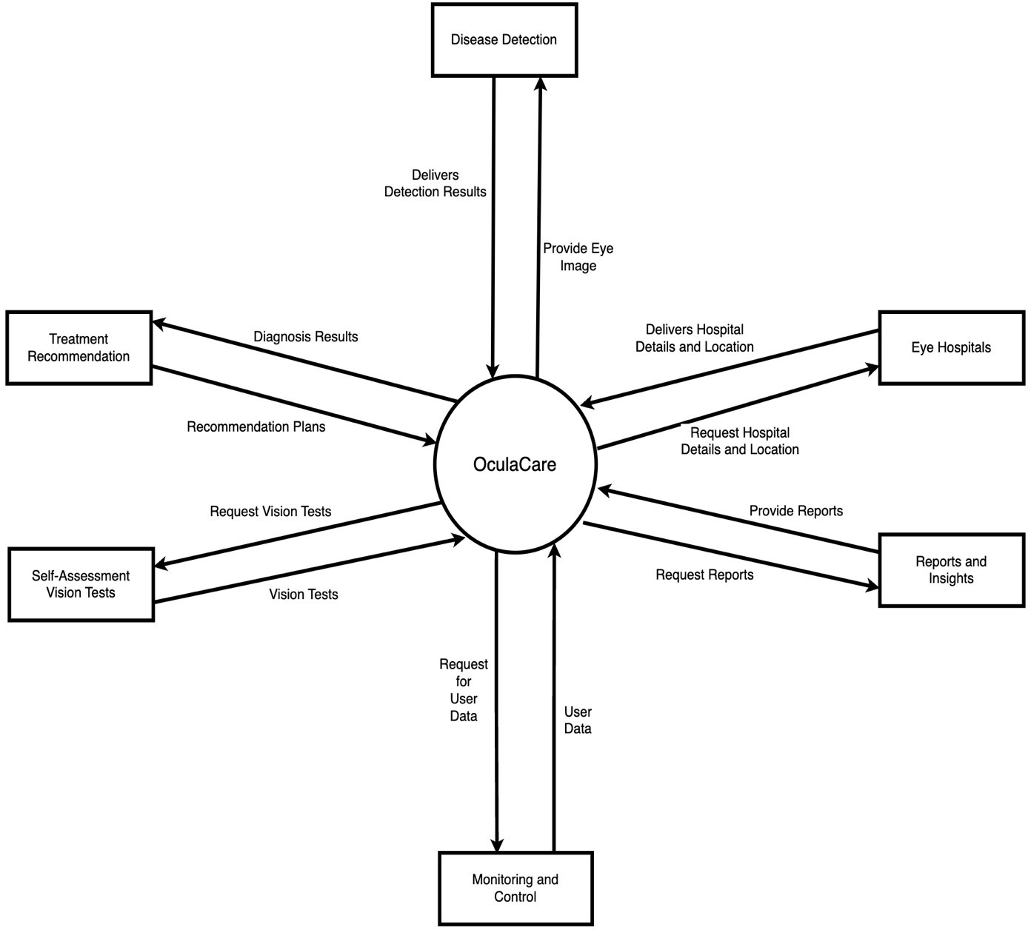

**Figure 7: Context Diagram of OculaCare**

### Architecture Diagram

The following figure shows the architecture diagram of OculaCare.

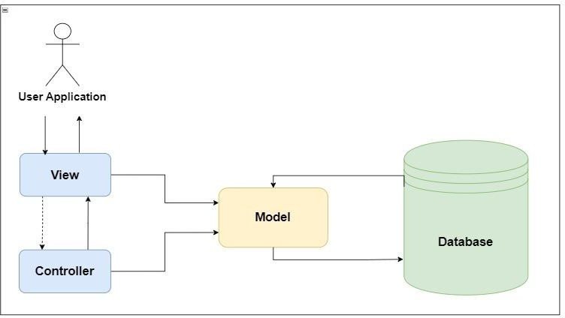

**Figure 8: Architecture Diagram of OculaCare**

.

## Design Models

This section provides information about the OculaCare design models.

### Activity Diagrams

This section shows the activity diagrams of major use cases of each module of OculaCare.

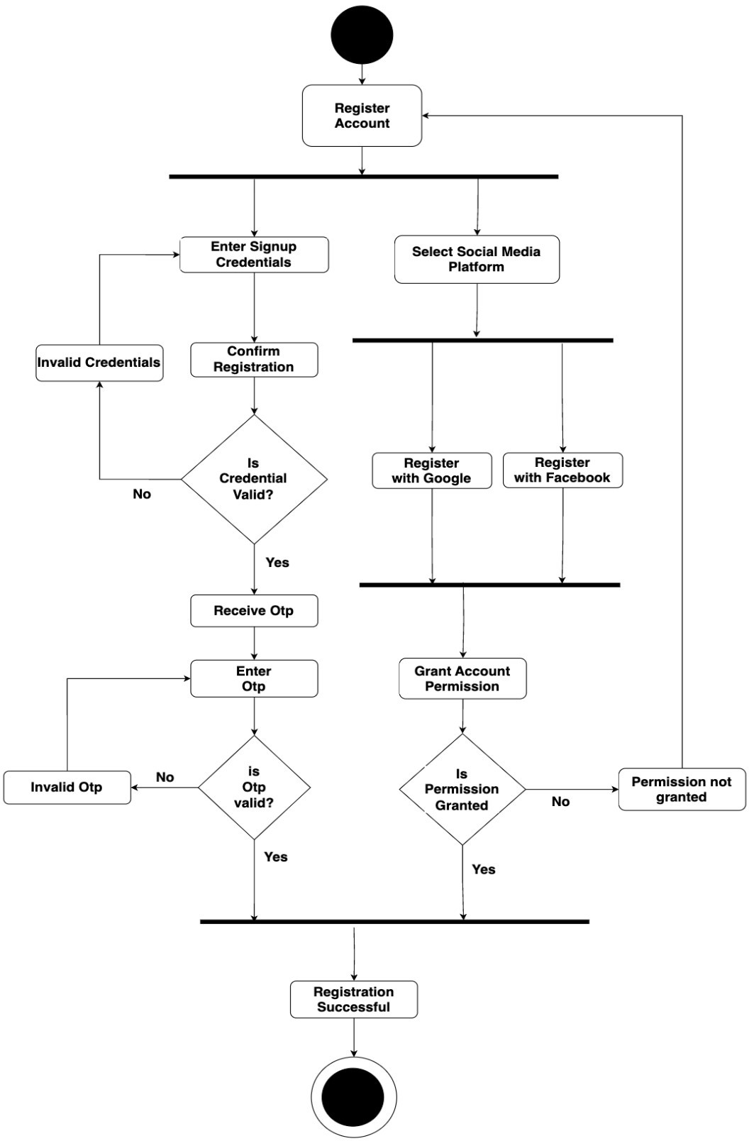

**Figure 9: Activity Diagram for Patient Registration**

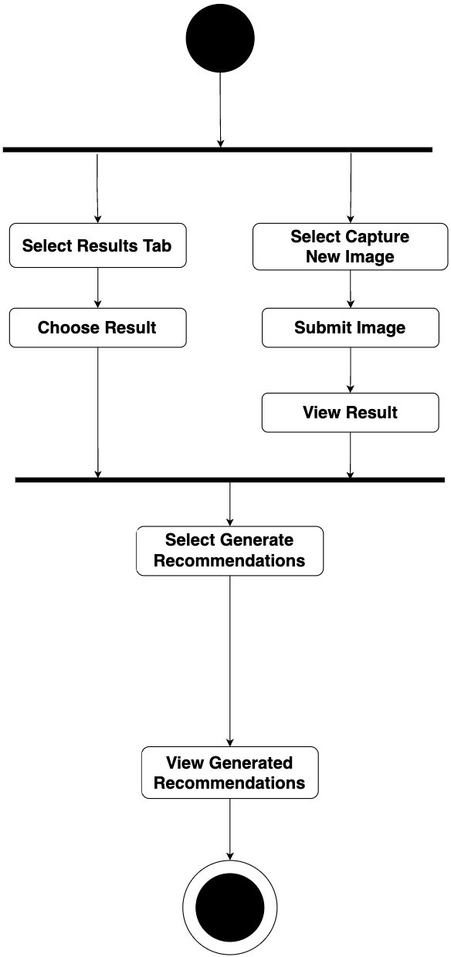

**Figure 10: Activity Diagram for Capturing Eye Image**

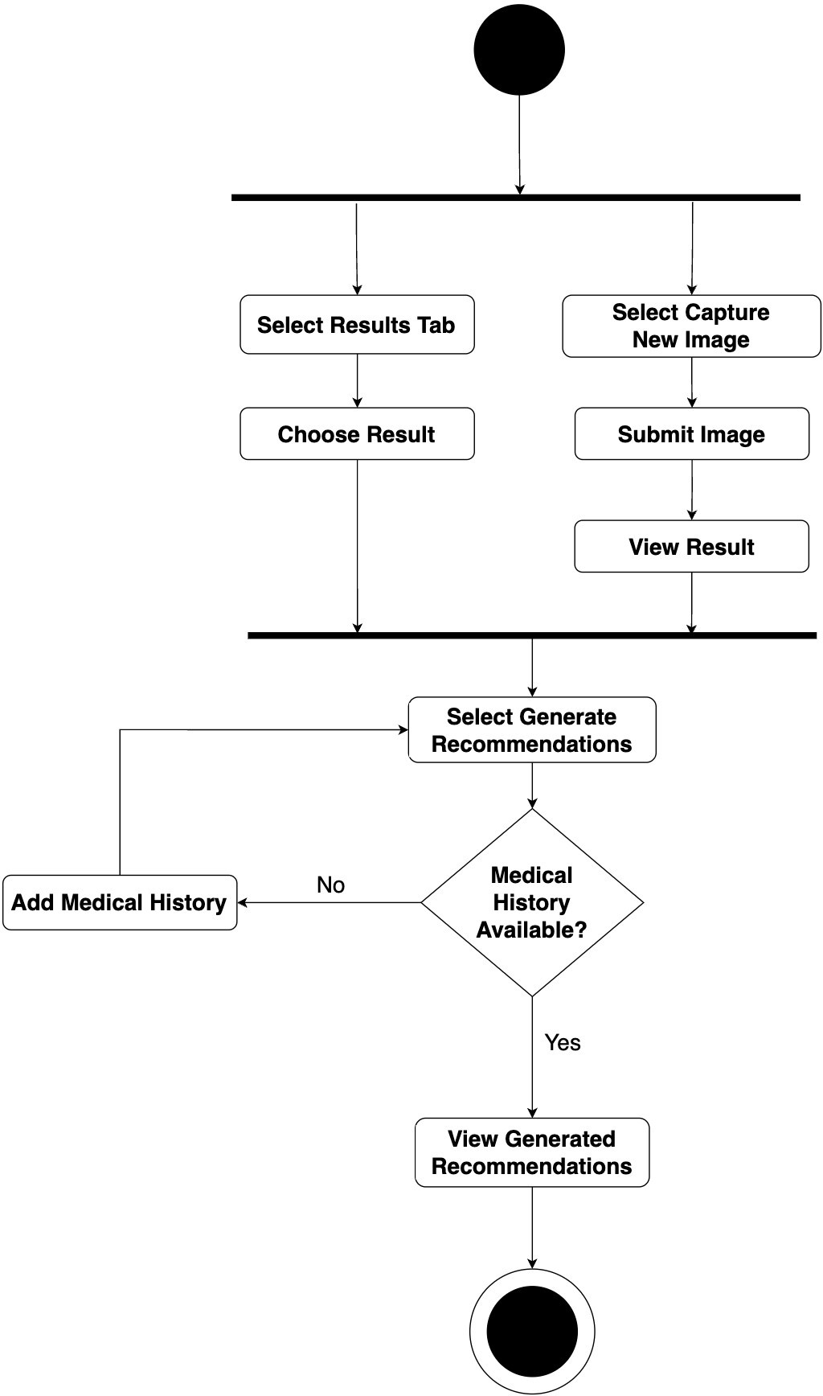

**Figure 11: Activity Diagram for Generating Treatment Recommendations**

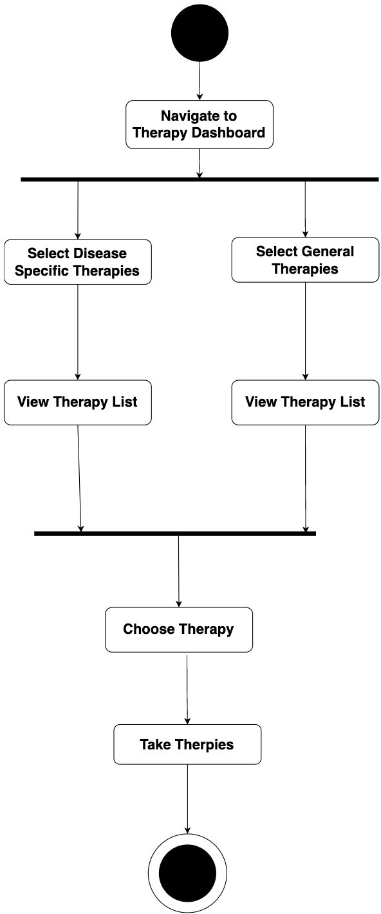

**Figure 12: Activity Diagram for Taking Therapy**

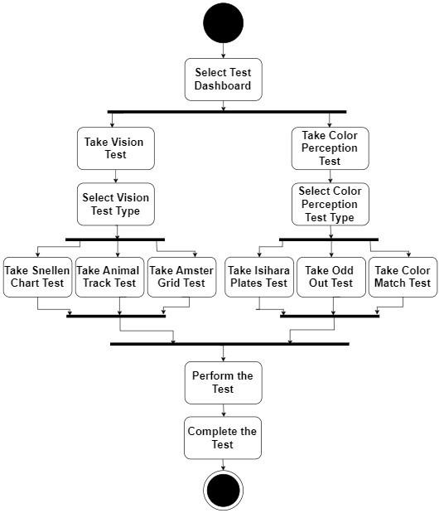

**Figure 13: Activity Diagram for Performing Self-Assessment Test**

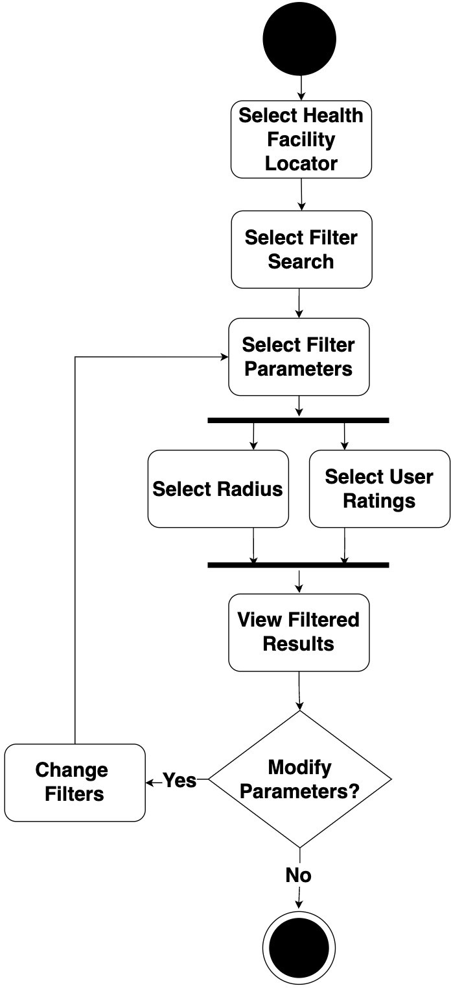

**Figure 14: Activity Diagram for Locating Eye Hospital**

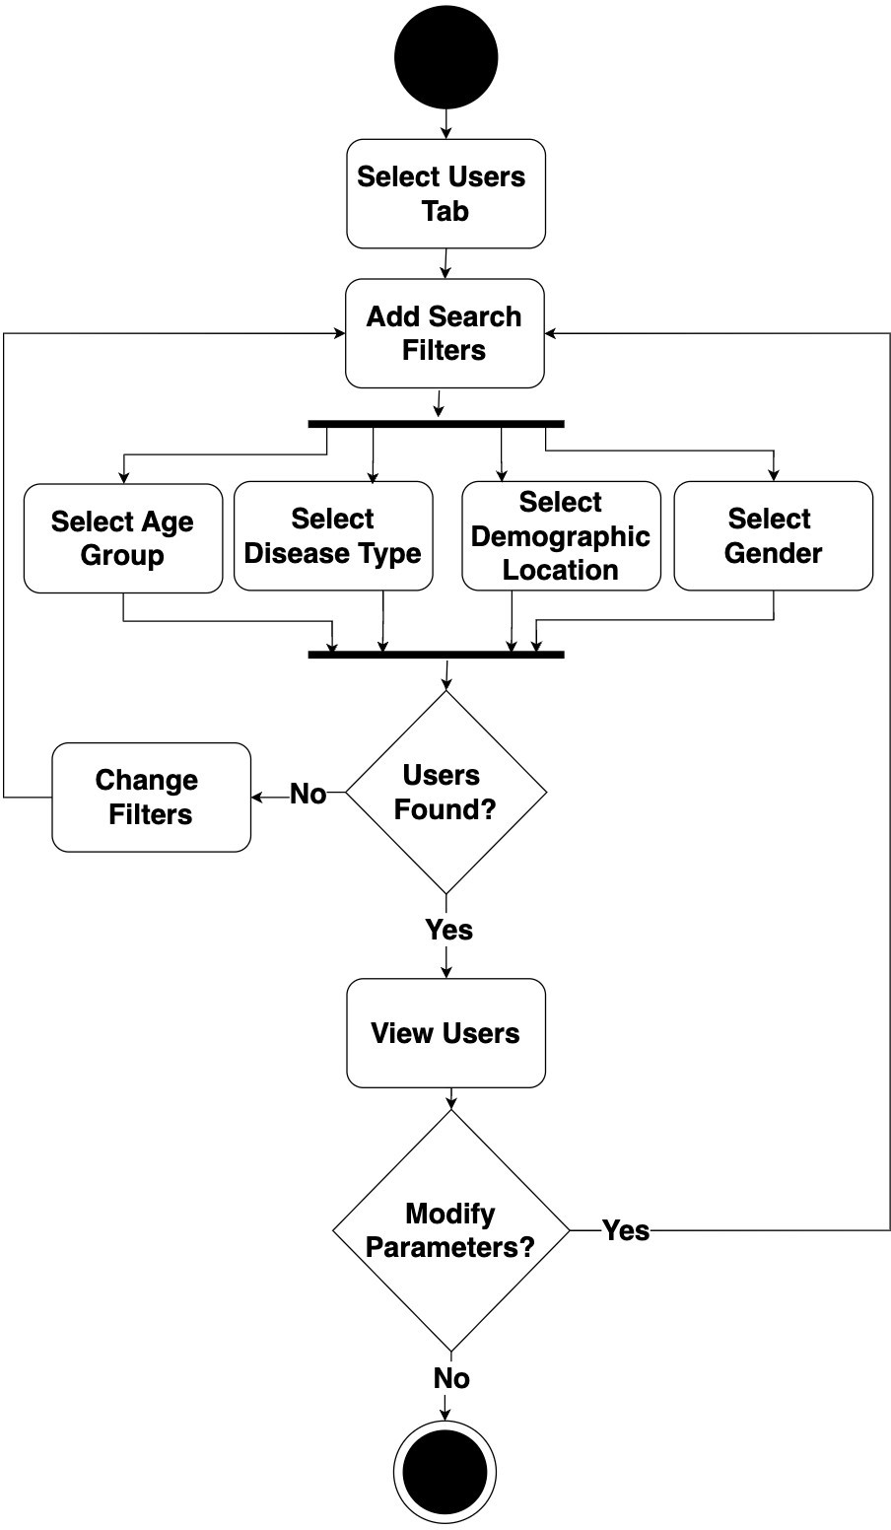

**Figure 15: Activity Diagram for Managing User Feedback**

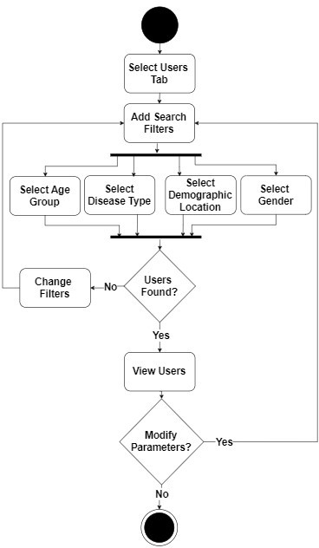

**Figure 16: Activity Diagram for Visualizing Data**

### Class Diagram

The following figure shows the OculaCare class diagram.

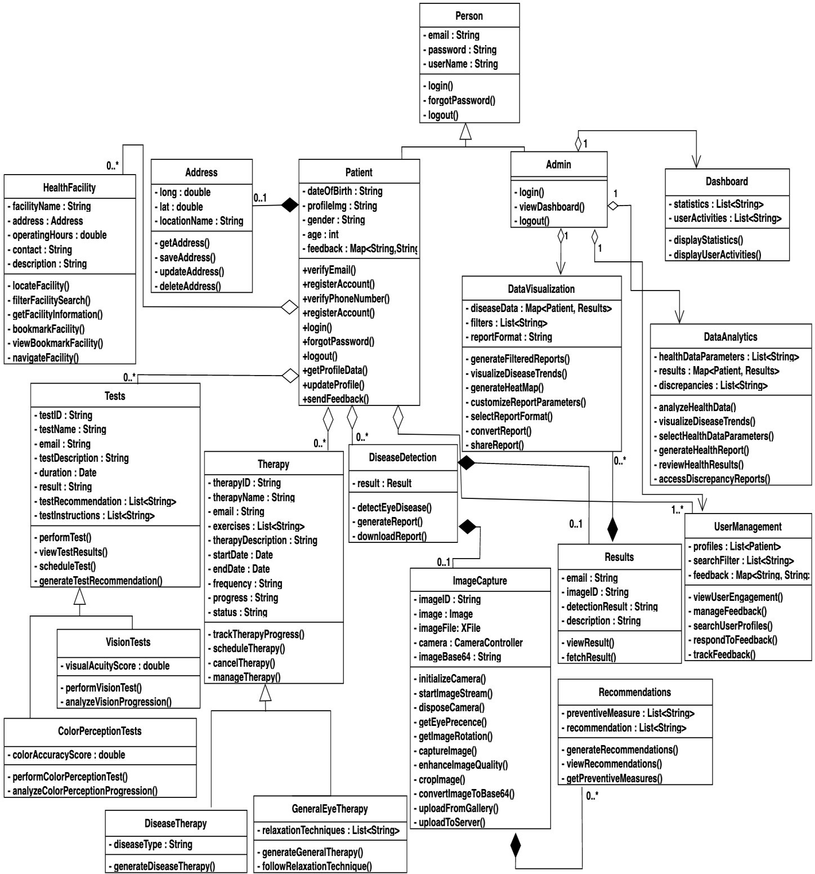

**Figure 17: Class Diagram of OculaCare**

### Sequence Diagrams

This section shows the sequence diagrams of major use cases of each module of OculaCare.

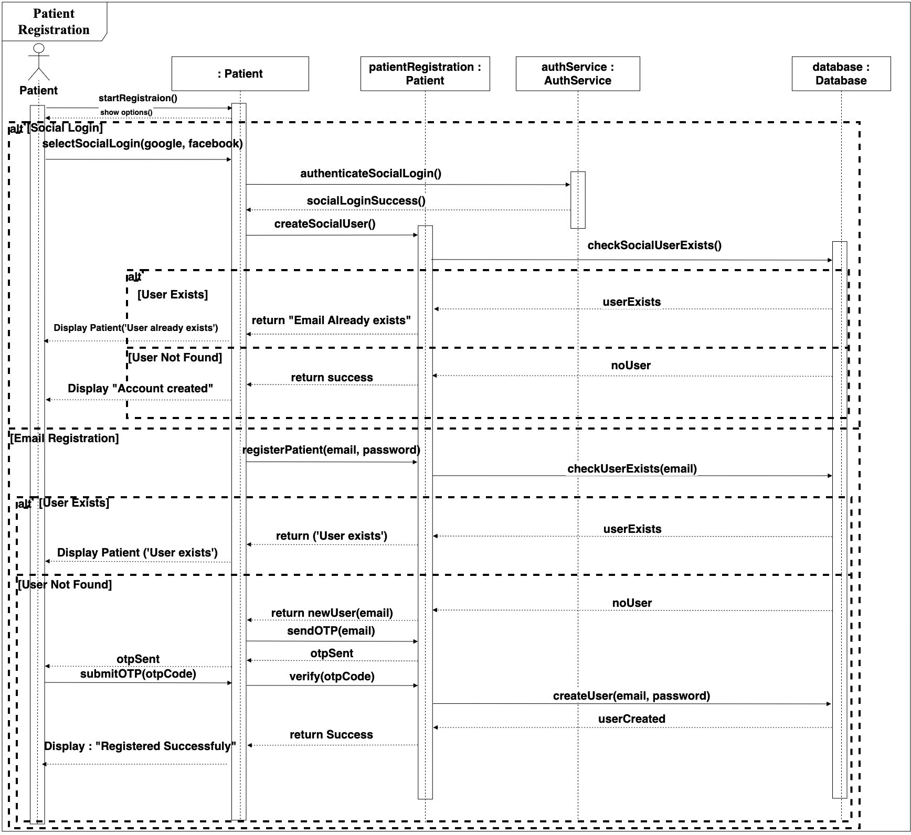

**Figure 18: Sequence Diagram for Patient Registration**

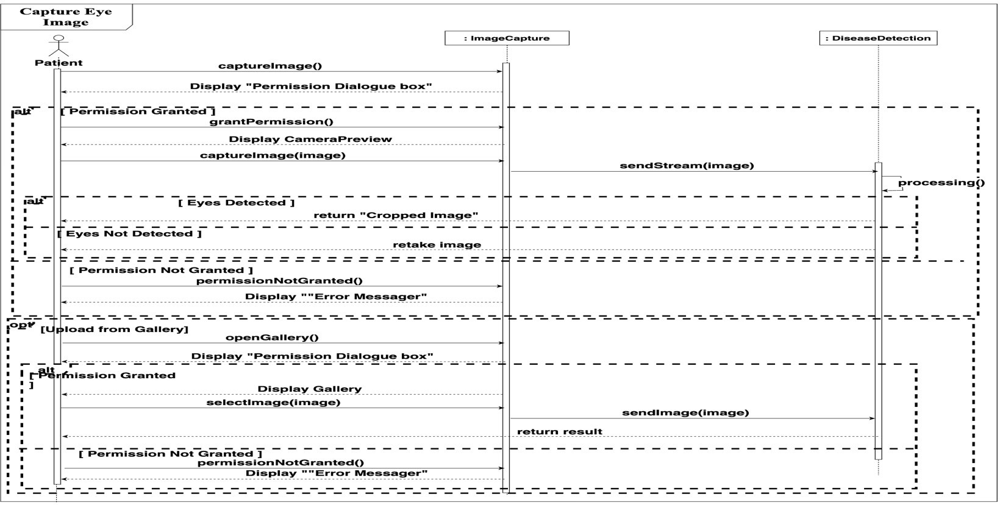

**Figure 19: Sequence Diagram for Capturing Eye Image**

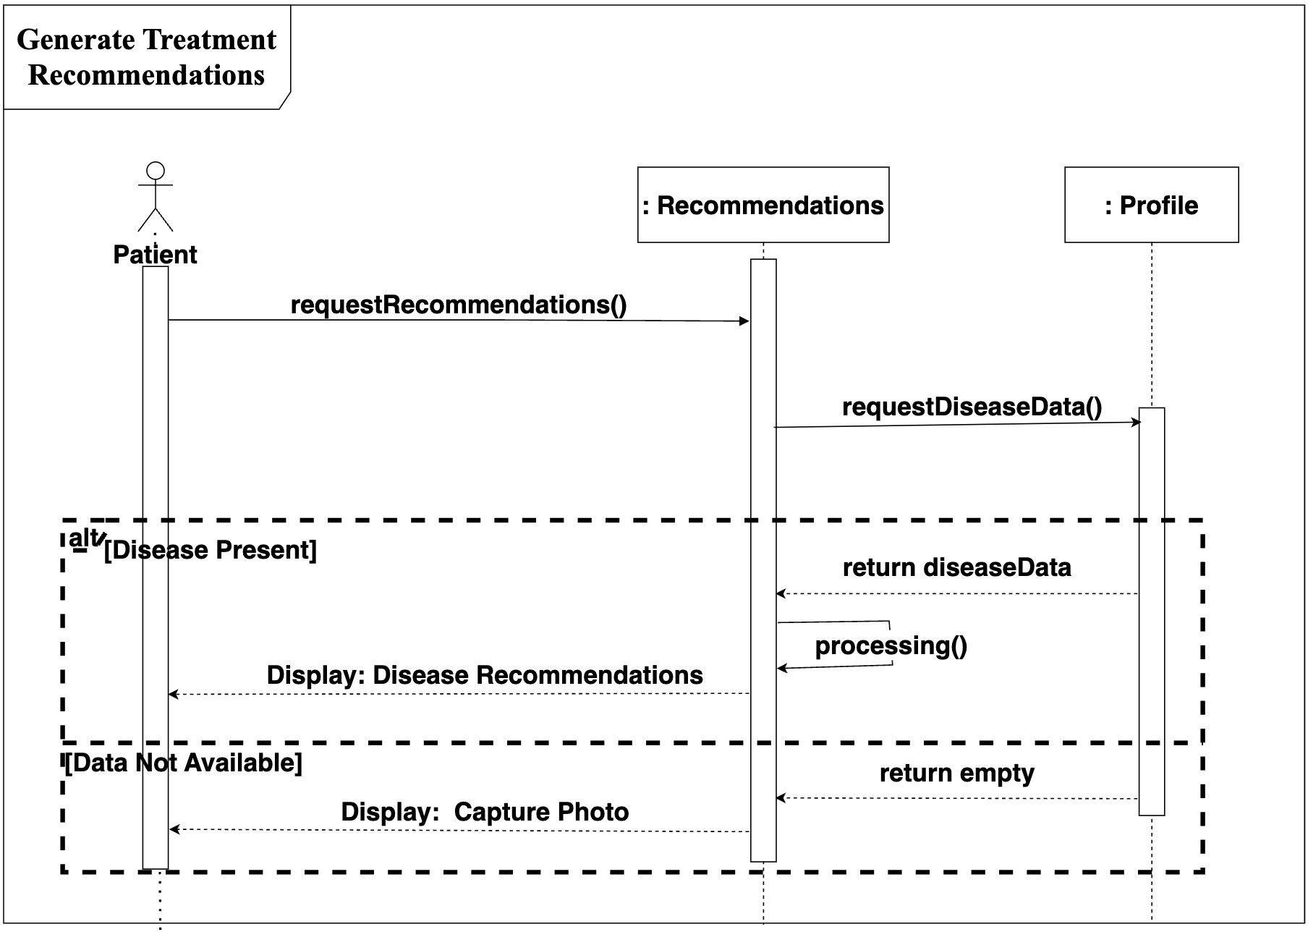

**Figure 20: Sequence Diagram for Generating Treatment Recommendation**

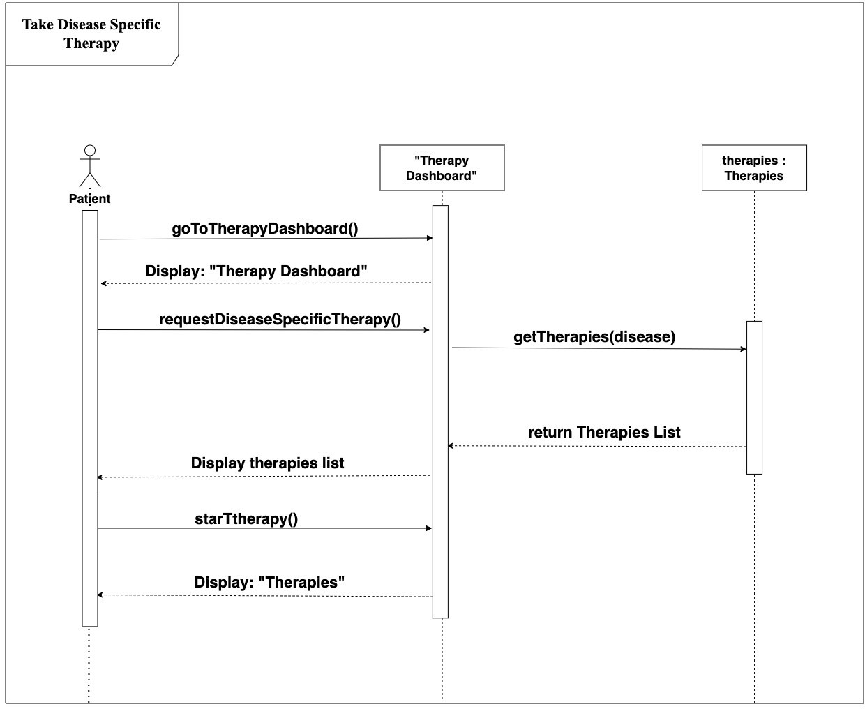

**Figure 21: Sequence Diagram for Generating Therapy Plan**

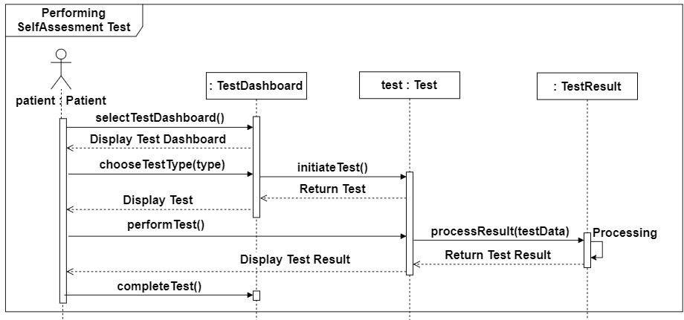

**Figure 22: Sequence Diagram for Performing Self-Assessment Test**

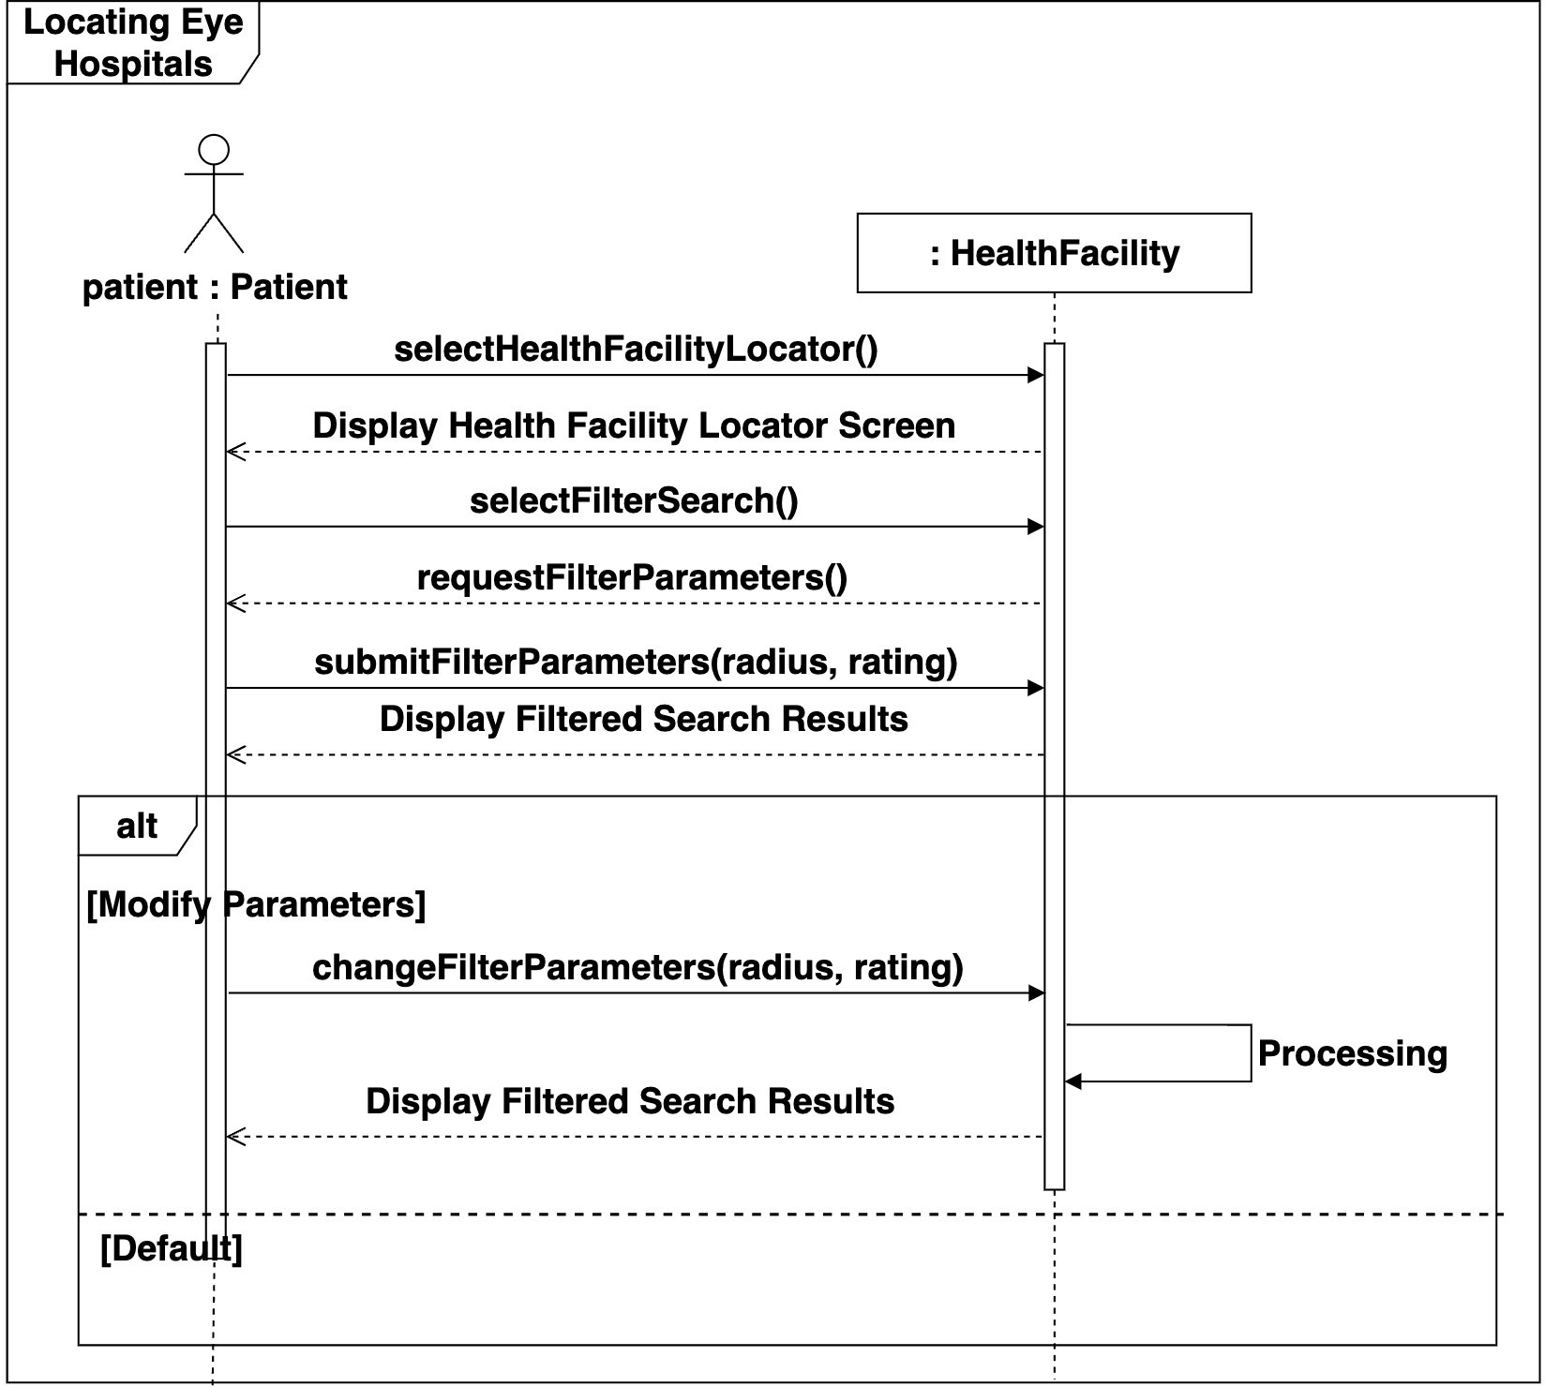

**Figure 23: Sequence Diagram for Locating Eye Hospitals**

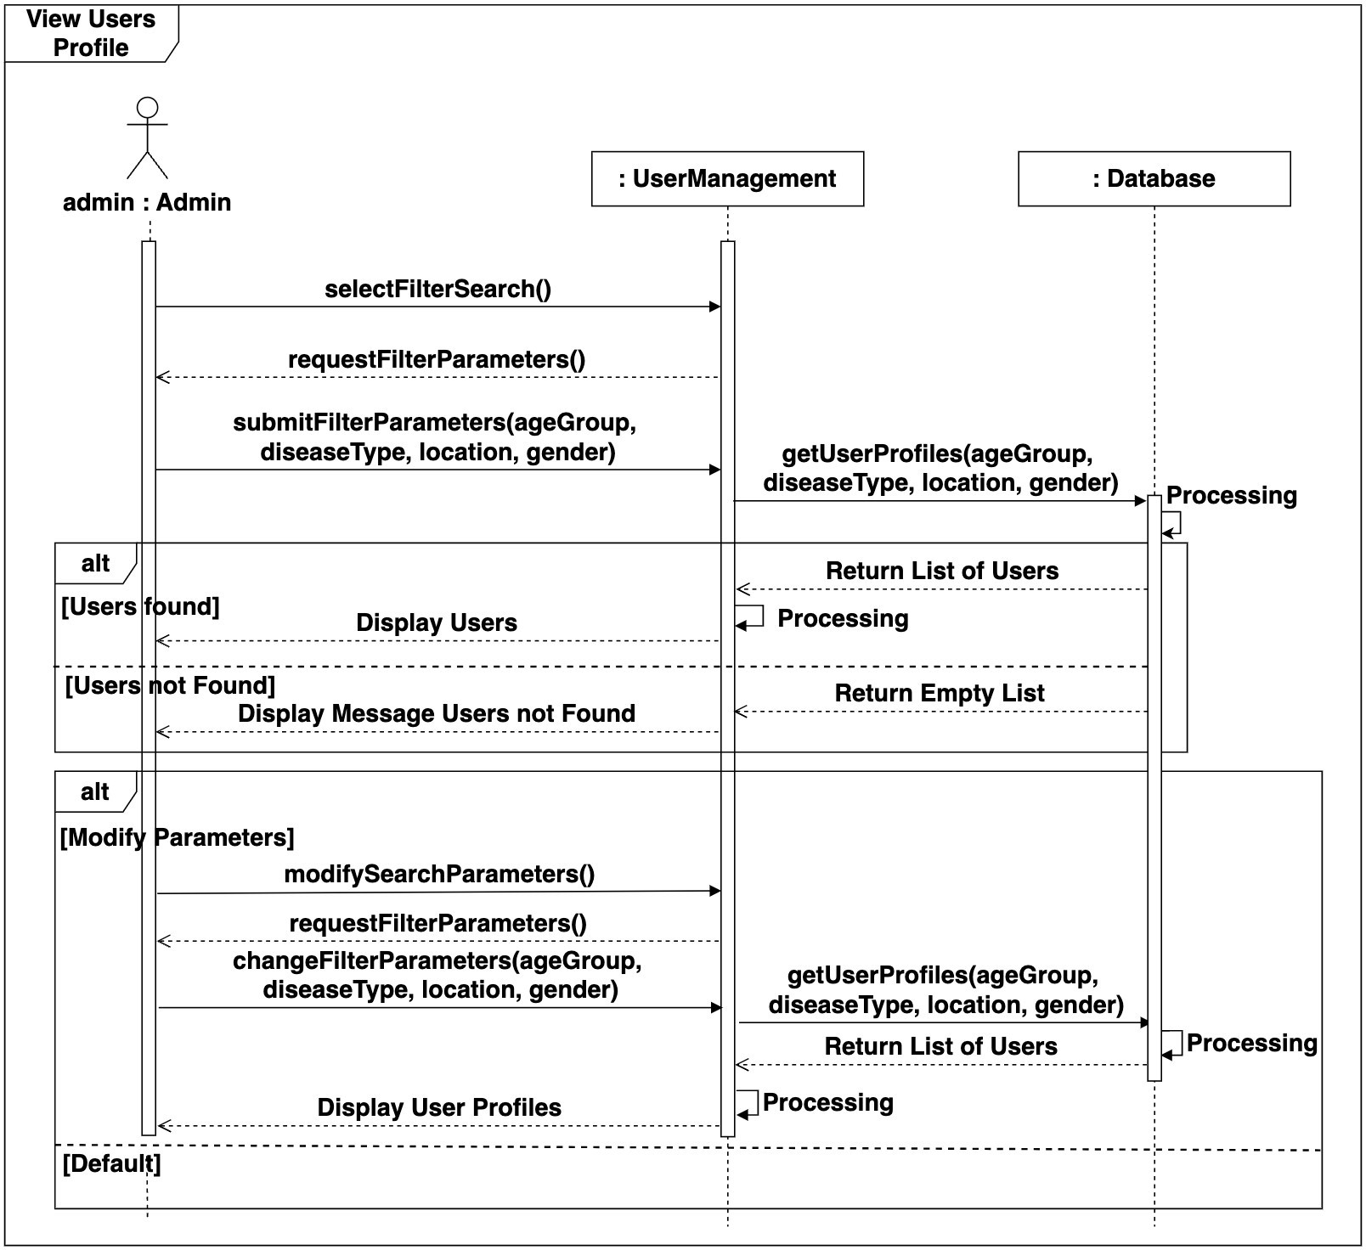

**Figure 24: Sequence Diagram for Managing Users Profile**

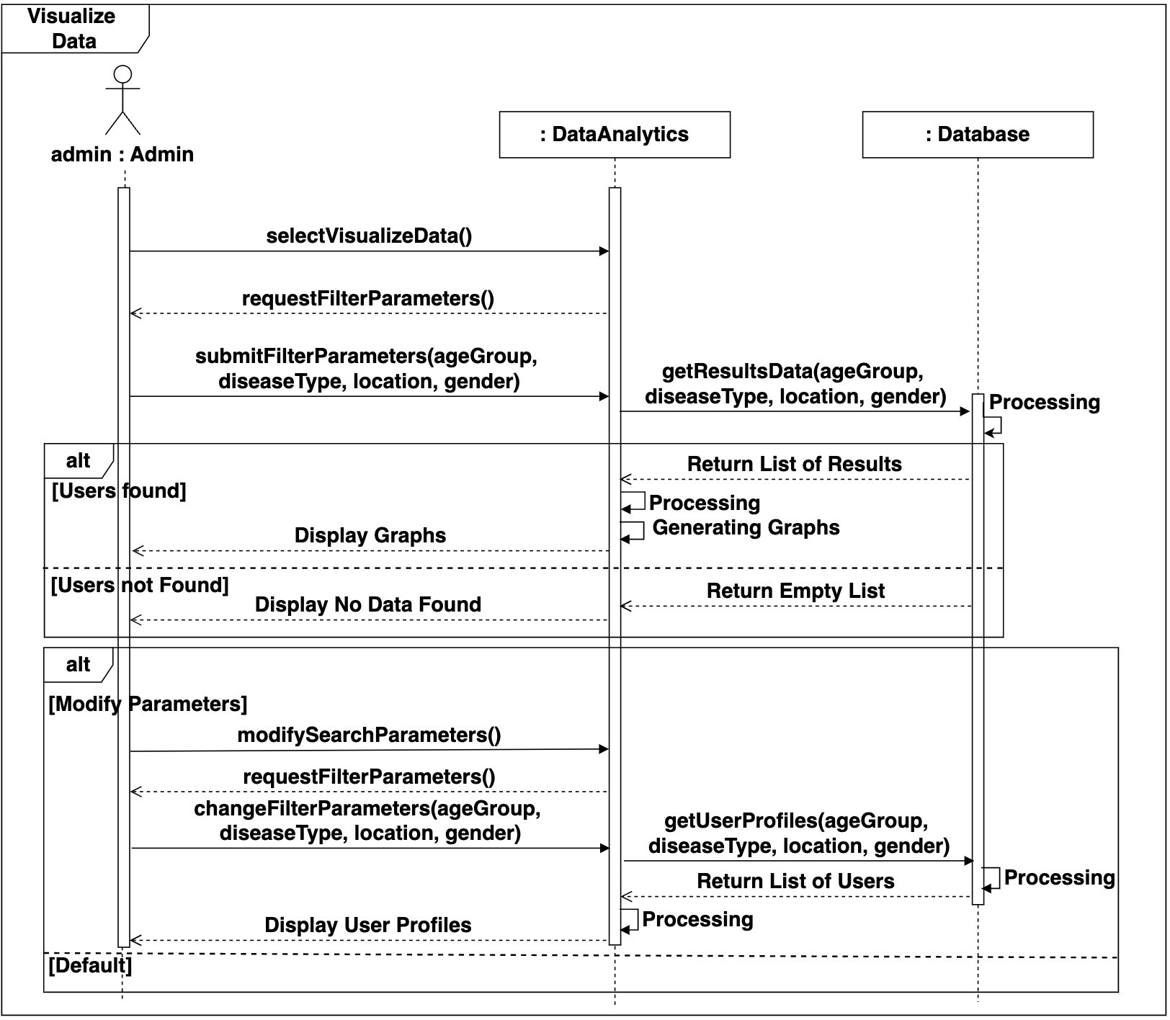

**Figure 25: Sequence Diagram for Visualizing Data**

## Data Design

This section explains how the information domain of our system is transformed into data structures.

### Schemas

Following are the schemas of OculaCare:

**Patient Schema:**

const mongoose = require('mongoose'); const patientSchema = new Schema ({

email: { type: String, required: true, unique: true

},

username: { type: String, required: true, unique: true

},

password: { type: String, required: true

},

profileImage: { type: String,

}, age: { type: Number

},

gender: {

type: String,

},

contactNumber: { type: String

}, address: { type: addressSchema,

}

}

,

{

timestamps: true

});

const Patient = mongoose.model('Patient', patientSchema); module.exports = Patient;

**Address Schema:**

const mongoose = require('mongoose'); const Schema = mongoose.Schema; const addressSchema = new

Schema({ lat: { type:

Number, required: true

}, long: { type: Number, required: true

},

locationName: { type: String, required: true

}

});

const Address = mongoose.model('Address', addressSchema); module.exports = Address;

**DiseaseDetection Schema:**

const mongoose = require('mongoose'); const Schema = mongoose.Schema;

const diseaseDetectionSchema = new Schema({ result: {

type: [resultSchema], required: true

},

reports: { type: [String], required: true

}

}

,

{

timestamps: true

});

const DiseaseDetection = mongoose.model('DiseaseDetection', diseaseDetectionSchema); module.exports = DiseaseDetection;

**Result Schema:**

const mongoose = require('mongoose'); const Schema = mongoose.Schema; const resultSchema = new Schema({ email: { type: String, required: true

},

imageID: { type: String, required: true

},

detectionResult: { type: String, required: true

},

description:

{ type: String, required: true

}

}

,

{

timestamps: true

});

const Result = mongoose.model('Result', resultSchema); module.exports = Result;

**Recommendation Schema:**

const mongoose = require('mongoose'); const Schema = mongoose.Schema; const recommendationSchema = new Schema({ preventiveMeasure: { type: [String], required: true

},

recommendation: { type: [String], required: true

}

}

,

{

timestamps: true

});

const Recommendations = mongoose.model('Recommendations', recommendationSchema); module.exports = Recommendations;

**Feedback Schema:**

const mongoose = require('mongoose'); const Schema = mongoose.Schema; const feedbackSchema = new Schema({

email: { type: String, required: true

},

category: { type: String, required: true

}, defaults:

{ type: [String], required: true

},

customMessage: { type: String,

}

},

{

timestamps: true

});

const Feedback = mongoose.model('Feedback', feedbackSchema); module.exports = Feedback;

**Health Facility Schema:**

const mongoose = require('mongoose'); const mongoose = require("mongoose");

const healthFacilitySchema = new Schema({ facilityName: { type: String, required: true

}, address: {

type: addressSchema, required: true

},

duration: { type: Date, required: true

},

operatingHours: { type: String, required: true

}, contact:

{ type: String, required: true

},

description: { type: String, required: true

}

}

,

{

timestamps: true

});

const HealthFacility = mongoose.model('HealthFacility', healthFacilitySchema); module.exports = HealthFacility;

**Therapy Schema:**

const mongoose = require("mongoose"); const Schema = mongoose.Schema; const therapyschema = new

Schema({ email: { type: String, required: true,

},

patient_name: { type: String, required: true,

}, date: { type: String,

},

therapy_type: { type: String,

},

therapy_name: { type: String,

},

duration:

{

type: Number,

},

});

const Therapy = mongoose.model("Therapy", therapyschema); module.exports = Therapy;

**Admin Schema:**

const mongoose = require('mongoose'); const Schema = mongoose.Schema; const adminSchema = new Schema({

adminID: { type: String, required: true, unique: true

},

username: { type: String, required: true, unique: true

},

password: {

type: String, required: true

}, email: { type: String, required: true, unique: true

}

}

,

{

timestamps: true

});

const Admin = mongoose.model('Admin', adminSchema); module.exports = Admin; **Test Schema:**

const mongoose = require('mongoose'); const Schema = mongoose.Schema; const testschema = new Schema({ email: {

type: String, required: true,

},

patient_name: { type: String, required: true,

}, date: { type: String, }, test_type: { type: String,

},

test_name:

{ type: String, }, test_score:

{

type: Number,

},

result_description:

{ type: String,

},

test_recommendations: { type: String,

},

test_impact: { type: String,

},

});

const Tests = mongoose.model("Test", testschema); module.exports = Tests;

### Data Dictionary

This section provides information about the system entities and major data along with their types and descriptions.

**Table 6: Data Dictionary for OculaCare**

|  |  |  |  |  |
| --- | --- | --- | --- | --- |
| **No.** | **Collection** | **Property** | **Datatype** | **Description** |
| 1. | **Patient** | email | String | Email address of the patient |
| 2. | **Patient** | username | String | Unique username for the patient |
| 3. | **Patient** | password | String | Password for patient account |
| 4. | **Patient** | profileImage | String | URL or base64 string  of the patient's profile image |
| 5. | **Patient** | age | Number | Age of the patient |
| 6. | **Patient** | gender | String | Gender of the patient |
| 7. | **Patient** | contactNumber | String | Contact number of the patient |
| 8. | **Patient** | address | Object | Address of the patient |
| 9. | **Address** | lat | Number | Latitude of the address |
| 10 | **Address** | long | Number | Longitude of the address |

|  |  |  |  |  |
| --- | --- | --- | --- | --- |
| 11. | **Address** | locationName | String | Name of the location |
| 12. | **DiseaseDetection** | result | Array | List of results for the  disease detection |
| 13. | **DiseaseDetection** | reports | Array | List of reports related to disease detection |
| 14. | **Result** | email | String | Email address of the  patient |
| 15. | **Result** | imageID | String | Unique identifier for  the image |
| 16. | **Result** | detectionResult | String | Result of the detection |
| 17. | **Result** | description | String | Description of the result |
| 18. | **Recommendations** | preventiveMeasure | Array | List of preventive measures |
| 19. | **Recommendations** | recommendation | Array | List of  recommendations |
| 20. | **HealthFacility** | facilityName | String | Name of the health  facility |
| 21. | **HealthFacility** | address | Object | Address of the health facility |
| 22. | **HealthFacility** | duration | Date | Duration of operation |
| 23. | **HealthFacility** | operatingHours | String | Operating hours of the facility |
| 24. | **HealthFacility** | contact | String | Contact information for the facility |
| 25. | **HealthFacility** | description | String | Description of the facility |
| 26. | **Admin** | adminID | String | Unique identifier for the admin |
| 27. | **Admin** | username | String | Username for  the admin |
| 28. | **Admin** | password | String | Password for the admin account |

# Implementation

This section provides information about the implementation of our proposed system.

.

## Algorithm

This section covers the algorithms used in implementing OculaCare.

* + 1. **Disease Detection and Classification from Uploaded Image Module:** Disease Detection and Classification

**Input:** Image from user

**Output:** Display result on user interface, results stored in database

**Pseudocode:**

1: Function uploadAndProcessImage(image): If image is not valid

Display "Invalid image. Please upload a valid image."

Return

imageBase64 <- convertImageToBase64(image) serverResponse <- sendImageToServer(imageBase64)

If serverResponse is "success" If disease detected

diseaseType <- classifyDisease(image) results <- createResults(diseaseType) saveResultsToDatabase(results) displayResults(results)

Else

Display "No disease detected."

Else

Display "Error in processing image."

2: Function convertImageToBase64(image): Convert image to Base64 format

Return base64Image

3: Function sendImageToServer(imageBase64): Send base64 encoded image to server via API Return response from server

4: Function classifyDisease(image):

Convert image to format required by ResNet50 model diseaseType <- applyResNet50Model(image)

Return diseaseType

5: Function createResults(diseaseType):

Create results object containing disease type and other relevant information Return results

6: Function saveResultsToDatabase(results):

Save results in the database with associated user information If success

Return "Results saved successfully" Else

Log error

Return "Error saving results"

7: Function displayResults(results): Display results on the user interface If results indicate presence of disease

Display "Disease detected: " + results.diseaseType Else

Display "No disease detected"

8: Function applyResNet50Model(image):

Apply ResNet50 model to the image to determine disease type Return diseaseType

### Performing Therapies

**Module: Monitoring and Therapy Plans**

**Input:** therapyType, diseaseType (in case of disease specific therapies) **Output:** Completion screen after therapy **Pseudocode:** 1: Function takeTherapy(therapyType, diseaseType=None):

If therapyType == "General": therapyList <- getGeneralTherapyList() therapy <- userSelectsTherapy(therapyList) Else If therapyType == "Disease-Specific": diseaseTherapyList <- getDiseaseSpecificTherapies(diseaseType) therapy <- userSelectsTherapy(diseaseTherapyList)

displayTherapyStartScreen(therapy)

for each step in therapy.steps: displayVisualCue(step.visual) playAudioCue(step.audio)

displayTextualCue(step.text)

duration <- getStepDuration(step) waitFor(duration)

displayTherapyCompletedScreen() logTherapyCompletion(therapyType, diseaseType,

therapy) offerFeedbackSubmission() 2: Function

getGeneralTherapyList():

Return list of general therapies available for all users

3: Function getDiseaseSpecificTherapies(diseaseType): Return list of therapies specific to the diseaseType

4: Function userSelectsTherapy(therapyList):

Display available therapies from therapyList userTherapy <- waitForUserSelection()

Return userTherapy

5: Function displayTherapyStartScreen(therapy):

Display "Therapy Starting" screen with therapy name and instructions

6: Function displayVisualCue(visual):

Render the visual animation guiding the user

7: Function playAudioCue(audio):

Play corresponding audio instructions for the therapy step

8: Function displayTextualCue(text):

Display textual guidance related to the current step

9: Function getStepDuration(step):

Return the duration of the current therapy step (in seconds)

10: Function waitFor(duration):

Pause the system for the specified duration before moving to the next step

11: Function displayTherapyCompletedScreen():

Display "Therapy Completed" screen with message of accomplishment

12: Function logTherapyCompletion(therapyType, diseaseType, therapy): Log the completion of the therapy session for the user in the database

13: Function offerFeedbackSubmission():

Prompt the user to submit feedback for the therapy session

### Performing Self-Assessment Test

**Module: Self-Assessment and Vision Monitoring Input:** User selections from UI

**Output:** Test results displayed to user and stored in database

**Pseudocode:**

1: Function initiateTestDashboard():

Display "Select Test Type" userInput <- getUserInput() If userInput is "Vision Test"

call performVisionTest()

ElseIf userInput is "Color Perception Test" call performColorPerceptionTest()

Else

Display "Invalid input. Please select a valid test type."

2: Function performVisionTest():

Display "Select Vision Test Type" visionTestType <- getUserInput() Switch visionTestType Case "Snellen Chart":

performSnellenChartTest() Case "Amsler Grid":

performAmslerGridTest() Default:

Display "Invalid test type selected."

3: Function performColorPerceptionTest():

Display "Perform Color Perception Test" testResult <- processColorPerceptionTest()

If additionalTimeNeeded() extendTestTime()

displayAndStoreResults(testResult)

4: Function performSnellenChartTest():

startTime <- getCurrentTime() userResponses <- getUserResponses() endTime <- getCurrentTime()

testResult <- processSnellenChartTest(userResponses, startTime, endTime) displayAndStoreResults(testResult)

5: Function performAmslerGridTest():

startTime <- getCurrentTime() userResponses <- getUserResponses() endTime <- getCurrentTime()

testResult <- processAmslerGridTest(userResponses, startTime, endTime) displayAndStoreResults(testResult)

6: Function additionalTimeNeeded():

Display "Do you need additional time?" userInput <- getUserInput()

Return userInput is "Yes"

7: Function extendTestTime():

additionalTime <- getAdditionalTimeAmount()

Display "Additional time (" + additionalTime + " minutes) added." Return additionalTime

8: Function displayAndStoreResults(testResult): Display "Test Result: " + testResult

Store testResult in database If storeSuccess

Display "Results stored successfully." Else

Display "Error storing results."

9: Function processSnellenChartTest(responses, startTime, endTime): correctAnswers <-

countCorrectAnswers(responses) timeTaken <- endTime - startTime score <- correctAnswers * 10

testResult <- "Score: " + score + ", Time Taken: " + timeTaken + " seconds" Return testResult

10: Function processAmslerGridTest(responses, startTime, endTime): correctMatches <- countCorrectMatches(responses) timeTaken <- endTime - startTime score <- correctMatches * 15

testResult <- "Score: " + score + ", Time Taken: " + timeTaken + " seconds" Return testResult

11: Function processColorPerceptionTest(): startTime <- getCurrentTime()

colorMatches <- getUserColorMatches() endTime <- getCurrentTime()

correctMatches <- countCorrectColorMatches(colorMatches) timeTaken <- endTime - startTime score <- correctMatches * 20

testResult <- "Score: " + score + ", Time Taken: " + timeTaken + " seconds" Return testResult

12: Function countCorrectAnswers(responses):

correctCount <- 0 For each response in

responses If response is correct

correctCount <- correctCount + 1 Return correctCount

13: Function countCorrectMatches(responses):

correctCount <- 0

For each response in responses

If response matches expected pattern correctCount <- correctCount + 1

Return correctCount

14: Function countCorrectColorMatches(matches):

correctCount <- 0 For each match in

matches If match is correct

correctCount <- correctCount + 1 Return correctCount

15: Function getCurrentTime(): Return systemCurrentTime

16: Function getUserResponses(): Collect user responses from UI Return responses

17: Function getUserColorMatches(): Collect color match inputs from UI

Return colorMatches

* + 1. **Visualize Disease Data Module:** Data Analytics and Reporting

**Input:** User selected parameters (Age group, Disease type, Location, Gender) **Output:** Displayed Graphs, Trends, and Heatmaps based on filtered data **Pseudocode:**

1: Function selectAnalyticsTab(): Display "Analytics Dashboard"

Display "Select Visualization Type"

visualizationType <- getUserInput()

If visualizationType is valid selectVisualizeData()

Else

Display "Invalid Visualization Type. Please select again."

2: Function selectVisualizeData(): Display "Select Parameters for Data

Visualization" parameters <-

requestFilterParameters() If parameters are valid

submitFilterParameters(parameters) Else

Display "Invalid parameters. Please enter valid data."

3: Function requestFilterParameters():

Display "Enter Filter Parameters: Age Group, Disease Type, Location, Gender" ageGroup <- getUserInput() diseaseType <- getUserInput() location <- getUserInput() gender <- getUserInput()

Return {ageGroup, diseaseType, location, gender}

4: Function submitFilterParameters(parameters): Display "Fetching Data..." fetchDataForVisualization(parameters)

If data is not empty Display "Generating

Visualization..."

generateVisualization(data) If modifyParametersNeeded() modifyFilterParameters(parameters)

Else

Display "Visualization Complete."

Else

Display "No Data Found."

5: Function fetchDataForVisualization(parameters):

Display "Contacting Server to Fetch Data..." serverResponse <- fetchAnalysisData(parameters)

Return serverResponse

6: Function fetchAnalysisData(parameters):

response <- Server.getResultsData(parameters.ageGroup, parameters.diseaseType, parameters.location, parameters.gender)

If response is empty Return {}

Else

Return response

7: Function generateVisualization(data): If visualizationType is "Graphs" generateGraphs(data)

ElseIf visualizationType is "Trends" generateTrends(data)

ElseIf visualizationType is "Heatmaps" generateHeatmaps(data)

Else

Display "Invalid Visualization Type."

8: Function generateGraphs(data):

Use data to plot graphs (age group vs. disease incidence, etc.) Display graphs on Analytics Dashboard

9: Function generateTrends(data):

Analyze data to find trends (increase or decrease in disease types over time) Display trend lines on Analytics Dashboard

10: Function generateHeatmaps(data): Display heatmaps on Analytics Dashboard

11: Function modifyFilterParameters(oldParameters): newParameters <- requestFilterParameters ()

submitFilterParameters(newParameters) 12: Function modifyParametersNeeded(): Display "Do you want to modify the parameters?" userInput <- getUserInput()

Return userInput is "Yes"

## External APIs/SDKs

The following table provides information about the external APIs used in OculaCare.

**Table 7: Details of APIs used in OculaCare**

|  |  |  |  |
| --- | --- | --- | --- |
| **Name of API and Version** | **Description of API** | **Purpose of Usage** | **API Endpoints** |
| Google Places API (version 3.0) | Provides information about places including name, address, and reviews | To get details of health facilities and other  relevant locations | GET/place/details/json |
| Google Distance Matrix API (version 3.0) | Provides travel distance and time for a matrix of origins and destinations | To calculate distance and travel time to health facilities | GET/distancematrix/json |

## User Interface

This section includes the user interface of OculaCare.

### Onboarding Screen

The onboarding screens for OculaCare provide users with an overview of the app's key features, including advanced detection tools for early identification of eye diseases, personalized therapy plans tailored to improve eye health, and comprehensive vision tests for regular monitoring. These screens ensure users understand the app's benefits and how it can aid in proactive eye health management.

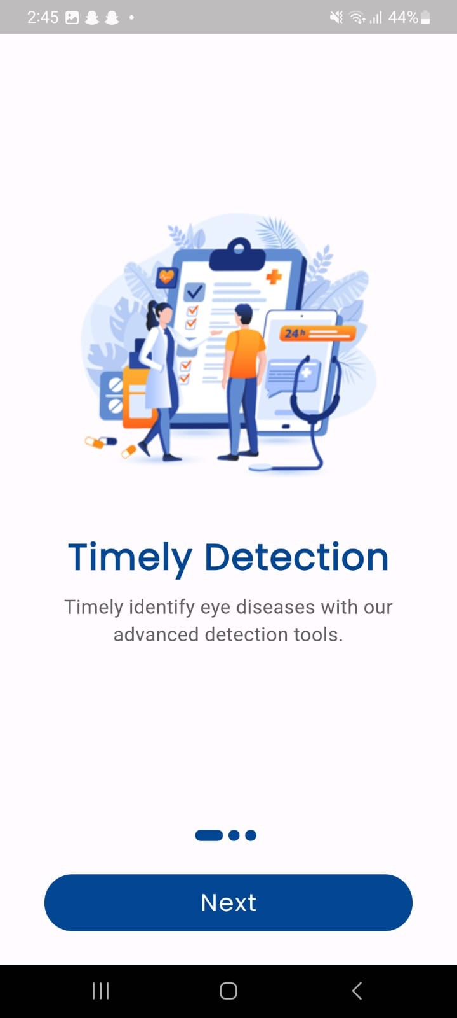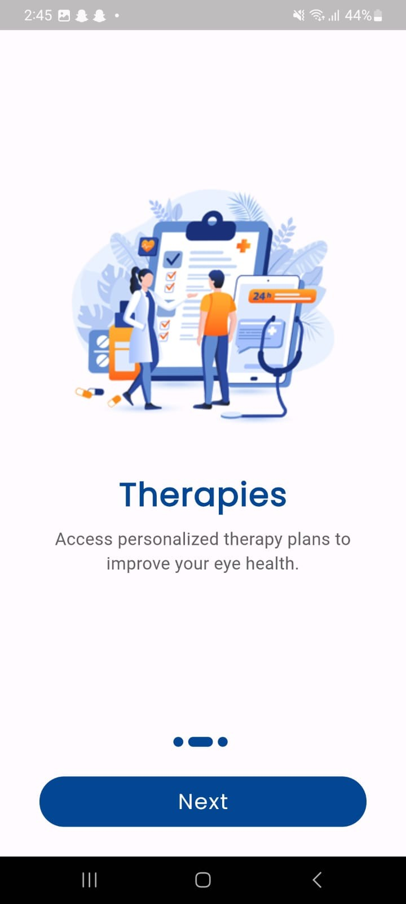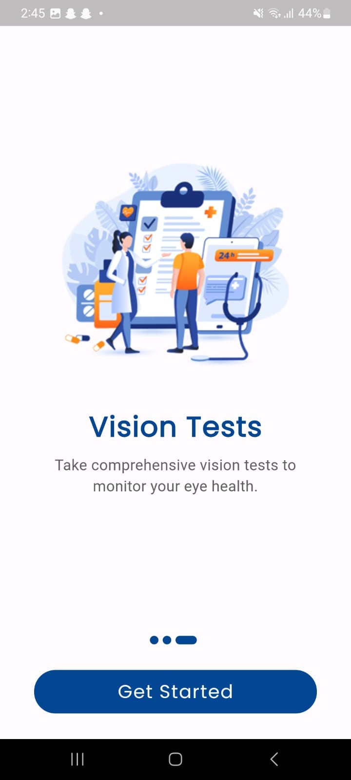

**Figure 26: Onboarding Screens**

### Registration Screen

The registration screen in OculaCare makes it easy for new users to create an account by entering their name, email, and password. For added convenience, users can also sign up using their Google or Facebook accounts. This streamlined process ensures quick access to the app's features, helping users get started with managing their eye health right away.

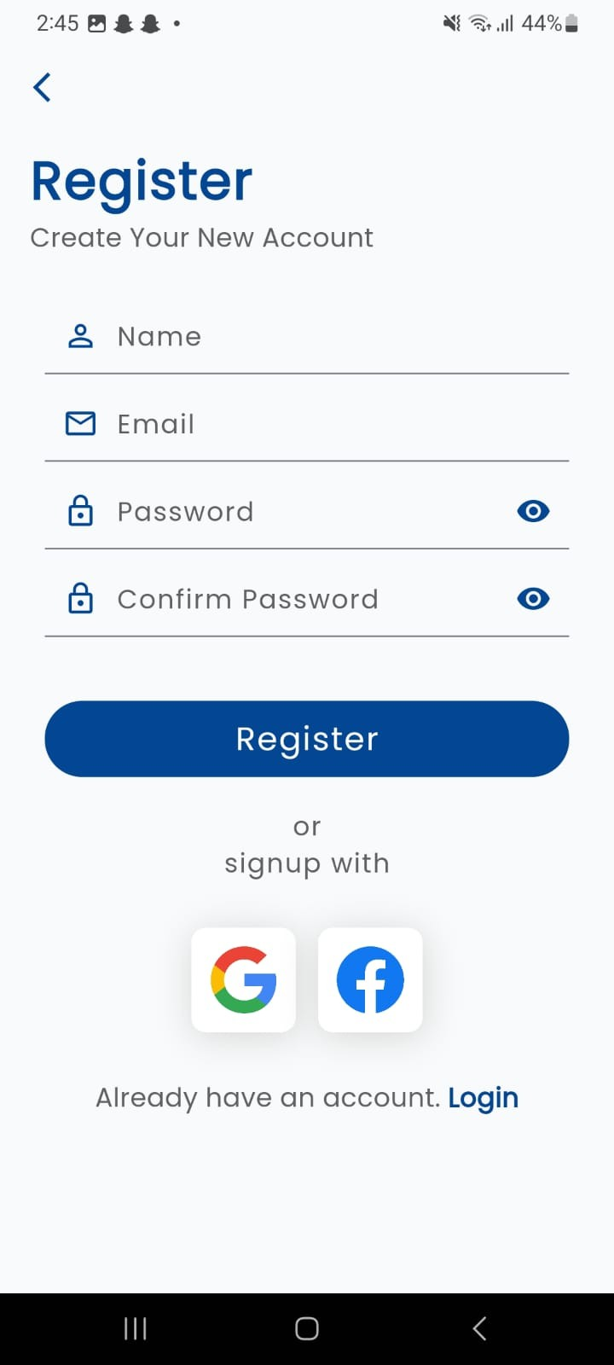

**Figure 27: Registration Screen**

### OTP Screen

The OTP screen in OculaCare ensures secure account verification by prompting users to enter the one-time password sent to their registered email. This step confirms their identity and secures their account, allowing users to proceed with confidence in the app's security measures.

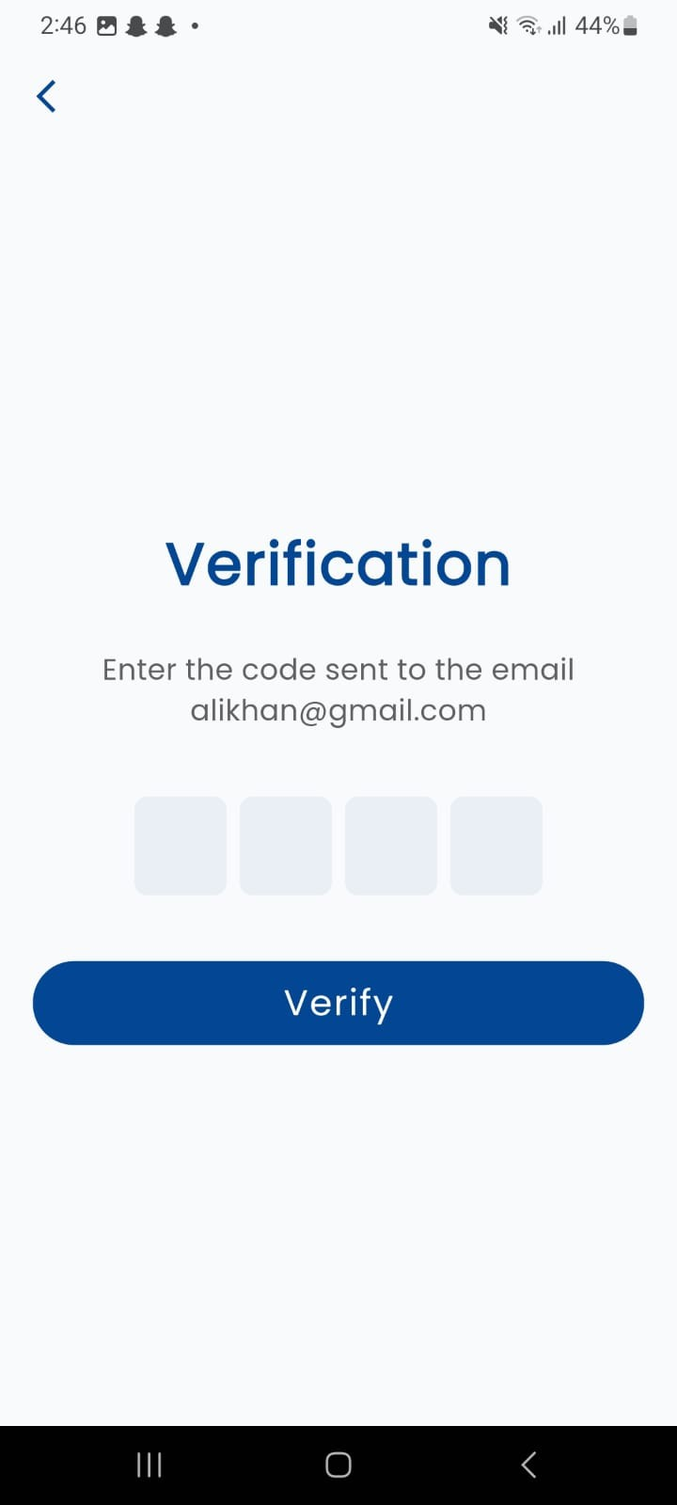

**Figure 28: OTP Verification Screen**

### Login Screen

The login screen in OculaCare welcomes users back and provides a simple and secure way to access their accounts. By entering their registered email and password, users can quickly log in to manage their eye health. The screen also includes options for password recovery and new user registration, ensuring smooth access for all users.

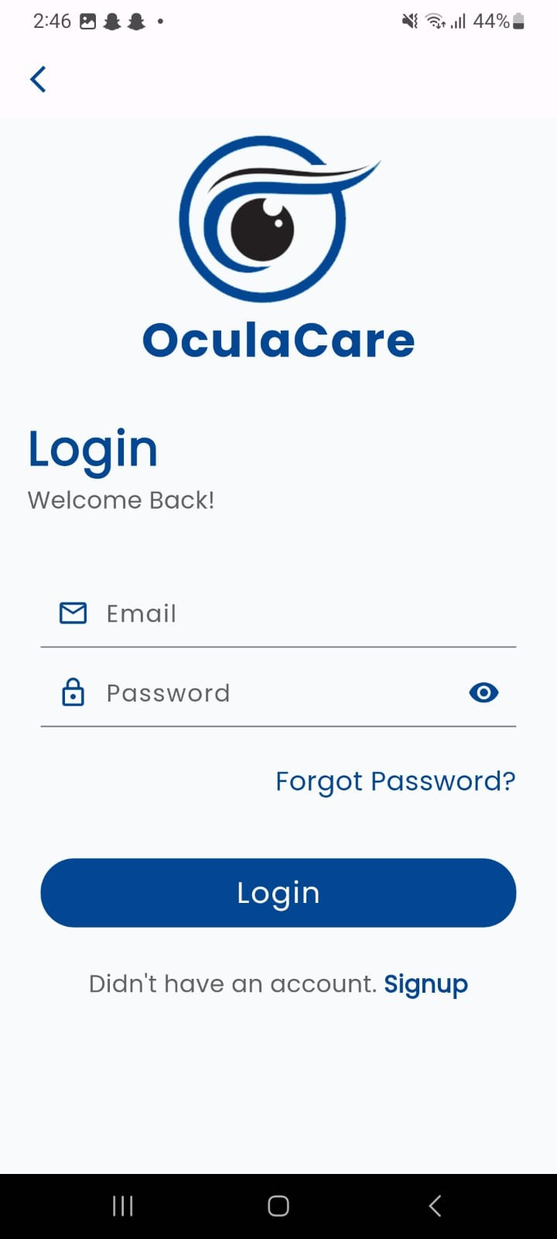

**Figure 29: Login Screen**

### Account Recovery Screen

The account recovery screen in OculaCare allows users to securely update their password by entering a new password and confirming it. This straightforward process ensures users can regain access to their accounts quickly and securely, enhancing the overall user experience and maintaining account security.

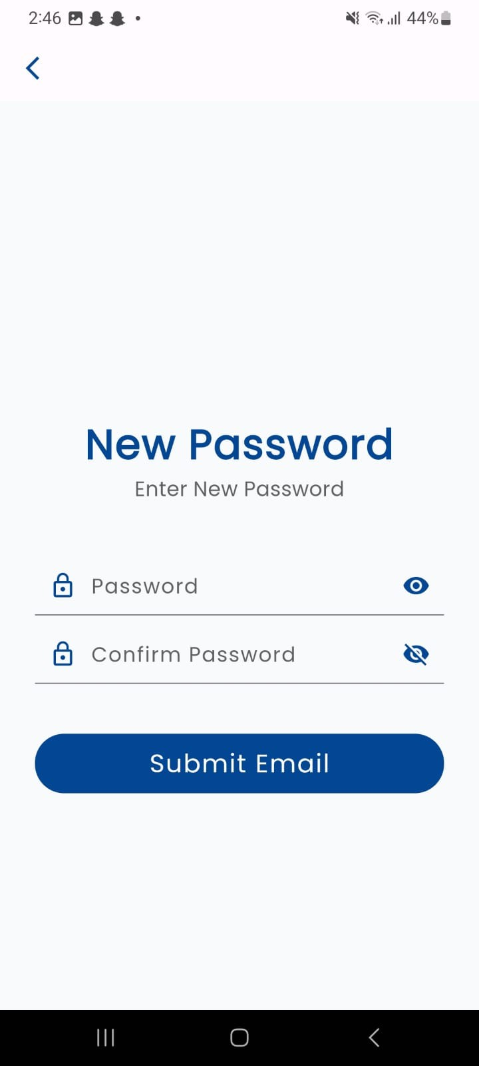

**Figure 30: Account Recovery Screen**

### Home Screen

The home screen in OculaCare welcomes users with a personalized greeting and provides quick access to key features such as disease detection, vision tests, and locating hospitals. It also includes educational content on eye health, making it easy for users to navigate the app and stay informed about maintaining their vision health.

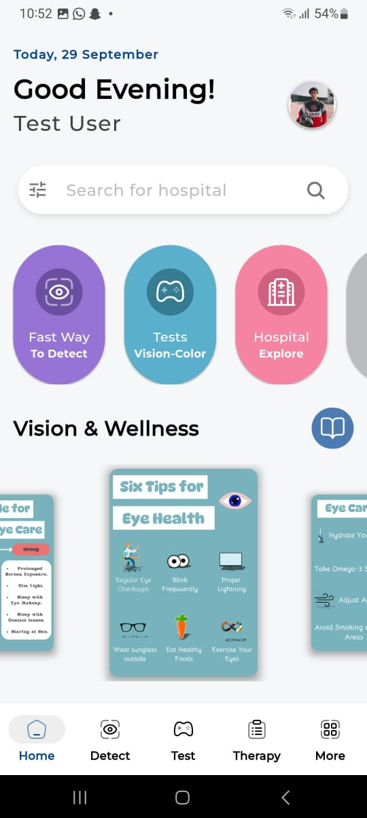

**Figure 31: Home Screen**

### Feedback Screen

The feedback screen in OculaCare allows users to rate their experience and provide specific comments. With options like "Loved it" and "Not Great," users can quickly share their satisfaction level. Additional options let users specify what they found easy, such as capturing images, tracking past results, and taking tests, ensuring comprehensive feedback for continuous improvement of the app.

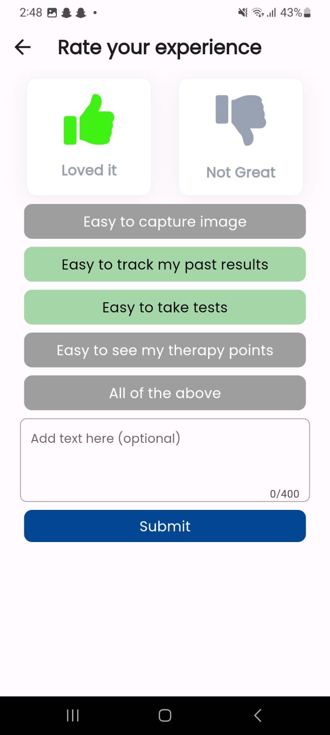

**Figure 32: Feedback Screen**

### Disease Detection Screen

The disease detection screen in OculaCare allows users to capture images for AI-guided disease detection and view their detection results. This user-friendly interface ensures easy access to important diagnostic features, helping users monitor their eye health efficiently. The screen also includes a reminder to seek professional medical advice for any diagnosis, reinforcing the app's supportive role in personal health management.

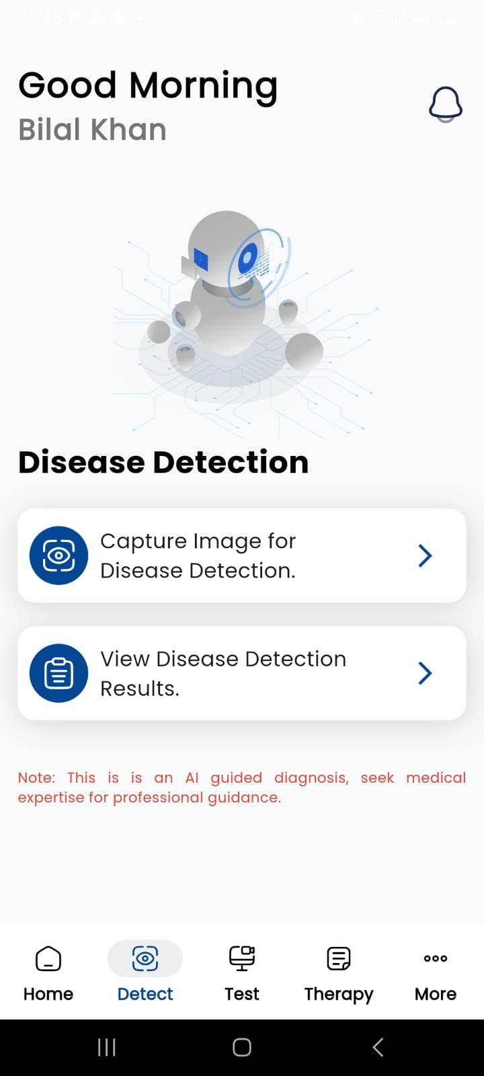

**Figure 33: Disease Detection Screen**

### Upload Image from Gallery Screen

The upload image from gallery screen in OculaCare allows users to easily select and upload photos from their device’s gallery for disease detection. This feature ensures users can conveniently use existing images for analysis, making the app more flexible and user-friendly. It streamlines the process of accessing the app's diagnostic tools, enhancing the overall user experience.

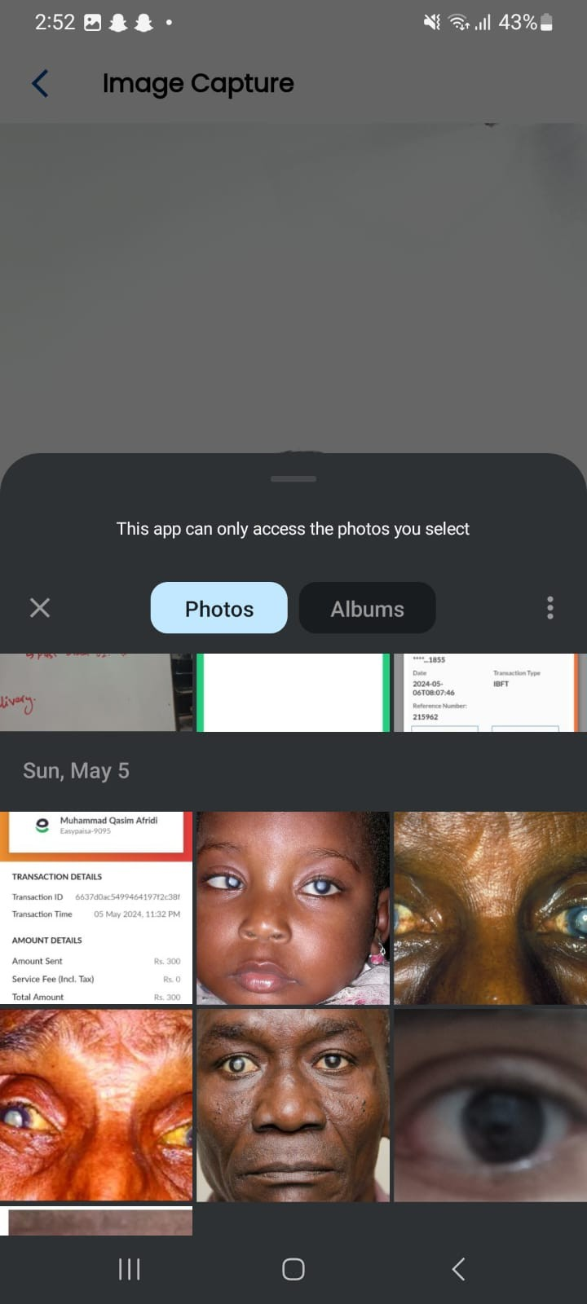

**Figure 34: Upload Image from Gallery**

### Image Capture Screen

The image capture screen in OculaCare guides users to position their eyes within the camera frame for accurate disease detection. The capture button remains disabled until the eyes are properly aligned, ensuring high-quality images for reliable analysis. This feature enhances user experience by providing clear instructions and preventing incorrect image submissions.

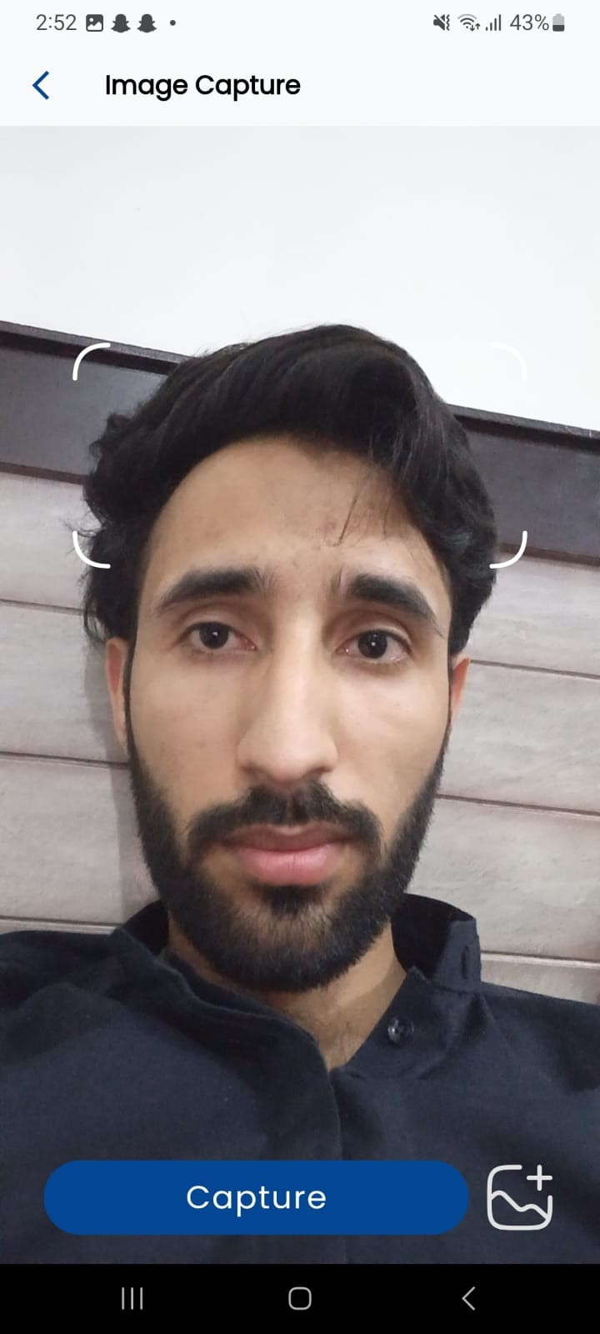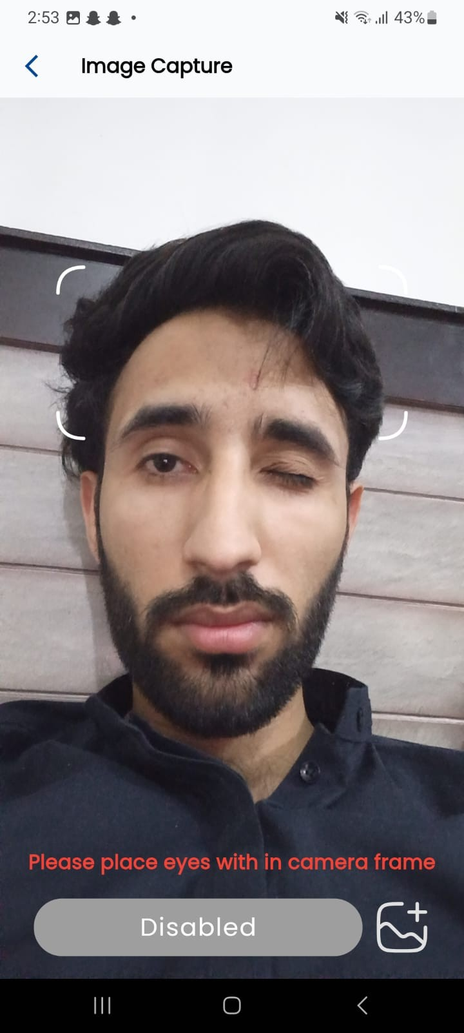

**Figure 35: Image Capture Screen**

### More Screen

The more screen in OculaCare provides users with additional features and settings, including managing their account, viewing the address book, exploring, and bookmarking eye hospitals, and accessing detection results. It also includes sections for FAQs and feedback, ensuring users can find comprehensive support and customize their experience within the app.

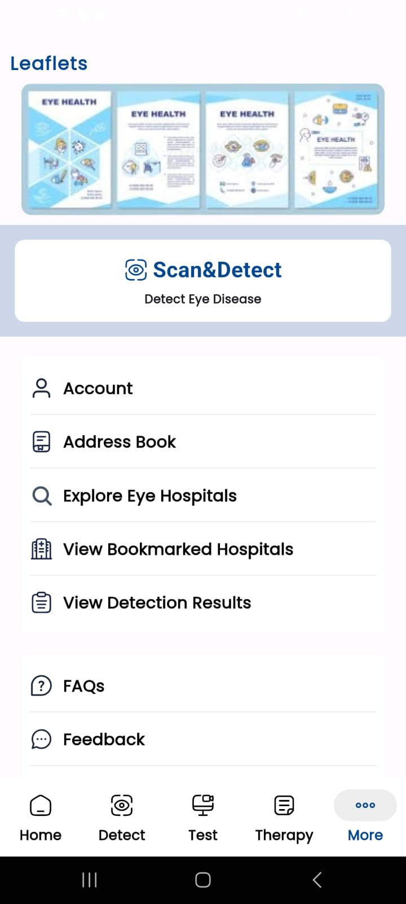

**Figure 36: More Screen**

### Profile Screen

The profile screen in OculaCare allows users to personalize their profiles by adding their gender, address, contact number, and age. This feature helps tailor the app experience to individual users, ensuring that the provided health insights and recommendations are relevant and accurate.

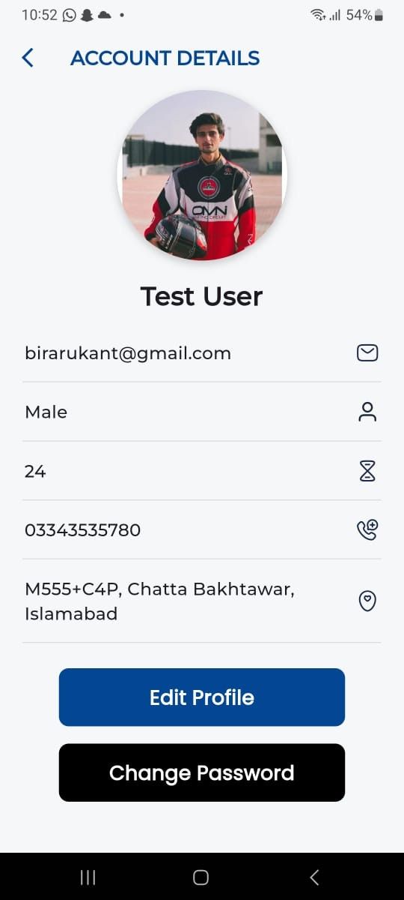

**Figure 37: Profile Screen**

### Add Address Screen

The add address screen in OculaCare enables users to select and save their address using an integrated map. This feature ensures that users can accurately provide their location, which is essential for services such as locating nearby hospitals and receiving personalized health recommendations based on their geographical area.

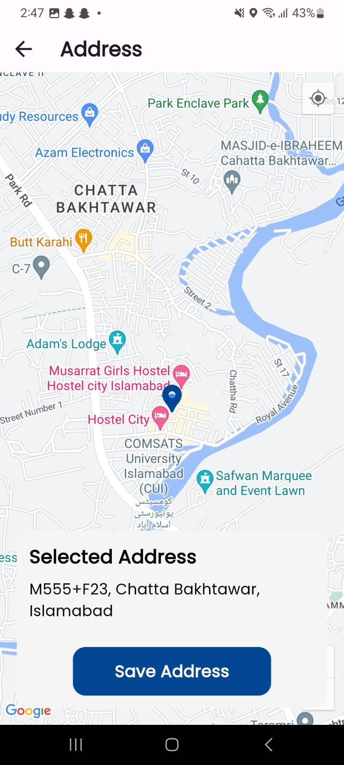

**Figure 38: Add Address Screen**

### Therapy Screen

The Therapy Dashboard provides access to recommended therapies and general eye exercises. Users can switch between **Therapies**, **History**, and **Progression** tabs, while a **Scheduled** button allows them to manage upcoming sessions. Therapies like **Cataracts** and **Bulgy Eyes** are displayed with engaging visuals, while exercises like **Mind-Chest Breathing** help users relieve stress.

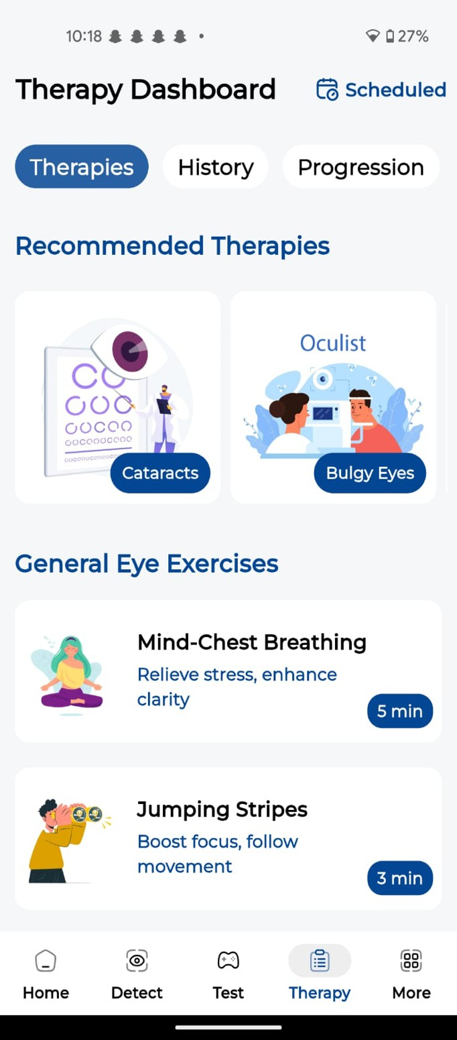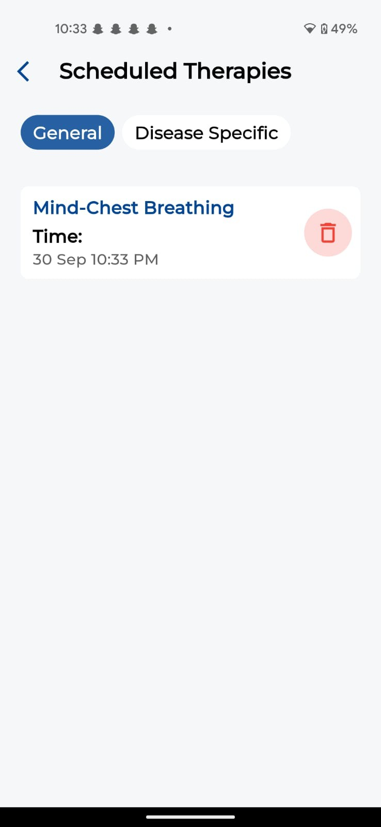

**Figure 39: Therapy Screens**

### Test Screens

The Test Dashboard allows users to take eye tests under categories like **Vision Acuity** and **Color Perception**. Tabs for **Tests**, **History**, and **Progression** help track progress, while tests like **Snellen Chart** and **Ishihara Plates** assess vision and color perception. The **Scheduled** button helps manage test appointments.

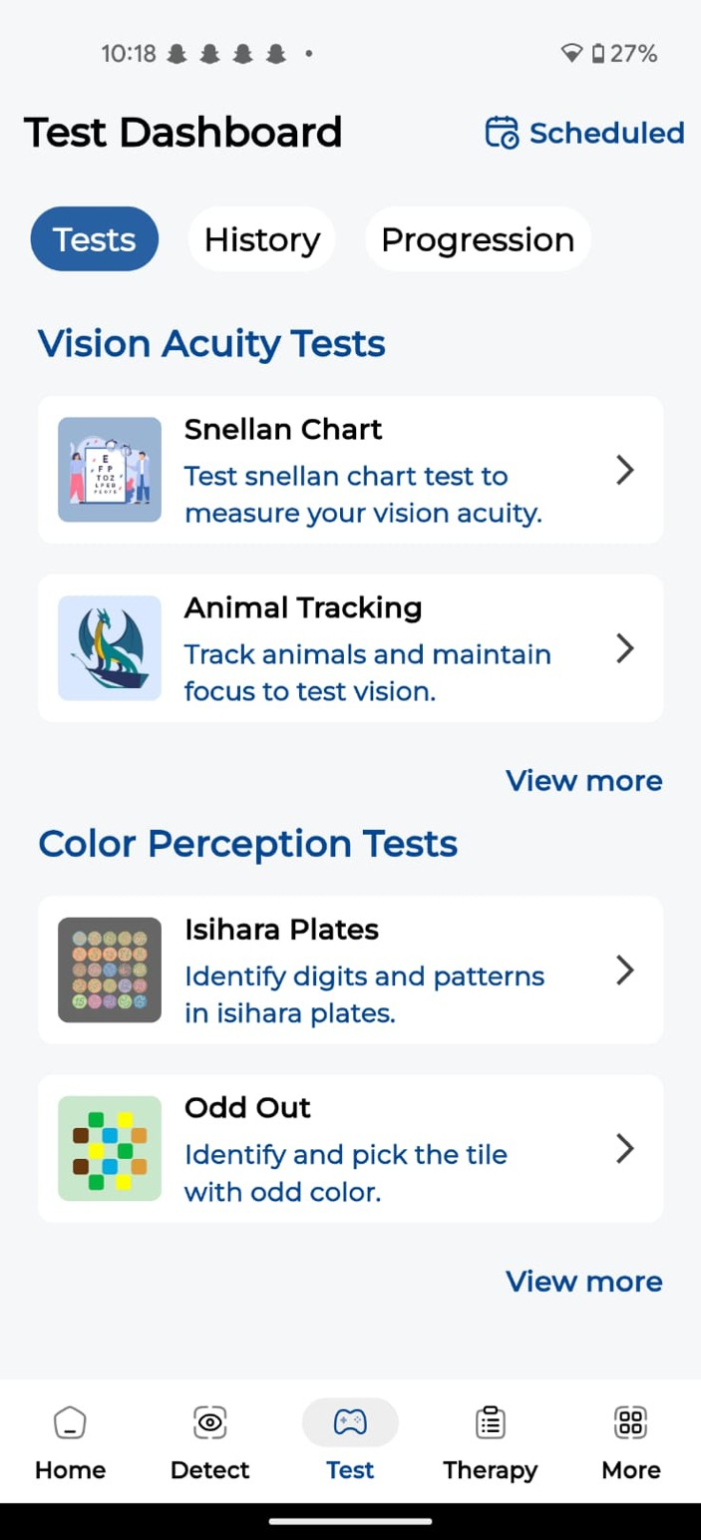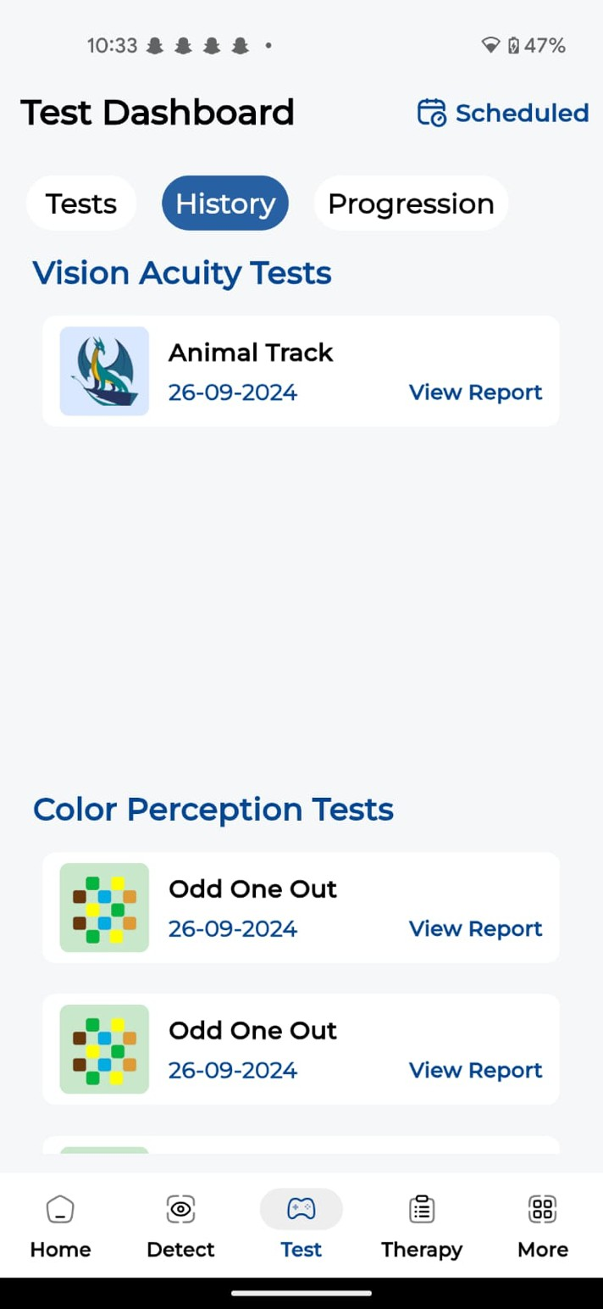

**Figure 40: Test Screens**

### Dashboard Page

The admin web application Dashboard Screen provides insight into user sessions and activities in the OculaCare aplication.

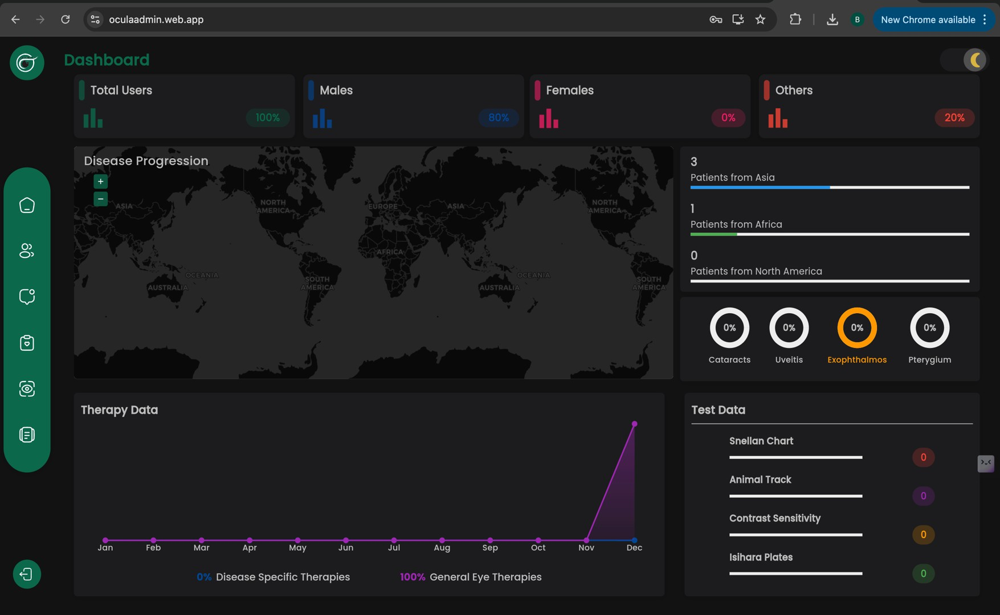

**Figure 41: Dashbaord Page**

### Patients Page

The patients page allows admin to view and manage patients registered in the application, it provides data visualizations in the form of graphs and also allow admin to filter records based on specific parameters and export data in multiple formats including CSV, pdf and excel.

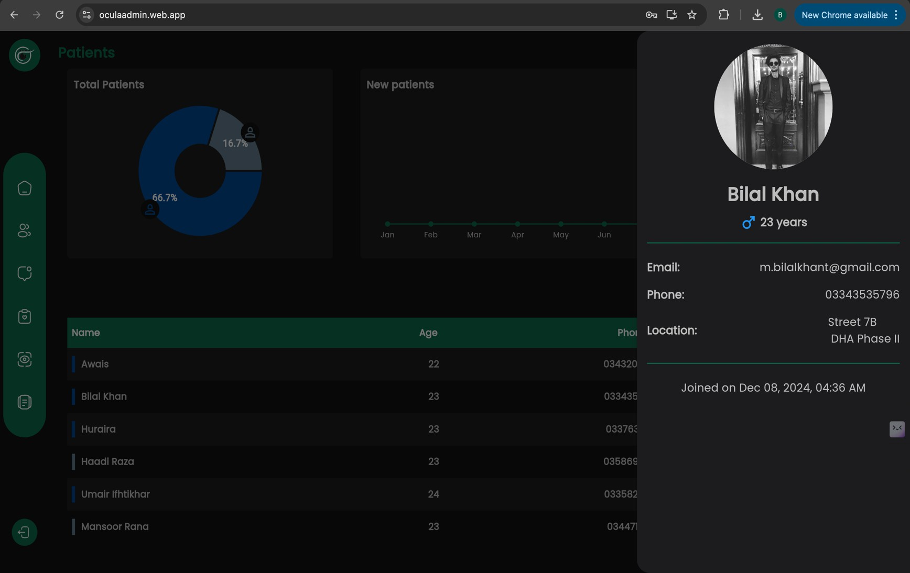

**Figure 42: Patients Page**

### Tests Page

The tests page allows admin to view and manage test performed by patients registered in the application, it provides data visualizations in the form of graphs and also allow admin to filter records based on specific parameters and export data in multiple formats including CSV, pdf and excel.

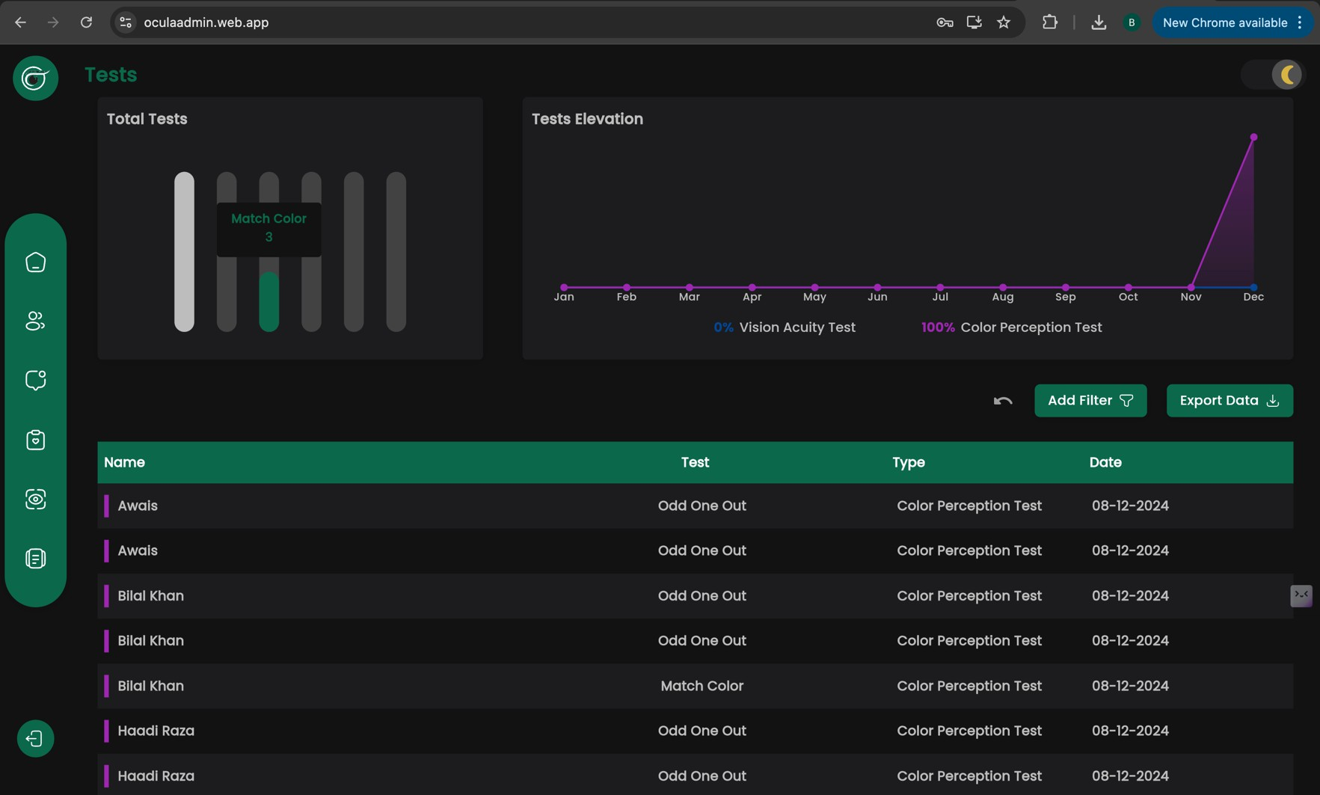

**Figure 43: Tests Page**

## Deployment

This section provides details about the current deployment stage of our application and future plans.

**Current Deployment**

Our application is currently in the staging phase and is running on a vercel server. This setup allows us to efficiently test and iterate on features before deploying to a production environment. The render server provides a controlled environment where we can simulate various scenarios and ensure the stability and functionality of the app.

**Future Deployment Plans**

In the future, we plan to deploy our application using Azure Kubernetes Service (AKS) with Kubernetes. This transition will enable us to leverage the scalability, reliability, and orchestration capabilities of Kubernetes, ensuring that our application can handle increased traffic and provide a seamless user experience. AKS will allow us to automate the deployment, scaling, and management of our containerized applications, providing a robust infrastructure for our production environment.

**Version Control**

Throughout the development process, we have utilized Git for version control. Git has facilitated efficient collaboration among our development team, enabling us to manage code changes, track progress, and maintain a history of all modifications. By using Git, we ensure that our codebase remains organized, and we can easily revert to previous versions if necessary.

# Testing and Evaluation

Following are the testing and evaluation of the system.

## Unit Testing

It is a level of software testing where individual units of a software/component are tested. The purpose is to validate that each unit of the software performs as designed.

**Module 01:**

### Unit Testing 1: User Registration and Account Management

**Testing Objective:** To ensure the user profile functionalities are working perfectly fine.

**Table 8: Unit Testing Module 01**

|  |  |  |  |  |  |
| --- | --- | --- | --- | --- | --- |
| **No.** | **Test Case** | **Attribute Value** | **Expected Result** | **Actual Result** | **Status** |
| 1. | Signup with valid credentials | username = "Bilal Khan", email = "[m.bilalkhant@gmail.co](mailto:m.bilalkhant@gmail.co) m", password = "MeBilalMe1." | System successfully registers user and sends confirmation toast | System successfully registers user and sends  confirmation toast | Pass |
| 2. | Signup with existing email | username = "Awais Ur Rehman", email = "[awaisjarral37@gmail.co](mailto:awaisjarral37@gmail.co)  m", password = "Test@123" | System shows email already exists error toast | System shows email already exists error toast | Pass |
| 3. | Signup with invalid email format | email = "m.bilalkhant@invalid", password =  "Secure_1234." | System shows invalid email format error | System shows invalid email format error | Pass |
| 4. | Signup with a weak password | username = "Awais Ur Rehman", email = "[awaisjarral37@gmail.co](mailto:awaisjarral37@gmail.co)  m", password = "weak" | System shows weak password error | System shows weak password error | Pass |
| 5. | Signup using Google or Facebook  account | Social login via Google/Facebook | System successfully registers user via  social media | System successfully registers user via  social media | Pass |
| 6. | OTP  verification | email =  "[awaisjarral37@gmail.co](mailto:awaisjarral37@gmail.co) m", | System verifies OTP and | System verifies OTP and | Pass |

|  |  |  |  |  |  |
| --- | --- | --- | --- | --- | --- |
|  | after  registration | OTP = "2467" | completes  registration | completes  registration |  |
| 7. | Resend OTP  for verification | email = "  [awaisjarral37@gmail.co](mailto:awaisjarral37@gmail.co) m " | System resends OTP successfully | System resends OTP  successfully | Pass |
| 8. | Login with valid credentials | email = "[awaisjarral37@gmail.co](mailto:awaisjarral37@gmail.co)  m", password = "Test@123" | System logs in user and redirects to Home Screen | System logs in user and  redirects to Home Screen | Pass |
| 9. | Login with invalid credentials | email = "[invalid@gmail.com](mailto:invalid@gmail.com)", password =  "WrongPassword" | System shows login error message via toast | System shows login error message via  toast | Pass |
| 10. | Password recovery using email  OTP | email = "[m.bilalt@gmail.com](mailto:m.bilalt@gmail.com)" | System sends OTP to the user's email | System sends OTP to the user's email | Pass |
| 11. | Password recovery with  invalid email | email = "[invalidemail@gmail.co](mailto:invalidemail@gmail.co)  m" | System shows email not found  error via toast | System shows email not found  error via toast | Pass |
| 12. | Edit profile  with valid data | name = "Awais Ur Rehman", phoneNumber  = "03445123196" | System updates  profile information | System updates  profile information | Pass |
| 13. | Edit profile with invalid phone  number | phoneNumber = "123345435" | System shows invalid phone number error via  toast | System shows invalid phone number error via  toast | Pass |
| 14. | Submit feedback with valid data | feedbackText = "This is a feedback message." | System successfully submits feedback and shows confirmation message via toast | System successfully submits feedback and shows confirmation  message via toast | Pass |
| 15. | Submit feedback with empty  fields | feedbackText = "" | System shows error for empty feedback via toast | System shows error for empty feedback via  toast | Pass |
| 16. | Logout functionality | isLoggedIn = false | System logs out  user and returns to login screen | System logs out  user and returns to login screen | Pass |

**Module 02:**

### Unit Testing 2: Disease Detection and Classification

**Testing Objective:** To ensure the disease detection functionalities are working perfectly fine.

**Table 9: Unit Test for Module 02**

|  |  |  |  |  |  |
| --- | --- | --- | --- | --- | --- |
| **No.** | **Test Case** | **Attribute Value** | **Expected Result** | **Actual Result** | **Status** |
| 1. | Capture eye image with valid image | image = "XFile Image" | System processes and sends the image | System processes and sends the  image | Pass |
| 2. | Capture eye image with no eye detected in  frame | frame = "noEyeDetected" | System does not capture the image, shows an error | System does not capture the image, shows  an error | Pass |
| 3. | Detect disease  with valid eye image | imageID = "XFile Image" | System detects  and classifies the disease | System detects  and classifies the disease | Pass |
| 4. | Upload image to the server | Image = "XFile" | System shows network error, prompts for retry | System shows network error, prompts for retry | Pass |
| 5. | Fail to upload image due to network issues | Image = "XFile", network = "offline" | System successfully registers user via social media | System successfully registers user via social  media | Pass |
| 6. | Camera button disabled when eye is not in  frame | frame = "noEyeDetected" | Camera button remains disabledcompletes  registration | Camera button remains disabled | Pass |
| 7. | Choose an image from the gallery | Image = "galleryImage.jpg" | System selects and uploads the image  successfully | System selects and uploads the image  successfully | Pass |
| 8. | Enhance image quality after capturing | image = "XFile Image", enhancement = "enabled" | System enhances image quality and confirms enhancement | System enhances image quality  and confirms enhancement | Pass |

|  |  |  |  |  |  |
| --- | --- | --- | --- | --- | --- |
| 9. | Classify  normal eye condition | imageID = "XFile Image" | System classifies the eye as normal | System  classifies the eye as normal | Pass |
| 10. | View detailed disease analysis report | imageID = "XFile Image" | System displays a detailed disease analysis report | System displays a detailed disease  analysis report | Pass |
| 11. | Store disease classification results in patient history | imageID = "XFile Image" | System stores the classification results in the patient’s history | System stores the classification results in the patient’s  history | Pass |

**Module 03:**

### Unit Testing 3: Disease Detection and Classification

**Testing Objective:** To ensure the disease detection functionalities are working perfectly fine.

**Table 10: Unit Test for Module 03**

|  |  |  |  |  |  |
| --- | --- | --- | --- | --- | --- |
| **No.** | **Test Case** | **Attribute Value** | **Expected Result** | **Actual Result** | **Status** |
| 1. | Generate a | diseaseDetected = | System generates | System | Pass |
|  | disease | "Cataract", eyeImageID | and displays a | generates and |  |
|  | detection | = "img1234.jpg" | detailed disease | displays a |  |
|  | report with |  | detection report | detailed disease |  |
|  | valid data |  |  | detection report |  |
| 2. | Fail to | diseaseDetected = null, | System shows an | System shows | Pass |
|  | generate a | eyeImageID = | error message | an error message |  |
|  | report due to | "img1234.jpg" | stating that | stating that |  |
|  | missing |  | disease data is | disease data is |  |
|  | disease data |  | missing | missing |  |
| 3. | Access past | email = | System retrieves | System retrieves | Pass |
|  | disease | "[awaisjarral37@gmail.c](mailto:awaisjarral37@gmail.c) | and displays | and displays |  |
|  | detection | om" | historical disease | historical |  |
|  | reports |  | detection reports | disease |  |
|  |  |  |  | detection reports |  |
| 4. | Fail to | email = | System shows a network error message | System shows a network error message | Pass |
|  | retrieve | “[awaisjarral37@gmail.c](mailto:awaisjarral37@gmail.c) |  |
|  | disease | om”, |  |
|  | report due to | network = "offline" |  |
|  | network |  |  |
|  | issues |  |  |

|  |  |  |  |  |  |
| --- | --- | --- | --- | --- | --- |
| 5. | Receive | diseaseDetected = | System generates | System | Pass |
|  | treatment | "Cataract" | and displays | generates and |  |
|  | recommendat |  | treatment | displays |  |
|  | ions for a |  | recommendations | treatment |  |
|  | diagnosed |  | based on | recommendation |  |
|  | disease |  | diagnosis | s based on |  |
|  |  |  |  | diagnosis |  |
| 6. | Receive | diseaseDetected = | System provides | System provides | Pass |
|  | medicinal | "Cataract"" | medicinal | medicinal |  |
|  | recommendat |  | recommendations | recommendation |  |
|  | ions for a |  | for the diagnosed | s for the |  |
|  | detected |  | disease | diagnosed |  |
|  | disease |  |  | disease |  |
| 7. | View | diseaseDetected = | System displays | System displays | Pass |
|  | prevention | "Cataract" | prevention | prevention |  |
|  | measures for |  | measures related | measures related |  |
|  | the |  | to the detected | to the detected |  |
|  | diagnosed |  | disease | disease |  |
|  | disease |  |  |  |  |

**Module 04:**

### Unit Testing 4: Disease Detection and Classification

**Testing Objective:** To ensure the disease detection functionalities are working perfectly fine.

**Table 11: Unit Tests for Module 04**

|  |  |  |  |  |  |
| --- | --- | --- | --- | --- | --- |
| **No.** | **Test Case** | **Attribute Value** | **Expected Result** | **Actual Result** | **Status** |
| 1. | Engage in general eye therapy with valid  instructions | TherapyType = "General", Instructions = "Voice and Text" | System starts therapy and provides valid instructions | System starts therapy and provides valid instructions | Pass |
| 2. | Engage in disease-  specific therapy | TherapyType = "Disease-specific", Condition = "Cataracts" | System starts therapy session  specific to the selected disease | System starts therapy session  specific to the selected disease | Pass |
| 3. | Receive voice instructions during a therapy  session | TherapyType = "General", Instructions = "Voice" | System provides voice instructions throughout the session | System provides voice instructions throughout the session | Pass |

|  |  |  |  |  |  |
| --- | --- | --- | --- | --- | --- |
| 4. | Receive written instructions during a therapy  session | TherapyType = "General", Instructions = "Text" | System displays written instructions throughout the session | System displays written instructions throughout the session | Pass |
| 5. | Schedule general eye therapy | TherapyType = "General", Date = "2024-09-25" | System schedules the therapy and sets a reminder | System schedules the therapy and sets  a reminder | Pass |
| 6. | Schedule disease- specific therapy | TherapyType = "Disease-specific", Date  = "2024-09-26",  Condition = "Strabismus" | System schedules the therapy specific to the disease and sets a reminder | System schedules the therapy specific to the disease  and sets a reminder | Pass |
| 7. | Receive timely notification for scheduled  therapy | TherapyID = 123, NotificationTime = "2024-09-25 10:00 AM" | System sends notification for scheduled therapy on time | System sends notification for scheduled therapy on time | Pass |
| 8. | Access and manage scheduled therapies | TherapyID = 123, Action = "View" | System displays scheduled therapies with  options to manage | System displays scheduled therapies with  options to manage | Pass |
| 9. | Remove a scheduled therapy | TherapyID = 123, Action = "Remove" | System successfully removes the scheduled  therapy | System successfully removes the scheduled  therapy | Pass |
| 10. | Track progress of general  therapy | TherapyType = "General", Progress = "Completed 3 of 10  sessions" | System updates and displays therapy progress | System updates and displays therapy progress | Pass |
| 11. | Track progress of disease-  specific therapy | TherapyType = "Disease-specific",  Progress = "Completed 2 therapies" | System updates and displays therapy progress | System updates and displays therapy progress | Pass |
| 12. | View therapy progress chart | TherapyType = "General", ProgressData  = [ General, Cataract, Bulgy Eyes] | System displays the therapy progress chart  with accurate data | System displays the therapy progress chart  with accurate data | Pass |

|  |  |  |  |  |  |
| --- | --- | --- | --- | --- | --- |
| 13. | Submit feedback after completing therapy  session | Therapy = Jumping Stripes, Feedback = "Session was helpful" | System successfully submits feedback and displays confirmation | System successfully submits feedback and displays  confirmation | Pass |
| 14. | View therapy history for past completed  sessions | UserID = [awaisjarral37@gmail.co](mailto:awaisjarral37@gmail.co) m, History = [Jumping Stripes, Palming] | System displays past completed therapy sessions | System displays past completed therapy sessions | Pass |

**Module 05:**

### Unit Testing 5: Disease Detection and Classification

**Testing Objective:** To ensure the disease detection functionalities are working perfectly fine.

**Table 12: Unit Test for Module 05**

|  |  |  |  |  |  |
| --- | --- | --- | --- | --- | --- |
| **No.** | **Test Case** | **Attribute Value** | **Expected Result** | **Actual Result** | **Status** |
| 1. | Perform vision test using  Snellen chart | TestType = "Snellen Chart", Distance = "35cm" | System starts vision test and provides clear  guidance for Snellen chart | System starts vision test and provides clear  guidance for Snellen chart | Pass |
| 2. | Perform animal tracking  vision test | TestType = "Animal Tracking", Animal = "Dragon" | System initiates the test and tracks animal on-  screen | System initiates the test and tracks animal on-screen | Pass |
| 3. | Ensure correct phone distance before  starting the test | Distance = "25cm" | System prompts patient to adjust phone to 35cm before proceeding | System prompts patient to adjust phone to 35cm before proceeding | Pass |
| 4. | Confirm correct phone distance and proceed  with test | Distance = "35cm" | System confirms correct distance and proceeds with the test | System confirms correct distance and proceeds with the test | Pass |

|  |  |  |  |  |  |
| --- | --- | --- | --- | --- | --- |
| 5. | Perform color perception test using Ishihara  plates | TestType = "Ishihara Plate", Plate = "Plate 4" | System shows color plates for color vision assessment | System shows color plates for color vision assessment | Pass |
| 6. | Perform color matching test | TestType = "Color Matching", Colors = ["Red", "Blue", "Green"] | System initiates color matching test and provides  feedback on accuracy | System initiates color matching test and provides  feedback on accuracy | Pass |
| 7. | Schedule a vision test | TestType = "Snellen Chart", Date = "2024- 09-30", Time = "10:00  AM" | System schedules the vision test and sets a  reminder | System schedules the vision test and sets a reminder | Pass |
| 8. | Schedule a color perception test | TestType = "Ishihara Plate", Date = "2024-10- 01", Time = "11:00 AM" | System schedules the color perception test and sets a  reminder | System schedules the color perception test and sets a  reminder | Pass |
| 9. | Receive timely notification for a scheduled  vision test | Test = “Snellen Chart”, NotificationTime = "2024-09-30 10:00 AM" | System sends notification for the scheduled test on time | System sends notification for the scheduled test on time | Pass |
| 10. | Remove a scheduled test | Test = “Snellen Chart”, Action = "Remove" | System successfully removes the  scheduled test | System successfully removes the  scheduled test | Pass |
| 11. | View detailed vision test  report | Report = "Snellen Chart Results" | System displays detailed test report with  insights | System displays detailed test report with  insights | Pass |
| 12. | View color perception test results | Test = “Snellen Chart”, Result = "Normal" | System displays the results of the color perception  test | System displays the results of the color perception  test | Pass |
| 13. | Track vision progress over time | VisionData = [Test1, Test2, Test3] | System displays interactive charts showing the patient's vision  progress | System displays interactive charts showing the patient's vision  progress | Pass |

## Functional Testing

Functional testing will take place after the unit testing. In this functional testing, the functionality of each of the modules is tested. This is to ensure that the system produced meets the specifications and requirements.

**Module 01:**

### Functional Testing 1: User Registration and Account Management

**Testing Objective:** To ensure the system functionalities work as expected from the user's perspective.

**Table 13: Functional Testing for Module 01**

|  |  |  |  |  |  |
| --- | --- | --- | --- | --- | --- |
| **No.** | **Test Case/Test Script** | **Steps** | **Expected Result** | **Actual Result** | **Result** |
| 1. | Signup with valid credentials | 1. Open Signup page 2. Enter username "Awais Ur Rehman" 3. Enter email [awaisjarral37@gmail.c](mailto:awaisjarral37@gmail.c) om 4. Enter password "Test_1234" 5. Click Signup | System successfully registers user and sends confirmation email | System successfully registers user and sends confirmation email | Pass |
| 2. | Signup with existing email | 1. Open Signup page 2. Enter username "Awais Ur Rehman" 3. Enter email [awaisjarral37@gmail.c](mailto:awaisjarral37@gmail.c) om 4. Enter password "Test_1234" 5. Click Signup | System shows email already exists error | System shows email already exists error | Pass |
| 3. | Login with valid credentials | 1. Open Login page 2. Enter email [awaisjarral37@gmail.c](mailto:awaisjarral37@gmail.c) om 3. Enter password "Test_1234" 4. Click Login | System logs in user and redirects to dashboard | System logs in user and redirects to dashboard | Pass |
| 4. | Login with invalid credentials | 1. Open Login page | System shows login error message | System shows login error message | Pass |

|  |  |  |  |  |  |
| --- | --- | --- | --- | --- | --- |
|  |  | 1. Enter email [awaisjarral37@gmail.c](mailto:awaisjarral37@gmail.c) om 2. Enter password "Test1234" 3. Click Login |  |  |  |
| 5. | OTP to Email with valid email | 1. Open Forgot Password page 2. Enter email [awaisjarral37@gmail.c](mailto:awaisjarral37@gmail.c) om 3. Click Send OTP | System sends OTP to the user's email | System sends OTP to the user's email | Pass |
| 6. | Feedback submission with valid data | 1. Open Feedback page 2. Enter feedback text "This is a feedback message." 3. Click Submit | System successfully submits feedback and shows confirmation message | System successfully submits feedback and shows  confirmation message | Pass |
| 7. | Edit profile with valid data | 1. Open Edit Profile page 2. Enter name "Bilal Khan" 3. Enter phone number "+92 334 3535796" 4. Click Save | System updates profile information | System updates profile information | Pass |

**Module 02:**

### Functional Testing 2: Disease Detection and Classification

**Testing Objective:** To ensure the system functionalities work as expected from the user's perspective.

**Table 14: Fictional Testing for Module 02**

|  |  |  |  |  |  |
| --- | --- | --- | --- | --- | --- |
| **No.** | **Test Case** | **Steps** | **Expected Result** | **Actual Results** | **Result** |
| 1. | Capture eye image with valid image | 1. Open Capture Image page 2. Position eye in frame 3. Click Capture button | System processes and stores image | System processes and stores image | Pass |

|  |  |  |  |  |  |
| --- | --- | --- | --- | --- | --- |
| 2. | Detect disease with valid eye image | 1. Open Disease Detection page. 2. Select image "XFile Image" 3. Click Detect | System detects and classifies disease | System detects and classifies disease | Pass |
| 3. | Upload image to the server | 1. Open Upload Image page 2. Select image "XFile Image" 3. Click Upload | System uploads image successfully, notification appears | System uploads image successfully, notification appears | Pass |
| 4. | Camera button remains disabled when eye is not present in frame | 1. Open Capture Image page 2. Ensure no eye is in frame 3. Observe Camera   button | Camera button is disabled | Camera button is disabled | Pass |
| 5. | Choose image from gallery | 1. Open Gallery 2. Select image "galleryImage.jpg" 3. Click Upload | System selects the image and uploads it successfully | System selects the image and uploads it successfully | Pass |

**Module 03:**

### Functional Testing 3: User Registration and Account Management

**Testing Objective:** To ensure the system functionalities work as expected from the user's perspective.

**Table 15: Functional Testing for Module 03**

|  |  |  |  |  |  |
| --- | --- | --- | --- | --- | --- |
| **No.** | **Test Case** | **Steps** | **Expected Result** | **Actual Result** | **Status** |
| 1. | Receive | 1. Complete disease | The system | The system | Pass |
|  | comprehensive | detection test | displays a | displays a |  |
|  | disease detection | 2. Open Disease | comprehensive | comprehensive |  |
|  | report | Report page | report with | report with |  |
|  |  |  | detailed analysis | detailed analysis |  |
|  |  |  | of the diagnosed | of the diagnosed |  |
|  |  |  | eye condition | eye condition |  |

|  |  |  |  |  |  |
| --- | --- | --- | --- | --- | --- |
| 2. | Access potential | 1. Open Disease | The system | Causes of the | Pass |
|  | causes of detected | Report page | displays detailed | detected disease |  |
|  | disease | 2. View detected | information | are displayed |  |
|  |  | disease causes | about potential | successfully |  |
|  |  |  | causes of the |  |  |
|  |  |  | detected disease |  |  |
| 3. | Access prevention | 1. Open Disease | The system | The system | Pass |
|  | measures for | Report page | provides | provides |  |
|  | diagnosed disease | 2. View prevention | prevention | prevention |  |
|  |  | measures for detected | measures and tips | measures and tips |  |
|  |  | disease | related to the | related to the |  |
|  |  |  | diagnosed | diagnosed |  |
|  |  |  | condition | condition |  |
| 4. | Receive customized | 1. Open Disease | Customized | Customized | Pass |
|  | treatment | Report page | treatment | treatment |  |
|  | recommendations | 2. View treatment | recommendations | recommendations |  |
|  |  | recommendations | based on the | are successfully |  |
|  |  |  | diagnosed | displayed |  |
|  |  |  | condition are |  |  |
|  |  |  | provided |  |  |
| 5. | Receive medicinal | 1. Open Disease | Medicinal | Medicinal | Pass |
|  | recommendations | Report page | recommendations | recommendations |  |
|  | based on diagnosis | 2. View medicinal | are provided | are provided |  |
|  |  | recommendations | based on the | based on the |  |
|  |  |  | diagnosis | diagnosis |  |
| 6. | Access and review | 1. Open Disease | The system | The system | Pass |
|  | past disease reports | History page | displays a list of | displays a list of |  |
|  |  | 2. View list of past | past disease | past disease |  |
|  |  | reports | reports with | reports with |  |
|  |  |  | diagnosis and | diagnosis and |  |
|  |  |  | analysis | analysis |  |
| 7. | Review past | 1. Open Disease | The system | The system | Pass |
|  | treatment history | History page | shows detailed | shows detailed |  |
|  |  | 2. Select a past | treatment history | treatment history |  |
|  |  | treatment record | for the selected | for the selected |  |
|  |  |  | report | report |  |

**Module 04:**

### Functional Testing 4: User Registration and Account Management

**Testing Objective:** To ensure the system functionalities work as expected from the user's perspective.

**Table 16: Functional Testing for Module 04**

|  |  |  |  |  |  |
| --- | --- | --- | --- | --- | --- |
| **No.** | **Test Case** | **Steps** | **Expected Result** | **Actual Result** | **Status** |
| 1. | Engage in general eye therapy with valid instructions | 1. Open Therapy page 2. Start therapy with instructions | Therapy starts with correct instructions | Therapy starts with correct instructions | Pass |
| 2. | Engage in disease- specific therapy session | 1. Open Therapy page 2. Start disease- specific therapy | Therapy starts with correct disease-specific  instructions | Therapy starts with correct disease-specific  instructions | Pass |
| 3. | Schedule general eye therapy | 1. Open Therapy dashboard. 2. Select a general eye therapy   2. Schedule a general eye therapy | Therapy is scheduled successfully | Therapy is scheduled successfully | Pass |
| 4. | Receive timely notification for scheduled therapy | 1. Schedule a therapy 2. Wait for notification | System sends notification on time | System sends notification on time | Pass |
| 5. | Track progress of general therapy | 1. Open Progress page 2. View progress   chart | System shows accurate progress data | System shows accurate progress data | Pass |

**Module 05:**

### Functional Testing 5: User Registration and Account Management

**Testing Objective:** To ensure the system functionalities work as expected from the user's perspective.

**Table 17: Functional Testing for Module 05**

|  |  |  |  |  |  |
| --- | --- | --- | --- | --- | --- |
| **No.** | **Test Case** | **Steps** | **Expected Result** | **Actual Result** | **Status** |
| 1. | Perform Snellen chart test with valid phone distance | 1. Open Snellen Chart Test page 2. Position phone at 35 cm from eyes 3. Perform test by reading characters | Test proceeds with valid phone distance, and the results are stored | Test proceeds with valid phone distance, and the results are stored | Pass |
| 2. | Attempt Snellen chart test with invalid phone distance | 1. Open Snellen Chart Test page 2. Position phone at less than 35 cm 3. Attempt to perform the test | System prompts user to adjust phone distance to 35 cm | System prompts user to adjust phone distance to 35 cm | Pass |
| 3. | Perform animal tracking test | 1. Open Animal Tracking Test page 2. Follow on-screen instructions to track   moving animal | Test completes successfully, and results are stored | Test completes successfully, and results are stored | Pass |
| 4. | Perform contrast sensitivity test | 1. Open Contrast Sensitivity Test page 2. Follow test instructions | Test completes  successfully, and results are stored | Test completes  successfully, and results are stored | Pass |
| 5. | Perform color perception test (Ishihara plates) | 1. Open Color Perception Test page 2. Select Ishihara Plates test 3. Follow test instructions | Test completes successfully, and results are stored | Test completes successfully, and results are stored | Pass |
| 6. | Perform color matching test | 1. Open Color Perception Test page 2. Select Color Matching test 3. Follow test instructions | Test completes successfully, and results are stored | Test completes successfully, and results are stored | Pass |
| 7. | Perform "Odd One Out" color perception test | 1. Open Color Perception Test page 2. Select "Odd One Out" test 3. Follow test instructions | Test completes successfully, and results are stored | Test completes successfully, and results are stored | Pass |

|  |  |  |  |  |  |
| --- | --- | --- | --- | --- | --- |
| 8. | Schedule a vision test | 1. Open Test Dashboard 2. Choose a vision test to schedule 3. Select date and time 4. Click "Schedule" | Test is successfully scheduled, and confirmation is shown | Test is successfully scheduled, and  confirmation is shown | Pass |
| 9. | View scheduled vision tests | 1. Open Scheduled Tests page 2. View the list of upcoming tests | Scheduled tests are displayed with correct details | Scheduled tests are displayed with correct  details | Pass |
| 10. | Remove a scheduled test | 1. Open Scheduled Tests page 2. Select a test to remove 3. Slide to "Remove" | Scheduled test is successfully removed | Scheduled test is successfully removed | Pass |
| 11. | Receive notification for a scheduled vision test | 1. Schedule a vision test 2. Wait for the scheduled time | System sends a notification for the upcoming test at the correct time | System sends a notification for the upcoming test at the correct  time | Pass |
| 12. | View test results and analysis | 1. Complete a vision test 2. Open Test History page 3. View the test result | Test results and analysis are displayed  accurately | Test results and analysis are displayed  accurately | Pass |

## Business Rules Testing

**Module 01:**

### Business Rule Testing 1:

The system must verify the authenticity of the email provided during registration through an OTP to ensure account security.

**Table 18: Business Rule Testing M1-1**

|  |  |  |  |  |
| --- | --- | --- | --- | --- |
| **Conditions** | **Rule 1** | **Rule 2** | **Rule 3** | **Rule 4** |
| Valid Email? | Yes | No | Yes | No |
| OTP Sent? | Yes | No | No | Yes |
| OTP Verified? | Yes | Yes | No | No |
| Actions |  |  |  |  |
| Create Account | Yes | No | No | No |
| Show 'Invalid Email' Error | No | Yes | No | Yes |
| Show 'OTP Verification Failed' Error | No | No | Yes | No |

### Business Rule Testing 2:

Patients must authenticate using their registered credentials to ensure the security of their account and the integrity of their health data.

**Table 19: Business Rule Testing M1-2**

|  |  |  |
| --- | --- | --- |
| **Conditions** | **Rule 1** | **Rule 2** |
| Valid Credentials? | Yes | No |
| Authentication Method? | password | Social media |
| Actions |  |  |
| Allow Access | Yes | No |
| Show 'Invalid Credentials' | No | Yes |

### Business Rule Testing 3:

The system must verify the identity of the patient through an OTP before allowing a password reset to ensure account security.

**Table 20: Business Rule Testing M1-3**

|  |  |  |  |  |
| --- | --- | --- | --- | --- |
| **Conditions** | **Rule 1** | **Rule 2** | **Rule 3** | **Rule 4** |
| Valid Email? | Yes | Yes | No | No |
| OTP Sent? | Yes | No | Yes | No |

|  |  |  |  |  |
| --- | --- | --- | --- | --- |
| OTP Verified? | Yes | No | Yes | No |
| Actions |  |  |  |  |
| Allow Password Reset | Yes | No | No | No |
| Show 'OTP Verification Failed' | No | Yes | Yes | No |
| Show 'Invalid Email' | No | No | Yes | Yes |

### Business Rule Testing 4:

Passwords must adhere to established complexity standards*.*

**Table 21: Business Rule Testing M1-4**

|  |  |  |  |  |
| --- | --- | --- | --- | --- |
| **Conditions** | **Rule 1** | **Rule 2** | **Rule 3** | **Rule 4** |
| Password Length Valid? | Yes | No | Yes | No |
| Contains Special Characters? | Yes | Yes | No | Yes |
| Contains Numbers? | Yes | Yes | No | No |
| Actions |  |  |  |  |
| Allow Password Change | Yes | No | No | No |
| Show 'Password Too Short' | No | Yes | No | No |
| Show 'Invalid Password Format' | No | No | Yes | Yes |

**Module 02:**

### Business Rule Testing 1:

The application must provide real-time feedback and instructions for improvement.

**Table 22: Business Rule Testing M2-1**

|  |  |  |  |  |
| --- | --- | --- | --- | --- |
| **Conditions** | **Rule 1** | **Rule 2** | **Rule 3** | **Rule 4** |
| Eye Detected? | Yes | Yes | No | No |
| Visual Feedback Active? | Yes | No | Yes | No |
| **Actions** |  |  |  |  |
| Provide Feedback | Yes | Yes | Yes | Yes |
| Show 'Eye Not Detected' | No | No | Yes | Yes |

### Business Rule Testing 2:

All instructions must be clear and easily understandable.

**Table 23: Business Rule Testing M2-2**

|  |  |  |  |
| --- | --- | --- | --- |
| **Conditions** | **Rule 1** | **Rule 2** | **Rule 3** |
| Instructions Available? | Yes | Yes | No |
| Instructions Understandable? | Yes | No | No |
| **Actions** |  |  |  |
| Capture Button Available | Yes | Yes | No |
| High Quality Image Captured | Yes | No | No |

### Business Rule Testing 3:

The shutter should be enabled only when the ML kit confirms correct eye detection.

**Table 24: Business Rule Testing M2-3**

|  |  |  |  |
| --- | --- | --- | --- |
| **Conditions** | **Rule 1** | **Rule 2** | **Rule 3** |
| Camera Permissions Granted? | Yes | Yes | No |
| Eyes Detected? | Yes | No | No |
| **Actions** |  |  |  |
| Shutter Enabled | Yes | No | No |
| Show 'Eye Not Detected' | No | Yes | No |

### Business Rule Testing 4:

Results shall be communicated to the patient promptly after classification*.*

**Table 25: Business Rule Testing M2-4**

|  |  |  |  |
| --- | --- | --- | --- |
| **Conditions** | **Rule 1** | **Rule 2** | **Rule 3** |
| Image Submitted Successfully? | Yes | Yes | No |
| Eye Disease Detected? | Yes | No | No |
| **Actions** |  |  |  |
| Show 'Results Available' Message | Yes | Yes | No |
| Show Classification Results | Yes | Yes | No |
| Show Disease Detected | Yes | No | No |

**Module 03:**

### Business Rule Testing 1:

All disease analysis reports must be accessible to the patient in a readable and understandable format.

**Table 26: Business Rule Testing M3-1**

|  |  |  |  |  |
| --- | --- | --- | --- | --- |
| **Conditions** | **Rule 1** | **Rule 2** | **Rule 3** | **Rule 4** |
| Report Available? | Yes | Yes | No | Yes |
| Report Format is Understandable? | Yes | No | Yes | No |
| Language is Understandable? | Yes | Yes | Yes | No |
| Actions |  |  |  |  |
| Show Report | Yes | No | No | No |
| Show 'Report Not Available' Error | No | No | Yes | No |
| Show 'Format Unreadable' Error | No | Yes | No | Yes |

### Business Rule Testing 2:

Preventive care information must be easily accessible post-diagnosis.

**Table 27: Business Rule Testing M3-2**

|  |  |  |  |  |
| --- | --- | --- | --- | --- |
| **Conditions** | **Rule 1** | **Rule 2** | **Rule 3** | **Rule 4** |
| Diagnosis Available? | Yes | No | Yes | No |
| Preventive Care Info Available? | Yes | Yes | No | Yes |
| Preventive Care Info is Accessible? | Yes | No | Yes | No |
| Actions |  |  |  |  |
| Show Preventive Care Information | Yes | No | No | No |
| Show 'No Diagnosis Available' Error | No | Yes | No | Yes |
| Show 'Preventive Info Not Accessible' | No | No | Yes | Yes |

### Business Rule Testing 3:

The system must present the historical data in a user-friendly manner.

**Table 28: Business Rule Testing M3-3**

|  |  |  |  |  |
| --- | --- | --- | --- | --- |
| **Conditions** | **Rule 1** | **Rule 2** | **Rule 3** | **Rule 4** |
| Historical Data Available? | Yes | Yes | No | Yes |
| Historical Data Format is User-Friendly? | Yes | No | Yes | No |
| Data Visualization Available (Charts)? | Yes | Yes | No | No |
| Actions |  |  |  |  |
| Show Historical Data | Yes | No | No | No |
| Show 'Data Format Not Friendly' Error | No | Yes | No | Yes |
| Show 'Data Not Available' Error | No | No | Yes | No |

**Module 04:**

### Business Rule Testing 1:

Instructions for therapies must be clear and easy to follow.

**Table 29: Business Rule Testing M4-1**

|  |  |  |  |
| --- | --- | --- | --- |
| **Conditions** | **Rule 1** | **Rule 2** | **Rule 3** |
| Instructions Provided? | Yes | Yes | No |
| Instructions Clear? | Yes | No | No |
| **Actions** |  |  |  |
| Proceed with Therapy | Yes | Yes | No |
| Instructions Displayed? | Yes | Yes | No |

### Business Rule Testing 2:

All therapy session data must be accurately recorded for effective progress assessment and feedback.

**Table 30: Business Rule Testing M4-2**

|  |  |  |  |
| --- | --- | --- | --- |
| **Conditions** | **Rule 1** | **Rule 2** | **Rule 3** |
| Therapy Data Recorded? | Yes | Yes | No |
| Progress Assessed Based on Data? | Yes | No | No |
| **Actions** |  |  |  |
| Show 'Recording Failed' Error | No | No | No |
| Update Therapies Progress | Yes | No | No |

### Business Rule Testing 3:

Reminders for sessions must be configured to alert the patient adequately.

**Table 31: Business Rule Testing M4-3**

|  |  |  |  |  |
| --- | --- | --- | --- | --- |
| **Conditions** | **Rule 1** | **Rule 2** | **Rule 3** | **Rule 4** |
| Reminder Configured by Patient? | Yes | Yes | Yes | No |
| Alert Sent on Time? | Yes | Yes | No | No |
| Patient Acknowledged Reminder? | Yes | No | No | No |
| **Actions** |  |  |  |  |
| Notification Received | Yes | Yes | No | No |
| Proceed with Session | Yes | No | No | No |

### Business Rule Testing 4:

All reminders must be sent in accordance with the patient's selected preferences.

**Table 32: Business Rule Testing M4-4**

|  |  |  |  |
| --- | --- | --- | --- |
| **Conditions** | **Rule 1** | **Rule 2** | **Rule 3** |
| Reminder Sent According to Preferences? | Yes | Yes | No |
| Patient Responded to Reminder? | Yes | No | No |
| **Actions** |  |  |  |
| Notification Received | Yes | Yes | No |
| Proceed with Session | Yes | No | No |

**Module 05:**

### Business Rule Testing 1:

Vision Acuity tests must be conducted with the correct distance between the patient’s eyes and the phone for accurate results.

**Table 33: Business Rule Testing M5-1**

|  |  |  |  |  |
| --- | --- | --- | --- | --- |
| **Conditions** | **Rule 1** | **Rule 2** | **Rule 3** | **Rule 4** |
| Correct Distance? | Yes | No | No | Yes |
| Distance Calibration Successful? | Yes | Yes | No | No |
| Eye Alignment Proper? | Yes | No | Yes | Yes |
| Actions |  |  |  |  |
| Proceed with Test | Yes | No | No | Yes |
| Show 'Distance Too Close/Far' Error | No | Yes | Yes | No |
| Show 'Alignment Issue' Error | No | Yes | No | No |

### Business Rule Testing 2:

The system must process and display assessment results promptly.

**Table 34: Business Rule Testing M5-2**

|  |  |  |  |
| --- | --- | --- | --- |
| **Conditions** | **Rule 1** | **Rule 2** | **Rule 3** |
| Test Process Completed? | Yes | Yes | No |
| Data Analyzed? | Yes | No | Yes |
| Actions |  |  |  |
| Show Test Results | Yes | No | Yes |
| Show 'Analysis Error' | No | Yes | Yes |

### Business Rule Testing 3:

The report must include all relevant and requested vision test data while ensuring it’s presented in an easily interpretable format.

**Table 35: Business Rule Testing M5-3**

|  |  |  |  |  |
| --- | --- | --- | --- | --- |
| **Conditions** | **Rule 1** | **Rule 2** | **Rule 3** | **Rule 4** |
| Complete Data Included? | Yes | Yes | No | Yes |
| Data Format is Understandable? | Yes | No | Yes | No |
| Requested Data Included? | Yes | Yes | No | No |
| Actions |  |  |  |  |
| Show Report | Yes | No | No | Yes |
| Show 'Missing Data' Error | No | Yes | Yes | No |
| Show 'Unreadable Format' Error | No | Yes | No | Yes |

## Integration Testing

Integration testing is used to test the interface between different modules. It ensures that the data is correctly passed from one module to another.

* + 1. **Module 1: Integration Test M1 Integration Test 1:** Signup to Login Integration

**Testing Objective:** To ensure that the system correctly redirects to the login screen after successful signup.

**Table 36: Integration Test M1-1**

|  |  |  |  |  |  |
| --- | --- | --- | --- | --- | --- |
| **No.** | **Test Case** | **Attribute Value** | **Expected Result** | **Actual Result** | **Status** |
| 1. | Signup and Redirect | Signup details: | Successfully | User registered | Pass |
|  | to Login Screen | username = "Awais", | register user and | and redirected |  |
|  |  | email = | redirect to login | to login |  |
|  |  | "[awais@gmail.com](mailto:awais@gmail.com)", | screen |  |  |
|  |  | password = |  |  |  |
|  |  | "Test_1234" |  |  |  |

**Integration Test 2:** Signup to OTP Verification Integration

**Testing Objective:** To ensure that after successful signup, the system redirects to the OTP verification screen.

**Table 37: Integration Test M1-2**

|  |  |  |  |  |  |
| --- | --- | --- | --- | --- | --- |
| **No.** | **Test Case** | **Attribute Value** | **Expected**  **Result** | **Actual**  **Result** | **Status** |
| 2. | Signup and | Signup details: | Successfully | User | Pass |
|  | Redirect to OTP | username = "Awais", | register user and | registered and |  |
|  | Screen | email = | redirect to OTP | redirected to |  |
|  |  | "[awais@gmail.com](mailto:awais@gmail.com)", | verification | login |  |
|  |  | password = |  |  |  |
|  |  | "Test_1234" |  |  |  |

**Integration Test 3:** Login to Dashboard Integration

**Testing Objective:** To ensure that after login, the system correctly redirects the user to the dashboard.

**Table 38: Integration Test M1-3**

|  |  |  |  |  |  |
| --- | --- | --- | --- | --- | --- |
| **No.** | **Test Case** | **Attribute Value** | **Expected Result** | **Actual Result** | **Status** |
| 3. | Login and Redirect | Login details: email | Successfully log | User logged | Pass |
|  | to Dashboard | = | in user and | in and |  |
|  |  | "[awais@gmail.com](mailto:awais@gmail.com)", | redirect to | redirected to |  |
|  |  | password = | dashboard | dashboard |  |
|  |  | "Test_1234" |  |  |  |

**Integration Test 4:** Password Recovery Integration

**Testing Objective:** To ensure that after successful password recovery via email, the user is redirected to the login screen.

**Table 39: Integration Test M1-4**

|  |  |  |  |  |  |
| --- | --- | --- | --- | --- | --- |
| **No.** | **Test Case** | **Attribute Value** | **Expected Result** | **Actual Result** | **Status** |
| 4. | Password | Email = | Successfully | Password | Pass |
|  | Recovery to Login | "[awais@gmail.com](mailto:awais@gmail.com)", | recover | recovered; |  |
|  | Screen | OTP = "123456", | password and | user redirected |  |
|  |  | New password = | redirect to login | to login |  |
|  |  | "Test_1234" | screen |  |  |

**Integration Test 5:** Edit Profile to Dashboard Integration

**Testing Objective:** To ensure that after updating profile details, the system redirects the user back to the dashboard with updated information.

**Table 40: Integration Test M1-5**

|  |  |  |  |  |  |
| --- | --- | --- | --- | --- | --- |
| **No.** | **Test Case** | **Attribute Value** | **Expected Result** | **Actual Result** | **Status** |
| 5. | Edit Profile and | Updated details: | Successfully | Profile | Pass |
|  | Redirect to | name = "Bilal | update profile | updated, |  |
|  | Dashboard | Khan", phone | and redirect to | redirected to |  |
|  |  | number = "+92 | dashboard | dashboard |  |
|  |  | 344 5123196" |  |  |  |

**Integration Testing 6:** Feedback Screen to Success Screen

**Testing Objective:** To ensure the feedback screen correctly transitions to a success or failure screen upon submission.

**Table 41: Integration Test M1-6**

|  |  |  |  |  |  |
| --- | --- | --- | --- | --- | --- |
| **No.** | **Test cases** | **Attribute and value** | **Expected result** | **Actual result** | **Status** |
| 1 | Submit Feedback and Redirect to Success Screen | Feedback: feedbackText = "This is feedback" | Successfully submit feedback and redirect to  success screen | Feedback submitted, redirected to  success screen | Pass |
| 2 | Submit Feedback and Handle  Submission Error | Feedback: feedbackText = "This  is feedback" | System shows error message. | Error message shown, stays on  feedback screen | Pass |

### Module 2: Integration Test M2

**Integration Test 1:** Capture Eye Image to Disease Detection

**Testing Objective:** To ensure that after capturing an eye image, the system correctly proceeds with disease detection.

**Table 42: Integration Test M2-1**

|  |  |  |  |  |  |
| --- | --- | --- | --- | --- | --- |
| **No.** | **Test Case** | **Attribute Value** | **Expected Result** | **Actual Result** | **Status** |
| 1. | Capture Eye | image = "XFile | Successfully | Image captured; | Pass |
|  | Image and | Image" | capture image | system starts |  |
|  | Proceed to |  | and proceed with | disease detection |  |
|  | Disease |  | disease detection |  |  |
|  | Detection |  |  |  |  |

**Integration Test 2:** Upload Eye Image to Server

**Testing Objective:** To ensure that after uploading the eye image to the server, the system proceeds with disease detection.

**Table 43: Integration Test M2-2**

|  |  |  |  |  |  |
| --- | --- | --- | --- | --- | --- |
| **No.** | **Test Case** | **Attribute Value** | **Expected Result** | **Actual Result** | **Status** |
| 2. | Upload Eye | image = "XFile | Successfully | Image uploaded; | Pass |
|  | Image and | Image" | upload image | system starts |  |
|  | Proceed to |  | and proceed with | disease detection |  |
|  | Disease |  | disease detection |  |  |
|  | Detection |  |  |  |  |

**Integration Test 3:** Camera Eye Detection to Capture Eye Image

**Testing Objective:** To ensure that once the system detects an eye in the camera stream, it allows the capture of the eye image.

**Table 44: Integration Test M2-3**

|  |  |  |  |  |  |
| --- | --- | --- | --- | --- | --- |
| **No.** | **Test Case** | **Attribute Value** | **Expected Result** | **Actual Result** | **Status** |
| 3. | Detect Eye and Proceed to Capture Image | frame = "eyeDetected" | Successfully detect eye and enable camera for image  capture | Eye detected, camera enabled for image  capture | Pass |

**Integration Test 4:** Classify Disease After Detecting Eye Image

**Testing Objective:** To ensure that after detecting the eye image, the system proceeds to classify the disease.

**Table 45: Integration Test M2-4**

|  |  |  |  |  |  |
| --- | --- | --- | --- | --- | --- |
| **No.** | **Test Case** | **Attribute Value** | **Expected Result** | **Actual Result** | **Status** |
| 4. | Detect Eye Image and Classify  Disease | image = "XFile Image" | Successfully detect eye and enable camera for image  capture | Eye detected, camera enabled for image  capture | Pass |

**Integration Test 5:** Disease Classification to Viewing Detailed Report

**Testing Objective:** To ensure that after disease classification, the system proceeds to generate and display the detailed disease report.

**Table 46: Integration Test M2-5**

|  |  |  |  |  |  |
| --- | --- | --- | --- | --- | --- |
| **No.** | **Test Case** | **Attribute Value** | **Expected Result** | **Actual Result** | **Status** |
| 5. | Classify Disease and  View Detailed Report | classification = "Cataract Detected" | Successfully generate and display  detailed disease report | Disease classified; report displayed | Pass |

**Integration Test 6:** Enhance Image Quality and Classify Disease

**Testing Objective:** To ensure that after enhancing the eye image quality, the system can classify the disease with improved accuracy.

**Table 47: Integration Test M2-6**

|  |  |  |  |  |  |
| --- | --- | --- | --- | --- | --- |
| **No.** | **Test Case** | **Attribute Value** | **Expected Result** | **Actual Result** | **Status** |
| 6. | Enhance Image and | Enhanced | Successfully | Image | Pass |
|  | Proceed to Disease | image = | enhance image and | enhanced; |  |
|  | Classification | "Enhanced | proceed to disease | system starts |  |
|  |  | Image" | classification | disease |  |
|  |  |  |  | classification |  |

### Module 4: Integration Test M4

**Integration Test 1:** Engage in General Eye Therapy and Track Progress

**Testing Objective:** To ensure that after completing a general eye therapy session, the system tracks and updates the therapy progress.

**Table 48: Integration Test M4-1**

|  |  |  |  |  |  |
| --- | --- | --- | --- | --- | --- |
| **No.** | **Test Case** | **Attribute**  **Value** | **Expected Result** | **Actual Result** | **Status** |
| 1. | Engage in General | TherapyType | Successfully | Therapy | Pass |
|  | Eye Therapy and | = "General | complete therapy | completed; |  |
|  | Track Progress | Eye Therapy", | and track progress | progress |  |
|  |  | therapyName |  | tracked |  |
|  |  | = "Palming" |  |  |  |

**Integration Test 2:** Engage in Disease-Specific Therapy and Update Therapy History **Testing Objective:** To ensure that after completing a disease-specific therapy session, the system updates the therapy history.

**Table 49: Integration Test M4-2**

|  |  |  |  |  |  |
| --- | --- | --- | --- | --- | --- |
| **No.** | **Test Case** | **Attribute**  **Value** | **Expected Result** | **Actual Result** | **Status** |
| 2. | Engage in Disease- | TherapyType | Successfully | Therapy | Pass |
|  | Specific Therapy | = "Crossed | complete disease- | completed; |  |
|  | and Update History | Eye Therapy", | specific therapy | history updated |  |
|  |  | therapyNmae | session and update |  |  |
|  |  | = "Eye | history |  |  |
|  |  | Rotation" |  |  |  |

**Integration Test 3:** Receive Voice Instructions During Therapy

**Testing Objective:** To ensure that the system provides clear voice instructions during an ongoing therapy.

**Table 50: Integration Test M4-3**

|  |  |  |  |  |  |
| --- | --- | --- | --- | --- | --- |
| **No.** | **Test Case** | **Attribute Value** | **Expected Result** | **Actual Result** | **Status** |
| 3. | Receive Voice Instructions During Therapy | TherapyType = "General Eye Therapy", therapyNmae = "Mind Chest  Breathing" | System successfully provides voice instructions during the therapy session | Voice instructions provided | Pass |

**Integration Test 4:** Schedule General Therapy and Receive Notification

**Testing Objective:** To ensure that after scheduling a general therapy session, the system sends timely notifications.

**Table 51: Integration Test M4-4**

|  |  |  |  |  |  |
| --- | --- | --- | --- | --- | --- |
| **No.** | **Test Case** | **Attribute**  **Value** | **Expected Result** | **Actual Result** | **Status** |
| 4. | Schedule General Therapy and Receive Notification | TherapyType = "Eye Rolling", therapyTime = "2024-09-22  10:00" | Successfully schedule therapy and receive a notification at the scheduled time | Therapy scheduled; notification received | Pass |

**Integration Test 5:** Remove Scheduled Therapy and Update Therapy List

**Testing Objective:** To ensure that the system successfully removes a scheduled therapy session and updates the therapy list accordingly.

**Table 52: Integration Test M4-5**

|  |  |  |  |  |  |
| --- | --- | --- | --- | --- | --- |
| **No.** | **Test Case** | **Attribute**  **Value** | **Expected Result** | **Actual Result** | **Status** |
| 5. | Remove Scheduled Therapy and Update Therapy List | TherapyType  = "Focus Shifting", | Successfully remove therapy session and update the scheduled  therapy list | Therapy removed; list updated | Pass |

**Integration Test 6:** Submit Feedback After Completing Therapy Session

**Testing Objective:** To ensure that after completing a therapy session, the system allows the user to submit feedback and stores it successfully.

**Table 53: Integration Test M4-6**

|  |  |  |  |  |  |
| --- | --- | --- | --- | --- | --- |
| **No.** | **Test Case** | **Attribute**  **Value** | **Expected Result** | **Actual Result** | **Status** |
| 6. | Submit Feedback After Completing Therapy | TherapyType  = "Blinking Exercise", feedback = "Great  session" | Successfully submit feedback and store it in the system | Feedback submitted and stored | Pass |

**Integration Test 7:** Track and View Therapy Progress in Therapy History

**Testing Objective:** To ensure that the system tracks the progress of completed therapies and allows the user to view their therapy progress.

**Table 54: Integration Test M4-7**

|  |  |  |  |  |  |
| --- | --- | --- | --- | --- | --- |
| **No.** | **Test Case** | **Attribute**  **Value** | **Expected Result** | **Actual Result** | **Status** |
| 7. | Track Progress and | TherapyType | Successfully track | Progress | Pass |
|  | View Therapy | = "General | progress and display | tracked; |  |
|  | History | Eye | therapy history | therapy |  |
|  |  | Therapy" |  | history |  |
|  |  |  |  | displayed |  |

### Module 5: Integration Test M5

**Integration Test 1:** Perform Vision Test and Track Results

**Testing Objective:** To ensure that the system correctly tracks and stores results after performing a vision test.

**Table 55: Integration Test M5-1**

|  |  |  |  |  |  |
| --- | --- | --- | --- | --- | --- |
| **No.** | **Test Case** | **Attribute Value** | **Expected Result** | **Actual Result** | **Status** |
| 1. | Perform Vision Test and Track Results | TestType = "Snellen  Chart" | Successfully complete the test and store  results in the system | Test completed;  results stored | Pass |

**Integration Test 2:** Ensure Correct Phone Distance Before Vision Test

**Testing Objective:** To ensure the system checks and confirms the correct phone distance before starting the test.

**Table 56: Integration Test M5-2**

|  |  |  |  |  |  |
| --- | --- | --- | --- | --- | --- |
| **No.** | **Test Case** | **Attribute**  **Value** | **Expected Result** | **Actual Result** | **Status** |
| 2. | Ensure Correct | TestType = | System ensures correct | Correct | Pass |
|  | Phone Distance | "Snellen | distance before | distance |  |
|  | Before Vision Test | Chart", | starting the test | ensured; test |  |
|  |  | distance = |  | started |  |
|  |  | "35 cm" |  |  |  |

**Integration Test 3:** Perform Color Perception Test and Generate Report

**Testing Objective:** To ensure that the system successfully generates a report after performing a color perception test.

**Table 57: Integration Test M5-3**

|  |  |  |  |  |  |
| --- | --- | --- | --- | --- | --- |
| **No.** | **Test Case** | **Attribute**  **Value** | **Expected Result** | **Actual Result** | **Status** |
| 3. | Perform Color Perception Test and Generate Report | TestType = "Ishihara Plates" | Successfully perform the test and generate a detailed report | Test performed; report  generated | Pass |

**Integration Test 4:** Schedule Vision Test and Receive Notification

**Testing Objective:** To ensure that the system allows the scheduling of a vision test and sends timely reminders.

**Table 58: Integration Test M5-4**

|  |  |  |  |  |  |
| --- | --- | --- | --- | --- | --- |
| **No.** | **Test Case** | **Attribute**  **Value** | **Expected Result** | **Actual Result** | **Status** |
| 4. | Schedule Vision Test and Receive Notification | TestType = "Contrast Sensitivity" | Successfully schedule the test and receive a reminder at the  scheduled time | Test scheduled; reminder  received | Pass |

**Integration Test 5:** Manage Scheduled Vision Tests

**Testing Objective:** To ensure that users can view, manage, and remove their scheduled vision tests.

**Table 59: Integration Test M5-5**

|  |  |  |  |  |  |
| --- | --- | --- | --- | --- | --- |
| **No.** | **Test Case** | **Attribute Value** | **Expected Result** | **Actual Result** | **Status** |
| 5. | Manage Scheduled Vision Tests | TestType = "Animal Tracking" | Successfully view and manage scheduled tests, remove test if  needed | Scheduled tests viewed and managed | Pass |

**Integration Test 6:** Track Vision Test Progress Over Time

**Testing Objective:** To ensure that the system tracks the progress of the user's vision tests and displays progress charts over time.

**Table 60: Integration Test M5-6**

|  |  |  |  |  |  |
| --- | --- | --- | --- | --- | --- |
| **No.** | **Test Case** | **Attribute**  **Value** | **Expected Result** | **Actual Result** | **Status** |
| 6. | Track Vision Test Progress Over Time | TestType = "Snellen Chart" | Successfully track progress and display vision test progress  chart | Progress tracked; chart displayed | Pass |

# Conclusion and Future Work

This section concludes the project and highlights future work.

## Conclusion

OculaCare addresses critical challenges in eye healthcare, including accessibility, affordability, and early detection of eye diseases. Using advanced AI and machine learning, it ensures accurate and timely diagnoses for conditions like cataracts, pterygium, uveitis, and bulgy eyes using simple smartphone-based image analysis. The app streamlines eye health management by offering personalized recommendations, disease-specific therapies, and self-assessment tools.

With its cross-platform availability, OculaCare makes essential eye care more accessible to underserved and remote areas, reducing barriers to professional care. By integrating advanced technology with a user-friendly interface, OculaCare enhances patient engagement and provides a practical approach to managing eye health. This solution aims to make comprehensive, accessible, and preventive eye care a standard for all.

## Future Work

Future developments for OculaCare include integrating generative AI features, such as adaptive questioning for personalized symptom analysis, enabling a more tailored and user-centric diagnostic experience. Collaborations with doctors from Wateem Medical College are underway to create an AI-powered assistant for healthcare professionals, introducing a screening phase where users can upload eye images for online analysis and receive prompt results. This assistant will also allow doctors to provide direct input to the AI model, continuously improving its accuracy and adaptability.

Plans are in place to expand the Therapy Dashboard with more advanced, interactive therapies, promoting long-term eye health management. Additionally, predictive analytics features will be explored to offer early warnings for high-risk users, enabling timely interventions. To address regulatory challenges, OculaCare will focus on building region-specific compliance modules to ensure seamless adoption across diverse markets. These enhancements aim to position OculaCare as a comprehensive tool that bridges gaps in accessibility, quality, and personalization in eye healthcare.

# References

1. S. R. L. H. C. X. D. L. K. W. D. e. a. Zhang Z, “A survey on computer aided diagnosis for ocular diseases,” *BMC Medical Informatics and Decision Making,* vol. 14, 2014.
2. A. o. m. l. i. o. i. modalities, “Tong Y, Lu W, Yu Y, Shen Y,” *Eye and Vision,* vol. 7, 6 April 2020.
3. D. A. Murdoch TB, “The inevitable application of big data to health care,” *Journal of the American Medical Association (JAMA),* vol. 309, pp. 1351-1352, 2013.
4. R. N. T, “Eye Disease Detection Using TensorFlow and Azure's CustomVision.ai,” 29 November 2019. [Online]. Available: https://dzone.com/articles/glaucoma-cataract-and- retina-disease-detection-usi.
5. L. Z. F. X. A. A. N. S. R. T. C. C. T. Y. Goh JHL, “Artificial Intelligence for Cataract Detection and Management,” *Asia-Pacific Journal of Ophthalmology,* vol. 9, no. 2, pp. 88- 95, March–April 2020.
6. L. Z. R. M. R. G. D. Y. F. Z. M. C. V. R. M. L. A. C. M. M. M. P. S. M. L. S. M. M. R. B. J.

M. P. M. Luis F. Nakayama MD, “Artificial intelligence in uveitis: A comprehensive review,” *Survey of Ophthalmology ,* vol. 68, no. 4, pp. 669-677, July–August 2023.

1. L. F. M. A. U. K. M. S. K. W. B. D. J. F. P. A. B. M. T. M. M. G. M. M. M. S. M. C. K. M.

J. R. L. M. M. K. S. M. K. Xiaoxuan Liu MBChB, “A comparison of deep learning performance against health-care professionals in detecting diseases from medical imaging: a systematic review and meta-analysis,” *The Lancet Digital Health,* vol. 1, no. 6, pp. e271- e297, October 2019.

1. M. A. A. A.M. Mutawa, “Multilayered rule-based expert system for diagnosing uveitis,”

*Artificial Intelligence in Medicine,* vol. 99, August 2019.

# Plagiarism Report

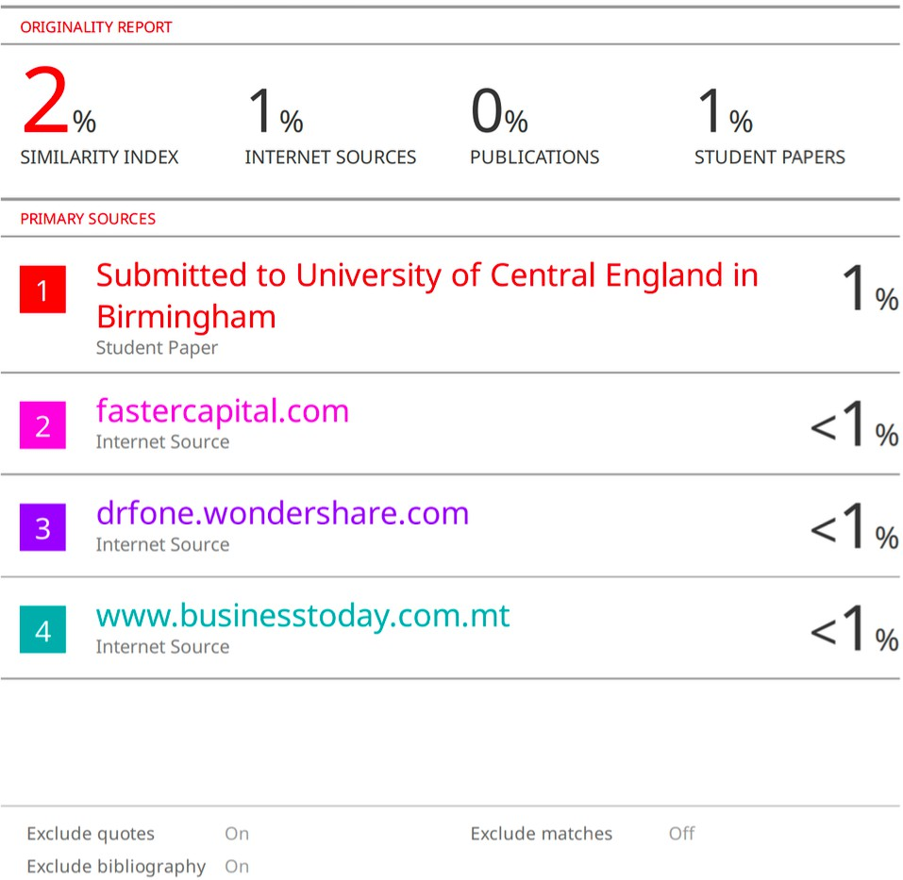

**Figure 44: Plagiarism Report**